**Non-linear associations of 25-hydroxyvitamin D concentrations with risk of cardiovascular disease and all-cause mortality: results from The Health Improvement Network (THIN) database**

Francesca L Crowe, Rasiah Thayakaran, Neil Gittoes, Martin Hewison, G Neil Thomas, Robert Scragg*, Krishnarajah Nirantharakumar *

*Joint Senior Authors

**Corresponding Authors**

Krishnarajah Nirantharakumar Tel: +44 0121 4148344, Email:[K.Nirantharan@bham.ac.uk](mailto:K.Nirantharan@bham.ac.uk)

Robert Scragg<Tel:+64>-9-9236336, Fax: +64-9-3737 503 Email:[r.scragg@auckland.ac.nz](mailto:r.scragg@auckland.ac.nz)

**Affiliations**

Institute of Applied Health Research (FLC, RT, GNT, KN), Institute of Metabolism and Systems (NG, MH), and Centre for Endocrinology, Diabetes and Metabolism, College of Medical and Dental Sciences (NG), University of Birmingham, Birmingham, UK; School of Population Health, Faculty of Medical and Health Sciences, University of Auckland, Auckland, New Zealand (RS).

**Abstract**

**Background:** There is increasing evidence that vitamin D supplementation may only be beneficial in people with vitamin D deficiency, and the lack of sufficient people with very low vitamin D levels could explain the lack of protection against cardiovascular disease (CVD) reported in recent clinical trials of vitamin D supplementation. The aim of this study was to assess associations of low to moderate circulating concentrations of 25-hydroxyvitamin D (25(OH)D with risk of incident CVD and all-cause mortality, as well as the risk of ischaemic heart disease (IHD), cerebrovascular disease, and heart failure separately.

**Methods and Results**: Longitudinal analysis of electronic health records in The Health Improvement Network (THIN), a UK primary care database. The analysis included 180,263 patients age 18 years and older without a history of CVD and with circulating concentrations of 25(OH)D. After a mean follow-up of 2.2 (SD 1.7) years, there were 3,747 patients diagnosed with CVD and 3,912 patients died. Compared to patients in the highest quintile of 25(OHD) (≥ 67.5 nmol/L), those in the lowest 25(OH)D quintile (<23.1 nmol/L) had a hazard ratio (HR) of 1.24 (95% CI 1.12–1.38, *P* < 0.001) for CVD and 1.71 (1.55–1.88, P < 0.001) for mortality. The HR for both outcomes associated with 25(OH)D concentration was non-linear, being significantly increased in patients with 25(OH)D <35 nmol/L, and highest in those with 25(OH)D <25 nmol/L, although increased for mortality at 25(OH)D ≥100 nmol/L. The increased CVD HR in the lowest 25(OH)D quintile was more from IHD (1.35, 95% CI 1.13–1.60) and heart failure (1.38, 95% CI 1.08–1.77), than from cerebrovascular disease (1.13, 95% CI 0.97–1.31).

**Conclusion:** Low 25(OH)D are associated with highest risk of CVD and mortality, and are consistent with accumulating evidence that increased risk of these diseases occurs primarily in people with vitamin D deficiency.

**Keywords:** 25-hydroxyvitamin D; cardiovascular disease, electronic health records; mortality; vitamin D.

**Introduction**

A recent meta-analysis of prospective studies (1) showed evidence of an inverse association between circulating concentrations of cardiovascular disease (CVD) and circulating concentrations of the vitamin D biomarker 25-hydroxyvitamin D (25(OH)D). However, there was considerable between study heterogeneity with the association of 25(OH)D with CVD risk being much stronger in two studies where the lowest category of circulating 25(OH)D levels was less than 25 nmol/L (2, 3). Lower circulating concentrations of 25(OH)D have also been associated with an increased risk of mortality (4-7). Results from a recent individual participant meta-analysis of standardised circulating 25(OH)D concentrations showed that mortality was raised among participants with 25(OH)D lower than 50 nmol/L (5). Despite the consistent finding of an inverse association of 25(OH)D and risk of CVD and mortality in observational studies, meta-analyses of randomised controlled trials of vitamin D supplementation and CVD and mortality have generally been mixed (8, 9). Many of the trials, including the recent trials conducted in New Zealand – the Vitamin D Assessment (ViDA) study (10), and the US – the VITamin D and OmegA-3 TriaL (VITAL) (11) were limited by the fact they included only a small proportion of participants with low circulating concentrations of 25(OH)D.

The Health Improvement Network (THIN) database includes general practice (GP) records of over 11 million patients from over 700 UK general practices, many of whom have been tested for vitamin D deficiency. THIN therefore offers the opportunity to examine the prospective association between circulating concentrations of 25(OH)D and risk of CVD and all-cause mortality in a large cohort of individuals. The large sample size provides an opportunity to analyse the relation of 25(OH)D with CVD and mortality within subgroups defined by smoking status, BMI and presence of other risk factors, thereby reducing the potential for confounding by these factors, and also for specific cardiovascular diseases. Importantly, approximately, one-third of the patients with measurements of 25(OH)D in THIN have low (less than 30 nmol/L) circulating concentrations of 25(OH)D and 16% have 25(OH)D values above 75 nmol/L (12). This makes it an ideal population for examining the relation between vitamin D status and risk of CVD and mortality across a wide range of 25(OH)D concentrations.

The primary objective of this analysis is to describe the relationship of low to moderate circulating concentrations of 25-hydroxyvitamin D (25(OH)D, with subsequent risk of incident CVD and all-cause mortality, as well as the risk of ischaemic heart disease (IHD), cerebrovascular disease, and heart failure individually. A secondary objective is to determine whether these associations are modified by other major risk factors such as smoking, BMI or the presence of risk factors.

**Methods**

This study was a large open cohort design using The Health Improvement Network (THIN) primary care database that contains health records for more than 11 million patients from over 750 general practices (GP) in the UK. The distribution of age, sex, prevalence of major medical conditions and mortality rates in the THIN cohort is generalisable to the UK population (13). The diagnoses in the THIN database are recorded using a hierarchical system called Read Codes which are terms or short-phrases used to describe a health-related concept in GP records (14). Collection of data for THIN was approved by the South-East Multicentre Research Ethics Committee in 2003; under the terms of this approval, studies must undergo independent scientific review. Approval for this analysis was obtained from the Scientific Review Committee (for the use of THIN data) in September 2018 (SRC reference18THIN066).

*Study population and period*

All data included in this study were from practices that met the acceptable mortality reporting (AMR) and acceptable computer usage (ACU) standards – measures of quality assurance for THIN data (15, 16). Individuals age 18 years and older who were registered with a THIN practice contributing data between January 1, 2005 and May 10, 2016 were included in this analysis.

Read Codes for vitamin D tests were used as the exposure in this analysis. Only patients who had measures indicating total 25-hydroxyvitamin D (i.e. the sum of 25-hydroxyvitamin D2 and 25-hydroxyvitamin D3) or 25-hydroxyvitamin D3 were included in the analysis. Some individuals had circulating concentrations of 25(OH)D tested on multiple occasions but only the first test was used in the analysis. Individuals who had their first recorded test for 25(OH)D before the date of entry to THIN (January 1, 2005) or before they turned 18 years were excluded from the analysis.

There were 202,804 individuals with a valid measurement of circulating 25(OH)D included in the study population for this analysis. Individuals were excluded from the analysis if they had prevalent IHD (*n*=14,502), cerebrovascular disease (*n*=6,595), heart failure (*n*=1,427), or if they had no follow-up (*n*=17), leaving 180,263 available for this analysis (**Supplementary figure 1**). Median (IQR) concentrations of 25(OH)D were 38.0 (23.2 to 60.1) nmol/L in individuals with pre-existing CVD excluded from the analysis, which was slightly lower than the individuals included in the analysis 41.0 (26.1 to 61.8) nmol/L.

*Cardiovascular disease ascertainment*

Primary care Read codes were used to identify diagnoses of the following three presentations of CVD: IHD (angina, ischaemic heart disease, and myocardial infarction); cerebrovascular disease (transient ischaemic attack, ischaemic stroke, and haemorrhagic stroke); and heart failure. The Read codes used for these outcomes were taken from the Annual Quality and Outcomes Framework (introduced in 2004 for primary care), additional codes identified by searching medical dictionary keywords, and online clinical code repositories. Incident CVD was defined at the first record of CVD in the primary care records.

The validity of the Read codes used for CVD has been previously published (17-19) as has recording of mortality in primary care records (20).

*Statistical analysis*

Season-adjusted (deseasonalised) values of 25(OH)D were calculated for each patient by using their 25(OH)D concentration and date of blood sample collection in a sinusoidal model (**Supplementary Figure 2**) (21). Mean 25(OH)D values were plotted by month and as published reports for 25(OH)D concentrations show that they follow a sinusoidal pattern with month of the year, a cosinor model was fitted to the data. Person-years were calculated from the date when the circulating concentration of 25(OH)D were first measured up to whichever of the following were first documented: diagnosis of cardiovascular disease, exit from the THIN database (transferred practice or died), the last date practice data was collected, or May 10, 2016). Cox regression models with attained age as the underlying time variable were used to estimate hazard ratios (HRs) and 95% confidence intervals (CI) of cardiovascular disease by quintiles of circulating concentrations of 25(OH)D. The highest quintile of 25(OH)D was chosen as the reference category. Analyses were adjusted for sex, quintiles of socioeconomic status (based on Townsend deprivation score), ethnicity (white, black or black British, mixed race, Asian or British Asian and other) body mass index (<18.5, 18.5 to 24.9, 25 to 29.9, ≥ 30 kg/m2), smoking (never, past, current), history of hypertension, history of diabetes, use of lipid lowering medication, and history of atrial fibrillation. To account for similarity of outcomes within practices, statistical inference from the Cox regression model was based on cluster-robust standard errors. Data were missing for approximately <1% for smoking status, 8% for BMI, 9% for socioeconomic group, and 38% of patients for ethnicity. To ensure that the same patients were being compared in all analyses the patients with a missing value for each particular variable were assigned to a separate category for that variable and included in the regression analysis.

In the subgroup analysis, the quintiles of 25(OH)D were replaced with the base-2 logarithm of serum concentration of 25(OH)D in the Cox regression model, which represents a doubling of concentrations of 25(OH)D. Heterogeneity in the associations across the subgroups of patients according to sex, age at baseline, smoking, socioeconomic status, ethnicity, BMI, and presence of CVD risk factors was assessed using a standard chi-squared test (χ2) test. It is possible that undiagnosed disease may cause people to become unwell, which can result in some individuals changing their lifestyle to spend less time outside in the sun, and may lead to reverse causation bias whereby low 25(OH)D are a consequence, rather than a cause, of the disease. To minimise this type of bias, analyses for CVD and mortality were repeated according to subgroups of follow-up time (< 3 and ≥ 3 years). Repeat analyses were restricted also to those with complete data on BMI, ethnicity, smoking and socioeconomic group.

All statistical analyses were performed using Stata statistical software, V.15 (StataCorp, College Station, Texas, USA). Two-sided *P* values < 0.05 were considered statistically significant.

**Results**

There were 133,518 women and 46,745 men included in this analysis. At baseline their mean age was 52 (SD 17) years and median (IQR) 25(OH)D concentration was 41.0 (26.1 to 61.8) nmol/L. **Table 1** shows the characteristics of the men and women included in the analysis and details of their follow-up, by quintiles of circulating concentrations of 25(OH)D. Compared to patients in the highest quintile of circulating 25(OH)D (median=83.4 nmol/L), those in the lowest quintile (median=16.5 nmol/L) were younger, were more likely to be non-white ethnicity, had a higher BMI, and were more likely to be in the lowest socioeconomic group, be current smokers and have diabetes. Those in the lowest quintile of 25(OH)D were less likely to have a history of atrial fibrillation compared to the highest quintile.

After a mean follow-up of 2.2 (SD 1.7) years, there were 3,747 patients diagnosed with cardiovascular disease and 3,912 patients died. **Table 2** shows the HR (95% CI) of CVD, mortality, IHD, cerebrovascular disease, and heart failure by quintiles of circulating concentrations of 25(OH)D. There was a strong and highly statistically significant inverse association between 25(OH)D and risk of CVD. In a model adjusted for only age, the risk of CVD was 39% (HR 1.39, 95% CI 1.26–1.55) higher among patients in the lowest compared to the highest quintile of 25(OH)D. Associations were attenuated after adjusting for a number of covariates but still remained significantly elevated in the lowest quintile, with the risk of CVD being 24% greater than the highest quintile (HR=1.24, 95% CI 1.12–1.38, *P* < 0.001). There was a strong inverse relation between circulating 25(OH)D and mortality; after adjusting for confounding variables there was a 71% greater hazard of mortality in those with 25(OH)D less than 23.1 nmol/L (95% CI 1.55–1.88) and 16% greater in those with 25(OH)D 23.1–34.8 nmol (95% CI 1.05–1.29), compared to those with circulating 25(OH)D greater than 67.5 nmol/L. There were strong inverse associations between 25(OH)D and IHD and

**Table 1** Characteristics of THIN patients according to quintiles of circulating concentrations of 25-hydroxyvitamin D

|  |  |  |  |  |  |  |  |
| --- | --- | --- | --- | --- | --- | --- | --- |
|  | **Quintiles of circulating concentrations of 25-hydroxyvitamin D** | | | | |  |  |
| Range, nmol/L | 0.05 to 23.09 | 23.10 to 34.83 | 34.84 to 48.27 | 48.28 to 67.49 | 67.50 to 206.49 | *P* value | **All** |
| Number of patients | 36,055 | 36,056 | 36,049 | 36,051 | 36,052 |  | 180,263 |
| Median (IQR) 25-hydroxyvitamin D, nmol/L | 16.5 (12.0–19.9) | 29.0 (26.1–31.9) | 41.0 (37.9–44.6) | 56.9 (52.4–61.8) | 83.4 (74.4–97.8) |  | 41.0 (26.1–61.8) |
| Patients characteristics |  |  |  |  |  |  |  |
| Mean age (± SD) in years | 49.4 ± 18.2 | 50.8 ± 17.4 | 51.8 ± 16.8 | 53.0 ± 16.8 | 55.2 ± 17.4 | < 0.001 | 52.1 ± 17.4 |
| BMI, kg/m2* mean ± SD | 27.5 ± 6.7 | 27.5 ± 6.4 | 27.3 ± 6.0 | 26.6 ± 5.6 | 25.6 ± 5.2 | < 0.001 | 26.9 ± 6.0 |
| Women (%) | 26,439 (73.3%) | 25,955 (72.0%) | 26,209 (72.7%) | 26,880 (74.6%) | 28,035 (77.8%) | < 0.001 | 133,518 (74.1%) |
| Socioeconomic status, most deprived* (%) | 8,215 (22.8%) | 6,546 (18.2%) | 5,238 (14.5%) | 4,275 (11.9%) | 3,684 (10.2%) | < 0.001 | 27,958 (15.5%) |
| Ethnicity, white* (%) | 9,460 (26.2%) | 13,817 (38.3%) | 16,481 (45.7%) | 17,791 (49.4%) | 18,975 (52.6%) | < 0.001 | 76,524 (42.5%) |
| Current smokers* (%) | 5,802 (16.1%) | 6,317 (17.5%) | 5,868 (16.3%) | 4,894 (13.6%) | 4,640 (12.9%) | < 0.001 | 27,521 (15.3%) |
|  |  |  |  |  |  |  |  |
| History hypertension (%) | 8,021 (22.3%) | 8,204 (22.8%) | 7,961 (22.1%) | 7,832 (21.7%) | 8,207 (22.8%) | 0.002 | 40,225 (22.3%) |
| Diabetes (%) | 4,004 (11.1%) | 3,434 (9.5%) | 2,911 (8.1%) | 2,482 (6.9%) | 2,149 (6.0%) | < 0.001 | 14,980 (8.3%) |
| Use of lipid lowering medication (%) | 7,681 (21.3%) | 7,783 (21.6%) | 7,761 (21.5%) | 7,688 (21.3%) | 7,830 (21.7%) | 0.615 | 38,743 (21.5%) |
| History of atrial fibrillation (%) | 691 (1.9%) | 698 (1.9%) | 676 (1.9%) | 717 (2.0%) | 822 (2.3%) | 0.001 | 3,604 (2.0%) |
| Follow-up |  |  |  |  |  |  |  |
| Person-years of follow-up | 86,741.7 | 80,880.0 | 79,034.3 | 77,681.8 | 78,688.6 |  | 403,026.3 |
| New cases of cardiovascular disease | 828 | 781 | 707 | 674 | 757 |  | 3,747 |
| Deaths | 1,117 | 752 | 674 | 591 | 778 |  | 3,912 |
| BMI, body mass index; THIN, The Health Improvement Network | |  |  |  |  |  |  |
| *Unknown for some patients: 515 (0.3%) for smoking, 13,842 (7.7%) for BMI, 15,597 (8.7%) for socioeconomic status, and 69,122 (38.3%) for ethnicity. | | | | | | | |

**Table 2** Hazards ratio (95% CI) of cardiovascular disease overall, by subtypes of disease and overall mortality by quintiles of circulating concentrations of 25-hydroxyvitamin D

|  |  |  |  |  |  |
| --- | --- | --- | --- | --- | --- |
|  | **Quintiles of circulating concentrations of 25-hydroxyvitamin D (nmol/L)** | | | | |
|  | 0.05 to 23.09 | 23.10 to 34.83 | 34.84 to 48.27 | 48.28 to 67.49 | 67.50 to 206.49 |
| **Cardiovascular disease (*n*)** | 828 | 781 | 707 | 674 | 757 |
| HR (95% CI)* | 1.39 (1.26–1.55) | 1.30 (1.18–1.43) | 1.14 (1.03–1.26) | 1.03 (0.92–1.14) | 1.00 (ref) |
| Adjusted HR (95% CI)† | 1.24 (1.12–1.38) | 1.16 (1.05–1.27) | 1.05 (0.95–1.16) | 0.97 (0.88–1.08) | 1.00 (ref) |
|  |  |  |  |  |  |
| **All-cause mortality (*n*)** | 1,117 | 752 | 674 | 591 | 778 |
| HR (95% CI)* | 1.76 (1.59–1.94) | 1.20 (1.08–1.33) | 1.09 (0.98–1.21) | 0.91 (0.81–1.01) | 1.00 (ref) |
| Adjusted HR (95% CI)† | 1.71 (1.55–1.88) | 1.16 (1.05–1.29) | 1.06 (0.95–1.18) | 0.90 (0.80–1.00) | 1.00 (ref) |
|  |  |  |  |  |  |
| **Ischaemic heart disease (*n*)** | 334 | 270 | 262 | 251 | 261 |
| HR (95% CI)* | 1.62 (1.36–1.93) | 1.28 (1.07–1.53) | 1.18 (1.00–1.40) | 1.08 (0.91–1.28) | 1.00 (ref) |
| Adjusted HR (95% CI)† | 1.35 (1.13–1.60) | 1.09 (0.91–1.30) | 1.05 (0.88–1.25) | 1.00 (0.84–1.19) | 1.00 (ref) |
|  |  |  |  |  |  |
| **Cerebrovascular disease (*n*)** | 329 | 365 | 301 | 283 | 364 |
| HR (95% CI)* | 1.16 (1.00–1.34) | 1.27 (1.10–1.46) | 1.02 (0.88–1.19) | 0.90 (0.76–1.07) | 1.00 (ref) |
| Adjusted HR (95% CI)† | 1.13 (0.98–1.31) | 1.21 (1.04–1.40) | 0.98 (0.84–1.14) | 0.89 (0.75–1.05) | 1.00 (ref) |
|  |  |  |  |  |  |
| **Heart failure (*n*)** | 165 | 146 | 144 | 140 | 132 |
| HR (95% CI)* | 1.58 (1.25–2.00) | 1.40 (1.12–1.76) | 1.38 (1.12–1.70) | 1.26 (1.01–1.58) | 1.00 (ref) |
| Adjusted HR (95% CI)† | 1.38 (1.08–1.77) | 1.18 (0.93–1.50) | 1.22 (0.98–1.53) | 1.14 (0.90–1.44) | 1.00 (ref) |
| CI, confidence intervals; HR, hazard ratio | |  |  |  |  |
| *Adjusted for age | | | | | |
| †Adjusted for age, sex, socioeconomic status, ethnicity, smoking , BMI, hypertension, diabetes, use of lipid-lowering medication, and atrial fibrillation | | | | | |

heart failure; the HR for the lowest versus the highest quintile of concentrations of 25(OH)D was 1.35 (95% 1.13–1.60, *P*=0.001) and 1.38 (95% CI 1.08–1.77, *P*=0.026), respectively. The hazard ratio for cerebrovascular disease in patients in the lowest quintile of 25(OH)D was not statistically significantly higher than those in the highest quintile but the overall trend was (*P*=0.001).

The associations of 25(OH)D concentrations with hazard ratios of CVD and mortality (**Figure 1**) showed evidence for a non-linear association. Compared to patients with 25(OH)D concentrations of 75.0–99.9 nmol/L the HR for CVD and mortality were significantly different for values of 25(OH)D <35 nmol/L and the HR of mortality for those with 25(OH)D ≥ 100 nmol/L was also significantly greater.

The HR of CVD for a doubling of 25(OH)D by subgroups of patient and CVD characteristics are shown in **Supplementary Figure 3**. The lower hazard of CVD for a higher concentration of 25(OH)D did not vary significantly between subgroups of patients defined by their sex, age, smoking, socioeconomic status, ethnicity, body mass index, whether they had CVD risk factors at baseline or by the time between testing for vitamin D and diagnosis of CVD.

The lower HR of mortality associated with a doubling of 25(OH)D did not differ according to sex, smoking, socioeconomic status, or BMI (**Supplementary Figure 4**). In contrast, the association between 25(OH)D and mortality differed according to baseline age where the association was not as strong in patients who were older than 75 years when 25(OH)D was measured compared to younger patients (*P* heterogeneity < 0.001) and by ethnicity where the association was not as strong among non-white patients (*P* heterogeneity = 0.04). The association between 25(OH)D and mortality also differed according to follow-up where it

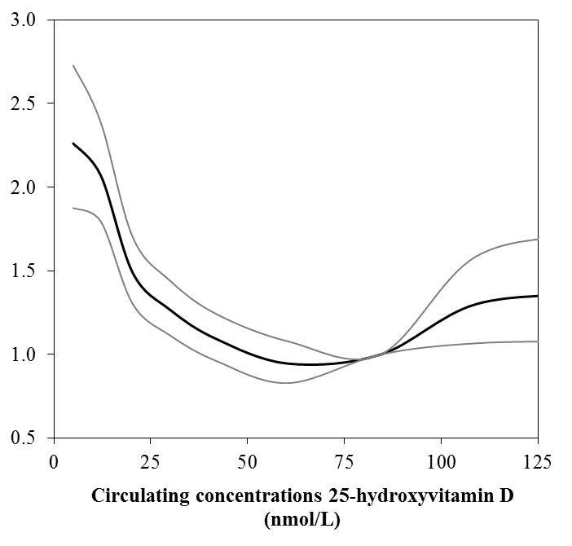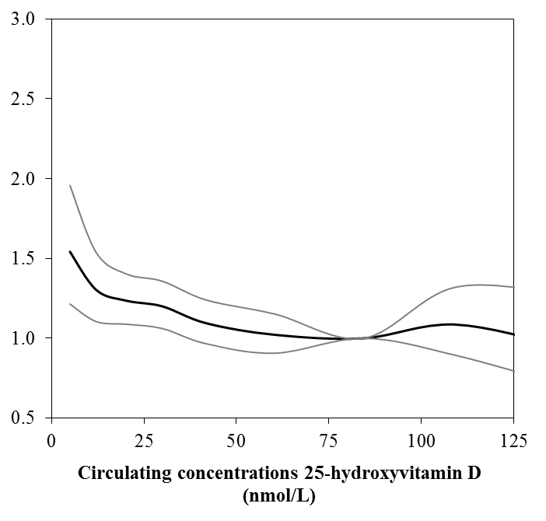

A. Cardiovascular disease

B. All-cause mortality

**Figure 1** Dose-response trend of hazard ratios of (*A*) cardiovascular disease and (*B*) mortality by circulating concentrations of 25-hydroxyvitamin D.Adjusted for age, sex, smoking, socioeconomic status, ethnicity, BMI, hypertension, diabetes, use of lipid-lowering medication, and atrial fibrillation.Hazard ratios [black line with 95% confidence interval as the grey lines] refer to the 25(OH)D concentration of 84.4 nmol/L (i.e. the median 25(OH)D concentration for the group with 25(OH)D concentrations from 75 to 99.9 nmol/L).

was stronger among patients who died in the first three years of follow-up than among patients with a longer follow-up time (*P* heterogeneity = 0.002).

In sensitivity analysis, inclusion of only patients with complete data on BMI, ethnicity, smoking, and socioeconomic group made minimal difference to the associations of 25(OH)D with HR of CVD and mortality (**Supplementary table 1**).

**Discussion**

In this large cohort, the median concentration of 25(OH)D was just above that for men and women age 19-64 in the UK (41.0 versus 40.6 nmol/L) (22). There was a statistically significant greater risk of cardiovascular disease (including IHD and heart failure) and mortality among patients with lower 25(OH)D. The mortality association, but not that for CVD events, was much stronger over the first three years of follow-up compared to a longer follow-up time period

The most recent meta-analysis showed that each 25 nmol/L increase in 25(OH)D was associated with a reduction in incident CVD of 10% (RR=0.90 95% CI 0.86–0.94) (1). The current study found a slightly weaker association whereby a 25 nmol/L increase in 25(OH)D reduced the risk of CVD by 7% (HR 0.93, 95% CI 0.90–0.96). The previous results suggested that a non-linear association with CVD risk of increasing only among participants with 25(OH)D <60 nmol/L. In our study the elevated risk of CVD was particularly apparent among patients with vitamin D status <35 nmol/L, a level considered insufficient. There was no evidence that risk of CVD was greater among patients with 25(OH)D that was 100 nmol/L or higher. Our data and those from the meta-analysis provide strong evidence that the risk of CVD was higher among those with 25(OH)D insufficiency.

Our results also showed an inverse association between low circulating 25(OH)D specifically and a greater risk of developing IHD, and cerebrovascular disease which are generally consistent with findings from several meta-analyses of observational studies of IHD (23). Similar findings were observed between 25(OH)D and heart failure which is consistent with results from some (24, 25) but not all (26-28) prospective studies. However, it was likely that many of these studies were underpowered, as it was the studies with more than 500 cases of heart failure that showed evidence of a significant association. Therefore, the totality of the evidence would suggest that lower circulating concentrations of 25(OH)D are associated with an greater risk of heart failure.

The finding of an increased mortality in patients with low 25(OH)D is consistent with results from other individual participant meta-analyses (5, 29), tabular meta-analyses(4, 30), and other cohort studies not included in these meta-analyses (6, 7). While these studies showed no evidence of a major difference in risk among participants with a longer follow-up time, the findings reported herein suggest that the association between 25(OH)D and mortality was only apparent during the first three years of follow-up which has also been reported in another individual study (31). It is possible that differences between studies in the underlying participant population might account for some of this heterogeneity where the population for these studies were drawn from patients attending primary care practices who had circulating concentrations of 25(OH)D measured. Those with prevalent CVD were excluded from this analysis. However, it is possible that others with undiagnosed ill health had lower 25(OH)D levels from reduced photosynthetic production because they spent less time outdoors and had reduced dietary intake of vitamin D through a poorer diet due to their underlying illness (8, 32). This may therefore be an example of reverse causation which is illustrated by the finding of a stronger association of circulating 25(OH)D and risk of mortality in the first three years but not after three years. This was not however the case with CVD events.

These results also showed that patients with 25(OH)D that was 100 nmol/L or higher also had a greater risk of dying which has also been reported in another study (6) but not in the individual participant meta-analyses (5, 29) and likewise may be due to patients with ill health starting to take high-dose vitamin D supplements (33).

The biological mechanisms that may underlie the associations of vitamin D and heart disease are yet to be fully elucidated. A possible mechanism of action includes an anti-inflammatory effect of vitamin D, which may help protect against CVD by inhibiting the formation of foam cells from macrophages (34). A recent systematic review showed that patients with type 2 diabetes supplemented with vitamin D had lower circulating concentrations of the inflammatory marker tumour necrosis factor-alpha (TNF-α), giving some weight to the case for biological plausibility (35) but future studies may help understand these mechanisms better (36). The mechanisms of action are unlikely to include an effect of vitamin D on CVD risk factors such as blood pressure, lipids, or markers of glucose metabolism as a recent individual participant meta-analysis of randomised controlled trials showed no evidence for an effect of vitamin D supplementation on these biomarkers, even in participants with vitamin D levels considered deficient (37).

Due to the wide-range range of potential confounders, and the possibility that low circulating 25(OH)D may be a result rather than a cause of disease (38), large randomised controlled trials were initiated and have recently reported their findings. Two large trials of vitamin D supplementation, ViDA (10) and VITAL (11), found no evidence in their primary outcomes to support a beneficial effect of vitamin D supplementation on the risk of CVD. One of the main limitations of the VITAL study was that overall the study sample was relatively vitamin D replete, with a mean baseline 25(OH)D of 75 nmol/L; only 13% had a 25(OH)D less than 50 nmol/L. Even in the ViDA study, fewer than 25% of the study participants had circulating 25(OH)D less than 50 nmol/L. The finding from this study and other studies show that the risk of CVD is only higher among those whose circulating 25(OH)D are below 50 nmol/L. Therefore, a possible explanation for recent findings that vitamin D supplementation has shown little benefit in preventing CVD is that there were too few participants with levels below this threshold included in these trials. Nevertheless, individual participant meta-analyses of these existing randomised controlled trials (e.g. VITAL and ViDA) offer an opportunity to determine whether there are beneficial effects of vitamin D supplementation in people with low levels of 25(OH)D. The trials and our data show that circulating 25(OH)D levels above 50 nmol/L are not associated with an increased risk of CVD.

Mendelian randomisation studies of 25(OH)D with risk of CVD do not support a causal role of vitamin D (39-42) however, such studies are not able to provide a definitive answer on causality for two reasons. First, Mendelian randomisation studies assume a linear association between 25(OH)D and CVD but our results and that of others have shown this association is non-linear. Second, the distribution of 25(OH)D concentrations from Mendelian randomisation studies do not extend to levels that would be considered low enough to exclude a causal relationship between vitamin D with CVD. Future trials that include participants with insufficient levels of 25(OH)D may help to overcome this limitation (32), although such studies would need to be carefully designed to address ethical considerations of assigning vitamin D deficient participants to a placebo (43).

Strengths of this study include its very large sample size, and the inclusion of patients with a wide range of circulating concentrations of 25(OH)D. More than 60% of this study population had 25(OH)D less than 50 nmol/L and just over 20% had values less than 25 nmol/L. We were also able to include a number of risk factors for CVD including a diagnosis of atrial fibrillation, an important risk factor, which has not been included as a confounding variable in many other cohort studies. Nevertheless, physical activity is not routinely collected in the THIN database so we were not able to adjust for this confounding variable. Moreover, while heterogeneity in the associations was examined in a range of subgroups, it is possible that there may be residual confounding in the associations with 25(OH)D. There was a greater number of women compared with men because this cohort was taken from a population who were tested for vitamin D deficiency in primary care and women were more likely to be tested than men (12). Despite this imbalance, there was no evidence that the associations of 25(OH)D with risk of CVD and mortality differed between men and women.

In summary, the evidence from this large prospective study suggests that circulating concentrations of 25(OH)D less than 35 nmol/L are associated with an increased risk of CVD and mortality. Taken together with strong evidence of these associations from other observational studies, these results suggest that the effects of vitamin D supplementation on CVD should be investigated in future large clinical trials that include large number of vitamin D insufficient participants.

**Sources of funding**

No specific funding was received for this work

**Declarations of interest**

None

**References**

1. Zhang R, Li B, Gao X, Tian R, Pan Y, Jiang Y, Gu H, Wang Y, Wang Y, Liu G. Serum 25-hydroxyVitamin D and the risk of cardiovascular disease: Dose-response meta-analysis of prospective studies1-3. Am J Clin Nutr 2017;105:810-9.

2. Wang TJ, Pencina MJ, Booth SL, Jacques PF, Ingelsson E, Lanier K, Benjamin EJ, D'Agostino RB, Wolf M, Vasan RS. Vitamin D deficiency and risk of cardiovascular disease. Circulation 2008;117:503-11.

3. Semba RD, Houston DK, Bandinelli S, Sun K, Cherubini A, Cappola AR, Guralnik JM, Ferrucci L. Relationship of 25-hydroxyvitamin D with all-cause and cardiovascular disease mortality in older community-dwelling adults. Eur J Clin Nutr 2010;64:203-9.

4. Garland CF, Kim JJ, Mohr SB, Gorham ED, Grant WB, Giovannucci EL, Baggerly L, Hofflich H, Ramsdell JW, Zeng K, et al. Meta-analysis of all-cause mortality according to serum 25-hydroxyvitamin D. Am J Public Health 2014;104:e43-50.

5. Gaksch M, Jorde R, Grimnes G, Joakimsen R, Schirmer H, Wilsgaard T, Mathiesen EB, Njølstad I, Løchen M-, Maürz W, et al. Vitamin D and mortality: Individual participant data meta-analysis of standardized 25-hydroxyvitamin D in 26916 individuals from a European consortium. PLoS ONE 2017;12:e0170791.

6. Degerud E, Nygard O, de Vogel S, Hoff R, Svingen GFT, Pedersen ER, Nilsen DWT, Nordrehaug JE, Midttun O, Ueland PM, et al. Plasma 25-Hydroxyvitamin D and Mortality in Patients With Suspected Stable Angina Pectoris. J Clin Endocrinol Metab 2018;103:1161-70.

7. Zhu K, Knuiman M, Divitini M, Hung J, Lim EM, Cooke BR, Walsh JP. Serum 25-hydroxyvitamin D as a predictor of mortality and cardiovascular events: A 20-year study of a community-based cohort. Clin Endocrinol (Oxf) 2018;88:154-63.

8. Autier P, Mullie P, Macacu A, Dragomir M, Boniol M, Coppens K, Pizot C, Boniol M. Effect of vitamin D supplementation on non-skeletal disorders: a systematic review of meta-analyses and randomised trials. Lancet Diabetes Endocrinol 2017;5:986-1004.

9. Rejnmark L, Bislev LS, Cashman KD, Eiríksdottir G, Gaksch M, Grübler M, Grimnes G, Gudnason V, Lips P, Pilz S, et al. Non-skeletal health effects of Vitamin D supplementation: A systematic review on findings from meta-Analyses summarizing trial data. PLoS ONE 2017;12:e0180512.

10. Scragg R, Stewart AW, Waayer D, Lawes CMM, Toop L, Sluyter J, Murphy J, Khaw K-, Camargo CA. Effect of monthly high-dose vitamin D supplementation on cardiovascular disease in the vitamin D assessment study: A randomized clinical trial. JAMA Cardiol 2017;2:608-16.

11. Manson JE, Cook NR, Lee IM, Christen W, Bassuk SS, Mora S, Gibson H, Gordon D, Copeland T, D'Agostino D, et al. Vitamin D Supplements and Prevention of Cancer and Cardiovascular Disease. N Engl J Med 2019;380:33-44.

12. Crowe FL, Jolly K, MacArthur C, Manaseki-Holland S, Gittoes NJL, Hewison M, Scragg R, Nirantharakumar K. Trends in the incidence of testing for vitamin D deficiency in primary care in the United Kingdom: a retrospective analysis of The Health Improvement Network (THIN), 2005 to 2015. BMJ Open 2019;9:e028355.

13. Blak BT, Thompson M, Dattani H, Bourke A. Generalisability of the Health Improvement Network (THIN) database: Demographics, chronic disease prevalence and mortality rates. Informatics Prim Care 2011;19:251-5.

14. Booth N. What are the Read Codes? Health Libr Rev 1994;11:177-82.

15. Maguire A, Blak BT, Thompson M. The importance of defining periods of complete mortality reporting for research using automated data from primary care. Pharmacoepidemiol Drug Saf 2009;18:76-83.

16. Horsfall L, Walters K, Petersen I. Identifying periods of acceptable computer usage in primary care research databases. Pharmacoepidemiol Drug Saf 2013;22:64-9.

17. Gaist D, Wallander MA, Gonzalez-Perez A, Garcia-Rodriguez LA. Incidence of hemorrhagic stroke in the general population: validation of data from The Health Improvement Network. Pharmacoepidemiol Drug Saf 2013;22:176-82.

18. Hammad TA, McAdams MA, Feight A, Iyasu S, Dal Pan GJ. Determining the predictive value of Read/OXMIS codes to identify incident acute myocardial infarction in the General Practice Research Database. Pharmacoepidemiol Drug Saf 2008;17:1197-201.

19. Ruigomez A, Martin-Merino E, Rodriguez LA. Validation of ischemic cerebrovascular diagnoses in the health improvement network (THIN). Pharmacoepidemiol Drug Saf 2010;19:579-85.

20. Herrett E, Thomas SL, Schoonen WM, Smeeth L, Hall AJ. Validation and validity of diagnoses in the General Practice Research Database: a systematic review. Br J Clin Pharmacol 2010;69:4-14.

21. Sachs MC, Shoben A, Levin GP, Robinson-Cohen C, Hoofnagle AN, Swords-Jenny N, Ix JH, Budoff M, Lutsey PL, Siscovick DS, et al. Estimating mean annual 25-hydroxyvitamin D concentrations from single measurements: The Multi-Ethnic Study of Atherosclerosis. Am J Clin Nutr 2013;97:1243-51.

22. Bates B, Lennox A, Prentice A, et al. National Diet and Nutrition Survey Results from Years 5 and 6 (combined) of the Rolling Programme (2012/2013 – 2013/14). London: Public Health England, 2016.

23. Theodoratou E, Tzoulaki I, Zgaga L, Ioannidis JPA. Vitamin D and multiple health outcomes: Umbrella review of systematic reviews and meta-analyses of observational studies and randomised trials. BMJ 2014;348:g2035.

24. Anderson JL, May HT, Horne BD, Bair TL, Hall NL, Carlquist JF, Lapp DL, Muhlestein JB. Relation of vitamin D deficiency to cardiovascular risk factors, disease status, and incident events in a general healthcare population. Am J Cardiol 2010;106:963-8.

25. Lutsey PL, Eckfeldt JH, Ogagarue ER, Folsom AR, Michos ED, Gross M. The 25-hydroxyvitamin D3C-3 epimer: Distribution, correlates, and reclassification of 25-hydroxyvitamin D status in the population-based Atherosclerosis Risk in Communities Study (ARIC). Clin Chim Acta 2015;442:75-81.

26. Bansal N, Zelnick L, Robinson-Cohen C, Hoofnagle AN, Ix JH, Lima JA, Shoben AB, Peralta CA, Siscovick DS, Kestenbaum B, et al. Serum parathyroid hormone and 25-hydroxyvitamin d concentrations and risk of incident heart failure: The Multi-Ethnic Study of Atherosclerosis. J Am Heart Assoc 2014;3:e001278.

27. Giuseppe RD, Buijsse B, Hirche F, Wirth J, Arregui M, Westphal S, Isermann B, Hense HW, Dierkes J, Boeing H, et al. Plasma fibroblast growth factor 23, parathyroid hormone, 25-hydroxyvitamin D3, and risk of heart failure: A prospective, case-cohort study. J Clin Endocrinol Metab 2014;99:947-55.

28. Wannamethee GS, Welsh PW, Papacosta OP, Lennon L, Whincup PH, Sattar N. Elevated parathyroid hormone, but not vitamin D deficiency, is associated with increased risk of heart failure in older men with and without cardiovascular disease. Circ Heart Fail 2014;7:732-9.

29. Schöttker B, Jorde R, Peasey A, Thorand B, Jansen EHJM, De Groot L, Streppel M, Gardiner J, Ordóñez-Mena JM, Perna L, et al. Vitamin D and mortality: Meta-analysis of individual participant data from a large consortium of cohort studies from Europe and the United States. BMJ 2014;348:g3656.

30. Chowdhury R, Kunutsor S, Vitezova A, Oliver-Williams C, Chowdhury S, Kiefte-De-Jong JC, Khan H, Baena CP, Prabhakaran D, Hoshen MB, et al. Vitamin D and risk of cause specific death: Systematic review and meta-analysis of observational cohort and randomised intervention studies. BMJ 2014;348:g1903.

31. Durup D, Jorgensen HL, Christensen J, Tjonneland A, Olsen A, Halkjaer J, Lind B, Heegaard AM, Schwarz P. A Reverse J-Shaped Association Between Serum 25-Hydroxyvitamin D and Cardiovascular Disease Mortality: The CopD Study. J Clin Endocrinol Metab 2015;100:2339-46.

32. Jorde R. RCTS are the only appropriate way to demonstrate the role of vitamin D in health. J Steroid Biochem Mol Biol 2018;177:10-4.

33. Ensrud KE, Ewing SK, Fredman L, Hochberg MC, Cauley JA, Hillier TA, Cummings SR, Yaffe K, Cawthon PM, Study of Osteoporotic Fractures Research Group. Circulating 25-hydroxyvitamin D levels and frailty status in older women. J Clin Endocrinol Metab 2010;95:5266-73.

34. Rebsamen MC, Sun J, Norman AW, Liao JK. 1a,25-dihydroxyvitamin D3 induces vascular smooth muscle cell migration via activation of phosphatidylinositol 3-kinase. Circ Res 2002;91:17-24.

35. Mousa A, Naderpoor N, Teede H, Scragg R, de Courten B. Vitamin D supplementation for improvement of chronic low-grade inflammation in patients with type 2 diabetes: A systematic review and meta-analysis of randomized controlled trials. Nutr Rev 2018;76:380-94.

36. Mousa A, Misso M, Teede H, Scragg R, De Courten B. Effect of Vitamin D supplementation on inflammation: Protocol for a systematic review. BMJ Open 2016;6:e010804.

37. Swart KMA, Lips P, Brouwer IA, Jorde R, Heymans MW, Grimnes G, Grübler MR, Gaksch M, Tomaschitz A, Pilz S, et al. Effects of Vitamin D supplementation on markers for cardiovascular disease and type 2 diabetes: An individual participant data meta-analysis of randomized controlled trials. Am J Clin Nutr 2018;107:1043-53.

38. Meyer HE, Holvik K, Lips P. Should vitamin D supplements be recommended to prevent chronic diseases? BMJ 2015;350:h321.

39. Jorde R, Schirmer H, Wilsgaard T, Joakimsen RM, Mathiesen EB, Njølstad I, Løchen M, Figenschau Y, Berg JP, Svartberg J, et al. Polymorphisms related to the serum 25-Hydroxyvitamin D level and risk of Myocardial infarction, diabetes, cancer and mortality. The Tromsø study. PLoS ONE 2012;7(5):e37295

40. Afzal S, Brøndum-Jacobsen P, Bojesen SE, Nordestgaard BG. Genetically low vitamin D concentrations and increased mortality: Mendelian randomisation analysis in three large cohorts. BMJ 2014;349: g6330.

41. Brøndum-Jacobsen P, Benn M, Afzal S, Nordestgaard BG. No evidence that genetically reduced 25-hydroxyvitamin D is associated with increased risk of ischaemic heart disease or myocardial infarction: A Mendelian randomization study. Int J Epidemiol 2015;44:651-61.

42. Manousaki D, Mokry LE, Ross S, Goltzman D, Brent Richards J. Mendelian Randomization Studies Do Not Support a Role for Vitamin D in Coronary Artery Disease. Circ Cardiovasc Genet 2016;9:349-56.

43. Scragg R. Limitations of vitamin D supplementation trials: Why observational studies will continue to help determine the role of vitamin D in health. J Steroid Biochem Mol Biol 2018;177:6-9.

**Supplementary material**

202,804 patients with circulating concentrations of 25(OH)D

22,541 patients excluded

* prevalent IHD (*n*=14,502)
* prevalent cerebrovascular disease (*n*=6,595)
* prevalent heart failure (*n*=1,427)
* no follow-up (*n*=17)

180,263 patients included in the 25(OH)D CVD and mortality analysis

**Supplementary Figure 1**

Flow diagram of patients included in associations of circulating concentrations of 25(OH)D with risk of CVD and mortality

Calculation of de-seasonalised circulating concentrations of 25(OH)D

The mean vitamin D values were plotted by month using a cosinor model. The regression model for a single component cosinor (one cycle) is given as:

Yn = M + Acos(2πtn/τ + ϕ)+en

Where,

Yn – Vitamin D collected at time tn (n = 1,2,,…. N) and N is the number of observed values

M – MESOR (midline statistic of rhythm),

A – The amplitude (a measure of half the extent of predictable variation within a cycle),

ϕ – The acrophase (a measure of the time of overall high values recurring in each cycle),

τ – The period or duration of one cycle,

en – The error term and assumed to be independently normally distributed with mean 0 and constant variance $σ^{2}$.

We considered that τ (τ=12) is known and using the trigonometric formula, the model can be rewritten as Yn = M + βx + γz +en,

Where, β=Acosϕ, γ= -Asinϕ, x=cos(2πtn/12), z=sin(2πtn/12) and M is the annual mean.

This model is now linear and its parameters M, β and γ. The least square method was used to estimate the parameters. The estimated values for amplitude (A) and acrophase (ϕ) are given by $\hat{A}={({\hat{β}}^{2} +{\hat{γ}}^{2})}^{1/2}$ and $\hat{ϕ}$ = arctan(- $\hat{γ}/\hat{β}$).

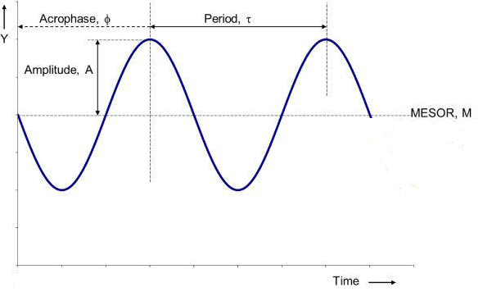

**Supplementary Figure 2**

Graphical representation of the cosinor curve

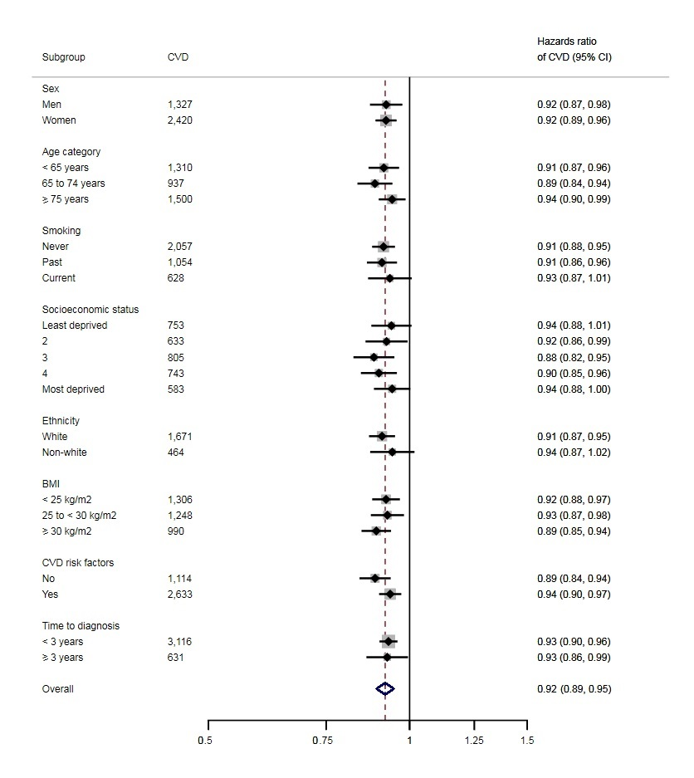

**Supplementary Figure 3**

Hazard ratio (95% CI) of cardiovascular disease for a doubling of concentration of 25(OH)D by chosen characteristics. Adjusted for age, sex, smoking, socioeconomic status, ethnicity, BMI, hypertension, diabetes, use of lipid-lowering medication, and atrial fibrillation (where appropriate). All subgroup analyses P heterogeneity > 0.05.



**Supplementary Figure 4**

Hazard ratio (95% CI) of mortality for a doubling of concentration of 25(OH)D by chosen characteristics. Adjusted for age, sex, smoking, socioeconomic status, ethnicity, BMI, hypertension, diabetes, use of lipid-lowering medication, and atrial fibrillation (where appropriate). Subgroup *P* heterogeneity < 0.001 for age category, and *P* = 0.037 for ethnicity and *P* = 0.002 for follow-up time (all other subgroups *P* heterogeneity > 0.05).

|  |  |  |  |  |  |
| --- | --- | --- | --- | --- | --- |
| **Supplementary Table 1** Hazards ratio (95% CI) of cardiovascular disease and mortality by quintiles of circulating concentrations of 25-hydroxyvitamin D among patients with complete data for all variables* | | | | | |
|
|  |  |  |  |  |  |
|  | **Quintiles of circulating concentrations of 25-hydroxyvitamin D (nmol/L)** | | | | |
|  | 0.05 to 23.09 | 23.10 to 34.83 | 34.84 to 48.27 | 48.28 to 67.49 | 67.50 to 206.49 |
| Cardiovascular disease† | 1.30 (1.12 to 1.52) | 1.27 (1.11 to 1.46) | 1.09 (0.95 to 1.26) | 1.10 (0.95 to 1.28) | 1.00 (ref) |
| All-cause mortality† | 1.75 (1.52 to 2.03) | 1.14 (0.97 to 1.33) | 1.02 (0.88 to 1.19) | 0.91 (0.78 to 1.07) | 1.00 (ref) |
| CI, confidence intervals |  |  |  |  |  |
| *94,642 patients including 1,924 cases of CVD and 1,757 deaths. | | |  |  |  |
| †Adjusted for age, sex, socioeconomic status, ethnicity, smoking , BMI, hypertension, diabetes, use of lipid-lowering medication, and atrial fibrillation | | | | | |