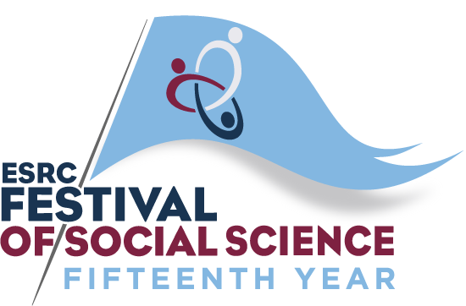

Supporting young people with vision impairment through post-16 transition

10th November 2017 1-5pm, Impact Hub Birmingham

Programme

1-1.30 Registration and Lunch

1.30-1.40 Introduction (Mike McLinden, VICTAR)

1.40-2.15 Overview of key findings from the Longitudinal Transitions Study (Graeme Douglas & Rachel Hewett (VICTAR) and Sue Keil, (VIEW))

2.15-2.35 Reflections from a Local Authority Service (Kay Wrench, Oldham Council)

2.35-2.45 Introduction to the sector campaign (Lucy Dixon, RNIB)

2.45-3.00 Refreshment break

3.00-4.30 Directed discussion in groups

4.30-4.40 Refreshment break

4.40-5.00 Where do we go from here? (Rory Cobb, VIEW)

