Table 1: School satisfaction Factor loadings and mean ratings
Survey question | Factor
 | School Support | Legislation Impact | Autonomy | Effect of difficulties | Accessibility | Within-Child View
Enough information to decide what next |  |  | .818
Able to choose what next |  |  | .880
Child feels settled in school | .564 |  | .456
Child is making good progress at school | .682
Satisfied with the way school is treating child | .802
Child looks forward to going to school | .590
Difficulties caused by Local Authority | -.472 |  | -.516
Difficulties cause by school organization | -.861
Difficulties caused by lack of understanding in school | -.871
Difficulties are just the way s/he is | .485 |  |  |  |  | .521
School is doing well helping child with difficulties | .702 | .507
Child’s difficulties will stop him/her doing well |  |  |  | .855
Child’s difficulties will prevent them learning in school |  |  |  | .847
Child’s difficulties will stop them moving around the school |  |  |  | . | .817
Child’s difficulties will stop them doing extra activities at school |  |  |  |  | .832
Child’s difficulties will stop him/her getting a good job |  |  |  | .467 |  | .666
Teachers encourage child to aim high | .646 | .510
Child’s difficulties will prevent him/her continuing in education |  |  |  | . |  | .693
DDA requires schools not disadvantage disabled children |  | .585
DDA has improved how schools treat disabled children |  | .696
School works hard to fulfil duties under DDA | .445 | .739
I know how the DDA helps my child at school |  | .778
Mean Ratings | 2.05 | 2.04 | 2.10 | 2.82 | 3.79 | 2.66
Std deviation | .76 | .79 | .83 | 1.07 | .98 | .99
N | 561 | 540 | 560 | 433 | 423 | 442

Table 2: Background characteristics of parents and children / young people in the LDD group
Background information about parents, and children / young people with learning difficulties and disabilities (LDD)
(n=562)
 |  | n | %* |  |  | n | %
Type of geographical  area | Scottish Urban  England Urban  England Rural  Wales Mixed | 36  328  140  58 | 6.4  58.3  24.9  10.3 | Gender of child | Male  Female  Missing | 332  224  6 | 59.7  40.3  -
Ethnic Origin | White British  White Other  White and Black Caribbean  White and Black African  White and Asian  Indian  Pakistani  Bangladeshi  Other Asian  Caribbean  African  Chinese  Other  Missing | 449  9  11  3  4  7  38  9  4  11  5  2  2  8 | 81.0  1.6  2.0  0.5  0.7  1.3  6.9  1.6  0.7  2.0  0.9  0.4  0.4  - | Special Need, Disability or Difficulty  [tick all that apply; groups not independent] | Mental health  Emotional or behavioural (EBD)  Language and communication  Autistic Spectrum Disorder (ASD)  Long term illness  Learning Disability (LD)  Prejudice  Bullying  Physical disability  Visual impairment  Hearing difficulties  Other medical  Other behavioural  School induced | 24  146  136  79  27  271  12  50  64  25  47  19  15  16
Main language spoken in the home | English  Asian / Arabic  African  Oriental  Western European  Eastern European  Sign Language  Welsh  Missing | 476  37  2  4  3  2  5  2  31 | 89.6  7.0  0.4  0.8  0.5  0.4  0.9  0.4  - | Child receiving free school meals? | Yes  No  Don’t know  Missing | 171  380  4  7 | 30.8  68.5  0.7  -
Employment  status | Modern professional  Clerical/ intermediate  Senior manager / admin  Technical and craft  Semi-routine and service  Routine manual  Middle and junior managers  Traditional professional  More than one ticked  Missing | 100  41  57  61  67  61  27  36  10  102 | 21.7  8.9  12.4  13.2  14.6  13.25  5.9  7.8  2.2  - | Statement of SEN | Yes  No it has ended  No never  Pending  Don’t know  Missing | 276  22  173  4  65  22 | 51.1  4.1  32.0  0.7  12.0  -
Sampling strata [type of school] | SEN /ASN register or list at mainstream  Special School  Mainstream | 97  242  223 | 17.3  43.1  39.7 | Does your child have a disability? | Yes  No  Don’t know  Missing | 280  235  23  24 | 52.0  43.7  4.3  -
Year Group  [England & Wales] | 5 or 6 (Scotland: P6 & P7): Late Primary  7 (Scotland: S1): Early Secondary  11 (Scotland: S4): Late Secondary  12 or 13 (Scotland: S5 & S6): Post-16 | 154  159  138  111 | 27.4  28.3  24.6  19.8 | * %ge of actual responses (does not include ‘missing’)

Table 3: Number of statements or Records of Need by Educational Strata

Have a statement / Record of Need? |  | Strata
Have a statement / Record of Need? |  | List/ register | Special | Mainstream
Yes | n | 38 | 191 | 47
Yes | % within Strata | 40.9% | 80.3% | 22.5%
No it has ended | n | 9 | 8 | 5
No it has ended | % within Strata | 9.7% | 3.4% | 2.4%
No never | n | 30 | 9 | 134
No never | % within Strata | 32.3% | 3.8% | 64.1%
Pending | n | 0 | 3 | 1
Pending | % within Strata | .0% | 1.3% | .5%
Don't know | n | 16 | 27 | 22
Don't know | % within Strata | 17.2% | 11.3% | 10.5%

Table 4: Employment status (grouped) compared to GB figures
 |  | Strata |  |  | GB norm¹
 |  | List/ register | Special | Mainstream | %
Prof + Managerial | n | 43 | 62 | 115
Prof + Managerial | % within Strata | 52.4% | 37.8% | 56.4% | 33.7%
Prof + Managerial | % of Total | 9.6% | 13.8% | 25.6% | 33.7%
Clerical | n | 5 | 20 | 16
Clerical | % within Strata | 6.1% | 12.2% | 7.8% | 12.2%
Clerical | % of Total | 1.1% | 4.4% | 3.6% | 12.2%
Routine + manual | n | 26 | 58 | 44
Routine + manual | % within Strata | 31.7% | 35.4% | 21.6% | 29.8%
Routine + manual | % of Total | 5.8% | 12.9% | 9.8% | 29.8%
Technical | n | 8 | 24 | 29
Technical | % within Strata | 9.8% | 14.6% | 14.2% | 10.1%
Technical | % of Total | 1.8% | 5.3% | 6.4% | 10.1%
¹ From the 2001 census figures, summarised in Rose, Pevalin and O’Reilly (2005); combined average totals for England, Scotland and Wales

Table 5: Ethnicity (grouped) compared to national figures

 |  | Strata |  |  | National combined average¹ (primary and secondary)
 |  | List/ register | Special | Mainstream
White | n | 83 | 170 | 205 | 82.7%
 | % within Strata | 85.6% | 70.2% | 91.9% | 82.7%
Mixed ethnicity | n | 3 | 11 | 4 | 13.6%
Asian | n | 6 | 46 | 6 | 13.6%
Black | n | 3 | 9 | 4 | 13.6%
Mixed, Asian + Black Combined² | % within Strata | 12.4% | 27.2% | 6.3% | 13.6%
¹ According to SEN provision (with and without statements) (DfES, 2005)
² Chinese (n=2) and ‘other’ (n=2) not included
Table 6. Summary of mean ratings (and standard deviations) for all statistically significant comparisons, by numbered Results section

Results section | Independent variable | Dependent measure or Factor | Mean rating |  | s.d.
3.1 | Ask the school to change? | School Support | Yes | 2.55 | .82
3.1 | Ask the school to change? | School Support | No | 1.85 | .64
3.1 | Ask the school to change? | Legislation Impact | Yes | 2.44 | .82
3.1 | Ask the school to change? | Legislation Impact | No | 1.87 | .72
3.1 | Ask the school to change? | Autonomy | Yes | 2.41 | .85
3.1 | Ask the school to change? | Autonomy | No | 1.98 | .79
3.1 | Ask the school to change? | Effect of Difficulties | Yes | 2.57 | .90
3.1 | Ask the school to change? | Effect of Difficulties | No | 2.96 | 1.14
3.2 | Educational Strata | School Support | List/register | 2.37 | .82
3.2 | Educational Strata | School Support | Special | 1.81 | .70
3.2 | Educational Strata | School Support | Mainstream | 2.17 | .73
3.2 | Educational Strata | Legislation Impact | List/register | 2.17 | .80
3.2 | Educational Strata | Legislation Impact | Special | 1.88 | .79
3.2 | Educational Strata | Legislation Impact | Mainstream | 2.16 | .76
3.2 | Educational Strata | Effect of Difficulties | List/register | 2.67 | .91
3.2 | Educational Strata | Effect of Difficulties | Special | 2.64 | 1.10
3.2 | Educational Strata | Effect of Difficulties | Mainstream | 3.09 | 1.07
3.2 | Educational Strata | Accessibility | List/register | 3.93 | .85
3.2 | Educational Strata | Accessibility | Special | 3.57 | 1.06
3.2 | Educational Strata | Accessibility | Mainstream | 3.98 | .89
3.2 | Educational Strata | Within-Child View | List/register | 2.70 | .81
3.2 | Educational Strata | Within-Child View | Special | 2.25 | .92
3.2 | Educational Strata | Within-Child View | Mainstream | 3.12 | .95
3.3a | Learning Disability | Effect of Difficulties | Yes | 2.68 | 1.07
3.3a | Learning Disability | Effect of Difficulties | No | 3.02 | 1.05
3.3a | Learning Disability | Within-Child View | Yes | 2.42 | .96
3.3a | Learning Disability | Within-Child View | No | 3.01 | .95
3.3b | Language and Autism | Effect of Difficulties | Yes | 2.58 | 1.05
3.3b | Language and Autism | Effect of Difficulties | No | 2.97 | 1.06
3.3b | Language and Autism | Within-Child View | Yes | 2.32 | .87
3.3b | Language and Autism | Within-Child View | No | 2.87 | 1.00
3.3b | Language and Autism | Accessibility | Yes | 3.60 | 1.02
3.3b | Language and Autism | Accessibility | No | 3.91 | .94
3.3c | Psychosocial difficulties | School Support | Yes | 2.31 | .82
3.3c | Psychosocial difficulties | School Support | No | 1.93 | .70
3.3c | Psychosocial difficulties | Legislation Impact | Yes | 2.16 | .81
3.3c | Psychosocial difficulties | Legislation Impact | No | 1.98 | .77
3.3c | Psychosocial difficulties | Autonomy | Yes | 2.24 | .85
3.3c | Psychosocial difficulties | Autonomy | No | 2.03 | .81
3.3c | Psychosocial difficulties | Effect of Difficulties | Yes | 2.66 | .97
3.3c | Psychosocial difficulties | Effect of Difficulties | No | 2.92 | 1.13
3.3c | Psychosocial difficulties | Accessibility | Yes | 3.63 | .99
3.3c | Psychosocial difficulties | Accessibility | No | 3.91 | .96
3.3d | Motor and sensory difficulties | School Support | Yes | 1.90 | .73
3.3d | Motor and sensory difficulties | School Support | No | 2.09 | .77
3.3d | Motor and sensory difficulties | Within-Child View | Yes | 2.41 | .99
3.3d | Motor and sensory difficulties | Within-Child View | No | 2.75 | .98
3.3d | Motor and sensory difficulties | Accessibility | Yes | 3.37 | 1.15
3.3d | Motor and sensory difficulties | Accessibility | No | 3.93 | .88
3.4 | Statement or Record of Needs | School Support | Yes | 1.92 | .76
3.4 | Statement or Record of Needs | School Support | No | 2.25 | .77
3.4 | Statement or Record of Needs | Legislation Impact | Yes | 1.95 | .82
3.4 | Statement or Record of Needs | Legislation Impact | No | 2.21 | .77
3.4 | Statement or Record of Needs | Effect of Difficulties | Yes | 2.63 | 1.08
3.4 | Statement or Record of Needs | Effect of Difficulties | No | 3.06 | 1.04
3.4 | Statement or Record of Needs | Accessibility | Yes | 3.66 | 1.03
3.4 | Statement or Record of Needs | Accessibility | No | 3.97 | .86
3.4 | Statement or Record of Needs | Within-Child View | Yes | 2.37 | .91
3.4 | Statement or Record of Needs | Within-Child View | No | 3.08 | .93
3.4 | Aware of the DDA? | Autonomy | Yes | 2.16 | .83
3.4 | Aware of the DDA? | Autonomy | No | 2.01 | .78
3.4 | Know the DDA applies to schools? | Legislation Impact | Yes | 1.93 | .64
3.4 | Know the DDA applies to schools? | Legislation Impact | No | 2.10 | .85
Table 7: Child attending school parent wants by Educational Strata
Strata |  | Does your child currently go to the type of school that you want?
 |  | Yes (%) | No | Don't know | Total
 | List/ register | 85 (90.4) | 3 | 6 | 94
 | Special | 204 (87.2) | 22 | 8 | 234
 | Mainstream | 191 (86.4) | 25 | 5 | 221
Total |  | 480 (87.4) | 50 | 19 | 549

Table 8: Number of difficulties by Educational Strata
 | Number of students with LDD |  |  |  |  |  |  |  | Total no of students | Total no of LDDs | Average no of LDDs
No of LDDs | 0 | 1 | 2 | 3 | 4 | 5 | 6 | 7
List/ register | 17 | 42 | 25 | 6 | 5 | 1 | 1 | 0 | 97 | 141 | 1.45
Special | 41 | 65 | 52 | 39 | 26 | 11 | 3 | 5 | 242 | 498 | 2.06
Mainstream | 43 | 99 | 52 | 18 | 7 | 2 | 2 | 0 | 223 | 307 | 1.38
Total | 101 | 206 | 129 | 63 | 38 | 14 | 6 | 5 | 562 | 946 | 1.68

Table 9: Interrelations between reported difficulties
 | EBD | Lang & Comm | ASD | Long-term illness | LD | Prejudice | Bullying | Physical | Visual | Hearing
Mental health | 15 | 8 | 4 | 3 | 10 | 2 | 4 | 8 | 1 | 4
EBD |  | 52 | 37 | 8 | 72 | 5 | 23 | 20 | 6 | 16
Lang & Comm |  |  | 37 | 14 | 91 | 5 | 9 | 29 | 12 | 27
ASD |  |  |  | 6 | 44 | 3 | 8 | 10 | 2 | 6
Long-term illness |  |  |  |  | 18 | 1 | 5 | 10 | 3 | 2
LD |  |  |  |  |  | 4 | 26 | 44 | 15 | 22
Prejudice |  |  |  |  |  |  | 4 | 1 | 0 | 2
Bullying |  |  |  |  |  |  |  | 7 | 1 | 2
Physical |  |  |  |  |  |  |  |  | 8 | 9
Visual |  |  |  |  |  |  |  |  |  | 6

Fig 1: Composition of LDD group (n=541)

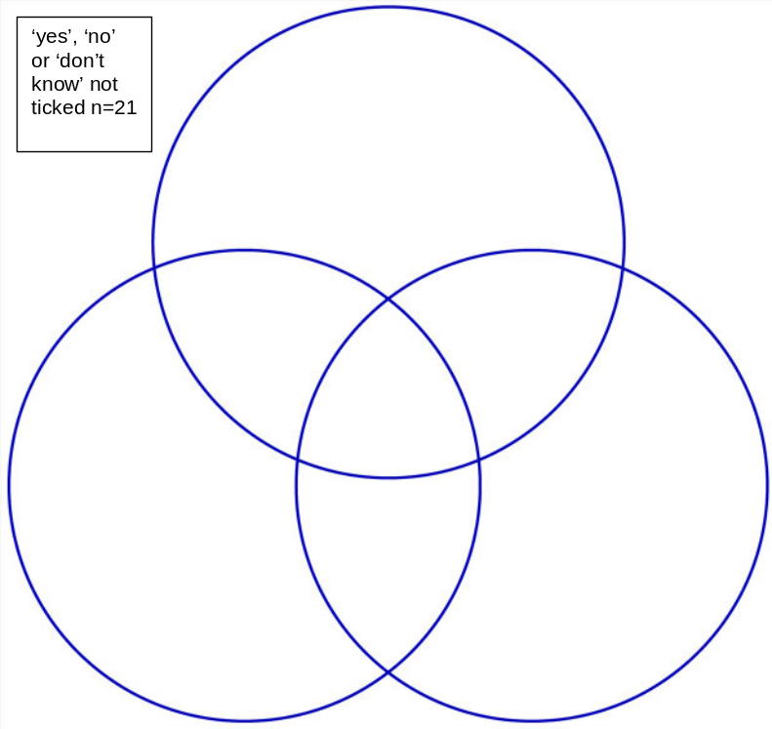

12

104

41

214
Special Educational
Needs
49
Difficulties at school
111

Disability
10

Fig 2 a-e: School satisfaction Factors by Educational Strata (for significant main effects only)

(2a) School Support
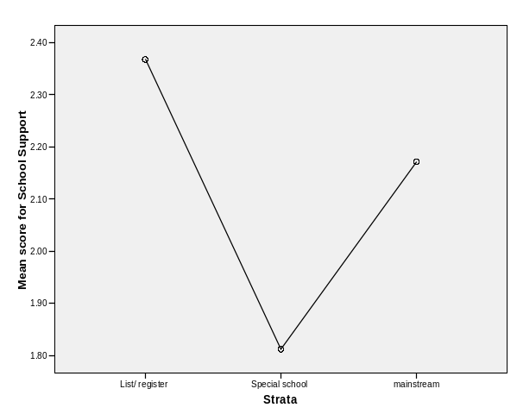
(2b) Legislation Impact
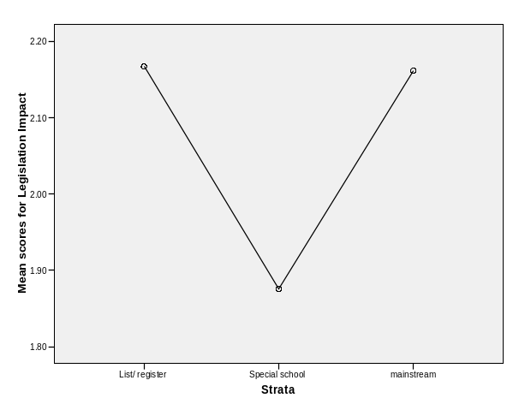
(2c) Effect of Difficulties
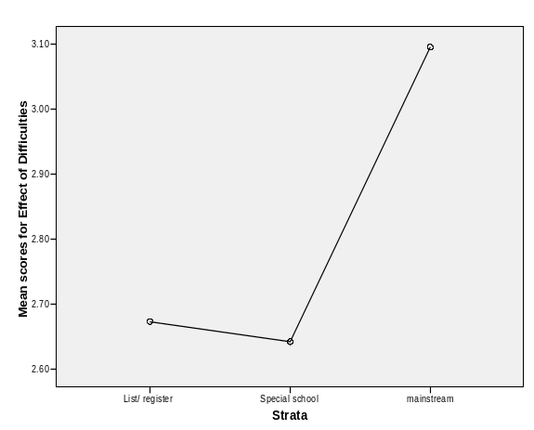
(2d) Accessibility
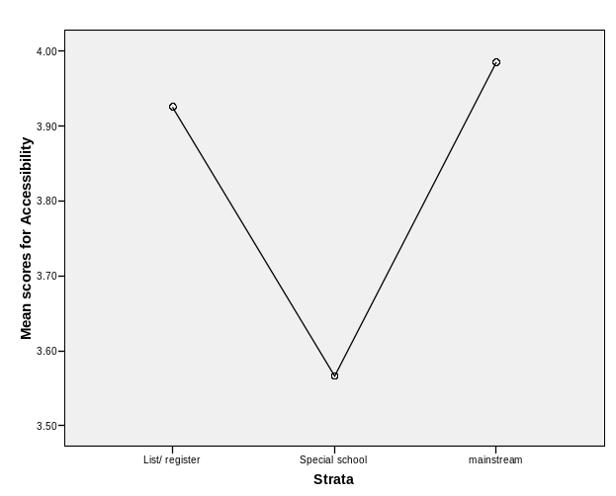
(2e) Within-Child View
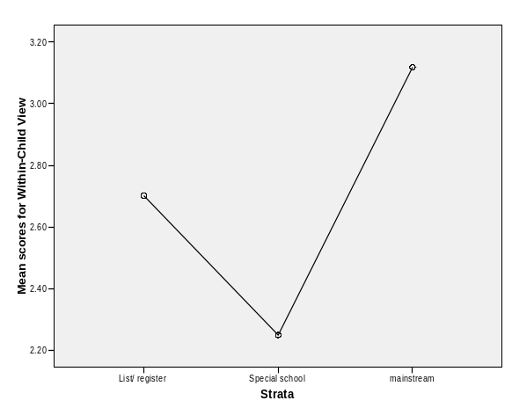

Fig 3: Awareness of DDA/DRC by Employment status

(a) Heard of Disability Rights Commission?
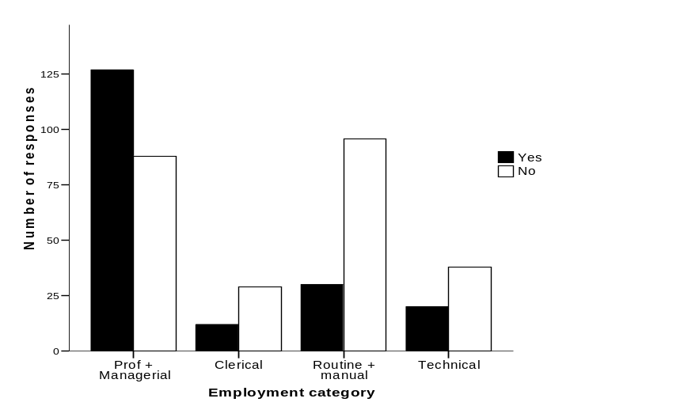
(b) Aware of the DDA?
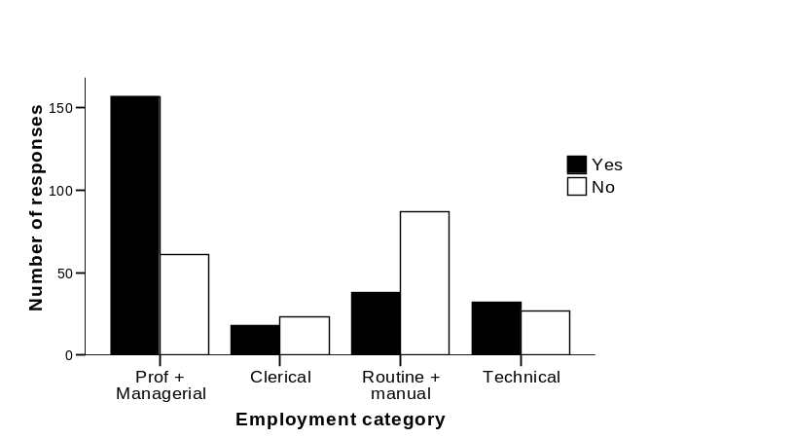
(c) DDA applies to schools?
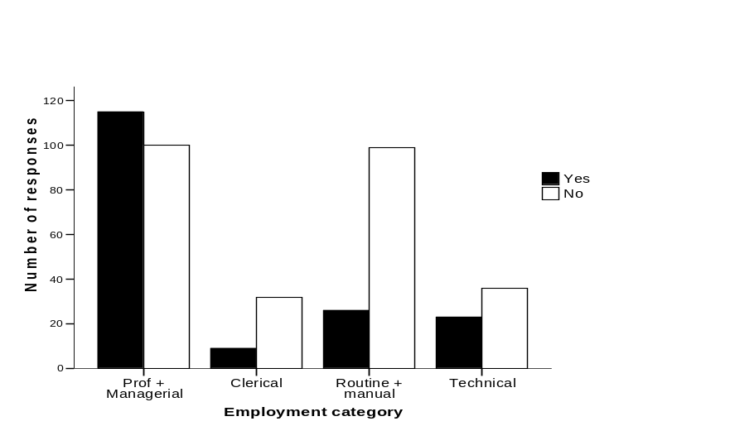
Fig 4a: Interaction between Disability (Language and Autism) and Strata: Within-Child 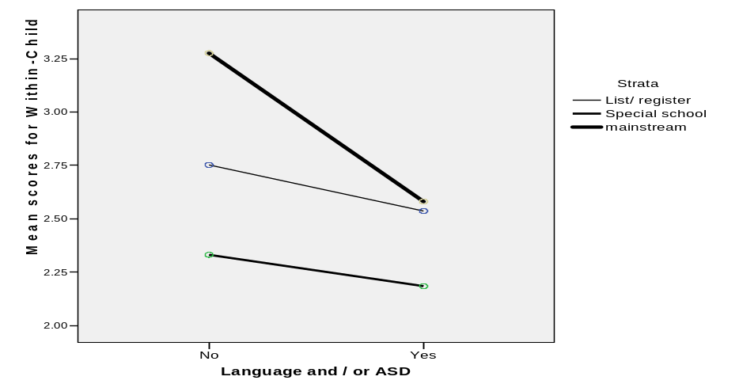
Fig 4b: Interaction between Disability (Psychosocial) and Strata: School Support
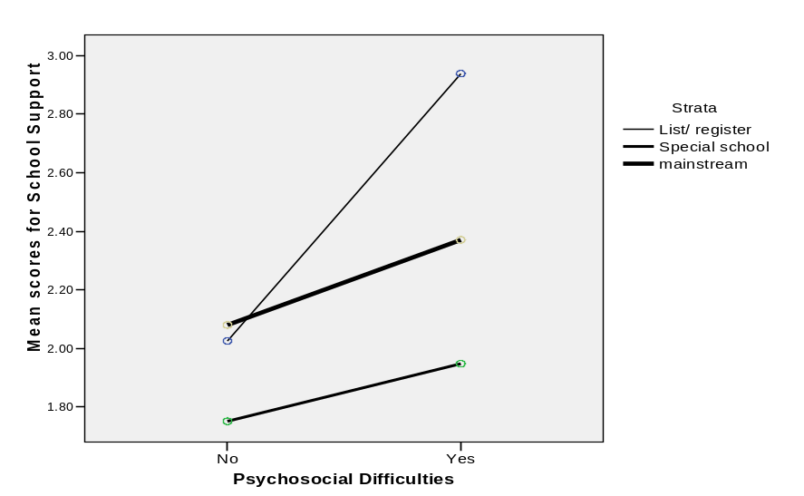

Fig 4c Interaction between Disability (Psychosocial) and Strata: Legislation impact


