Rebel constituencies and rebel violence against civilians in civil conflicts

Martin Ottmann
GIGA German Institute of Global and Area Studies

Abstract
This article examines how the civilian constituencies of rebel groups affect their use of violence against civilians. While past research has acknowledged the importance of rebel constituencies, they are primarily seen as only having an indirect effect on rebel behavior. In contrast, I conceptualize rebel constituencies as a central political opportunity structures for rebel groups providing incentives and imposing restraints on their use of strategic violence as well as the violent behavior of individual rebel fighters. In particular, I hypothesize that a constituency overlap between rebels and the government of a state acts as a restraint making large-scale violence against civilians less likely. In contrast, high levels of constituency fractionalization and polarization induce strategic violence and predatory behavior increasing the chances for large-scale civilian victimization. I conduct a statistical analysis of rebel one-sided violence in sub-Saharan Africa using newly collected data on rebel constituencies to test these hypotheses. The results only provide limited empirical support for the hypothesized relationship between constituency overlap and rebel violence against in civilians. There is clear empirical evidence, however, that heavily fractionalized and polarized rebel constituencies are associated with higher levels of violence against civilians.

Keywords
rebel groups; rebel constituencies; violence against civilians; civil conflict

Corresponding author
Martin Ottmann, GIGA German Institute of Global and Area Studies, Neuer Jungfernstieg 21, 20354 Hamburg, Germany. Email: martin.ottmann@gmail.com

Acknowledgements
I would like to thank Anisa Santoso, Cees van der Eijk, Sabine Carey, Stefan Wolff, Jessica Andersson-Hudson, Jonathan Rose, Nadine Ansorg, Glenn Palmer and the anonymous reviewers for their helpful comments and insights. All remaining errors are my own.

Funding
This research received no specific grant from any funding agency in the public, commercial or not-for-profit sectors.

Introduction
How do the civilian constituencies of rebel groups affect their use of violence against civilians? Rebels critically depend upon the support of the population. Nevertheless, rebel groups frequently engage in civilian victimization and target those for whom they claim to fight and draw upon for recruits and resources. In this study, I turn to rebel constituencies and explore how their characteristics affect rebel-civilian relations and, ultimately, the level of rebel violence against civilians. Recent research on civilian victimization in internal armed conflicts has devoted much attention towards the relationship between rebels and civilians and its repercussions on violence against civilians . The theoretical and empirical findings of these studies have identified the strategic interaction between conflict actors as well as rebels’ organizational configuration as the main determinants of violence against civilians. While the large majority of these studies acknowledge the general importance of the conflict actors’ constituencies, few have explicitly analyzed their direct impact on civilian victimization. Constituencies are often seen as just an intermediate factor shaping the influence of other factors on violence against civilians. Moreover, variations in the composition of civilian constituencies are only sometimes taken into account when analyzing violence against civilians.
In this article, I argue that the characteristics of rebel constituencies need to move into the focus to better understand rebel violence against civilians. Civilian constituencies constitute one of the central political opportunity structures providing incentives and imposing restraints on rebel groups. Variations between rebel constituencies consequently affect rebels’ use of violence against civilians. These variations can affect the strategic calculus motivating violence used as a tool to enforce support. They can also affect the cost-benefit calculus of the individual rebel fighters and their decision to prey on or protect civilians. To explore the determinants of these basic relationships, I develop hypotheses linking particular features of rebel constituencies to the level of violence against civilians. These features are the extent to which the constituencies of the government and the rebel group overlap, the fractionalization of a rebel constituency into multiple subgroups and, lastly, the degree of polarization between these subgroups. I test the hypotheses with a statistical analysis of rebel one-sided violence in sub-Saharan Africa between 1989 and 2010 using newly collected data on rebel constituencies. I only find limited empirical support that rebel groups sharing their constituencies with the government of a state are more likely to engage in low levels of civilian victimization. However, my results clearly indicate that heavily fractionalized and polarized constituencies are associated with higher levels of violence against civilians in civil conflicts. Overall, these findings establish rebel constituencies as an additional impact factor on civilian victimization.
This study proceeds in five parts. The next section reviews existing research on rebel violence against civilians. Following this, I discuss the concept of rebel constituencies and link it to existing theories of civilian victimization. The subsequent section presents the data used in the statistical analysis. Section five reports the results of this statistical analysis, while the final section concludes the article.

Literature review
Rebel violence against civilians is a common feature of civil conflicts . It is a major puzzle for conflict researchers, however, why rebels attack the population they ultimately rely on. Recent studies suggest that such violence against civilians is not a mere by-product of armed violence between government and rebels but a purposeful action of its perpetrators. Two main theoretical arguments have been presented. A first strand of research argues that rebel groups use violence against civilians strategically in order to enforce popular support . By attacking civilians, rebels punish defectors and demonstrate the severe consequences of denying support to the rebel group. A second strand of research identifies rebel rank and file actors as the main agents of violence against civilians . Based on an understanding of such rebel fighters as rational utility maximizer, fighters interested in material benefits are differentiated from fighters committed to a political cause. If a rebel group is dominated by the former type of fighters, the rebel group is more likely resort to violence against civilians.
These two theoretical approaches are not necessarily rivaling each other. As a matter of fact, studies following either one of these approaches converge on the same set of factors determining violence against civilians. Firstly, scholars have identified the distribution of territorial control between the conflict actors, the intensity of battles between government and rebels or the use of violence against civilians by government forces – that is, the strategic interaction between the conflict actors – as explanatory factors . Secondly, research refers to rebel organization itself as causing violence against civilians. Here, researchers consider rebel capabilities , the organizational cohesion of rebel groups and their economic and material endowments as factors driving civilian victimization. However, the emphasis on the strategic interaction between conflict actors and rebel organization relegates an important additional determinant of violence against civilians to an intermediate level: The characteristics of the civilian population.
So far, only a few scholars have explicitly focused on this factor. Balcells , for example, explores civilians’ ideological allegiances and show how they impact conflict actors’ use of strategic violence in conventional civil wars. Relatedly, Fjelde and Hultman analyze the role of ethnic allegiances for the occurrence of strategic violence against civilians. Both studies conceptualize civilians’ allegiances exclusively along the master cleavage of an armed conflict. Except for variation caused by the conflict actors’ strategic interaction, they assume that the conflict actors’ constituencies are ultimately monolithic and can be clearly separated from each other. This assumption, however, only applies to a small number of conventionally fought civil conflicts and not necessarily to the large majority of non-conventional internal conflicts which are characterized by diffuse affiliations between conflict actors and civilians .
In contrast, studies conceptualizing violence as being perpetrated by rebel rank and file fighters pay more attention to the political, economic and social characteristics of the civilian population . Here, however, it is assumed that these characteristics only exert an implicit influence on civilian victimization. Scholars postulate a causal chain linking the civilian constituency of a rebel group to a particular configuration of rebel organization and, following from that, to violence against civilians. That is, the initial setup of the rebel organization given their respective civilian constituency determines to what extent rebels cooperate with or prey on civilians throughout the whole duration of a civil conflict. Moreover, this approach disregards that rebel organizations are shaped by more factors than just the characteristics of the civilian population. The shape of rebel organizations is also affected by environmental factors as, for example, divisions between rebel leaders, external supporters and regional dynamics of conflict and cooperation between states .
Given this body of research, I argue that the civilian constituencies of rebel groups have insufficiently been explored as a determinant of violence against civilians. This is a surprising omission as Kalyvas has already highlighted the importance of civilians at the local level in the production of violence. In the penultimate chapter of his seminal study, he identifies the characteristics and features of the civilian population as important driver of violence against civilians. Civilians link themselves to the master cleavage of the civil conflict and in its shadow they manipulate rebels into fighting their feuds with competing civilians. Raleigh presents empirical support for this theoretical claim. Looking at the temporal and spatial distribution of violence against civilians, Raleigh concludes that this type of violence is not predominantly used by conflict actors in territorially contested areas. Instead, it appears that violence against civilians is driven by competition between non-state actors and this competition, in turn, is driven by the number of ethnic groups located within rebel-controlled territory. This finding also resonates with research on the internal fragmentation of opposition groups . Here, scholars identify in-group dynamics as central determinant of rebels’ violent behavior.
Against this background, I conclude that research on rebel violence against civilians needs to re-consider the role of rebel constituencies in the production of this type of violence. In the following, I firstly propose a theoretical framework linking a rebel group’s civilian support base to rebel violence against civilians. I then move on to an empirical test of my hypotheses using novel cross-sectional data on rebel constituencies.

Theoretical framework
A rebel constituency encompasses those parts of a country’s civilian population from which the group originally emerged and for which they claim to fight in their struggle against the government of a state . It is this group of civilians from which a rebel group tries to secure political and material support in order to start their rebellion and which characteristics – in conjunction with other factors – shape the rebel organization . As I have shown in the preceding section, past research on rebel violence against civilians principally acknowledges the existence and importance of rebel constituencies. However, this research relegates rebel constituencies to a subordinate role once civil conflicts are under way. In the following, I will argue that this influence continues to persist and is an additional determinant for civilian victimization after the initial stages of a rebellion .
The starting point for this endeavor is the empirical reality that rebel constituencies are not alike. Driven by environmental factors, the composition and configuration of rebel constituencies often differ across rebel groups . To begin with, the level and extent of marginalization and repression varies among countries. Whereas there might only be one societal group experiencing marginalization and repression in one country and therefore supporting a rebellion, there might be a number of groups suffering from these government policies in another country. Also, societal groups often feature overlapping allegiances. Parts of these groups might be inclined to support a rebellion even when the government of a state primarily draws its support from the exact same group. Simply because members of the group might either expect even more benefits going their way after a rebel victory. Finally, prospective rebel leaders often have to forge alliances between societal groups to acquire the necessary support base for their violent challenge of central governments.
Contrary to past research , I do not assume that these differences in rebel constituency characteristics lose their impact on a civil conflict once a rebel organization has emerged. To begin with, rebel organizations are not shaped by the constituencies alone but also by the traits of rebel leaders, external actors and the international context . That is, rebel organizations are not perfectly reflecting the characteristics of rebel constituencies but institutions in their own right. Furthermore, the allegiances, intra-constituency cleavages and group alliances within rebel constituencies do not suddenly dissolve but continue to persist throughout the civil conflict. As a matter of fact, they now form the central environment in which rebel actors fight the government and try to maintain their political and material support.
Rebel constituencies can consequently be conceptualized as a political opportunity structure. Depending on their actual composition and configuration, they provide different incentives and constraints for the behavior of the rebel group during the civil conflict . This is especially so as rebel constituencies remain outside the immediate and short-term influence of rebel groups. Once a rebel group relies on a particular constituency, its leaders are careful not to fundamentally change this alliance of local actors as it could tear the whole alliance apart . Moreover, the societal groups forming the constituency also quickly become dependent upon the protection of rebels as their support to the rebel group has made them a target for government reprisals . The political opportunity structure ‘rebel constituency’ therefore is a constant impact factor on the behavior of rebel groups.
Kalyvas provides a first elaboration of how the characteristics of rebel constituencies continue to affect rebel group behavior – and especially civilian victimization – long after the formation and emergence of rebel outfits. According to Kalyvas, a rebel constituency can be regarded as an alliance of various local actors with a rebel group. For a rebel group, this alliance provides the much-needed recruits and support. For the local actors, in contrast, an alliance with a rebel group serves the purpose to gain political and/or material advantages in their struggles with competing local actors. When a rebel constituency does not feature many of these local struggles, the rebel-civilian alliance is likely to work firmly in the favor of the rebel group. It receives recruits and supports without getting drawn into local feuds. A heterogeneous and fissured rebel constituency, in contrast, is characterized by tense relations between constituency subgroups and various struggles between them. These features are likely to constrain rebels’ ongoing recruitment efforts and their ability to muster support. Eventually, these constraints trigger the use of civilian victimization for different purposes and aimed at different types of civilians. It can affect the strategic use of violence by rebel groups as well as opportunistic violence by individual rebel fighters. If intra-constituency cleavages do not play a central role, for example, the necessity to use violence to enforce support might be reduced as civilians lend political and material support to the insurgents without foiling their support through local feuds. Also, the absence of cleavages is likely to reduce incentives for rebel fighters to prey on civilians. With the presence of intra-constituency cleavages, however, large-scale violence against civilians might be more likely. Civilians’ willingness to support rebels might then be thwarted by factionalism causing rebels to resort to violence to enforce lacking support. Similarly, cleavages and factionalism might provide more incentives for rebel fighters to prey on particular subgroups of the rebel constituency.
In the following, I will flesh out this basic logic by focusing on two aspects of a rebel constituency. Firstly, I will examine the relationship between a rebel constituency and the core constituency of the government of the state. In particular, I will ask how overlaps between rebel and government constituencies might affect violence against civilians. Secondly, I will turn to the level of heterogeneity within a rebel constituency. Specifically, I will investigate how the level of fractionalization and polarization shape violence against civilians. These two factors – constituency overlap and constituency heterogeneity – can be regarded as two defining features of a rebel constituency as they provide information on a constituency’s allegiances and composition. Moreover, these two factors allow me to disaggregate the concept of rebel constituency. Instead of assuming a uniform rebel support base, I examine how cleavages within a constituency affect the rebel group’s violent behavior.
In the discussion of these two factors, I particularly focus on how the ethnic characteristics of a rebel constituency structure the production of violence against civilians. Ethnic identities offer very visible and ‘sticky’ markers of identity and community based on characteristics like physical appearance, religion, language, region of residence and similar indicators of a common descent and are often paramount in forming and sustaining rebel groups . Ethnicity, of course, is not always the dominant driver of rebel group formation in civil conflicts and is sometimes complemented or even replaced by alternative markers of identity.

Government-rebel constituency overlap
The first characteristic of a rebel constituency is the level of overlap it has with the government support base. The societal groups from which a rebel group emerges and which sustain its fight are not necessarily the exclusive constituencies of these rebels. Often, the government also draws support from members of these societal groups. Either the regime has already tried to co-opt a group in the past or the whole rebellion is actually an intra-group struggle over state power.
The absence or existence of constituency overlap can have a very different impact on violence against civilians. When there is no overlap between the rebel constituency and the government constituency, these two sides are clearly separated from each other. This separation might induce violence against civilians in a number of ways. First of all, such a separation facilitates the emergence of an ‘us versus them’ narrative which might eventually result in exterminatory policies towards the enemy constituency in order to weaken the adversary . Clear boundaries between constituencies might also increase predatory violence by rebel rank and file fighters towards enemy supporters. After all, fighters do not have to fear repercussions from either their superiors or their own constituency if they prey on civilians outside their rebel group’s support base .
In contrast, the existence of an overlap between rebel and government constituencies reduces the risk of large-scale civilian victimization. A constituency overlap renders exterminatory policies extremely dangerous for the rebel group. Rebels are aware that they strategically compete with the government side over the support of the shared constituency and therefore they exercise restraint towards civilians . Large-scale violence against civilians supporting government forces might backfire when rebel supporters of the same ethnic group realize how easily rebels have targeted their ethnic brethren. Moreover, a constituency overlap puts the choice to join a rebellion next to the – less dangerous – option to simply continue one’s support for the government. A rebel group based on a shared constituency will therefore primarily attract committed fighters interested in the political cause of the rebel group who wish to return to their home communities once the rebellion has ended . The share of self-interested and opportunistic fighters will consequently be much smaller reducing the probability of predatory violence. Additionally, rebel leaders will take great pains to ensure adequate levels of discipline among their fighters as predatory behavior among their rank and file might easily cause civilians to defect to the other side . The rebel MFDC in the Casamance region of Senegal provides anecdotal evidence for these violence-dampening influences of constituency overlap. Emerging out of the Diola ethnic group, the MFDC has lamented political marginalization despite the fact that Diola politicians have frequently occupied influential political positions in post-independence Senegal . This cooptation of the Diola in the capital and, coming with it, the involvement of many Diola activists in legal politics has forced the MFDC rebels to use violence against civilians selectively and on a low level in order to avoid alienating larger parts of their support base.
H1: When rebel groups rely on a constituency highly overlapping with the government constituency, violence against civilians is likely to decrease.

Heterogeneous rebel constituencies
The second characteristic of a rebel constituency is its heterogeneity. As already explained, rebel groups either rely on just one ethnic group as a support base or they have forged multi-ethnic alliances . As long as the rebel group relies on just one ethnic group, it is able to easily tap into the corresponding ethnic group’s networks and institutions to secure popular support. In such a homogenous constituency, there exist common values among civilians that can be utilized to facilitate broader popular support and recruit committed fighters . When civilians can rely on their relatives, neighbors or co-ethnics to act as well, the costs of this support are also shouldered by a larger group which effectively decreases the costs for each individual . Moreover, a homogenous constituency is likely to have established strong sanction mechanisms deterring rebel fighters’ misbehavior . Last but not least, rebel fighters are also likely to refrain from preying on civilians when these are their ethnic brethren and they have to reintegrate back into this same ethnic group .
When a rebel group relies on a constituency comprised of more than one ethnic group, however, this picture changes. Consider the example of the SPLA during the Sudanese civil war. The SPLA’s constituency was strongly fractionalized along ethnic lines and also featured a dominant ethnic group – the Dinka – among its ranks. These ethnic divisions and the polarization within the SPLA constituency have frequently coincided with large-scale killings of Dinka and its internal competitors from the Nuer, Shilluk or Equatorian ethnic groups . To understand the impact of constituency heterogeneity on violence against civilians, two factors are consequently of particular interest. Firstly, the cohesion of the rebel constituency conceptualized as the degree of its fractionalization and, secondly, the polarization of the constituency.
The concept of ethnic fractionalization within a rebel constituency describes the degree of fragmentation of this constituency into multiple subgroups. Increasing ethnic fractionalization among the rebel constituency means that there are no universal values within it. Due to ethnic boundaries, the constituency is instead characterized by differences and fissures. Consequently, the patterns of solidarity within a fractionalized constituency are much weaker and the distrust between civilians from different ethnic groups is likely to be greater. This might bring about reluctance among civilians in the constituency to lend support to the rebel group. Civilians do not know whether other civilians from other ethnic group will carry the same burden in terms of provided resources and face the same risk of government reprisals. In such a situation, rebels are more likely to resort to violence to enforce lacking support. In addition, a fractionalized constituency is unlikely to have developed strong sanction mechanisms offering opportunities for rebel fighters to prey on the population. Also, rebel fighters can simply prey on communities other than their origin community without facing any risk of punishment once they returned home .
H2a: When rebel groups rely on a highly fractionalized constituency, violence against civilians is likely to increase.
The other aspect of a heterogeneous rebel constituency is its degree of polarization. A constituency is polarized when it is characterized by a small number of ethnic groups with a high degree of homogeneity within the group and a high degree of heterogeneity across groups . If a rebel group is built on such a constituency, it does not only face the task of transcending numerous ethnic boundaries. It also has to master the challenge to tap into the resources of a few roughly equally sized and antagonistic ethnic groups. In such case, a rebel group can quickly be perceived as having a partisan bias towards one of its ethnic constituencies. Rebels’ recruitment efforts are then hampered by the aforementioned problem that patterns of solidarity and social networks are interrupted by the ethnic group boundaries within the constituency . Additionally, rebels also have to deal with the problem that commitment to their struggle might be less pronounced in parts of the constituency. Civilians’ expected benefits from a rebel victory in the civil conflict are likely to be lower when these civilians belong to an ethnic group which is dominated by another ethnic group. While a rebel victory might be preferred over the status quo by such a subdued ethnic group, civilians in this ethnic group are nevertheless often fearful of new patterns of repression and exploitation by the new rulers. Eventually, these civilians might therefore withhold resources from the rebels causing the rebel group to resort to violence against civilians in an attempt to enforce support . Finally, rebel fighters drawn from a polarized rebel constituency might also be more inclined to prey on civilians from the ‘other’ ethnic group . In this sense, polarization offers incentive for opportunistic fighters interested in their material gain.
H2b: When rebel groups rely on a highly polarized constituency, violence against civilians is likely to increase.

Research design

To test these hypotheses, I conduct a statistical analysis of rebel one-sided violence (OSV) in civil conflicts in sub-Saharan Africa between 1989 and 2010. The unit of analysis is the rebel group year. I use the UCDP Dyadic Dataset to identify all rebel groups active in an internal armed conflict in sub-Saharan Africa between 1989 and 2010. The sample encompasses 334 group-year observations with 96 rebel groups involved in 33 internal armed conflicts in 23 countries. While the theoretical framework outlined above is assumed to apply for rebel violence against civilians occurring in all world regions, I restrict the empirical analysis on sub-Saharan Africa due to limited data available for my explanatory variables. The sample under analysis nevertheless features sufficient variation on the dependent and independent variables as sub-Saharan Africa is a hot spot of civil conflicts with a substantial variation in the level of OSV and the composition of rebel constituencies. Besides this, the geographical focus also allows me to limit the influence of potentially intervening factors which are not included in the statistical models.

Dependent variable
The dependent variable is the number of civilians killed by rebel groups taken from the UCDP One-sided Violence Dataset . This dataset focuses on direct and intentional killing of civilians in non-combat situations and excludes any civilian fatalities due to famines, diseases or crossfire. Given the difficulties to obtain reliable information from war zones, this dataset does not provide any systematic information on the identity of the victims of this violence or the purpose of this violence. The empirical analysis is therefore restricted to test the impact of rebel constituency on OSV in general. For each rebel group in my dataset, I allocate the corresponding yearly fatality count. Years in which a rebel group does not cross the threshold of 25 killed civilians take the value of zero.
The resulting count variable ranges from zero to 30,110 with a variance far greater than one indicating over-dispersion. Moreover, only 32 of the total of 96 rebel groups in the dataset have resorted to deadly violence against civilians above this threshold resulting in only 111 observations of 25 and more civilian fatalities and 223 zero observations. This clustering might indicate the existence of two latent or unobserved subgroups within the sample . One set of rebel groups might resort to OSV during their existence. The count observations within this subgroup range from zero to any positive integer. That is, some rebel groups will have an OSV level of zero and others will have an OSV level above 25 civilian fatalities. There might be a second subgroup, however, encompassing rebel groups which will never use OSV for some particular structural reason. This subgroup only features zero observations and – because of their structurally different origin – these zero observations are understood as excess zeroes. Conflict characteristics are most likely to cause these two latent subgroups. Rebel groups might never use OSV because they are either quickly defeated by government forces or the fighting occurs on a very low-scale and is easily contained. Under these circumstances, strategic violence against civilians might simply not be necessary and predatory violence not occurs. A final implication of this clustering is that the number of civilians killed by a rebel group in one year is very likely to be dependent on previous observations of OSV by this rebel group. The statistical analysis will take all these properties of the dependent variable into account.
Despite this clustering, however, there is still substantial variation in the level of OSV between rebel groups. Figure 1 displays the mean number of civilians killed for each rebel group engaging in such violence between 1989 and 2010. Half of all 32 rebel groups engaging in OSV kill on average less than 100 civilians. The average fatality count for the other half of rebel group ranges between 100 to more than 1,000. While some rebel groups appear to be more restraint towards the civilian population, others are less so and some rebel groups even engage in large-scale massacres of civilians.

[Figure 1 in here]

Explanatory variables
I operationalize the ethnic groups forming a rebel constituency by identifying the number of languages spoken within the constituency. Using Ethnologue data, I construct a unique data collection on language groups within rebel constituencies in sub-Saharan Africa. Admittedly, the exclusive use of language as a marker of ethnic identity disregards additional factors shaping ethnic identity. I argue, however, that the focus on language is justifiable due to two reasons. Firstly, language is frequently used as one of the main determinants of ethnic group membership. This is especially so in sub-Saharan Africa . Moreover, recent research has provided evidence that linguistically distinctive groups are more likely to engage in civil conflict than groups characterized by alternative markers of identity . The use of language as sole marker of identity is therefore certainly limiting but not the extent that the empirical test of my hypotheses is seriously biased.
Second, the exclusive use of language as a marker of identity allows me to construct a more fine-grained measure of rebel constituencies. While existing data collections on ethnic groups include a variety of ethnic identity markers , the price of this comprehensiveness is a restricted number of covered identity groups. This is often justified with a focus on so-called ‘politically relevant’ ethnic groups . However, while some language groups in a country might not be ‘politically relevant’ on a national level, they are important for rebel groups operating on a sub-national level. My use of language as marker of group identity therefore allows a more detailed measurement of the composition of rebel constituencies. To illustrate this point, I refer to the following two examples. Using the concept of ‘politically relevant’ groups, the Ethnic Power Relations (EPR) data only identifies the Toubou ethnic group as the constituency of the Nigerien Democratic Front for Renewal (FDR). My data collection, however, shows that the Toubou are divided into two – closely associated – sub-groups each having its own language: Tedaga and Daza. Moreover, my data also shows that the FDR recruited from the Arab Choa and the Kanuri. Turning to another example, the language approach highlights that the SPLA-supporting Dinka in Southern Sudan is not one homogeneous ethnic group (as reported by EPR) but a macro language comprised of several Dinka sub-groups. This is an important facet as these Dinka groups tend to have very tense relations with each other .
Using this language data, I firstly measure the share of language groups within a rebel constituency which also acts as a support base for the central government. I compare the language groups within a rebel constituency against the EPR data on ethnic groups and their political status. If one of the language groups within the rebel constituency has an EPR political status of either ‘monopoly’, ‘dominant’, senior partner’ or ‘junior partner’, I consider this language group and the number of people within this language group as being shared between government and rebels. I then compute the share of people within the rebel constituency shared between government and rebels given the overall size of the rebel constituency. The resulting constituency overlap variable ranges from zero to one. There are 31 rebel constituencies and 124 rebel group-year observations in the sample with a value above zero. The variable has a mean of 0.32 and a mode of zero.
Next, I measure the fractionalization and polarization of a rebel constituency. Using data on the size of each language group, I construct a linguistic fractionalization Herfindahl index for each rebel constituency ranging from zero to one . This index measures the probability that two randomly selected individuals in a rebel group’s constituency speak different languages. Following Montalvo and Reynal-Querol , I also compute a linguistic polarization index for each rebel constituency ranging from zero to one. Any value above zero on this index indicates that a population is clustered around two or more poles. 41 rebel groups have a multi-lingual constituency adding up to 43% of the group-year observations under analysis with a linguistic fractionalization or polarization score above zero. The mean value of linguistic fractionalization is 0.23 while the mean for the polarization score is 0.3.

Control variables
To establish rebel constituencies as an additional impact factor on violence against civilians, it is necessary to account for alternative explanatory factors in the statistical analysis. To this end, I include the following control variables in the regressions.
First, I assume that rebel OSV costs more civilians' lives when a country is densely populated. Civil conflicts in more densely populated countries increase the probability of rebel-civilian encounters which could result in more civilian fatalities. The data for this variable is taken from the World Bank Development Indicators and is log-transformed .
The next two control variables account for the impact of rebel organization. A rebel group using ethnic appeals to their constituency is likely to attract more popular support and more rank and file fighters committed to the rebels’ political cause . As a consequence, violence against civilians is likely to be at lower levels. I use a binary variable taking the value of one when a rebel group publicly announces that it is fighting on behalf of one or more ethnic groups and zero otherwise. Next, I control for the impact of rebels’ resource financing. Rebel groups relying on natural resources to fund their struggle are often assumed to be more violent towards the civilian population due to a reduced dependence upon popular support and a higher amount of opportunistic fighters among their ranks . I use a binary variable taking the value of one when rebels use natural resources to finance their rebellion .
The final set of control variables account for the impact of the strategic interaction between government and rebels. First of all, I control for the relative strength of the rebel group vis-à-vis the government forces . Relatively strong rebels groups are less likely to resort to large-scale OSV as they are more likely to have non-violent strategies to enforce popular support at their disposal. I include a binary variable indicating whether rebels’ military strength is equal or even higher than the military strength of government forces. The data is taken from the Non-State Actor Dataset . Second, I control for the intensity of fighting between government and rebels. In high intensity conflicts, rebels’ resources are under substantial pressure, causing the rebels to use OSV to extort additional resources from the population or to signal their continuing resolve to fight . I use the annual number of battle deaths in the civil conflict dyad to control for these mechanisms . Third, I control for the impact of government violence against civilians using an estimate of the number of civilian fatalities killed by government forces . When the government uses OSV, civilians might be more willing to support rebels based on the hope to be protected against government raids by rebels . Alternatively, it is also possible that government violence is successful in deterring civilians from lending support to rebels, causing the latter to increase the intensity of their violent attacks against the population . The battle death and government OSV are both log-transformed in order to minimize the impact of a small number of outlying observations. Finally, I control for the number of years since the first 25 battle deaths in the conflict between the government and the rebel group occurred . The longer a conflict lasts, the more civilian survival is threatened due to abundant violence and the hardships of war . Civilians’ willingness to lend support to rebels is therefore likely to decline, forcing rebels to respond with higher levels of violence against civilians. While some civil conflicts are concluded within a few years, there are also exceptionally long-lasting conflicts. I therefore include a squared term of the conflict duration variable to test for the possibility that it is especially long-lasting conflicts that make large-scale violence more likely. Table 1 provides summary statistics for the dependent variable and all explanatory and control variables.

[Table 1 in here]

Empirical analysis
I use a zero-inflated negative binomial regression (ZINB) model to test the hypotheses linking rebel constituency characteristics to the number of civilians killed . The negative binomial regression part of the ZINB model accounts for the over-dispersed distribution of the dependent variable. The zero-inflation, on the other hand, takes care of the excess zeroes. As already explained above, some zero observations are likely to be caused by the same process which causes other observations to be above the 25 civilian fatalities threshold. A second subgroup, however, is likely to only include zero observations caused by a structurally different process. These are the potential excess zeroes in the sample. The ZINB regression model proceeds in two steps to distinguish between these two latent subgroups. First, a logit inflation is used to estimate the effects of the independent variables on the probability that a rebel group never uses OSV. That is, it accounts for the differences between the two latent subgroups in the sample. Using the same sample, a negative binomial regression then estimates the effects of the independent variables on the count of civilians killed adjusted for the excess zeroes. This stage addresses the question what factors determine whether the OSV count takes the value of zero or any positive integer above 25 fatalities. The estimates obtained by this stage are used to assess the hypotheses. Finally, I conduct the ZINB regression using robust standard errors clustered on rebel groups to address the possibility that the clusters of observations for each group share certain characteristics which are unaccounted for in the statistical models and correlate with the dependent variable.

Regression results
I estimate a series of models in order to test the hypotheses linking the configuration of rebel constituencies to the level of rebel violence against civilians. Models 1a and 1b only include the variables measuring constituency overlap and constituency fractionalization and polarization respectively. These models provide a first, basic test of the hypotheses outlined above. Following this, I add three different sets of control variables in a stepwise manner to the baseline models. Models 2a and 2b also include the logged population density measure. Models 3a and 3b also comprise the rebel organization variables. Models 4a and 4b, finally, also incorporate the variables accounting for the strategic interaction between the rebel group and government forces. This stepwise extension of the baseline models allows me to assess whether the hypothesized relationship between rebel constituencies and OSV persist once I account for alternative causes of violence against civilians.
Table 2 reports the estimates of these ZINB regressions. The upper half of Table 2 reports the negative binomial regression coefficients. The lower half of Table 2 displays the coefficients of the logit inflation stage of the ZINB regression. Positive signs for the logit inflation estimates indicate an increased probability that a rebel group belongs to the subgroup of rebel groups never using OSV. Finally, Table 2 also reports Vuong test statistics for each model comparing the statistical fit of the ZINB regression to the fit of a simple negative binomial regression. The test statistics are all statistically significant indicating that the zero-inflated model is the preferred statistical estimator.

[Table 2 in here]
The estimates for the constituency overlap variable in Models 1a and 1b are inconclusive. The coefficient in Model 1a features a negative sign whereas it has a positive sign in Model 1b. Moreover, both coefficients are statistically not significant. This provides no empirical support for the claim that rebel violence against civilians decreases when the rebel group relies on a constituency highly overlapping with the government constituency. In contrast, the constituency fractionalization and polarization coefficients both behave as predicted by Hypotheses 2a and 2b. High levels of constituency fractionalization and polarization increase the level of rebel violence against civilians. With a p-value of 0.106, however, the constituency fractionalization estimate slightly misses the statistical significance threshold. The constituency polarization estimate, in contrast, is statistically significant.
In Models 2a and 2b, I add the logged population density measure to the baseline models. As the level of rebel violence against civilians is likely to be higher in more densely populated countries, the inclusion of this control variable might account for variation in the number of civilian fatalities which is not causally connected to the rebel constituency variables. This certainly applies to the constituency fractionalization and polarization variables. They retain their signs and both are now statistically significant lending clear empirical support to Hypotheses 2a and 2b. The estimates for the constituency overlap variable improve only moderately. While both now behave as predicted by Hypothesis 1, only the coefficient in Model 2a is statistically significant. The population density measure, finally, is statistically significant indicating that rebels in densely populated countries kill more civilians.
Models 3a and 3b also incorporate the measures for ethnic appeals and resource financing in order to account for any potential impact of rebel organization on OSV. Apart from both constituency overlap estimates being statistically not significant, there are no substantial changes when compared to the previous models. Turning to the rebel organization variables, I only find very limited support for an impact on the level of violence against civilians. Only the coefficient for resource financing in Model 3a is statistically significant.
The final two estimations, Models 4a and 4b, also include those variables accounting for the strategic interaction between the rebel group and government forces. In these models, the constituency overlap variables are statistically significant for the very first time lending empirical support to Hypothesis 1. There is no substantial change regarding the constituency fractionalization and polarization variables. Hypotheses 2a and 2b therefore still receive sound empirical support. Regarding the control variables, I find that resource financing is now statistically significant at the 0.05 level in Model 4a and the 0.1 level in Model 4b. The level of violence against civilians increases when a rebel group relies on the exploitation of natural resources. Turning to the new set of control variables, I find strong statistically significant evidence that stronger rebel groups are less likely to resort to large-scale OSV . As Downes and Hultman , I also find evidence that high levels of battle violence are associated with higher levels of OSV. Regarding the use of government OSV, Models 4a and 4b provide statistically significant support for the argument that government civilian victimization induces rebels to resort to higher levels of OSV as well . Both conflict duration terms are also statistically significant in Models 4a and 4b with the normal count of years having a negative coefficient and its squared term having a positive sign. This indicates a convex relationship between conflict duration and the level of OSV: Rebels kill more civilians in the first few years of a civil conflict and at later stages of the conflict.
Taken together, the regression results provide only tentative support for Hypothesis 1. With the exception of Model 1b, all estimates of the constituency overlap point into the hypothesized direction. However, the coefficients only become statistically significant in a consistent manner in the final two models. In contrast, the constituency fractionalization and polarization measures are reasonably robust in terms of direction and statistical significance over the course of all estimated models lending empirical support to Hypotheses 2a and 2b. Overall, these findings establish rebel constituencies as an additional predictor of rebel OSV but they also indicate that it is especially the level of heterogeneity within a rebel constituency that affects such violence. The regression results also show that none of included control variables act as a confounding or intervening variable . Their inclusion improves the overall goodness of fit of the models but they do not cause fundamental changes in the direction and statistical significance of the constituency variables.
Lastly, I turn to the estimates of the logit inflation stage. As explained above, the logit inflation stage does not account for the level of rebel OSV ranging from zero to the maximum count of fatalities in the sample. Rather, the logit inflation determines the possibility that some zero observations are excess zeroes originating from a different structural process . In all eight estimated models, the logit inflation estimates of the rebel constituency variables are statistically not significant. This is not overly surprising, however. As presumed in the discussion of the OSV data, the statistically significant coefficients of the logit inflation stage reveal conflict characteristics as main determinant for the overall likelihood of OSV to occur in a civil conflict. Rebel groups face the possibility to use OSV in recently begun conflicts in sparsely populated countries characterized by the absence of resource financing and very low levels of battle violence and government OSV. In other words, rebel OSV is unlikely to occur in those conflicts which are fought by underfunded rebel groups and in which combat is taking place on a very low scale in far-away places. Also, it is unlikely when civil conflicts are quickly terminated through a military defeat of the rebels. This implies that rebel violence against civilians only becomes a strategy of warfare or predation once a civil conflict has crossed a particular threshold.

Substantive effects
To further evaluate the regression results, I examine the substantive effects of rebel constituency on the number of civilians killed. Despite the only tentative support for Hypothesis 1, I include the constituency overlap variable alongside the constituency fractionalization and polarization measures in order to compare their respective effects on the dependent variable.
The first objective is to assess the impact of rebel constituency on violence against civilians relative to complementary determinants of such violence. I therefore rely on the regression results of Models 4a and 4b when computing the substantive effects. Figure 2 displays the effects of the constituency variables and those control variables which are statistically significant at the 0.05 level in both models. One can see that a standard deviation change in the measure of constituency overlap centered on the mean decreases the level of OSV by 12 (Model 4a) and 11 (Model 4b) fatalities respectively. In contrast, a standard deviation change in the measure of fractionalization in a rebel constituency centered on the mean increases the number of civilians killed by rebels by nine. The same change in the measure of polarization in rebel constituencies increases the count of civilian fatalities by seven. While the substantive effects in this particular model specification appear rather small, Figure 2 also shows that the substantive effects of rebels’ relative strength and conflict duration are roughly of the same magnitude. Only the battle deaths measure, government OSV and population density have a larger effect on the number of civilians killed. This shows that the characteristics of rebel constituencies are a relevant additional impact factor on rebel OSV.
[Figure 2 in here]
Next, I explore whether the substantive effects of the rebel constituency variables on the count of civilian fatalities have a nonlinear trajectory once the variables move from the lowest to their highest score. I therefore graph the predicted number of civilians killed over the entire span of all possible values for the three rebel constituency variables. Figure 3 reveals that the substantive effect of constituency overlap decreases from a fatality count of 30 when there is no overlap between rebels’ and government’s constituency to eight when there is a total overlap. Interestingly, the predicted fatality count decreases substantially slower once this index has crossed the 0.5 mark. If a rebel group already shares half of its constituency with the government, further increases in this share have a comparatively smaller impact on the predicted level of rebel OSV. A similar – albeit inverse – observation can be made with regard to the substantive effects of a fractionalized and polarized constituency on the number of civilians killed by rebels. An increase in the fractionalized constituency measure from zero to 0.5 doubles the predicted rate of rebel OSV from 14 to 29 fatalities. When this measure increases from 0.5 to 1, the predicted civilian fatality count more than doubles and climbs from 29 to 62. The increase for the measure of a polarized constituency is a bit smaller but follows the same trajectory. From zero to 0.5, the predicted number of civilian fatalities goes from 14 to 23. When this index moves from 0.5 to 1, one can see an increase to 40 fatalities. It appears that especially rebel groups with higher levels of fractionalization and polarization within their constituencies are likely to kill more civilians.

[Figure 3 in here]append

Alternative specifications
To check the robustness of my findings, I finally present a number of alternative specifications of the regression models presented above. By and large, these robustness checks confirm the initial ZINB regressions.
First, I address the possibility that the regression results are driven by a few outlying observations on the dependent variable. To account for this, I take the natural log of the number of civilians killed and use it as the dependent variable for the same series of models conducted in the main analysis. While the results confirm constituency fractionalization and polarization as statistically significant predictors of OSV, the coefficient for constituency overlap does not become statistically significant throughout the stepwise regression process. The robustness check is therefore unable to provide any additional evidence supporting Hypothesis 1. Also, the resource financing and conflict duration coefficients are now statistically insignificant in the negative binomial regression. This lends further support to my assumption that excess zeroes on the dependent variable are driven by a structurally different process.
Next, I check whether the regressions results are affected by temporal dependence as the level of rebel OSV in one year might be dependent upon the rebels’ previous use of violence. I therefore insert the dependent variable lagged one year into each model of the stepwise ZINB regressions. The results, however, do not substantially deviate from the regression results presented above. Notably, the rebel organization control variables are now almost consistently statistically not significant in the negative binomial regression. As a further check of temporal dependence, I control for the possibility that rebel OSV respond to previous rather than to contemporaneous battle violence between government and rebel forces and government violence against civilians. I consequently estimate Models 4a and 4b with both of these variables lagged one year. Here, the constituency variables do not experience major changes. Interestingly, however, the ethnic appeals variable is now statistically significant in the alternatively specified Model 4a (p<0.05) and the resource financing variables is statistically significant in Models 4a (p<0.01) and 4b (p<0.001). However, there is no immediately apparent indication why this alternative specification should be preferred over the main models.
In a third set of robustness checks, I use alternative measures for a rebel group’s organization and the conflict between government and rebels and re-estimate Models 4a and 4b. The objective is to determine whether the results of the three constituency variables remain robust when controlling for alternative indicators for these complementary determinants of rebel OSV. The first alternative specifications control for the possibility that the measures for ethnic appeals and rebels’ resource financing do not adequately capture rebels’ mobilization capabilities and the level of indiscipline among rebels’ rank and file fighters. I use two variables from the Non-State Actor (NSA) dataset as alternative measures . To replace the variable measuring ethnic appeals, I use an indicator measuring the mobilization capacity of a rebel group. This variable takes the value of one when rebels’ ability to successfully mobilize among its constituencies is moderate or high relative to the government. The measure of resource financing used in the main models is replaced with a dichotomous variable taking the value of one when a rebel organization has at least a moderately strong central command structure. If a rebel organization exhibits a low level of internal control, rebel rank and file fighters that may be violently preying on civilians will go unpunished, leading to further predation. The inclusion of these alternative measures of rebel organization does not affect the rebel constituency variables. Next, I include an additional indicator measuring the extent of a rebel group’s territorial control. Kalyvas and Kalyvas and Kocher argue that violence against civilians is more likely when territorial control exists but is weak and disputed. Using the aforementioned NSA dataset, I add a binary variable taking the value of one when rebels exercise low control over a particular territory into Models 4a and 4b. Again, this alternative specification of the main models also does not affect the constituency variables.
Finally, I also estimate all ZINB regressions with rebel constituency variables computed on the basis of the EPR data . As explained in the data section, I refrained from using EPR data in order to measure the characteristics of rebel constituencies as this data is less detailed. For example, the number of rebel groups with heterogeneous constituencies decreases from 41 to 20 when using EPR data. The fractionalization and polarization scores also have a lower mean and standard deviation. Due to these differences, it is not surprising that the results show no statistically significant effect of rebel constituencies on OSV. It therefore rather demonstrates that detailed data is needed to capture the configuration of rebel constituencies.

Conclusion
So far, the role of rebel group constituencies as one of the main political opportunity structures shaping rebel violence against civilians has received insufficient scholarly attention. However, the allegiances and cleavages within and between the ethnic groups making up a rebel group’s support base can have a substantial impact on such violence. They impose additional incentives and restraints on the level of popular support for the group and its fighters’ behavior. This, in turn, determines whether rebels engage in only low levels of civilian victimization or resort to large-scale killings.
In this article, I have statistically tested this hypothesized impact of rebel constituencies on OSV while controlling for alternative explanations for such violence. My findings show empirical support for the core theoretical argument: Rebel constituencies are an additional impact factor on civilian victimization. However, not every characteristic of rebel constituencies play an equally important role. The analysis provides only limited evidence that rebel groups sharing parts of their constituency with the government side are more likely to kill fewer civilians. While most estimated models show a negative effect of constituency overlap on OSV, the predictor is only statistically significant in a subset of these models. The analysis is therefore unable to further corroborate past research claiming that rebels act in a more restrained manner when they compete with government forces over the same support base . In contrast, however, my results clearly indicate that rebel groups with a heterogeneous constituency are more likely to engage in large-scale OSV. A fractionalized rebel constituency is characterized by distrust between ethnic groups hampering the provision of support and it lacks effective, constituency-wide sanction mechanisms deterring rebel fighters to prey on the population . Likewise, the divisions within a polarized rebel constituency restricts rebels’ ability to secure popular support and provide incentives to opportunistic rebel fighters to prey on civilians .
Before placing these findings in the larger body of research on violence against civilians, it is necessary to address two – already previously mentioned – limitations of the present study. First, the theory and empirical analysis of this article focuses on rebel constituencies defined along ethnic lines. Ethnicity is a frequent and dominant marker of identity for rebel group formation but it is certainly not the only one. Religions and political ideologies, for example are possible additional factors shaping rebel constituencies. While the identified relationships should – in theory – also be applicable to these alternative factors, it is nevertheless necessary to further explore them and their impact on rebel groups in future research. The second limitation of this study is its focus on rebel groups in sub-Saharan Africa. As explained above, the empirical focus on civilian victimization in this world region was due to data limitations. The theoretical framework of this article, however, is not built upon the peculiarities of African rebel groups and their civilian constituencies. Rebel groups in other world regions are also emerging from heterogeneous support bases with variation in their allegiances and composition .
Against this background, the important lesson of this study for future research on violence against civilians is that rebel constituencies matter far more than previously thought. Rebel constituencies do not only shape the organizational configuration of a rebel group, they also appear to have a continuing impact on rebels’ violent behavior throughout the civil conflict. Moreover, this study shows that different dimensions of rebel constituencies have separate impacts on civilian victimization. While the obtained evidence for a violence-reducing impact of constituency overlap is admittedly inconclusive, it nevertheless highlights that the interplay between rebel constituencies and collective targeting in civil conflicts is in need of further research. Such violence might not be caused by civilians’ allegiances per se but it might rather be a function of the exclusiveness of these allegiances. The finding that constituency heterogeneity is a consistent predictor of higher levels of violence, on the other hand, extends past research identifying a rebel group’s local context as an important determinant of civilian victimization . It appears that rebel violence in civil conflicts is not necessarily driven by their military capabilities or the competition between government and rebels alone but also by the nature and extent of their intra-constituency cleavages. In this light, I conclude that the characteristics of rebel constituencies are pivotal for our attempts to understand how rebel groups operate in civil conflicts.

References
Table 1. Summary statistics
 | N | Mean | SD | Min | Max
Rebel OSV | 334 | 198.57 | 1683.31 | 0 | 30110
Constituency overlap | 330 | .32 | .45 | 0 | 1
Constituency fractionalization | 334 | .23 | .30 | 0 | .86
Constituency polarization | 334 | .29 | .35 | 0 | 1
Ethnic appeals | 334 | .50 | .50 | 0 | 1
Resource financing | 334 | .28 | .45 | 0 | 1
Rebel group stronger than gov’t | 334 | .03 | .16 | 0 | 1
Battle deaths (ln) | 334 | 5.25 | 1.61 | 3.22 | 10.33
Gov’t OSV (ln) | 334 | 2.36 | 2.77 | 0 | 13.12
Conflict duration | 334 | 5.70 | 7.26 | 0 | 32
Conflict duration (squared) | 334 | 85.03 | 172.83 | 0 | 1024
Population density (ln) | 334 | 3.45 | 1.23 | 1.52 | 6.09

Table 2. ZINB regression
 | Model 1a | Model1b | Model2a | Model 2b | Model 3a | Model 3b | Model 4a | Model 4b
Negative binomial
Constituency overlap | -0.216 | 0.010 | -1.197** | -0.550 | -1.642 | -1.935 | -1.831* | -1.888+
 | (0.449) | (0.490) | (0.439) | (0.489) | (1.092) | (1.205) | (0.771) | (0.974)
Constituency fractionalization | 1.867 |  | 3.756** |  | 2.599* |  | 1.587**
 | (1.155) |  | (1.368) |  | (1.123) |  | (0.548)
Constituency polarization |  | 1.976+ |  | 3.874** |  | 2.944* |  | 1.560*
 |  | (1.095) |  | (1.205) |  | (1.296) |  | (0.623)
Population density (ln) |  |  | 0.833*** | 0.763*** | 1.161*** | 1.151*** | 1.203*** | 1.186***
 |  |  | (0.185) | (0.218) | (0.253) | (0.280) | (0.256) | (0.312)
Ethnic appeals |  |  |  |  | 0.194 | 0.959 | -0.198 | 0.088
 |  |  |  |  | (0.831) | (0.886) | (0.438) | (0.555)
Resource financing |  |  |  |  | 1.580+ | 1.440 | 1.045* | 1.026+
 |  |  |  |  | (0.835) | (0.948) | (0.496) | (0.540)
Rebel group stronger than gov’t |  |  |  |  |  |  | -1.295*** | -1.602***
 |  |  |  |  |  |  | (0.390) | (0.412)
Battle deaths (ln) |  |  |  |  |  |  | 0.361*** | 0.367***
 |  |  |  |  |  |  | (0.075) | (0.081)
Gov’t OSV (ln) |  |  |  |  |  |  | 0.177*** | 0.205***
 |  |  |  |  |  |  | (0.049) | (0.043)
Conflict duration |  |  |  |  |  |  | -0.191** | -0.153*
 |  |  |  |  |  |  | (0.062) | (0.062)
Conflict duration (squared) |  |  |  |  |  |  | 0.008*** | 0.006**
 |  |  |  |  |  |  | (0.002) | (0.002)
Constant | 5.730*** | 5.565*** | 2.165** | 2.087* | 0.550 | 0.267 | -1.332 | -1.574
 | (0.298) | (0.378) | (0.744) | (0.917) | (1.066) | (1.241) | (1.038) | (1.157)
Logit inflation
Constituency overlap | -0.666 | -0.652 | 0.161 | 0.107 | 0.153 | -0.016 | -0.676 | -0.779
 | (0.591) | (0.546) | (0.693) | (0.624) | (0.692) | (0.659) | (0.562) | (0.543)
Constituency fractionalization | -0.433 |  | -0.897 |  | -0.628 |  | 0.146
 | (0.865) |  | (0.793) |  | (0.976) |  | (0.733)
Constituency polarization |  | 0.227 |  | -0.115 |  | 0.236 |  | 0.622
 |  | (0.775) |  | (0.745) |  | (0.705) |  | (0.822)
Population density (ln) |  |  | -0.651* | -0.592* | -0.772** | -0.691** | -0.863** | -0.828**
 |  |  | (0.254) | (0.232) | (0.261) | (0.256) | (0.266) | (0.259)
Ethnic appeals |  |  |  |  | -0.036 | 0.011 | 0.696 | 0.752
 |  |  |  |  | (0.583) | (0.649) | (0.579) | (0.604)
Resource financing |  |  |  |  | -1.183* | -1.257* | -1.404** | -1.460**
 |  |  |  |  | (0.543) | (0.524) | (0.482) | (0.494)
Rebel group stronger than gov’t |  |  |  |  |  |  | -0.887 | -1.053
 |  |  |  |  |  |  | (0.769) | (0.980)
Battle deaths (ln) |  |  |  |  |  |  | -0.683*** | -0.682***
 |  |  |  |  |  |  | (0.177) | (0.171)
Gov’t OSV (ln) |  |  |  |  |  |  | -0.196* | -0.199*
 |  |  |  |  |  |  | (0.081) | (0.080)
Conflict duration |  |  |  |  |  |  | -0.208** | -0.207**
 |  |  |  |  |  |  | (0.079) | (0.077)
Conflict duration (squared) |  |  |  |  |  |  | 0.006* | 0.006*
 |  |  |  |  |  |  | (0.003) | (0.003)
Constant | 0.953* | 0.782+ | 3.126*** | 2.736*** | 3.910*** | 3.439*** | 9.162*** | 8.957***
 | (0.469) | (0.440) | (0.859) | (0.777) | (0.814) | (0.836) | (1.692) | (1.685)
AIC | 1984.058 | 1982.878 | 1936.181 | 1939.454 | 1915.318 | 1921.317 | 1793.581 | 1797.973
BIC | 2010.652 | 2009.472 | 1970.373 | 1973.646 | 1964.706 | 1970.705 | 1880.960 | 1885.352
Log pseudo likelihood | -985.029 | -984.439 | -959.091 | -960.727 | -944.659 | -947.658 | -873.791 | -875.986
Number of observations | 330 | 330 | 330 | 330 | 330 | 330 | 330 | 330
Vuong test statistic | 3.97*** | 3.72*** | 4.37*** | 4.02*** | 5.13*** | 4.16*** | 5.77*** | 5.83***
Robust standard errors clustered on rebel groups in parentheses
*** p<0.001; ** p<0.01; * p<0.05; + p<0.1

Figure 1. Mean number of civilians killed by rebel group
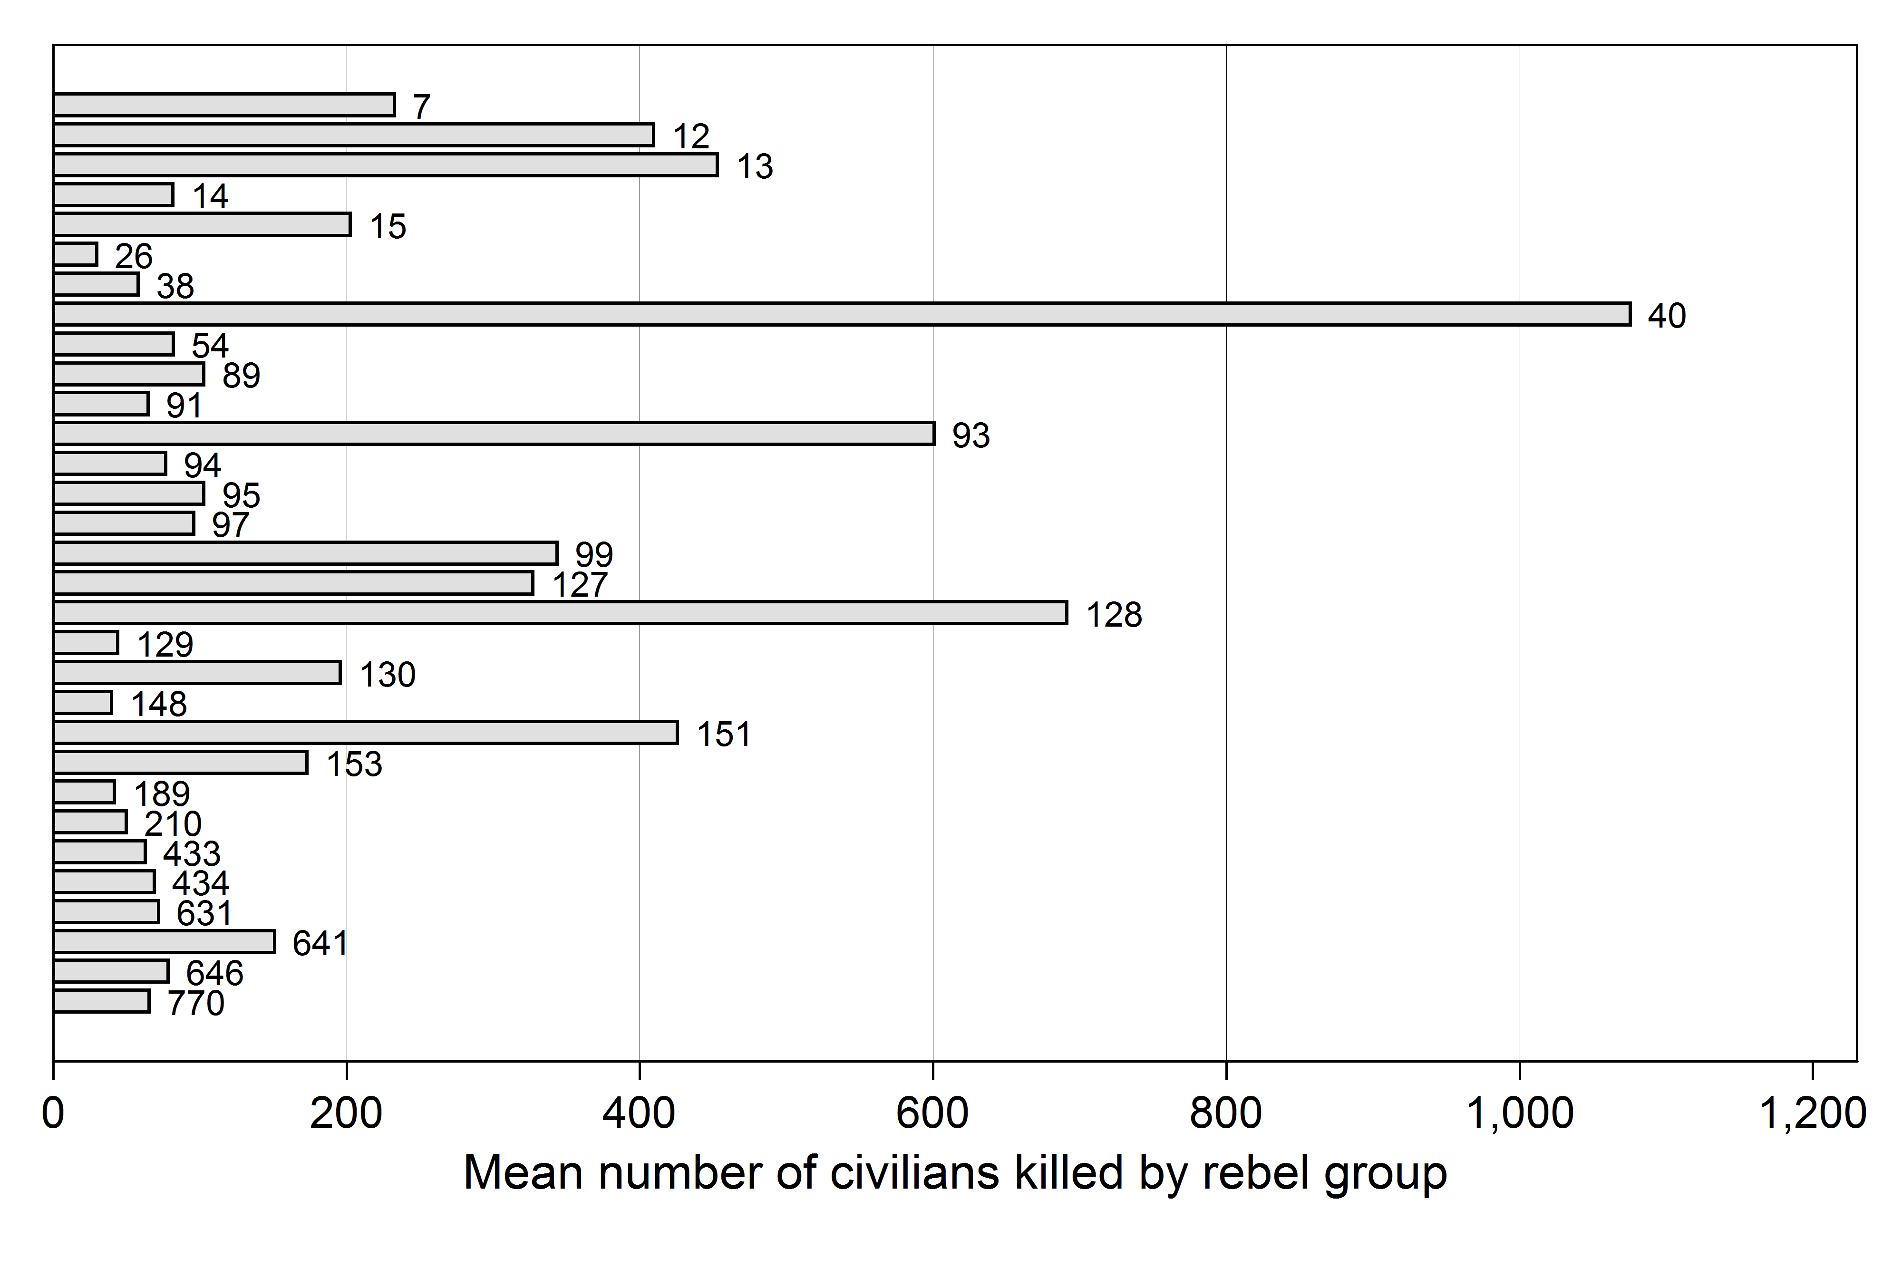
The figure only includes those rebel groups which have crossed the threshold of 25 civilian fatalities due to OSV at least in one year. The UCDP dyad identifier is used to indicate each rebel group. The figure excludes the AFDL in the Democratic Republic of Congo (UCDP dyad identifier 39) and its two outlying observations of OSV in order to avoid distorting the overall distribution pattern of OSV per rebel group.
Figure 2. Predicted number of civilians killed for selected independent variables
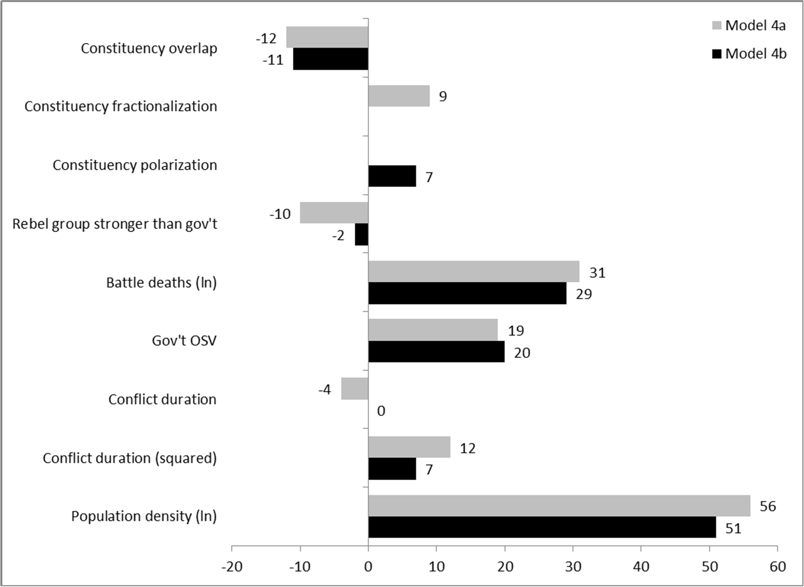
Predicted numbers estimated using SPOST . The figure depicts the change in the number of civilians killed when the respective variable changes from 1/2 standard deviation below the mean to 1/2 standard deviation above the mean while all other variables are held constant at their mean or mode.
Figure 3. Predicted number of civilians killed over the full range of each constituency variables
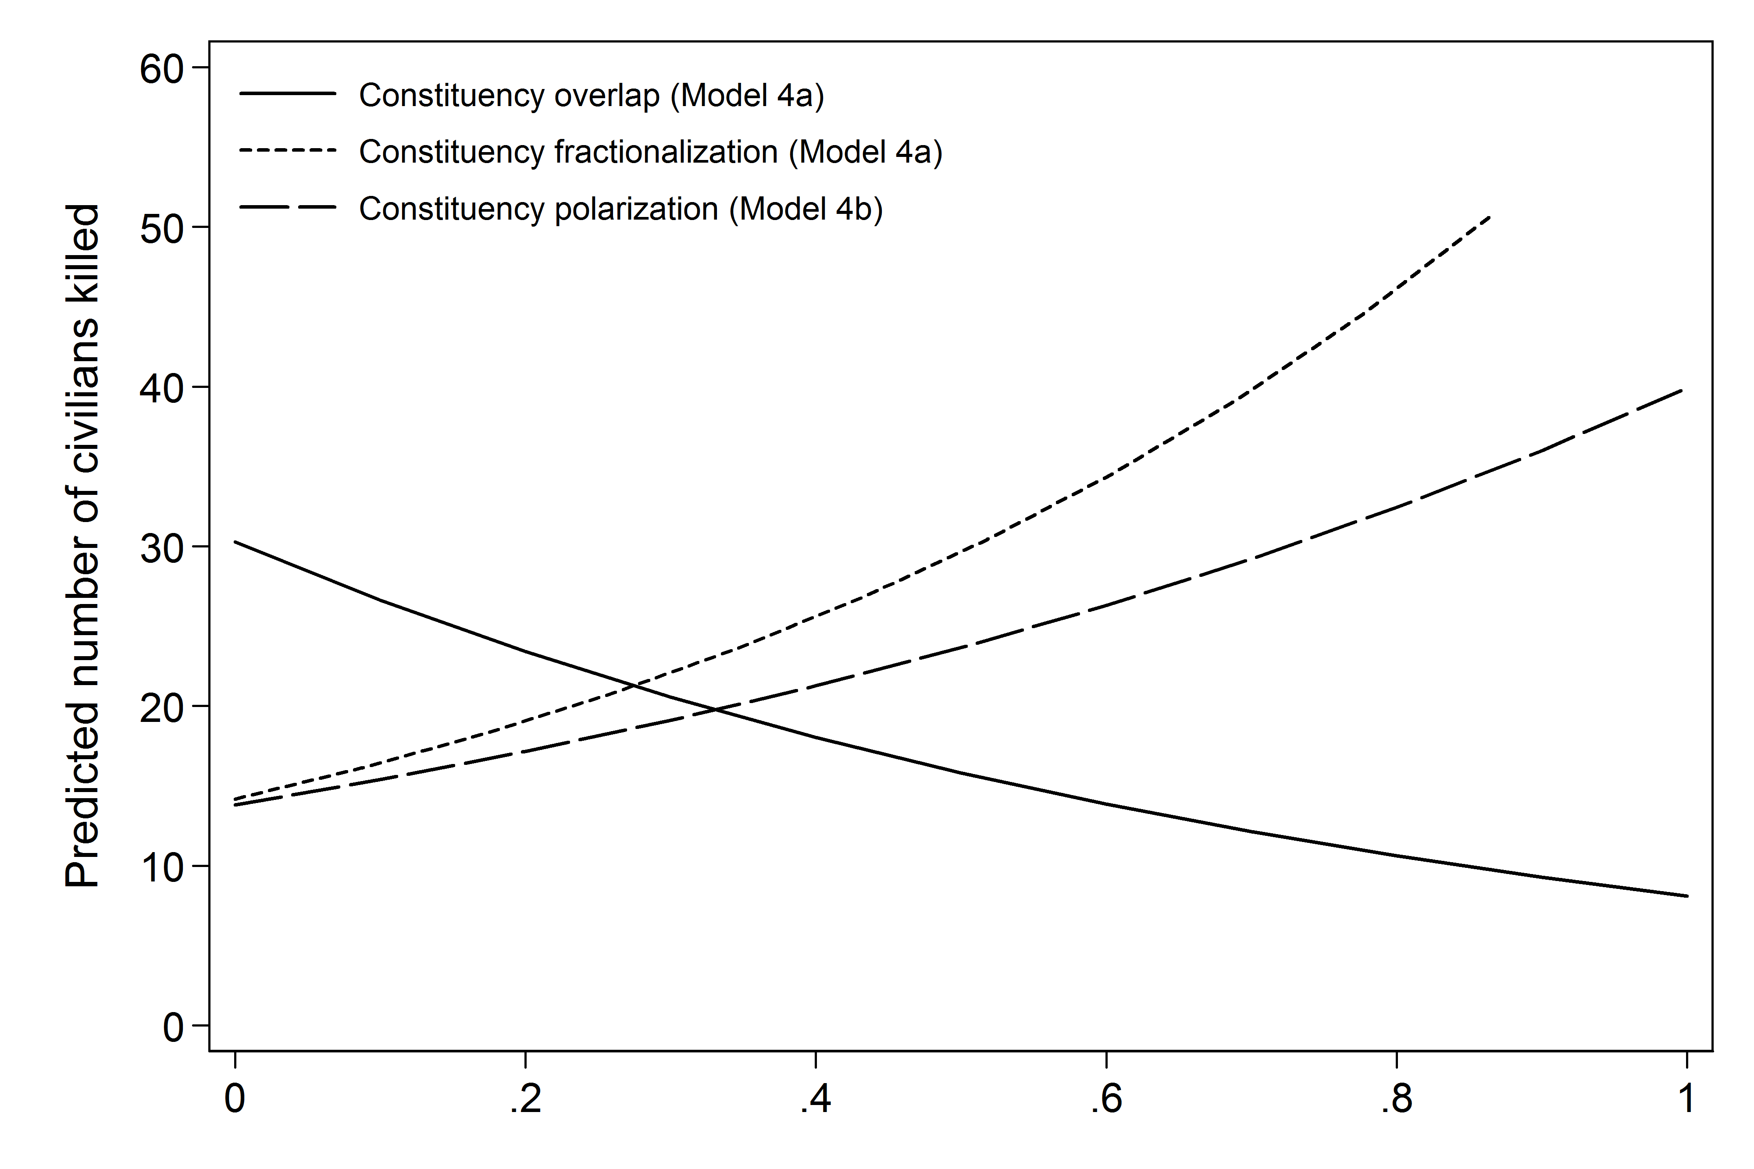
Predicted numbers estimated using SPOST . All other variables are held constant at their mean or mode.
Notes

I exclude military factions involved in coup d’états from this sample as they are different from opposition groups that take up arms against the state government.
I collected this data by examining qualitative descriptions of the composition of rebel group’s constituencies provided by the UCDP Conflict Encyclopedia , Terrorist Organization Profiles and the Political, Social and Cultural Series of the Africa Research Bulletin. I then used Ethnologue to determine the exact languages spoken in a particular rebel group’s constituency and how many of its speakers exist in the country against which government the group is fighting. To illustrate this process, consider the example of the rebel group Liberians United for Reconciliation and Democracy (LURD). An Africa Research Bulletin report from 2002 states that LURD draws it support from the Mandingo, Krahn and Mende ethnic groups. Using Ethnologue, this information is used to identify the Manya, Western Krahn, Eastern Krahn and Mende language groups as LURD’s constituency.
To equate EPR ethnic groups with Ethnologue language groups, I searched for the name of each EPR group in question in the corresponding Ethnologue country list. If the names of EPR groups and Ethnologue groups could not be matched properly, I conducted web searches for further information on the respective EPR groups.
While the exclusive focus on ‘politically relevant’ groups is insufficient to capture the extent of a rebel constituency, this concept is actually beneficial in identifying the core support base of the government of a state as I only identify those groups which are likely to be contested by government and rebels due to their political importance.
To code the ethnic appeals variable, I examined reports of rebels’ stated political objectives found in the UCDP Conflict Encyclopedia , Terrorist Organization Profiles and the Political, Social and Cultural Series of the Africa Research Bulletin.
For this study, I updated Rustad and Binningsbø’s data up to the year 2010.
The measure only captures those fatalities which have been caused by armed combat between government forces and the rebel group and is therefore conceptually distinct from OSV.
I add the value 1 to the government OSV variable before conducting the log-transformation so that observations with zero civilian fatalities due to government violence will not be removed from the sample.
The replication data and a web appendix are available from the author upon request.
I use two separate models as the variables measuring the fractionalization and polarization of rebel constituencies are highly correlated.
I explored the possibility that the characteristics of a rebel group’s constituency interacts with rebel organization and its relative strength. I rerun Models 4a and 4b with interaction terms of the rebel constituency variables on the one side and the ethnic appeals, resource financing and rebel strength variable on the other. Using marginal effects plots, I was unable to identify any statistically significant interactions between these variables. The marginal effect plots can be found in the web appendix.
The substantive effects of the independent variables on OSV are larger in Model 1a to Model 2b. With the inclusion of additional control variables, however, the size of the substantive effects of all independent variables decreases across the board.
The regression results of these alternative specifications can be found in the web appendix.
I add the value 1 to the dependent variable before conducting the log-transformation in order to keep the sample size intact for the robustness check.
I did not do use such a lagged dependent variable in the regression models presented above as it is sometimes deemed problematic .
To measure constituency overlap, I use a binary variable taking the value of one when any of the ethnic groups in the rebel constituency has an EPR power status of either ‘monopoly’, ‘dominant’, ‘senior partner’ or ‘junior partner’ and zero otherwise. The constituency fractionalization and polarization score has been computed using the group size information in the EPR data.

