Electrophysiological evidence for enhanced representation of food stimuli in working memory

Short title: enhanced food representation in working memory

Femke Rutters^{1,2}, Sanjay Kumar³, Suzanne Higgs¹, Glyn W. Humphreys⁴

¹ School of Psychology, University of Birmingham, Birmingham, United Kingdom

² Epidemiology and biostatistics, VU medical centre, Amsterdam, The Netherlands
³ Department of Psychology, Oxford Brookes University, Oxford, United Kingdom.

⁴ Department of Experimental Psychology, University of Oxford, Oxford, United Kingdom

School of Psychology

University of Birmingham

Edgbaston, Birmingham

B15 2TT, United Kingdom

+441214146241
Fax +44121 4144897

f.rutters@bham.ac.uk

f.rutters@vumc.nl

Conflict of interest: none of the authors disclose any conflict of interest

Correspondence should be addressed to FR

Abstract
Studies from our laboratory have shown that, relative to neutral objects, food-related objects kept in working memory (WM) are particularly effective in guiding attention to food stimuli (Higgs et al. 2012). Here, we used electrophysiological measurements to investigate the neural representation of food vs. non-food items in WM. Subjects were presented with a cue (food or non-food item) to either attend to or hold in WM. Subsequently, they had to search for a target, while the target and distractor were each flanked by a picture of a food or non-food item. Behavioural data showed that a food cue held in WM modulated the deployment of visual attention to a search target more than a non-food cue, even though the cue was irrelevant for target selection. Electrophysiological measures of attention, memory and retention of memory (the P3, LPP and SPCN components) were larger when food was kept in WM, compared to non-food items. No such effect was observed in a priming task, when the initial cue was merely identified. Overall, our electrophysiological data are consistent with the suggestion that food stimuli are particularly strongly represented in the WM system and enhance WM representations when they re-appear in the environment.

Highlights
- Food-related objects kept in working memory (WM) are particularly effective in guiding attention to food stimuli
- Electrophysiological measures of attention and memory were larger for food versus non food cues
- Food cues are better maintained in WM than non-food cues, perhaps because of their rewarding properties

Keywords: Attention, working memory, food and non-food cues, long-latency ERPs
1. Introduction
In our current obesogenic environment food cues are found all around us; from shop displays and television adverts, to pictures of food and eating in magazines. Though the abundance of food cues is not in itself problematic, heightened attention to food cues has been shown to enhance motivation to consume foods (Fedoroff et al. 1997; Loxton et al. 2011) and to predict weight gain (Calitri et al. 2010; Yokum et al. 2011), with attentiveness to food cues being particularly marked in obese children and adults (Braet and Crombez 2003; Castellanos et al. 2009; Nijs and Franken 2012). However, despite its potential importance, we lack detailed understanding of the mechanisms that determine heightened attention to food. The present study represents an attempt to do this using evoked response data.

Previously, we have reported that food directs attention in a top-down manner, via its representation in working memory (WM). We found that, in lean subjects, deliberately holding food items in WM is particularly effective in guiding attentional selection when food stimuli are re-presented in a display - with WM-based guidance of attention from food being stronger than the guidance from neutral stimuli (Higgs et al. 2012; Rutters et al. 2014). In these experiments, participants were presented with a food or non-food (neutral) cue to either attend to or hold in WM, and subsequently they had to search for a shape target (cf. (Soto et al. 2005)). The cue could re-appear in the search display either alongside the search target (valid trials) or a distractor (invalid trials). In addition, there were neutral trials, in which the cue did not re-appear. Reaction times were strongly affected by the re-appearance of a food cue, but only when the cues were held in WM rather than merely being attended to, as shown in the priming condition, designed to match the visual sequence used in the WM condition. The results indicate that a food cue in WM exerted a strong effect on search, when compared with neutral cues, and this was not driven by the initial appearance of the cue alone (in the priming condition) (Soto et al. 2005; Soto and Humphreys 2007; Soto et al. 2008; Higgs et al. 2012; Rutters et al. 2013). These data suggest that attentional biases towards food cues can be mediated by holding food-related information in WM, which in turn guides attention to food-related items in the environment (Higgs et al. 2012).

Here we assessed how the representation of food items in WM modulates attentional bias to food, using electroencephalography (EEG) to examine the time course of stimulus coding in memory and attention. Several studies have investigated the electrophysiological correlates of heightened attentiveness to motivational stimuli, including food cues (Leland and Pineda 2006; Nijs et al. 2008; Stockburger et al. 2008; Babiloni et al. 2009; Nijs et al. 2009; Stockburger et al. 2009; Toepel et al. 2009; Stingl et al. 2010; Svaldi et al. 2010). Only two studies have observed early stage Event Related Potential (ERP) differences between food and non-food items (Stockburger et al. 2008; Stingl et al. 2010), while the majority reported differences in longer-latency ERPs. Long-latency ERPs are generally thought to represent high-level processes reflecting decision making, memory, reward, motivation, and emotion (Stockburger et al. 2009; De Pascalis et al. 2010; Eimer and Kiss 2010; Stingl et al. 2010; Eckstein 2011; Yu et al. 2011). These findings of long latency effects suggest that the attentional bias towards motivational stimuli (food) involves relatively high-level processsing. A consistent finding has been that amplitudes of the P3 and Late Positive Potential (LPP) components are increased for food compared to non-food cues (Leland and Pineda 2006; Nijs et al. 2008; Nijs et al. 2009; Stockburger et al. 2009; Toepel et al. 2009; Nijs et al. 2010a; Svaldi et al. 2010). The P3 component is a postive peak that emerges at circa 300 ms after stimulus onset, and is located all over the scalp, with maximal amplitudes in the parietal scalp area (Picton 1992). This component is the first of the so-called endogeneous ERPs that is larger when processing emotional or motivationally relevant stimuli and typically taken to reflect attentional, mnemonic and evaluative processing of stimuli (Friedman and Johnson 2000; Stockburger et al. 2009; De Pascalis et al. 2010; Eckstein 2011; Yu et al. 2011). The LPP component follows the P3 component and is defined as the late positive ERP deflection that occurs 500 ms post stimulus, over the centro-parietal regions (Schupp et al. 2006). This component is thought to represent conscious stimulus recognition, the focussing of attention on a stimulus, and elaborated stimulus analysis, and it is larger for motivationally relevant stimuli than neutral stimuli. The LPP component is also thought to reflect memory updating, memory load and stimulus maintenance in WM (Picton 1992; Friedman and Johnson 2000; Schupp et al. 2000; Citron 2012; Littel et al. 2012).

Previous studies have never examined the SPCN component of the ERP response in relation to attention to food versus non-food stimuli. The SPCN amplitude can act as a long-latency marker for the retention of visual short-term working memory, and it is calculated by subtracting ipsilateral activity form contralateral activity relative to the target after about 500 ms post stimulus (Eimer and Kiss 2010; Eckstein 2011). Previous research indicated that the SPCN component is larger for more complex patterns and objects, and it returns to baseline sooner for the shorter retention intervals (Perron et al. 2009), highlighting that the SPCN is a marker for maintenance of visual short-term memory. The SPCN component is also larger for emotionally laden items compared to neutral iterms (angry faces versus neutral faces), which reflects that attention was more sustained for affective information (Holmes et al. 2009). We therefore predict that the amplitude of the SPCN will be greater when food versus non-food cues are kept in WM.

Overall, previous ERP studies showing increased P3 amplitudes for food compared to non-food cues implicate increased attentional, mnemonic and evaluative processing of food stimuli, while increased LPP amplitudes implicate increased memory updating, memory load and stimulus maintenance in WM of food stimuli (Leland and Pineda 2006; Nijs et al. 2008; Nijs et al. 2009; Stockburger et al. 2009; Toepel et al. 2009; Nijs et al. 2010a; Svaldi et al. 2010). However, these ERP studies have used several different paradigms to compare food versus non food items, ranging from simple tasks in which subjects only have to look at the presented pictures, to Posner, Stroop, and one-back tasks in which subjects have to attend to and memorize stimuli (Leland and Pineda 2006; Nijs et al. 2008; Nijs et al. 2009; Stockburger et al. 2009; Toepel et al. 2009; Nijs et al. 2010a; Svaldi et al. 2010). In these paradigms it is difficult to identify exactly which cognitive process, of the many potentially involved, is modulated by food. For example, under passive viewing conditions participants may represent the items in WM, and so any effects could reflect the status of the items in WM. In the present experiment we examine long-latency ERPs in the WM-based attentional guidance paradigm previously employed (Higgs et al. 2012). This paradigm is useful because it enables us to assess whether the long-latency ERPs modulated by food are affected by factors such as memory or merely attending to the picture. The WM-based guidance paradigm has been examined once before in an ERP study, but there was no examination of different cue types (Kumar et al. 2009). In the present study, for the first time, we directly compare food and non-food cues and examine the modulatory effects of food on late acting ERP components, to provide us insight into the electrophysiological correlates of food-related memory coding and attention.

2. Materials and Methods

2.1 Participants
Sixteen students (8 females and 8 males) from the School of Psychology of the University of Birmingham took part in this experiment for either course credits or cash. Their mean age was 23 years (range 19-38 years) and their mean body mass index (BMI) was 24.8 kg/m² (range 18.0 – 34.6 kg/m²), with 50% of the subjects being overweight. All participants had normal to corrected-to-normal-vision. Written informed consent was obtained from all participants. The study was approved by the Ethics Committee of the University of Birmingham, and conformed to the Declaration of Helsinki.

2.2 Tasks
There were two tasks, the priming and working memory tasks, in which we varied the instructions regarding the initial cue presented on each trial. In the priming task, participants were asked to attend to the cue but not to hold it in memory. On a small proportion of trials (20%), the priming cue disappeared and was replaced by a different image. On these priming probe trials participants were instructed not to carry out the search task which normally followed the initial cue. This ensured that participants attended to the cue. In the WM task participants were asked to hold the cue in memory across the trial, for a subsequent memory test on a minority of occasions (again 20% of the trials; see Figure 1a). On these memory probe trials, the search display that followed the initial cue was followed by a visual memory probe for 3000ms, which could correspond to the object being held in WM or to another object. Participants made a same or different judgement as to whether the cue and the memory item were the same. The priming and WM tasks were completed in a counterbalanced order. The priming task consisted of 1945 trials, taking about 120 minutes, and the WM task consisted of 1500 trials, and took 106 minutes to complete. The trials were divided into smaller blocks of about 150 trials, after which the subject had a few minutes rest. Each trial started with presentation of the cue for 500ms. The cue was either a picture of a food item, a car, or a stationery item, and 10 different pictures per category were used during both the priming and WM tasks. All pictures were presented in black and white, sized 480 x 480 pixels, and appeared in the middle of the screen with a black background. The cue was followed by a 200 to 1000ms blank interval with a fixation cross. After the interval, a search screen was presented with a target (circle) and a distractor (square) randomly to the left or right of fixation for 800ms. Participants had to press ‘c’ if the circle appeared on the left and ‘m’ if it appeared on the right, with the maximum response time set at 1200ms. The target and the distractor were each flanked by a picture of a food item, or non-food item (a car or stationery item). The search screen was followed by a 400ms blank interval with a fixation cross, and the inter-trial interval was 600ms.
There were three conditions in which the relations between the initial cue and the search display were varied: 1) on valid trials, the target in the search display was flanked by an image that was the same as the cue and the distractor was flanked by an image from one of the other cue categories, 2) on invalid trials, the distractor was flanked by an image that was the same as the cue and the target was flanked by an image from one of the other cue categories, 3) on neutral trials both the target and distractor were flanked by images from categories different from the cue. For example, in the neutral food trial the cue would be a food item and in the search display but the target and the distractor would be flanked by a stationery item or car picture (see Figure 1b for an example of the WM task, representing valid, neutral, and invalid trials for food cues). The conditions occurred randomly with equal probability. Trials with incorrect responses to the search task, catch trials, and the memory task, as well as reaction times (RTs) that were +/- 3 standard deviations from the mean, were removed. In both the priming and WM task, the accuracy for the search task was high; an average of 93% correct. In the priming task, responses on catch trials were withheld as instructed; an average of 92% correct, and in the WM task, responses to the memory task were correct in 87% of all cases. There was no evidence of a speed–accuracy trade off.

2.3 Apparatus
Stimuli were presented using E-Prime (Version 2.0– Psychology Software Tools) on a Pentium IV computer with an ATI RAGE PRO 128-MB graphics card, displayed on a SyncMaster 753s colour monitor (SAMSUNG, Seoul, Korea). The monitor resolution was 1024 x 768 pixels and the frame rate was fixed at 85hz.

2.4 Procedure
Participants consumed their regular breakfast half before the start of the study and the other half during the larger 15 minute break. Aspects of appetite were assessed using 100 mm visual analog scales (VAS) with questions about feelings of hunger, satiety, thirst, and desire to eat. Opposing extremes of each feeling were described at either end of the 100-mm horizontal line, and subjects marked the line to indicate how they felt at that moment. Completion of the VAS questionnaire took our experienced subjects about 1 minute. During the protocol, appetite profiles were assessed twice: before and after performing both tasks. Mean feelings of hunger, satiety, thirst and desire to eat were 13.6±13, 62.4±22, 31.8±22 and 14.5±14 before the tasks were performed and 40.8±29, 38.4±30, 47.8±22 and 44.6±29 after the tasks were performed (all P<0.05 for changes before and after). Participants completed the priming and working memory (WM) tasks in counterbalanced order, with an option of a 15-minute break between tasks. Before leaving, participants had their height (cm) and weight (kg) measured.

2.5 Electroencephalogram data processing

Electroencephalogram (EEG) recordings for each participant were taken continuously with Ag/AgCl electrodes from 128 scalp electrode locations. The electrodes were placed according to the 10-5 electrode system (Oostenveld and Praamstra 2001) using a nylon electrode cap. A unipolar electrode placed at the infra-orbital area of the left eye monitored vertical eye movements, and a bipolar electrode placed at the outer canthus of the left and right eyes monitored horizontal eye movements. Additional electrodes were used for references and ground. EEG and electro-oculogram signals were amplified (BioSemi ActiveTwo, Amsterdam, the Netherlands) and sampled at 512 Hz. The continuous EEG recordings were off-line referenced to the average of the left and right mastoids and band pass filtered between 0.5 and 30 Hz. Continuous EEG signals were segmented into epochs from 200 ms before trial onset to 900 ms after trial onset for each of the conditions for each subject. Epochs were rejected if the voltage in horizontal eye electrodes exceeded ±60 and ±100 µV in any other electrodes. The EEG data of one participant was discarded because of excessive horizontal eye-movement. The 200 ms prior to the onset of the search task was used as a baseline, and the EEG signals reported have been calculated relative to this baseline activity. Since our focus was to understand the electrophysiological correlates of identifying or holding a cue in WM on its subsequent coding, we focussed on the long-latency ERPs P3, LPP, and SPCN components occurring after the onset of the search display. The maximum positive deflections in the time windows of 250-500 ms and 530-730 ms were defined as the P3 and LPP respectively, both showing a posterior distribution. The negative deflection around 700-850 ms post-stimulus at posterior sites, contralateral to the evoking stimulus, was defined as the SPCN. The SPCN was computed by subtracting ipsilateral activity form contralateral activity relative to the target.

Further analyses were restricted to regions that showed the highest activity for the particular component of interest. The electrode with the highest activity was identified through visual inspection of the current source density (CSD) map of the grand average waveform. Electrical activity on the four electrodes surrounding the electrode with the highest activity of the particular component was then averaged for each time-point in the epoch interval, to generate a region-specific analysis. The same electrode combinations were then chosen on the contralateral side of the identified region for the particular component. The following electrodes were taken as representing left and right hemispheric activity for the P3 and LPP components: P1, PPO1h, CPP1h, CPP3h, PPO3h and P2, PPO2h, CPP2h, CPP4h, PPO4h. The SPCN component was analysed at the pooled five posterior and lateral occipital electrodes: PPO5h/PPO6h, PO5h/PO6h, PO3h/PO4h, O1/O2, and PO7/PO8 based on the SPCN CSD map where the source of the SPCN activity was observed across the conditions.

2.6 Statistical analyses
Statistical analyses were performed with SPSS version 20.0 (SPSS Inc., Chicago, IL). Continuous data were presented as means ± standard deviation (SD) or standard error of the mean (SEM). Using ANOVA repeated-measures, we analysed interactions and differences in reaction times (ms) for tasks (WM, priming), trials (valid, neutral, invalid) and cues (food vs. non-food items). Secondly, using ANOVA repeated-measures, we analysed interactions and differences in reaction times (ms) for tasks (WM, priming), trials (valid, neutral, invalid), cues (food vs. non-food items) and weight status (lean vs. overweight). Finally, using ANOVA repeated-measures, we analysed interactions and differences in ERP components (mean amplitude) for tasks (WM, priming), hemispheres (left, right), trials (valid, neutral, invalid) and cues (food vs. non-food items).

3. Results

3.1 Reaction times
Mean reaction times (in milliseconds) to the target next to the food or non-food cues for Valid, Invalid, and Neutral trials, for both the Priming and the Working Memory tasks, are presented in figure 2. We carried out a 2 X 3 X 2 repeated-measures ANOVA with the factors being task (priming vs. WM task), validity (valid, invalid, neutral trials), and cue (food vs. non-food items). Firstly, we observed several main effects; RTs were slower in the WM task than the priming task (F (1, 14) = 10.44; p < 0.006, ηp² = 0.4), consistent with the greater cognitive load during the WM task (see Soto et al., 2005 (Soto et al. 2005)). There was a main effect of validity (F (2, 28) = 60.9; p < 0.000, ηp² = 0.8), whereby RTs were faster for the valid trials than the neutral and invalid trials, and RTs for the neutral trials were faster than the invalid trials (all p < 0.05). There was also a main effect of cue (F (1, 14) = 5.6; p < 0.03, ηp² = 0.3); RTs following the food cues were faster than RTs following the non-food cues.

The three-way interaction between task, validity, and cue (F (2, 28) = 1.96; p = 0.16 ηp² = 0.1), and the two-way interaction between task and cue were not significant (F (1, 14) =1.3; p = 0.27 ηp² = 0.8). We did observe a significant two-way interaction between task and validity (F (2, 28) = 21.5; p < 0.001 ηp² = 0.6); RTs were faster for valid trials compared to invalid trials (p < 0.001), and to neutral trials (p<0.001) in the WM task. We observed a similar pattern in the priming task, however the effect was smaller, and only the difference between valid and neutral trials was reliable (p < 0.05). Additionally, we observed a significant two-way interaction between validity and cue (F (2, 28) = 47.8; p < 0.001 ηp² = 0.8); RTs were faster following food cues compared to non-food cues in the valid trials (p<0.001), but not in the invalid (p=0.7) or neutral trials (p=0.9).
Though there were trends for interactions of cue and task (WM vs. priming), these were not reliable, possibly because the relatively long cue-search display interval allowed all cue types to be consolidated in WM. However, given our prior results and the a priori prediction, we assessed the food advantage scores (%RT for [Non-food minus food]/Non-food) for the priming and WM tasks. This food advantage score provides an index of the effectiveness of the food cues in guiding attention. We observed a larger food advantage in the WM task compared to the priming task in the valid trials (3.9±1.6 vs. 2.4±1.6 %, P<0.002), while no significant differences were observed in the neutral (0.6±1.6 vs. 1.0±2.1%, P=0.61) and invalid (-2.0±2.2 vs. -1.9±3.0%, P=0.89) trials. Our results suggest that, compared to the priming condition, RTs were faster following food cues than non-food cues when they re-occurred and matched the flanked image in the WM task.

3.2 Electroencephalography data
To evaluate the long-latency ERPs responses to holding food or non-food information in WM, vs. merely attending to these stimuli, we compared the effect of cue type, validity and tasks on the mean amplitudes of the P3, LPP and SPCN components. First, we carried out 2 x 2 x 3 x 2 repeated-measures ANOVA with the factors being task (priming, WM), hemispheres (left, right), validity (valid, neutral and invalid trials), and cue (food, non-food) for the P3 component (mean amplitude between 250 to 500 ms). No interaction between tasks, hemispheres, validity and cue was observed (F_{2.28} = 0.317, P = 0.77 ηp² = 0.1). There was a reliable interaction between task and cue (F_{1.14} = 4.8, P < 0.05 ηp² = 0.3); the P3 component was larger in response to the food compared to the non-food cue in the WM task (P < 0.03), while it was not different in the priming task (P = 0.67) (Figure 3). Furthermore, we observed a reliable main effect for validity (F_{2.28} = 13.65, P = 0.001 ηp² = 0.5); the P3 component was larger in the neutral trials compared to the valid and invalid trials. There were no main effects on the P3 component for the effect of task (F_{1 .14} = 0.29, P = 0.60 ηp² = 0.1), hemisphere (F_{1 .14} = 1.27, P = 0.28 ηp² = 0.1) or cue type (food vs. non-food cues) (F_{1.14} = 0.326, P = 0.577 ηp² = 0.1).

Second, we carried out 2 x 2 x 3 x 2 repeated-measures with factors task (priming, WM), hemispheres (left, right), validity (valid, neutral and invalid trials), and cue (food, non-food) for the LPP component (mean amplitude between 530 to 730 ms). No interaction between tasks, hemispheres, validity, and cues was observed (F_{2.28} = 0.25, P = 0.78 ηp² = 0.1). There was however a two-way significant interaction between task and cue (F_{1.14} = 13.7, P = 0.002 ηp² = 0.5). There was an overall effect for cue in the WM task, with non-food < food cues (P < 0.02), while there was no reliable effect in the priming task (P = 0.45). Additionally, we observed a significant difference between the cues (F_{1.14} = 9.95, P < 0.001 ηp² = 0.4); the LPP component was larger for food compared to non-food cues (Figure 4). No significant differences were observed between tasks (F_{1 .14} = 0.10, P = 0.75 ηp² = 0.1), hemispheres (F_{1 .14} <1) and there was no overall effect of validity (F_{1.14} < 1).

Third, we carried out 2 x 3 x 2 repeated-measures with the factors being task (priming, WM), validity (valid, neutral, invalid), and cue (food, non-food) for the SPCN component (mean amplitude between 700 to 850 ms). No interaction between task, validity, and cue was observed (F_{2.28} < 1). We observed a two-way significant interaction between task and cue (F_{1.14} = 4.56, P = 0.05 ηp² = 0.3); there was an overall effect of cue in the WM task, with non-food < food cues (P < 0.001), and there was no reliable effect in the priming task (P = 0.19) (Figure 5). We also observed a two-way significant interaction between task and validity (F_{1.14} = 11.4, P = 0.001 ηp² = 0.4); the SPCN component was smaller on neutral trials than on the valid and invalid trials in the WM task (P<0.001); no such effect was observed in the priming task (P=0.28). Furthermore, an effect of validity was observed (F_{1 .14} = 9.46, P < 0.001 ηp² = 0.4); the SPCN component was smaller on neutral trials than on the valid and invalid trials (P<0.001). There was no overall difference between the tasks (F_{1 .14} = 0.32, P = 0.58 ηp² = 0.1), or cues (F_{1.14} = 0.18, P = 0.68 ηp² = 0.1).
4. Discussion
The aim of our current study was to assess the electrophysiological correlates of food-related memory coding in memory and attention. Our behavioural data broadly replicate earlier reported findings (Higgs et al. 2012; Rutters et al. 2013); a food cue held in WM modulated the deployment of visual attention to a search target more than non-food cues. This led to a larger food advantage on valid trials in the WM condition compared with the priming condition, while effects on neutral and invalid trials did not differ for food relative to non-food stimuli in the WM and priming conditions. In contrast, there were no behavioural effects of cue type when food or non-food stimuli had to be identified but not held in WM, in the priming task (Higgs et al. 2012; Rutters et al. 2013). These findings support our hypothesis that the processing of food-related information in WM is particularly effective for deploying attention to food stimuli, even when there are no differential bottom-up signals favouring food items.

To elucidate the mechanisms that underlie WM-based guidance of attention by food items, we studied differences in long-latency ERPs for food and non-food cues being held in WM or merely being attended to. We discuss only the ERP results that are relevant to our hypothesis, thus omitting our findings regarding validity and task interactions, which have been previously been discussed (Kumar et al. 2009). Our electrophysiological results showed that, for the LPP component, a food cue elicited a larger amplitude than a non-food cue regardless of the task (WM or priming condition) or cue validity. The LPP component is a known marker of enhanced cortical processing, and reflects memory updating, memory load and maintaining items in working memory (Friedman and Johnson 2000), especially if the items have high motivational value (Picton 1992; Friedman and Johnson 2000; Schupp et al. 2000; Citron 2012; Littel et al. 2012). Our finding suggests that there is stronger processing of food cues in general.

Our main finding, however, is the observed interaction between task and cue. This was present for all three components of interest: the P3, the LPP and the SPCN. All three components were larger when food items were held in WM than when non-food items were held in memory, and no such effect was observed in the priming task. The three ERP components have been associated with different underlying processes: the LPP with memory (Picton 1992; Friedman and Johnson 2000; Schupp et al. 2000; Citron 2012; Littel et al. 2012), the P3 with attention, mnemonic and evaluative processing (Friedman and Johnson 2000; Stockburger et al. 2009; De Pascalis et al. 2010; Eckstein 2011; Yu et al. 2011) and the SPCN for retention of information in visual short-term WM (Eimer and Kiss 2010; Eckstein 2011). Overall, the long-latency ERP components seem to reflect stronger representation of food in WM, implicating food cues are held in the forefront of WM more easily, perhaps because of their having intrinsic rewarding properties.

In previous studies using food versus non-food attention tasks, it is difficult to know exactly which processes are differentially activated by the cues; attention and/or memory. Using our paradigm enabled us to assess both processes separately. Previous studies showed similar differences in P3 and LPP components when they used tasks placing demands on memory, including one-back matching, counting task, oddball detection, Stroop and Posner cueing (Leland and Pineda 2006; Babiloni et al. 2009; Nijs et al. 2009; Nijs et al. 2010a; Nijs et al. 2010b; Stingl et al. 2010). Our study goes beyond this in linking the effects specifically to registration of food items held in working memory. The strong representation of food items in WM can also contribute to food items capturing attention, particularly on valid trials when the WM cue aligns with the search target (Higgs et al. 2012). The differential effect of food in WM as an attentional cue could have been somewhat weakened here due to the long interval between the cue and the search display, which could enable all the stimuli to be consolidated sufficiently in emmory to attract attention – even if food was the dominant memory representation.

Earlier studies, in which subjects only had to attend to pictures, showed only differences in P3 or LPP components similarly to here when comparisons were made between subjects, for example hungry vs. fed subjects and lean vs. obese (Nijs et al. 2008; Stockburger et al. 2008; Stockburger et al. 2009; Svaldi et al. 2010; Blechert et al. 2012). From this, we hypothesise that attention to food might be particularly powerful for obese and hungry individuals, and this effect may be exacerbated when such individuals are thinking about food and retaining food items in WM. Recent observations also show how this preoccupation with food might be overturned; LPP amplitudes when attending to food versus non-food items were decreased in succesful dieters and in those who just performed physical acticity (Blechert et al. 2012; Hanlon et al. 2012), suggesting exercise and restrained eating behavior may decrease attentional deployment to food by memory.
The SPCN has not previous been examined in relation to food. The SPCN was modulated by an interaction between task (WM vs. priming) and cue (food vs. non-food), similarly to the P3 and the LPP. This is consistent with the stronger encoding into WM of food items. In addition, there was an interaction of the task and validity. In the WM task, the SPCN was smaller on neutral trials than on valid and invalid trials. In an fMRI study of WM-based effects on attentional guidance, Soto, Rothstein and Humphreys (2007) reported evidence that several brain regionss (including the superior frontal, lingual and parahippocampal gyri) were uniquely activated under WM conditions when cues were repeated in the search display (Soto et al 2007). This elevated activation occurred both on valid and invalid trials, when compared with the neurtal condition. This clearly resembles the present finding and suggests that there is a general enhancement of WM from cue repetition which occurs irrespective of whether the cue validity indicates the location of the search target. Our data indicate that this effect of matching a new stimulus against the memory representation is particularly strong for food stimuli.

A final point that warrants discussion concerns the limitations of the study. First, due to the length of EEG testing it was difficult to control appetite. There was however only a small and non-significant increase in hunger and desire to eat over testing; in addition task order was counterbalanced, which makes it unlikely that changes in motivational state influenced the outcome. Our sample also included a relatively wide BMI range and in future studies it will be important to examine specific effects of BMI and adiposity on responding in the WM task.

5. Conclusions
In conclusion, our electrophysiological data are consistent with the suggestion that food stimuli are particularly strongly represented in the WM system and enhance WM representations when they re-appear in the environment.

Acknowledgements
This work was supported by grants from the Biotechnology and Biological Research Council, the Economic and Social Research Council, the European Union (FP7), and the Medical Research Council, UK.

Author contributions
Regarding author contribution: F.R and S.K conducted the experiment, analysed the data and wrote the manuscript. S.H. and G.H conceived and designed the study and reviewed and edited the manuscript. F.R. is the guarantor of this work and, as such, had full access to all the data in the study and takes responsibility for the integrity of the data and the accuracy of the data analysis.

Figure Legends

Figure 1a: Study design for Priming and Working Memory tasks

Figure 1b: Example of Working Memory task, representing a food valid, food neutral, and food invalid trial

Figure 2: Mean reaction times (in milliseconds) to the target next to the food or non-food cues for Valid, Invalid, and Neutral trials, for the Priming and Working Memory task.

Values are means ± SEM

Figure 3: current source density map of the voltage distributions in the 250-500 ms period after search onset, along with the grand-averaged waveforms from the pooled electrodes taken for the P3 analysis. The scalp sources did not differ across the different task and cue conditions. There was a reliable difference in P3 activity between the food and non-food cue for the working memory across the 250-500 ms time window.

Figure 4: current source density map of the voltage distributions in the 530-730 ms period after search onset, along with the grand-averaged waveforms from the pooled electrodes taken for the LPP analysis. The scalp sources did not differ across the different task and cue conditions. There was a reliable difference in LPP activity between the food and non-food cue for the working memory across the 530-730 ms time window.

Figure 5: current source density map of the voltage distributions in the 700-850 ms period after search onset, along with the grand-averaged waveforms from the pooled electrodes taken for the SPCN analysis. The scalp sources did not differ across the different task and cue conditions. There was a reliable difference in SPCN activity between the food and non-food cue for the working memory across the 700-850 ms time window.

References

Babiloni C, Del Percio C, Valenzano A, et al. (2009) Frontal attentional responses to food size are abnormal in obese subjects: an electroencephalographic study. Clin Neurophysiol 120:1441-1448
Blechert J, Sheppes G, Di Tella C, Williams H, Gross JJ (2012) See what you think: reappraisal modulates behavioral and neural responses to social stimuli. Psychol Sci 23:346-353
Braet C, Crombez G (2003) Cognitive Interference Due to Food Cues in Childhood Obesity. Journal of Clinical Child & Adolescent Psychology 32:32-39
Calitri R, Pothos EM, Tapper K, Brunstrom JM, Rogers PJ (2010) Cognitive Biases to Healthy and Unhealthy Food Words Predict Change in BMI. Obesity 18:2282-2287
Castellanos EH, Charboneau E, Dietrich MS, Park S, Bradley BP, Mogg K, Cowan RL (2009) Obese adults have visual attention bias for food cue images: evidence for altered reward system function. Int J Obes 33:1063-1073
Citron FM (2012) Neural correlates of written emotion word processing: A review of recent electrophysiological and hemodynamic neuroimaging studies. Brain Lang
De Pascalis V, Varriale V, D'Antuono L (2010) Event-related components of the punishment and reward sensitivity. Clin Neurophysiol 121:60-76
Eckstein MP (2011) Visual search: a retrospective. J Vis 11
Eimer M, Kiss M (2010) An electrophysiological measure of access to representations in visual working memory. Psychophysiology 47:197-200
Fedoroff IC, Polivy J, Herman CP (1997) The effect of pre-exposure to food cues on the eating behavior of restrained and unrestrained eaters. Appetite 28:33-47
Friedman D, Johnson R, Jr. (2000) Event-related potential (ERP) studies of memory encoding and retrieval: a selective review. Microsc Res Tech 51:6-28
Hanlon B, Larson MJ, Bailey BW, Lecheminant JD (2012) Neural Response to Pictures of Food after Exercise in Normal-Weight and Obese Women. Med Sci Sports Exerc
Higgs S, Rutters F, Thomas J, Naish K, Humphreys GW (2012) Top down modulation of attention to food cues via working memory. Appetite
Holmes A, Bradley BP, Kragh Nielsen M, Mogg K (2009) Attentional selectivity for emotional faces: evidence from human electrophysiology. Psychophysiology 46:62-68
Kumar S, Soto D, Humphreys GW (2009) Electrophysiological evidence for attentional guidance by the contents of working memory. Eur J Neurosci 30:307-317
Leland DS, Pineda JA (2006) Effects of food-related stimuli on visual spatial attention in fasting and nonfasting normal subjects: Behavior and electrophysiology. Clin Neurophysiol 117:67-84
Littel M, Euser AS, Munafo MR, Franken IH (2012) Electrophysiological indices of biased cognitive processing of substance-related cues: A meta-analysis. Neurosci Biobehav Rev
Loxton NJ, Dawe S, Cahill A (2011) Does negative mood drive the urge to eat? The contribution of negative mood, exposure to food cues and eating style. Appetite 56:368-374
Nijs, Franken (2012) Attentional Processing of Food Cues in Overweight and Obese Individuals. Curr Obes Rep 1:106-113
Nijs, Franken, Muris (2008) Food cue-elicited brain potentials in obese and healthy-weight individuals. Eat Behav 9:462-470
Nijs, Franken, Muris (2009) Enhanced processing of food-related pictures in female external eaters. Appetite 53:376-383
Nijs, Franken, Muris (2010a) Food-related Stroop interference in obese and normal-weight individuals: behavioral and electrophysiological indices. Eat Behav 11:258-265
Nijs, Muris, Euser, Franken (2010b) Differences in attention to food and food intake between overweight/obese and normal-weight females under conditions of hunger and satiety. Appetite 54:243-254
Oostenveld R, Praamstra P (2001) The five percent electrode system for high-resolution EEG and ERP measurements. Clin Neurophysiol 112:713-719
Perron R, Lefebvre C, Robitaille N, Brisson B, Gosselin F, Arguin M, Jolicoeur P (2009) Attentional and anatomical considerations for the representation of simple stimuli in visual short-term memory: evidence from human electrophysiology. Psychol Res 73:222-232
Picton TW (1992) The P300 wave of the human event-related potential. J Clin Neurophysiol 9:456-479
Rutters F, Humphreys GW, Dolmans HJ, Higgs S (2013) Eating behaviour influences top down modulation of attention to food cues via working memory. Submitted
Schupp HT, Cuthbert BN, Bradley MM, Cacioppo JT, Ito T, Lang PJ (2000) Affective picture processing: the late positive potential is modulated by motivational relevance. Psychophysiology 37:257-261
Schupp HT, Flaisch T, Stockburger J, Junghofer M (2006) Emotion and attention: event-related brain potential studies. Prog Brain Res 156:31-51
Soto, Heinke, Humphreys, Blanco (2005) Early, involuntary top-down guidance of attention from working memory. J Exp Psychol Hum Percept Perform 31:248-261
Soto, Hodsoll, Rotshtein, Humphreys (2008) Automatic guidance of attention from working memory. Trends in Cognitive Sciences 12:342-348
Soto, Humphreys (2007) Automatic guidance of visual attention from verbal working memory. J Exp Psychol Hum Percept Perform 33:730-737
Stingl KT, Rogic M, Stingl K, et al. (2010) The temporal sequence of magnetic brain activity for food categorization and memorization--an exploratory study. Neuroimage 52:1584-1591
Stockburger J, Schmalzle R, Flaisch T, Bublatzky F, Schupp HT (2009) The impact of hunger on food cue processing: an event-related brain potential study. Neuroimage 47:1819-1829
Stockburger J, Weike AI, Hamm AO, Schupp HT (2008) Deprivation selectively modulates brain potentials to food pictures. Behav Neurosci 122:936-942
Svaldi J, Tuschen-Caffier B, Peyk P, Blechert J (2010) Information processing of food pictures in binge eating disorder. Appetite 55:685-694
Toepel U, Knebel JF, Hudry J, le Coutre J, Murray MM (2009) The brain tracks the energetic value in food images. Neuroimage 44:967-974
Yokum S, Ng J, Stice E (2011) Attentional bias to food images associated with elevated weight and future weight gain: an FMRI study. Obesity (Silver Spring) 19:1775-1783
Yu R, Zhou W, Zhou X (2011) Rapid processing of both reward probability and reward uncertainty in the human anterior cingulate cortex. PLoS One 6:e29633

Fig 1
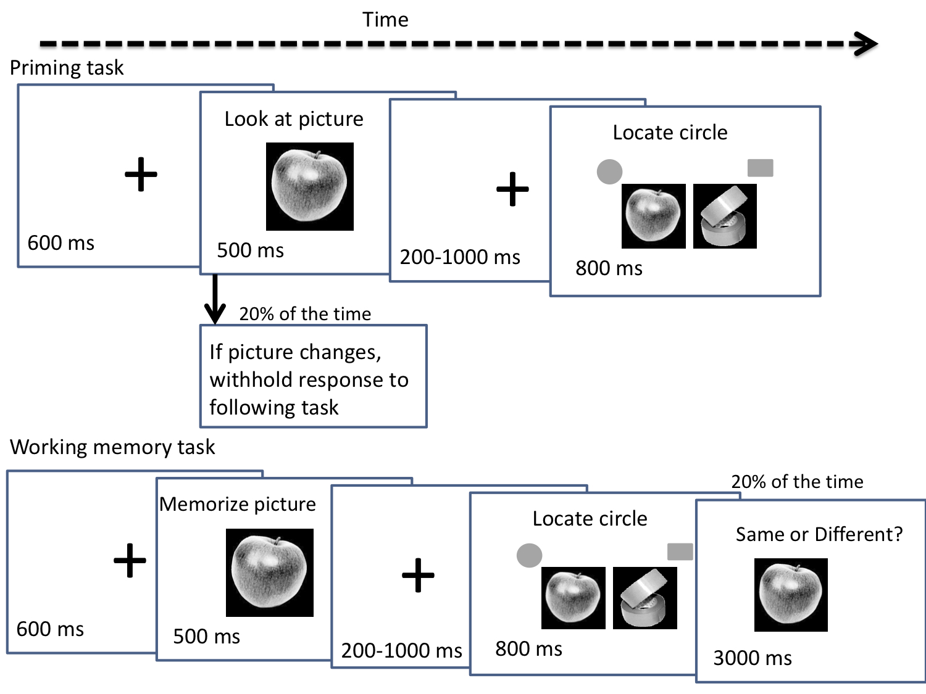
Fig 2.
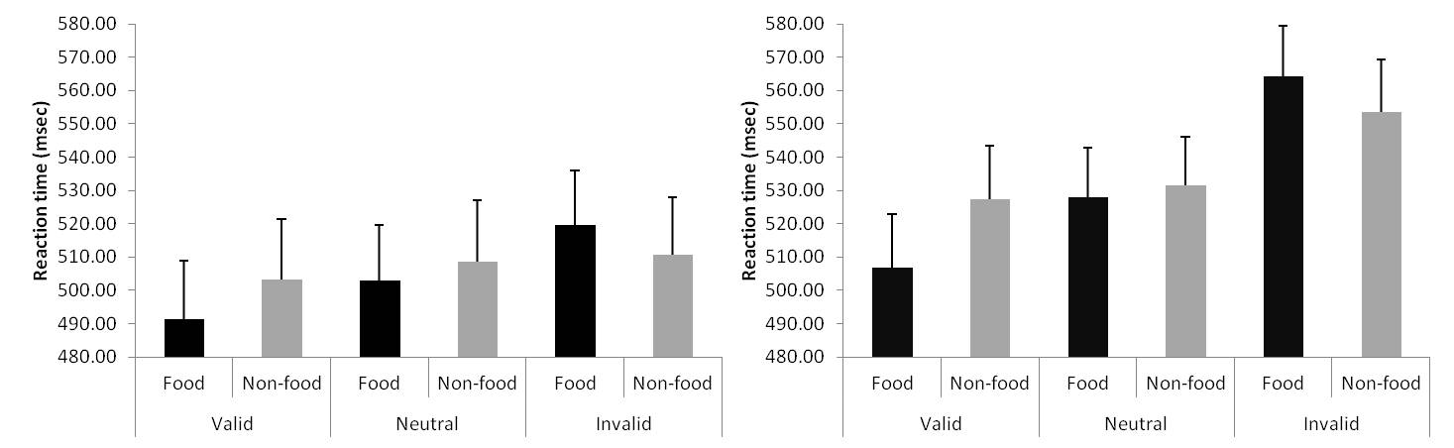Fig 3
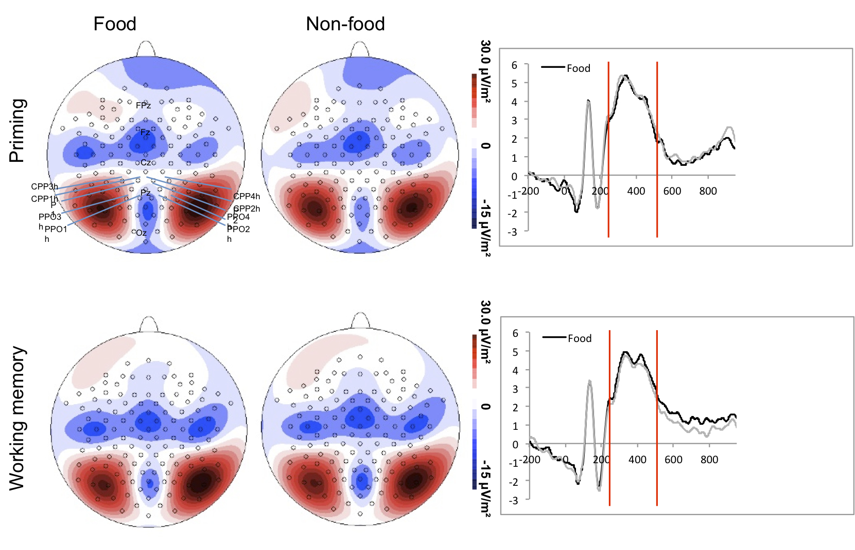
Fig 4
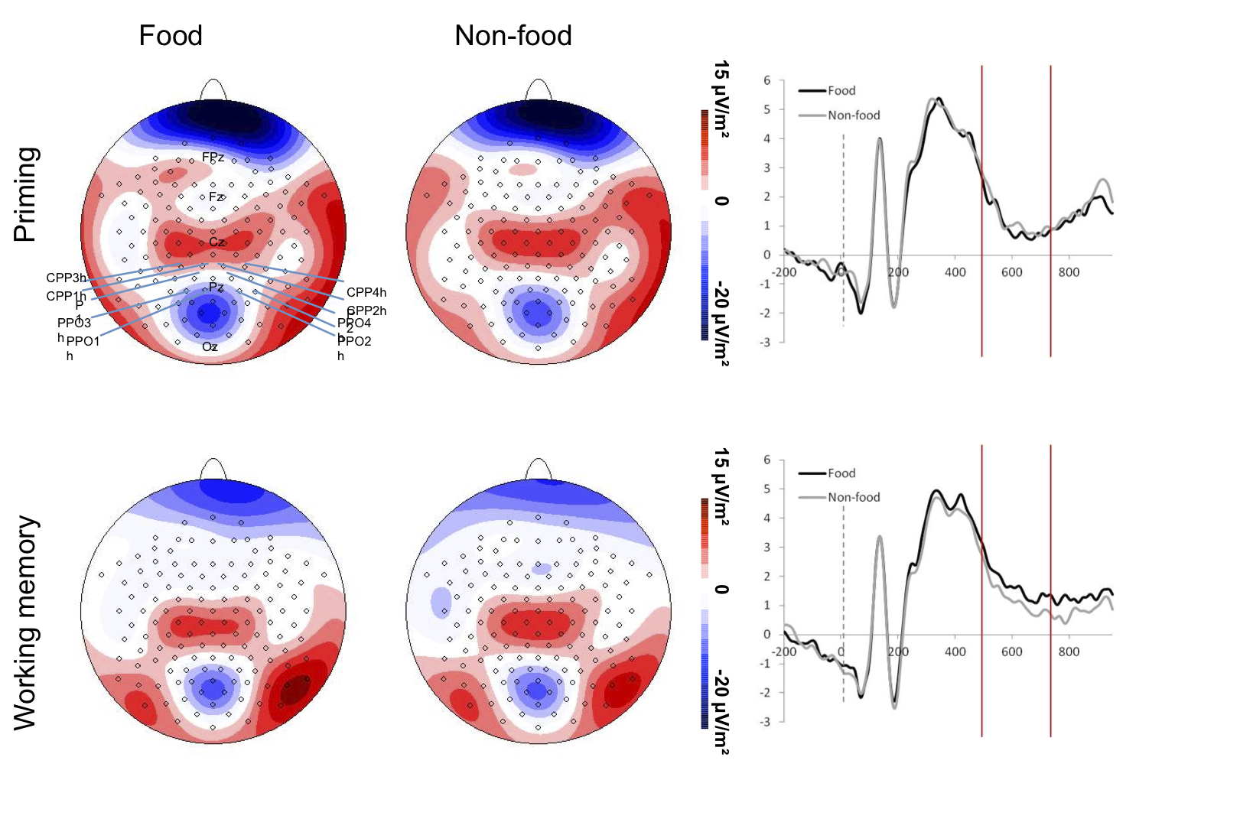
Fig 5
