Process Optimisation of Selective Laser Melting using Energy Density Model for Nickel-based Superalloys
Luke N. Carter, Xiqian Wang, Noriko Read, Raja Khan, Miren A. Segerra, Khamis Essa, & Moataz M. Attallah*
School of Metallurgy and Materials, The University of Birmingham, Edgbaston B15 2TT
(*Corresponding author: Email: M.M.Attallah@Bham.ac.uk; Telephone: (+44) 121 414 7842)

Abstract
The main challenge associated with the application of Selective Laser Melting (SLM) to Ni-based superalloys is the performance of process optimisation to maximise the mechanical properties. The energy density parameter has typically been used as a semi-quantitative approach to identify the energy threshold beyond which the material achieves virtually full consolidation. Nonetheless, some Ni-superalloys are susceptible to crack formation during SLM, which cannot be avoided via process optimisation. In this report, a comparative study is presented showing the utility of the energy density parameter in process optimisation for γ′ and γ′/γ′′ strengthened Ni-based superalloys. For both classes, it was found that the build density increases (i.e. void area (%) decreases) with the increase in the energy density. Nonetheless, no direct correlation can be found between the energy density parameter and the cracking density.

Introduction
Selective Laser Melting (SLM) is a process of ever growing interest and popularity for the production of Ni-based superalloys netshape components directly from metal powder. The specifics of SLM and its position within the family of technologies that make up ‘Additive Manufacturing’ is well documented; technology overviews and review papers can be found elsewhere ¹⁻⁴. As the interest in this, and other, additive manufacturing methods grows, so does the drive for high quality research to understand the process and its influence on the microstructure, mechanical properties, and behaviour of a wide range of Ni-based superalloys.
Previous work presented by Carter et al. ^{5, 6} has examined process optimisation of SLM for high γ′ volume-fraction alloys and associated microstructural in-homogeneity induced by the laser scanning strategy⁷. There has been significant focus on the alloy IN718 due to its weldability typified by the studies performed by Liu et al.^{8, 9} and Amato et al.¹⁰ which examine the microstructure with relation to the mechanical properties. Similar research has be carried out on Nimonic 263 by Vilaro et al.¹¹ focussing on residual stress development; the study presented by Rickenbacher et al.¹² examining the mechanical properties of IN738LC and the detailed investigation into the influence of pulse shaping on SLM fabricated IN625 presented by Mumtaz & Hopkinson¹³. These studies illustrate the range of research being carried out in this field and the interest specifically in the SLM forming of nickel alloys driven by both academic and industrial entities.
This paper summarises a number of studies examining SLM processing of various Ni-base superalloys, focusing on the application and validity of using a combined ‘energy density’ parameter to combine three of the key processing parameters.

Energy Density Studies

Energy Density Introduction
Parametric studies of SLM can be complex and lengthy due to the large amount of process variables involved. Studies have shown that certain measured responses can be related directly to a combined energy density parameter^{14, 15}, which can effectively reduce the complexity of parametric studies. Other studies employed statistical methods (e.g. Taguchi method or factorial experiments), which can speed up the optimisation process using a ‘black-box’, yet without probing the physics behind the process.
The results presented here have been collated from a number of parametric studies in which the individual process parameters were investigated for various Ni-based superalloys, including γ′-strengthened alloys (CM247LC and CMSX486) and γ′/γ′′-strengthened alloys (IN625 and IN718). Electron microscopy and image analysis using stereological methods were used to quantify the void (porosity) area (%) in CM247LC, CMSX486, IN625, and IN718, as well as the cracking density in the crack susceptible alloys (CM247LC and CSMX486). The exact methodology is described elsewhere ⁵, however, in general terms, a threshold was applied to micrographs to produce a binary image. The defects showing an area of > 500 μm² (≈ ∅ 25 μm) were defined as pores, with the sum of their areas was presented as a percentage of the total micrograph area examined. Smaller large aspect ratio defects were defined as cracks and their length approximated by the Feret diameter, which was summed and averaged with respect to micrograph area giving a cracking density in mm/mm². At the current time, no research has been carried out into the correlation between the sectioned image analysis and 3-dimensional volumetric data.
All studies were carried out using the Concept Laser M2 SLM facility located at the University of Birmingham, using argon gas atomised powder (+15 -53 μm) processed under argon atmosphere (<0.1% O₂). The laser power can be controlled up to the maximum of 400 W, with a maximum scanning speed of 7000 mm/s and the hatch spacing between the scan vectors defined by the a1 parameter as in Equation 1.
$a1=\frac{Scan Spacing (μm)}{Track Width (150 μm)}$ - Equation 1
Due to the collated nature of the data, the methodology for each study varied slightly. Table 1 provides key study details for each of the investigated materials. Equation 2 shows the calculation of energy density (J/mm²).
$Energy Density (J/{{mm}^{2})=\frac{Laser Power (W)}{Scan Speed ({mm}/{s) ×Scan Spacing (mm)}}}$ - Equation 2
Other studies in the literature have used a volumetric energy density function (J/mm³) which also includes the layer thickness ^{14, 15}. These studies have not specifically investigated the layer thickness as a parameter (all but the IN718 study being carried out using a constant 20 μm layer thickness); additionally the high degree of re-melting between layers (often several layers thick) calls into question its relevance as in the energy density function. The two-dimensional energy density function has therefore been used for this study, although future detailed investigations may focus on the relevance of layer thickness.
The nominal composition of each of the alloys investigated is provided in Table 2 for reference.
Figure 1 shows typical backscattered electrons (BSe) Scanning Electron Microscope (SEM) micrographs of CM247LC that were used to quantify the cracking density and void area (%). Figure 1 (a) shows a sample containing large voids with partially melted powder particles, which is a typical low energy density condition, whereas Figure 1 (b) shows a sample showing only cracks, mostly along the build direction.

Table 1: Key investigation details for parametric studies of CM247LC, CMSX486 & IN625
Material | CMSX486 | IN625 | CM247LC | CM247LC | IN718
Powder Supplier | Carpenter | LPW Technology | LPW Technology | LPW Technology | Erasteel
Laser Power Range Investigated (W) | 100 - 200 | 100 - 200 | 100 - 200 | 200-400 | 125-376
Scan Speed Range Investigated (mm/s) | 500 - 2500 | 1000 – 3000 | 400 - 2000 | 1000-3500 | 580-1420
Layer thickness (μm) | 20 | 20 | 20 | 20 | 30
Hatch Spacing Range Investigated (a1) | 0.2 – 0.8 | 0.2 – 0.8 | 0.2 – 0.53 | 0.2-0.8 | 0.37-0.7
Laser scanning strategy | Islands | Islands | Islands | Raster | Raster
Analysis Method | BSE SEM | Optical | BSE SEM | BSE SEM | Optical
No. of Micrographs per Specimen | 28 | 11 | 30 | 21 | 64
Approximate Area of Each Micrograph (mm²) | 0.24 | 0.47 | 0.24 | 0.05 | 1.86
Specimen Dimensions (X,Y,Z)(mm) | 10, 10, 20 | 10, 10, 20 | 10, 10, 20 | 10, 10, 10 | 10, 10, 10

Table 2: Nominal compositions of the alloys under investigation (wt. %)
 | C | Cr | Ni | Co | Mo | W | Ta | Ti | Al | B | Zr | Hf | Re | Nb | Fe | Mn | Cu
CM247LC | 0.07 | 8 | Bal. | 9 | 0.5 | 10 | 3.2 | 0.7 | 5.6 | 0.015 | 0.01 | 1.4 | N/A | N/A | N/A | N/A | N/A
CMSX486 | 0.07 | 5 | Bal. | 9.3 | 0.7 | 8.6 | 4.5 | 0.7 | 5.7 | 0.015 | 0.005 | 1.2 | 3 | N/A | N/A | N/A | N/A
IN625 | 0.05 | 21.5 | Bal. | N/A | 9 | N/A | N/A | 0.2 | 0.2 | N/A | N/A | N/A | N/A | 3.6 | 2.5 | N/A | N/A
IN718 | 0.08 | 17-21 | 50-55 | 1 | 2.8-3.3 | N/A | N/A | 0.3 | 0.65-1.15 | N/A | N/A | N/A | N/A | 4.75-5.5 | Bal. | 0.35 | 0.2-0.8

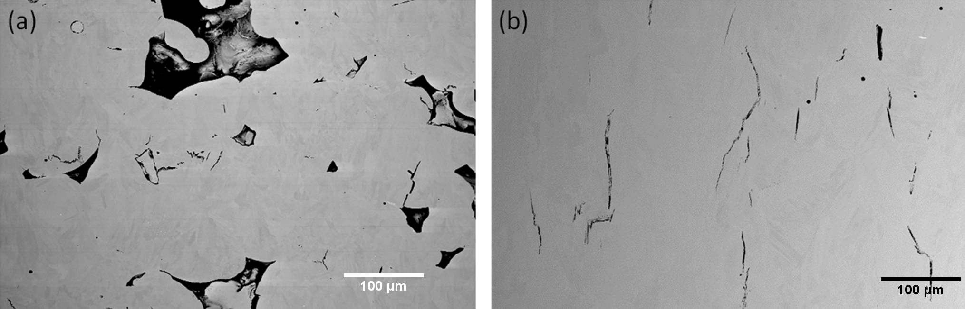
Figure 1: BSE SEM micrographs showing SLM fabricated CM247LC; (a) illustrates a typical sample showing large voids and (b) a sample showing cracking.

Energy Density Results
Figure 2 shows the void (porosity) area (%) measured by images analysis of all the samples in the five different studies plotted against the energy density. The dashed line indicates the approximate boundary between the high and low void area (%) regions of the processing window; this boundary occurs at approximately 1.7 J/mm² for all the nickel superalloys examined (equates to 85 J/mm³ if the layer thickness is considered). All the investigated alloys demonstrated the same trend, whereby the increase in the energy density results in a decrease in the void area (%), until a threshold energy density is achieved. Interestingly, the void area (%) does not increase again at higher energy density levels, which might have been expected if over-melting (e.g. evaporation or turbulent melting) was experienced. Figure 3 shows the cracking density of the cracking susceptible alloys (CM247LC and CMSX486) plotted against energy density; this relationship is much more complex than that for the void area (%). Nonetheless, the scatter of the CM247LC data appears to show a cracking density that increases with the increase in the energy density.
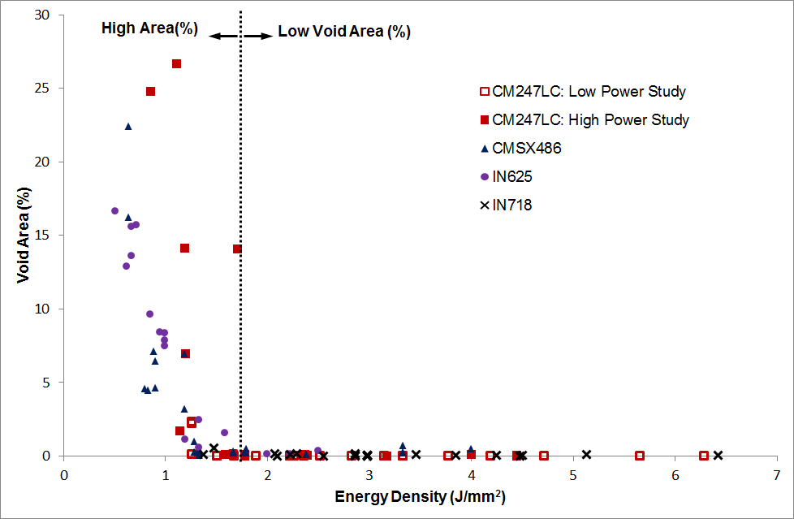
Figure 2: Void area (%) plotted against energy density generated from the collated results of five different studies relating to SLM of Ni-superalloys.

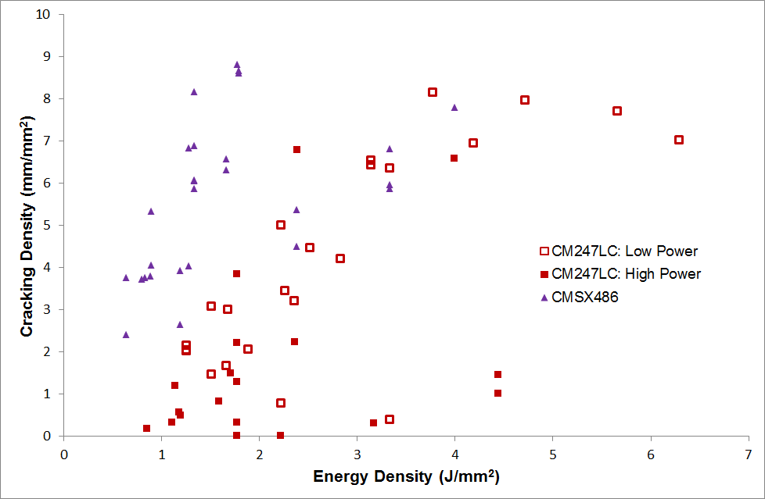
Figure 3: Cracking density and plotted against energy density for SLM fabricated CM247LC & CMSX486 generated from the collated results of three different studies.

Energy Density Discussion
Figure 2 clearly illustrates how the energy density can be used to define the portion of the processing window where ‘full-consolidation occurs’. In this instance, ‘full-consolidation’ refers to the point at which no large voids are present within the material, i.e. the SLM process has fully melted and densified the powder regardless of the other defects that may be present (for example residual gas-porosity introduced by the power feedstock, or microcracks within the material). The boundary between the fully consolidated material and material containing large voids is clearly visible in this case (occurring at approximately 1.7 J/mm²) and this energy density threshold could in future be used to quickly eliminate certain regions of the processing window of the system for future parametric studies. Additionally this threshold appears to be reasonably constant for all the Ni-based superalloys examined, interestingly regardless of the exact individual process parameters. This is a logical result as, regardless of final mechanical properties or usage, all Ni-based superalloys are likely to have a fairly similar absorption coefficient for this wavelength of radiation and a reasonably similar melting point. The threshold energy density value at which this occurs is most likely a relationship between the energy required to heat and melt the material, the specific absorption of the laser energy and the heat transfer properties of the material. The values for CM247LC, CMSX486 and IN625 (1.6, 1.4, 1.6 J/mm² respectively) are all very similar and are consistent with the research presented by Wu et al. ¹⁵ that found the threshold value for Hastelloy X to be ≈ 1.5 J/mm² which is comparable to the threshold value shown here. The research presented by Olakanmi et al. ¹⁴ investigated the SLM fabrication of an aluminium alloy (Al-12Si) and included the layer thickness in the energy density calculation (i.e. J/mm³) showing that maximum density was achieved at 67 J/mm³. Taking an average value for the threshold of consolidation for the Ni alloys presented here of 1.5 J/mm² and by considering the constant layer thickness of 20 μm then, by contrast to Al-12Si, this equates to a volumetric energy density of ≈ 75 J/mm³.
Figure 3 shows the cracking density (in those materials susceptible to weld cracking) plotted against energy density. In sharp contrast to Figure 2, there is no clear trend or threshold within the data. At best, it could be stated that a general trend appears to show cracking density increasing with energy density, however in this case there is a distinct risk of drawing false conclusions from the data without fully appreciating the experimental method. Based purely on the graph in Figure 3, it might be stated that the cracking density in CM247LC drops sharply below an energy density of approx. 1.8 J/mm² however this would be an erroneous conclusion as below 1.8 J/mm² large voids begin to appear in the samples (see Figure 2). These voids occupy a larger and larger portion of the micrographs as the energy density is reduced and therefore a smaller portion of solid material is visible for the cracking quantification. This change in analysed area is not taken into account during the image analysis process and it is assumed that the area of material analysed is always equal to the visible area within the micrograph; therefore the cracking density appears to drop sharply as the fraction of large voids increases.
Furthermore, examining the portion of Figure 3 in the region of energy densities greater than 1.8 J/mm² there is no clear trend in the data for the CM247LC (High Power) and CMSX486 studies. There does appear to be an almost linear trend in CM247LC (Low Power) study relating cracking density to energy density, however, examination of the experimental details reveal this to also be an erroneous conclusion. Due to the nature of the CM247LC (Low Power) study (full details can be found elsewhere ⁵) , the energy variation was achieved in many of the points by varying the laser scan speed and power, only a few samples were investigated where the scan spacing was the variable, these points relate to the low cracking density points seen at approximately 2.2 J/mm² and 3.3 J/mm².
By considering the void formation and the crack formation cases individually, further understanding can be gained. The formation of large voids in SLM fabricated material is due to the inability of the process to fully consolidate the material under that particular set of processing conditions. This is most likely due to the molten pool being insufficiently wide or cold to consolidate the current laser scan track with the surrounding material. By extending this idea, it is easy to see how increasing the laser power, or decreasing the scan speed would result in a greater energy input to the material and so a larger melt pool, and also that by reducing the scan spacing a smaller melt pool could also be accommodated to result in full consolidation. As these are the parameters combined to form energy density the idea of a threshold value at which full consolidation occurs is very logical. This threshold energy density for full consolidation could prove very useful in future work. By collecting threshold values for all materials processed by SLM and building a library it may be possible to ultimately link these values to the fundamental material properties (previously mentioned) and as such provide a good indication as to the processing window for new materials. This would allow initial process parameters to be quickly identified and reduce to the length and complexity of parametric studies.
The more complex interaction between cracking density and energy density seen in CM247LC and CMSX486 illustrates the limitations of using the energy density as a combined processing parameter. When considered in terms of energy density, these results are unclear and the individual interactions of the laser power, speed and spacing cannot be identified. The cracking behaviour can be much better understood by considering each parameter individually and by combining the measurements with the observation of the crack structure (outside the scope of this paper). As cracking is largely governed by the formation of residual stresses within the material, other factors such as laser scanning strategy and build geometry must also be considered.
The approach can be useful in creating porous structure, especially that the consolidation regime (prior to the threshold) shows somehow a linear trend, which can be used to tailor a specific level of porosity to control the mechanical properties or density, Figure 4.

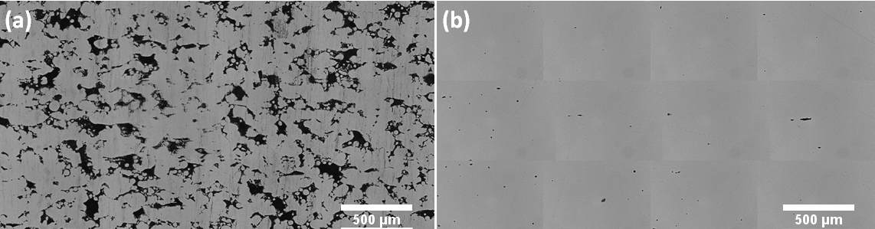
Figure 4: The consolidation regime in IN625, showing a) a low power build with a high void area (E = 0.5 J/mm²) and b) the optimum build with low void area (E = 2.2 J/mm²)
Combining several processing parameters into one overall parameter is an attractive option in order to reduce the length of parametric studies however, this collected research has illustrated that caution must always be used as information is always lost when doing this. The energy density function has therefore proven to be of interest when assessing the parameters required for full consolidation however has not proven to be effective when examining the cracking density of certain alloys.

Overall Conclusions
The collated research presented here has shown the value of comparing results across similar studies. The composite ‘energy density’ parameter has proven to be a useful tool in quickly assessing the processing window by proving a boundary for complete consolidation. In the case of the IN625 study this allowed for the optimisation of the process parameters to be based on processing speed once this window had been established. However with the use of this parameter, and every method where parameters are combined, a certain level of detail and potential understanding is lost; this was illustrated in the cracking density data.

Acknowledgements
The authors would like to acknowledge the support of our collaborators from MicroTurbo/Safran Group.

References
1. G. N. Levy, R. Schindel, and J. P. Kruth: 'Rapid manufacturing and rapid tooling with layer manufacturing (LM) technologies, state of the art and future perspectives', CIRP Annals - Manufacturing Technology, 2003, 52(2), 589-609.
2. X. Wu: 'A review of laser fabrication of metallic engineering components and of materials', Materials Science and Technology, 2007, 23(6), 631-640.
3. S. Das: 'Physical Aspects of Process Control in Selective Laser Sintering of Metals', Advanced Engineering Materials, 2003, 5(10), 701-711.
4. L. E. Murr, S. M. Gaytan, D. A. Ramirez, E. Martinez, J. Hernandez, K. N. Amato, P. W. Shindo, F. R. Medina, and R. B. Wicker: 'Metal Fabrication by Additive Manufacturing Using Laser and Electron Beam Melting Technologies', Journal of Materials Science and Technology, 2012, 28(1), 1-14.
5. L. N. Carter, M. M. Attallah, and R. C. Reed: 'Laser powder bed fabrication of nickel-base superalloys: Influence of parameters; characterisation, quantification and mitigation of cracking', 12th International Symposium on Superalloys, Superalloys 2012, September 9, 2012 - September 13, 2012, Seven Springs, PA, United states, 2012, Minerals, Metals and Materials Society, 577-586.
6. L. N. Carter, K. Essa, and M. M. Attallah: 'Optimisation of Selective Laser Melting for a high temperature Ni superalloy', Rapid Prototyping Journal, 2015, 21(4).
7. L. N. Carter, C. Martin, P. J. Withers, and M. M. Attallah: 'The influence of the laser scan strategy on grain structure and cracking behaviour in SLM powder-bed fabricated nickel superalloy', Journal of Alloys and Compounds, 2014, 615, 338-347.
8. F. Liu, X. Lin, C. Huang, M. Song, G. Yang, J. Chen, and W. Huang: 'The effect of laser scanning path on microstructures and mechanical properties of laser solid formed nickel-base superalloy Inconel 718', Journal of Alloys and Compounds, 2011, 509(13), 4505-4509.
9. F. Liu, X. Lin, G. Yang, M. Song, J. Chen, and W. Huang: 'Microstructure and residual stress of laser rapid formed Inconel 718 nickel-base superalloy', Optics and Laser Technology, 2011, 43(1), 208-213.
10. K. N. Amato, S. M. Gaytan, L. E. Murr, E. Martinez, P. W. Shindo, J. Hernandez, S. Collins, and F. Medina: 'Microstructures and mechanical behavior of Inconel 718 fabricated by selective laser melting', Acta Materialia, 2012, 60(5), 2229-2239.
11. T. Vilaro, C. Colin, J. D. Bartout, L. Naze, and M. Sennour: 'Microstructural and mechanical approaches of the selective laser melting process applied to a nickel-base superalloy', Materials Science and Engineering A, 2012, 534, 446-451.
12. L. Rickenbacher, T. Etter, S. Hovel, and K. Wegener: 'High temperature material properties of IN738LC processed by selective laser melting (SLM) technology', Rapid Prototyping Journal, 2013, 19(4), 282-290.
13. K. Mumtaz and N. Hopkinson: 'Selective laser melting of Inconel 625 using pulse shaping', Rapid Prototyping Journal, 2010, 16(4), 248-257.
14. E. O. Olakanmi, R. F. Cochrane, and K. W. Dalgarno: 'Densification mechanism and microstructural evolution in selective laser sintering of Al-12Si powders', Journal of Materials Processing Technology, 2011, 211(1), 113-121.
15. X. Wu, F. Wang, and D. Clark: 'On direct laser deposited Hastelloy X: dimension, surface finish, microstructure and mechanical properties', Materials Science and Technology, 2011, 27(1), 344 - 356.

Figure Captions:
Table 1: Key investigation details for parametric studies of CM247LC, CMSX486 & IN625
Figure 1: BSE SEM micrographs showing SLM fabricated CM247LC; (a) illustrates a typical sample showing large voids and (b) a sample showing cracking.
Figure 2: Void area (%) plotted against energy density generated from the collated results of five different studies relating to SLM of Ni-superalloys.
Figure 3: Cracking density and plotted against energy density for SLM fabricated CM247LC & CMSX486 generated from the collated results of three different studies.
Figure 4: The consolidation regime in IN625, showing a) a low power build with a high void area (%) (E = 0.5 J/mm2) and b) the optimum build with low void area (%) (E = 2.2 J/mm2)

