***Nonintrusive Investigation of Large Al-kaolin Fractal Aggregates with Slow Settling Velocities***

Rodrigo B. Moruzzia*, Luiza C. Camposb, Soroosh Sharific, Pedro Grava da Silvad, John Gregoryb

a Instituto de Geociências e Ciências Exatas, Univ. Estadual Paulista (UNESP), Av. 24-A, 1515, Jardim Bela Vista, Rio Claro, 13506-900. São Paulo, Brazil. E-mail: [rodrigo.moruzzi@unesp.br](mailto:rodrigo.moruzzi@unesp.br)

b Department of Civil, Environmental and Geomatic Engineering, University College London, Gower St, London, WC1E 6BT, United Kingdom. E-mail: [l.campos@ucl.ac.uk](mailto:l.campos@ucl.ac.uk) ; j.gregory@ucl.ac.uk

c Department of Civil Engineering, University of Birmingham, B15 2TT, United Kingdom. Email: [S.Sharifi@bham.ac.uk](mailto:S.Sharifi@bham.ac.uk)

d Programa de Pós-graduação em Engenharia Civil e Ambiental, Univ. Estadual Paulista (UNESP), Av. 24-A, 1515, Jardim Bela Vista, Rio Claro, 13506-900. São Paulo, Brazil. E-mail: [pedroagrava@gmail.com](mailto:pedroagrava@gmail.com)

**Address:**

* Corresponding author: Avenida 24-A, nº 1515, C. P. 178, CEP 13506-900, Office 23, Bela Vista, Rio Claro, São Paulo, Brazil. Phone: +55 19 3526-9339. *E-mail address*: [rodrigo.moruzzi@.unesp.br](mailto:rodrigo.moruzzi@.unesp.br)

**Abstract**

Although a combination of aggregate characteristics dictate particle settling, it is commonly assumed that large particles have higher terminal velocities. This simplifying assumption often leads to overprediction of large aggregate settling velocities which in turn negatively impacts on estimates of sedimentation clarification efficiency. Despite its importance, little attention has been given to large aggregates with slow-settling velocities. This paper addresses this gap, by investigating slow-settling velocities of large, heterodisperse and multi-shape Al-kaolin aggregates using non-intrusive methods. A particle image velocimetry technique (PIV) was applied to track aggregate velocity and a non-intrusive image technique was used to determine aggregate characteristics, including size (*df*), three-dimensional fractal dimension (*Df*), density (*f*), aggregate velocity (*Vexp*) and Reynolds number (Re). Results showed no strict dependence of settling velocity on aggregate size, shape and density, as Al-kaolin aggregates with same size exhibited different settling velocities. Further, it was found that large Al-kaolin aggregates can settle sufficiently slowly for Stokes-type expressions to apply. Comparing the results with the well-known Stokes’ law for velocity modified by a shape factor showed that settling velocities here measured can vary by 2 to 14 fold lower than predicted values for perfect sphere-shape aggregates with the same density and size. Furthermore, results have also shown large Al-kaolin aggregate’s drag coefficient (Cd) to be around 56/Re, for average fractal aggregate sphericity of around 0.58.

**Keywords:** flocculation, fractal dimension, velocity, aggregate density, sedimentation

**1- Introduction**

Sedimentation is widely used as a technique for separating suspended material in water treatment before filtration. This stage is commonly preceded by coagulation and flocculation processes, which destabilize colloids and promote their subsequent agglomeration, favouring the formation of large aggregates, which are commonly assumed as more likely to settle in sedimentation tanks. This comes from the belief that size and density are dependent features and that aggregates can be considered as spheres, as described by Stokes’ law. However, some studies (e.g. Chakraborti et al., 2000; Johnson, Li and Logan, 1996; Vahedi and Gorczyca, 2014) have shown that the complex mechanisms involving aggregation, breakage, restructuring of multi-shape primary particles and different relations among size, shape and density can result in different terminal settling velocities, even for fractal aggregates with the same size. As such, practitioners have reported that large aggregates may still remain in the supernatant water due to their very slow-settling velocity, which can be attributed to aggregate features other than its size (Vahedi and Gorczyca, 2012).

The aggregates formed from the flocculation of colloidal material are known as fractal objects (Jiang and Logan, 1991; Gregory, 1997), i.e. they have non-spherical shape and porous structure, and hence, cannot be fully geometrically represented by a sphere. Despite this, to reduce the complexities of aggregate settling hydrodynamics, it is still common to evaluate the sedimentation of particles by assuming impervious and perfect-shape sphere aggregates (Bushell et al., 2002). It is known that this oversimplification may lead to inaccurate predictions of settling velocity with significant errors, with actual velocity estimates varying from 4 to 8 times higher, as shown by Johnson et al. (1996) or even about 5 times lower, as shown by Vahedi and Gorczyca (2012). Thus, making it difficult to fully understand the phenomena and their relevance to engineering (Johnson et al., 1996, Gregory, 1997, Li et al., 2006 and Vahedi and Gorczyca, 2012). Therefore, for practical reasons, it is necessary to gain a better understanding of the complex relation between the characteristics of large fractal aggregates produced by coagulation and flocculation, and their settling velocities.

Fractal geometry has broad applications and can be used for flocculation studies in water treatment in relation to porosity, density and strength of flocs, sedimentation velocity, collision models and flocculation kinetics. Some works have aimed to incorporate the understanding of fractal geometry into the dynamics of aggregate removal. Some have followed a purely theoretical and conceptual approach, such as Gregory (1997) and Jarvis et al., (2005), and others (e.g. Vahedi and Gorczyca, 2014) have discussed computational simulation results. So far, only a handful of papers such as Johnson et al. (1996), Vahedi and Gorczyca (2012), and Chakraborti and Kaur (2014) have presented results that combine experiments and fundamental approach.

Vahedi and Gorczyca (2012) have studied lime softening flocs (denser than Alum flocs), where an average of 2.37x10-3 m·s-1 was measured for average size of 124 m of equivalent diameter, and slower than those presented by Johnson et al. (1996), who have studied fractal aggregates (2 - 40 m) formed from latex microspheres, coagulated with NaCl solution at a shear rate of 5 s-1. Their findings have shown settling velocities to be 4 to 8 times higher than Stokes’ law prediction, i.e. 1x10-4 to 1x10-3 m·s-1. These results are different from any other studies, and it is difficult to explain why such high velocities were measured, even considering high permeability and the flow-through floc effect, as pointed by Bushell et al. (2002).

Although primary particles in real flocs are heterodisperse and multi-shaped, latex spheres of known sizes were still used in many of these works to form aggregates. Nevertheless, Chakraborti and Kaur (2014) have also shown that even for large latex spheres (size larger than 100 m) settling velocities may also be lower than those predicted by Stokes’ law equation. They concluded that drag coefficients (Cd) assumed in the Stokes’ law velocity expression may be not applicable for larger particles, even with Re < 1. Furthermore, primary particles affect aggregates’ shape and there is evidence that large aggregates have fractal-like shape, with lower dimensions, resulting in lower density compared to smaller aggregates (Johnson et al., 2016; Vahedi and Gorczyca, 2012 and Moruzzi et al., 2017). According to Bushell et al. (2002), the impact of aggregation of primary particles on hydrodynamics may result either in the increase of drag forces, compared to spherical primary particles, or in the formation of aggregates that can become permeable, decreasing the drag force.

This study aims to systematically investigate and analyse the features and dynamics of slow settling Al-kaolin fractal aggregates, using a non-intrusive image-based method. The focus here is specifically, large, heterodisperse and multi-shape flocculated kaolin particles settled by gravity. Particle image velocimetry (PIV) is used to measure aggregates settling velocity as well as their size and shape. Furthermore, a novel procedure is applied to convert 2D fractal dimension into 3D from image analysis. Size and density were analysed and correlated from two approaches, individually and the entire population of aggregates. Shape, Reynolds number and drag coefficient of large Al-kaolin fractal aggregate velocities are determined, and experimental velocities are compared with estimates using Stokes’ equation modified by a shape factor, which has been widely used in predicting settling velocities.

2- **Methodology**

*2.1 Synthetic water preparation*

For the present study, commercial kaolin (Sigma-Aldrich) was used as primary particle and synthetic water was prepared from a stock suspension (turbidity 5000 ± 200 NTU), as recommended by Yukselen and Gregory (2004). For each assay, a volume of 10 mL from stock solution was diluted in 2 L of deionized water to produce water with turbidity 25 ± 2 NTU (15.8 ± 1.3 mg TSS· L-1), as described by Moruzzi et al. (2017). A MALVERN Mastersizer 2000 particle size analyser and a Scanning Electron Microscope (SEM) were used to measure kaolin size distribution and to define the representative pixel size, i.e. the ratio between image resolution and size that better describes flocs, for the kaolin bulk particles which form the aggregates, as discussed by Moruzzi et al. (2017). Analytical grade alum (Al2(SO4)3·14·H20) from Sigma-Aldrich was used as coagulant and analytical grade sodium bicarbonate (0.1 M, NaHCO3) was used as pH buffer during coagulation tests. Here, the coagulation conditions obtained by Oliveira et al. (2015) and Moruzzi et al. (2017) were applied, i.e. 2 mg Al·L-1 and pH of 7.5. The aggregates were obtained after flocculation with velocity gradients (*Gf*) ranging from 20 to 60 s-1 for 15 minutes of flocculation time in order to consider aggregates of different sizes and shapes. The temperature was kept at about 20 ± 1 ºC during all experiments.

*2.2 Non-intrusive image analysis*

To study aggregates with slow settling velocity, only the ones that remained in the supernatant after 5 minutes of sedimentation were monitored. This was to ensure minimum inertial fluid motion after flocculation, and predominance of aggregate vertical trajectory. In total, 118 aggregates were individually monitored applying a non-intrusive image acquisition system using a *High-Speed ​​Miro EX-4* camera with interchangeable lenses. The lighting system was set up as proposed by Moruzzi et al. (2019), and images were taken at a section located 50 mm from the jar wall to avoid hydrodynamic interaction. A schematic of the experimental setup is shown in Figure 1-a. For all experiments, a sampling frequency of 25 Hz was used for 40s at a resolution of 800 x 600 elemental units (pixel), with a field of view of 6 x 8 mm, and a shutter frequency of 800 μs. For these conditions, the pixel size was 10 μm and a total of 1000 images were obtained at time intervals of 40 ms (milliseconds) from *t0* to *tn*, with *n* changing from 1 to 1000 (Figure 1-b).

For the Particle Image Velocimetry (PIV) evaluation, *Image-Pro Plus®* software was used to analyse the images, i.e. conversion from 28 to 21 bits (i.e. from 256 grayscale to black & white image), enhancement, measurement and tracking of aggregates from centroid distances *d0* to *dn*, with *n* varying from 1 to 1000 frames, as shown in Figure 1-c.

Particles with cross sectional area projected vertically larger than 200 pixels and size greater than 15 pixels were chosen for accuracy in accordance with Chakraborti et al. (2003), Moruzzi and Silva (2018) and Moruzzi et al. (2019). The results were evaluated for 95% significance.

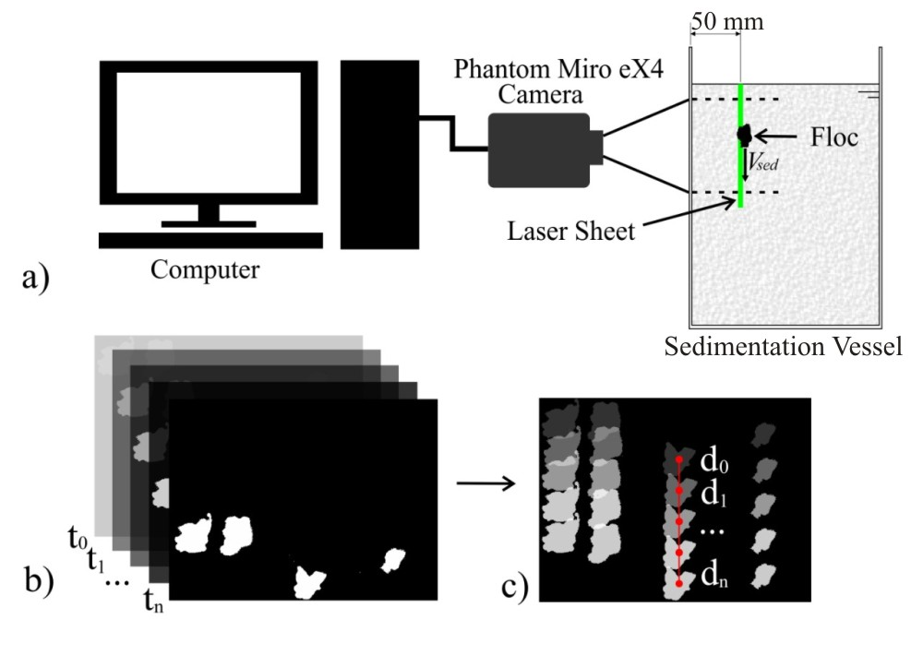

Figure 1 – (a) Schematic of the experimental arrangement used in the experiments; (b) image pack screened from time intervals from t0 to tn; and (c) tracking aggregates distances from d0 to dn using Particle Image Velocimetry (PIV) tool.

*2.3 Fractal aggregate features*

The three-dimensional fractal dimension (*Df*) for Al-kaolin aggregates was considered individually based on Jiang and Logan (1991) and Jarvis et al. (2005):

$N=b{\left[\frac{d_{f}}{d_{p}}\right]}^{D_{f}}$ (1)

where *Df* is the three-dimensional fractal dimension for individual Al-kaolin aggregates, *dp* is the primary particle size (m), here determined from the median size (*d50*) of primary kaolin particle size distribution, *df* is the floc size (m), *N* is the number of particles of size *dp* per floc of size *df* and *b* is the structure factor which comprises the packing and shape factors for aggregates and primary particles, as introduced by Bushell (2002).

The number of pixels counted in floc area was considered representative of *N* from Equation 1, as it agrees with the median size (*d50*) of around 10 m, discussed later on this paper. The volume of the fitted ellipsoid of revolution (E) to the aggregate was used to derive fractal dimension. This was calculated by rotating the encased ellipsoid around the longest size of E (*dmax*) limited by the smallest dimension (*dmin*), as proposed by Chakraborti et al. (2000). From these data, the three-dimensional fractal dimension (*Dfp*) was calculated for the set of aggregates, fitting the areas (*A*) and volumes (*V*) with aggregate longest length (*dmax.*) in *log-log* plots, using Equations 2 and 3, respectively:

$A\sim {d_{max.}}^{D_{fp}'}$ (2)

$V\sim {d_{max.}}^{D_{fp}}$ (3)

where *A* is the projected floc area on the image plane, *dmax.* is the longest dimension of the floc (m), *Dfp’* is the two-dimensional fractal dimension for the set of aggregates, *V* is the volume of the ellipsoid containing the floc (m3) and *Dfp* is the three-dimensional fractal dimension for the set of aggregates.

Finally, Equation 4 recently proposed by Moruzzi et al. (2020) was applied to determine the three-dimensional fractal dimension per aggregate (*Df*), based on the ratio *Dfp/ Dfp’* from the entire aggregate population and on 2D fractal dimension calculated individually:

$D_{f}=\frac{D_{fp}}{D_{fp}'}\left(\frac{LogN}{Log\left({d_{max}}/{d_{p}}\right)}\right)$ (4)

The key assumption here is that the *Dfp/ Dfp’* ratio, determined from the entire aggregate population, could be applied to convert 2D to 3D fractal dimensions for individual aggregates using image. This has never been described before in the literature; however it is expected that the entire population of aggregates can provide good approximations for the shape of individual flocs.

The density of the aggregates was determined from the mass balance between floc, particle and voids occupied by the liquid (Jiang and Logan, 1991and Johnson et al., 1996):

$ρ_{f}=ρ_{l}+\left(b{\left(\frac{d_{f}}{d_{p}}\right)}^{D_{f}-3}\left(ρ_{p}-ρ_{l}\right)\right)$ (5)

where *f* is the density of aggregate (kg·m-3), *l* is the density of water (kg·m-3) and *p* is the density of the primary particle (kg·m-3).

It is important to note that although Equation 5 describes density in terms of three-dimensional fractal dimension, it is still assumed that primary particles are perfect spheres, as pointed by Vahedi and Gorczyca (2014). Furthermore, it was also assumed that the entire aggregate size could be represented as a homogeneous aggregation of mono-sized primary particles.

Sphericity (*Ψ*) and aspect ratio (i.e. the larger and shorter aggregate length ratio) were also determined, with the value of 1 representing the shape of perfect sphere for both cases (Jarvis et al., 2005). The density of each aggregate (*f* in Equation 5) and their associated measured velocities obtained from the experiments were also used to determine the dimensionless Reynolds number (Re) for Al-kaolin aggregates:

$Re=\frac{ρ_{f}d_{f}V_{exp}}{μ}$ (6)

where Re is the dimensionless Reynolds number, *Vexp* is the measured Al-kaolin aggregate terminal velocity by PIV (m·s-1) and *μ* is the absolute viscosity (N·m-2·s).

Experimental velocities of fractal aggregates were compared with the modelling approach in a wide range of fractal dimensions, through the well-known Stokes’ law for settling velocity modified by a dimensionless shape factor:

$V_{calc}=\frac{∆ρg{d_{f}}^{2}}{θ18μ}$, valid for Re < 1 and *df* < 1mm, so that Cd=24/Re (7)

where* * is the differential density of aggregate and water, also named as aggregate buoyant density, (kg·m-3) and ** is the shape factor (dimensionless) that comprises all limitations resulting from simplifying assumptions such as, primary particles being compact and perfect sphere-shape with homogeneous size, aggregates being perfect shape and impervious spheres, porosity being homogeneous in aggregates, aggregates presenting mono structures, drag coefficient (Cd) being constant and represented by 24/Re for Re < 1.

Drag coefficient for Al-kaolin fractal aggregates were also calculated, based on fractal homogeneous aggregate porosity (ℰ) initially proposed by Jiang and Logan (1991), here adapted for the encased ellipsoid (E).

$Cd=\frac{4}{3}\frac{∆ρ d_{f} g (1-E)}{ρ_{f}{V_{exp}}^{2}}$ (8)

$E=1-b.{\left(\frac{d_{f}}{d_{p}}\right)}^{D_{f}-3}$ (9)

where ℰ is the Al-kaolin aggregate porosity.

**3- Results and Discussion**

*3.1 Physical attributes*

Figure 2-a shows the heterodisperse nature of dry kaolin powder with size distribution ranging from 1 to 100 m, and median size (*d50*) of around 10 m, which is in agreement with the findings of other researchers (e.g. Aparício et al., 2004; Zbik and Smart, 1998). This result reinforces the hypothesis that the assumption of homogeneous and perfect sphere-shape of primary particle is an oversimplification of a more complex shape and size distribution.

Although the pixel size of 10 m, used here, could be assumed to represent kaolin median size for volume distribution, using only one fractal dimension for flocs would result in an unrealistic high-density aggregate. Aggregates cannot be presumed as a sum of side-by-side primary particles, but a complex structure with multi-scale voids occupied by water and Al-kaolin precipitates. As described by Gorczyca and Ganczarczyk (1999), fractal aggregates are the result of primary particles attachment onto pre-formed flocs with different levels of aggregation, leading in different size and pore population within aggregates, i.e. *flocculi*, microflocs and flocs aggregates. Furthermore, Yu et al. (2015) found that when the coagulant is added to the suspension, flocs grew rapidly as primary particles enmesh within the hydroxide precipitate during the flocculation. Consequently, floc aggregates have different primary particle concentrations within fractal aggregates, and therefore, the density calculated using only one fractal dimension for flocs does not reflect the complex multilevel floc structure.

In order to overcome this issue, the cross sectional area of aggregates was analysed to determine kaolin within its structure, by performing image analysis based on different level of brightness. For this purpose, aggregates formed by Alum only were compared to those formed by Al-kaolin aggregates, making possible to define the multi threshold level for brightness. Figure 2-b shows an example of aggregate structure formed by kaolin (marked in yellow) and alum gel (marked in red). Similar analysis was performed in several images and results have shown that kaolin effective cross-sectional area is about 20 % of the total cross-sectional area average. This made it possible to calculate the floc effective bulk density (*f*) of 1,300 kg·m-3, based on relative quantities of Alum and kaolin within flocs. This finding is in agreement with the results reported by Tambo and Watanabe (1979).



**(a)**

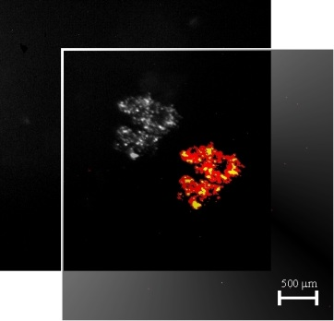

**b)**

Figure 2 – (a) Volume frequency distribution for dry kaolin powder used as primary particles in the tests. The image in the right hand side of (a) refers to (SEM) taken as sample from kaolin, as dry material. (b) Example of aggregate formed by kaolin and alum. Background shows original image and front image shows kaolin highlighted in yellow within aggregate structure of Alum in red.

Figure 3-a shows an example of one of the images used to characterize the aggregate, 5 minutes after flocculation had finished, i.e. during sedimentation. It is clear that the morphology of the aggregate formed after flocculation cannot be explained by Euclidean geometry and by assumption of impermeable sphere. Furthermore, the asymmetrical shape of aggregates can also be observed. The shape and the existence of voids inside the floc may alter the effective density of the aggregate, influencing the terminal velocity of the floc. Figure 3-b shows an example of one of the 118 tracked Al-kaolin aggregates monitored during sedimentation.

Figure 4 shows the value of two and three-dimensional fractal dimensions for the entire population of aggregates in the experimental data, according to Equations 2 and 3. The slopes of the fitted trend lines, i.e. 2.35 and 1.50, represent the three and two-dimensional fractal dimension for the set of aggregates, respectively, which is compatible with the findings of Chackraborti et al. (2003) and Johnson and Logan (1996). A structure factor of 0.74 was determined from the best fit line intercept of Figure 4-b.

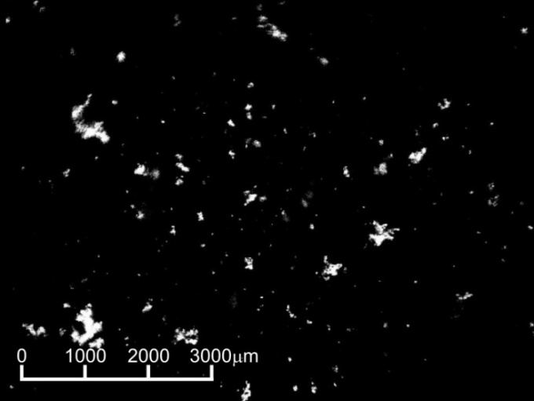 

1. **b)**

Figure 3 – (a) An example of Al-kaolin fractal aggregates image obtained after the flocculation at 15 x magnification; and (b) example of fractal aggregate tracking during sedimentation for frames extracted at 0, 6 and 14 s, 4 x magnification.

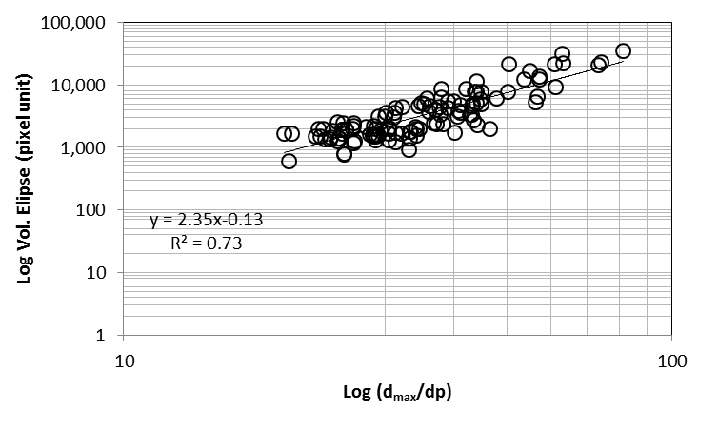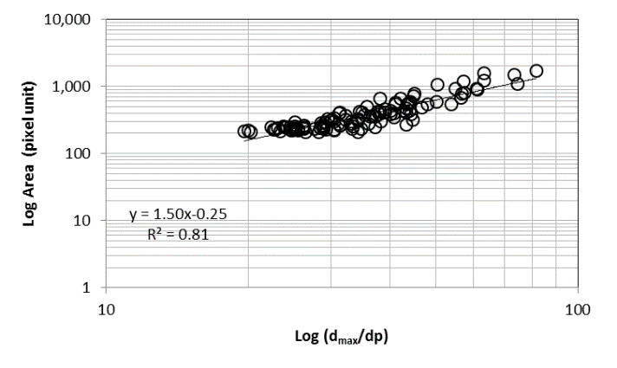

1. **b)**

Figure 4 - Fractal dimension obtained from image analysis based on the set of aggregates. (a) three-dimensional fractal dimension (*Dfp*) and (b) two-dimensional fractal dimension (*Dfp’*), calculated for the entire population of aggregates by the slope of *Log-Log* plot. Moruzzi et al. (2020).

The frequency distribution of the aggregates dimensionless size, i.e. *dmax*/*dp* ratio, can be observed in Figure 5. It can be seen that 86% of the measured aggregates were within the range of 30.0 ≤ *dmax*/*dp* ≤ 50.0 ± 2.2, that is, their longest lengths were between 30 and 50 times larger than the mean size of primary particles of kaolin (*d50* of 10 m). The distribution of the fractal dimension, *Df*, determined individually for the aggregates can be seen in Figure 6. Almost 70% of the measured *Df* were within in the interval of 2.60 – 2.70 ± 0.02, which deviates from the 2.35 fractal dimension calculated from the entire population of aggregates (Figure 4-a). However, there is no consensus on what approach yields the most accurate estimates of fractal dimension (Chakraborti et al., 2000). Later discussion on this paper will show how these two approaches relate to each other. Sphericity (*Ψ*) of ordinary Al-kaolin aggregates was determined individually, and found to be around 0.58 ± 0.02 for all 118 measured average aggregates, based on the encased ellipsoid (E), with average aspect ratios of about 2.7. Such results indicate irregular geometries, which cannot be adequately explained by regular plane geometry, and these findings agree with those presented by Vahedi and Gorczyca (2012).

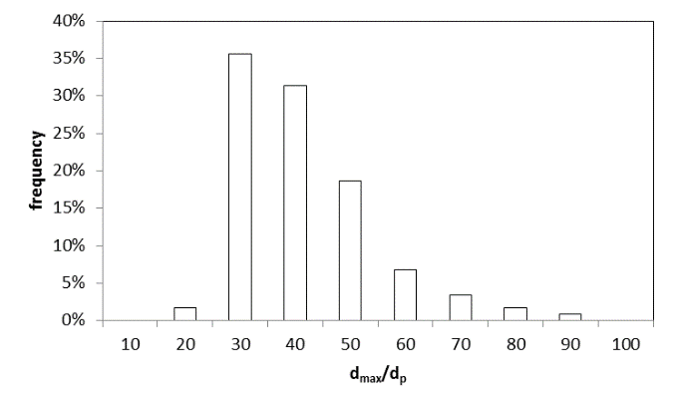

Figure 5 - Discrete distribution of dimensionless aggregate size, expressed by the ratio *dmax*/*dp*.

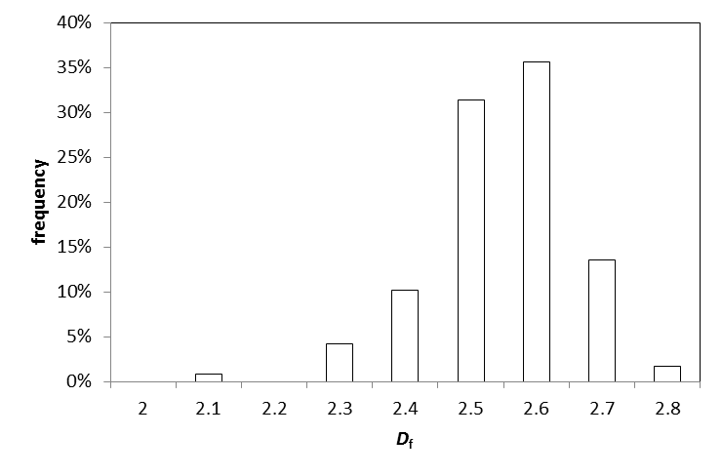

Figure 6 - Discrete distribution of the fractal dimension (*Df*) determined by aggregate individually.

In Figure 7, the three-dimensional fractal dimension is plotted against the longest length of fractal aggregate size. It is clear that shape is independent of aggregates size for the entire population of large aggregates (triangles in Figure 7), i.e. there is no dominant fractal dimension for large Al-kaolin aggregates. This is in agreement with the findings of Jiang and Logan (1991) who identified an overlap in fractal dimension for aggregates formed from Brownian motion and differential sedimentation, despite the different aggregates sizes in which those mechanisms are likely to be dominant. These results contradict the assumption of linear variation of fractal dimensions with floc size, for aggregates ranging from 1 to 250 m, presented by Vahedi and Gorczyca (2014). These authors also considered a non-linear behaviour for *Df* and floc size in a paper published in 2012 (Vahedi and Gorczyca, 2012), and reinforced that the variety of aggregation mechanisms, kinetics (aggregation and breakage) and the sort of primary particles are some of the possible reasons why flocs with the same size may exhibit many different structures and different fractal dimensions. However, a closer look at particular and smaller range of aggregates, ranging from 180 to 300 m (black circles in Figure 7), allows the identification of a linear relationship between *Df* and size, which is in accordance with the data presented by Vahedi and Gorczyca (2014). Furthermore, Vahedi and Gorczyca (2012) have also shown greater dispersion of *Df* for large flocs, with *Df* varying from 2.3 to 2.9 for floc size of 200 m, for example.

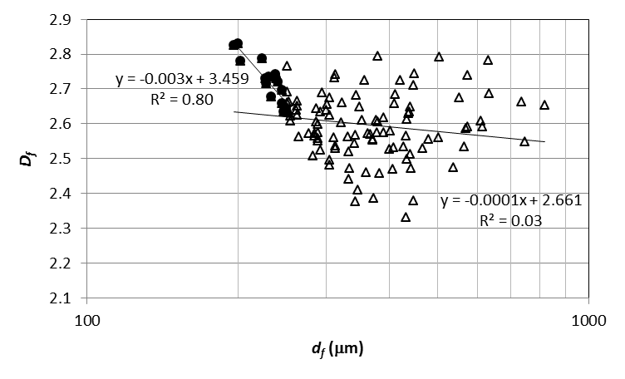

Figure 7 – Variation of the three-dimensional fractal dimension calculated individually with the longest length of fractal aggregate size. Triangles (Δ) refer to the entire population of large aggregates and black circles (•) refer to subset of longest length between 180 and 300 m.

Figure 8-a shows the values ​​of density (** determined from the fractal dimensions per aggregate (*Df*), using Equation 5. Individual aggregate densities vary from 1,020 to 1,140 kg·m-3, for *Df* within the range of 2.3 ≤ *Df* ≤ 2.7 and size range in the interval 20 ≤ *df*/*dp* ≤ 80.

The density of the aggregates, with an average of 1,068 ± 4 kg·m-3, seems to slightly vary with the *df*/*dp* ratio and also depends, to a lesser extent, on the fractal dimension (*Df*). As observed before for *Df­* values calculated individually, aggregate densities scatter in a wide range of *Df* and they seem to be slightly dependent on size for large aggregates, as several densities can be found for the same size, as also shown by Vahedi and Gorczyca (2012). The reason for this probably lies in the fact that the shape and compactness of the flocs have also influence on density. Thus, for Al-kaolin aggregates in the range of 180.0 to 816.0 ± 2.2 μm, there are a variety of shapes and densities, which are independent on their size only, when aggregates are considered individually. However, a linear behaviour can be observed, in the range of 180 to 300 m which is in accordance with previous analysis and suggests that large variation is expected for large aggregates size.

Another analysis for density and size relationship can be performed by rearranging Equation 5, so that results can be expressed in the form of Equation 10, presented by Gregory (1997) for the entire population of flocs. In this case, Equation 5 transforms to Equation 11, written in *Log-Log* format.

$ρ_{f}=B{d_{f}}^{-y}$, for *y* = 3- *Df* (10)

$Log\left(\frac{ρ_{f}-ρ_{l}}{ρ_{p}-ρ_{l}}\right)=Logb-yLog\left(\frac{d_{f}}{d_{p}}\right)$ (11)

Figure 8-b was plotted using Equation 11 applied to the same data used in Figure 8-a. It is clear that the entire population of aggregates behave as expected by Gregory (1997), and from the best fit line (in green) it is possible to determine that *y* of Equation 11 equals to 0.65, thus resulting in *Df* of 2.35, which is indeed the three-dimensional fractal dimension for the entire population of flocs, and agrees with the fractal dimension previously calculated using Equation 2 and shown in Figure 4-a.

**(a)**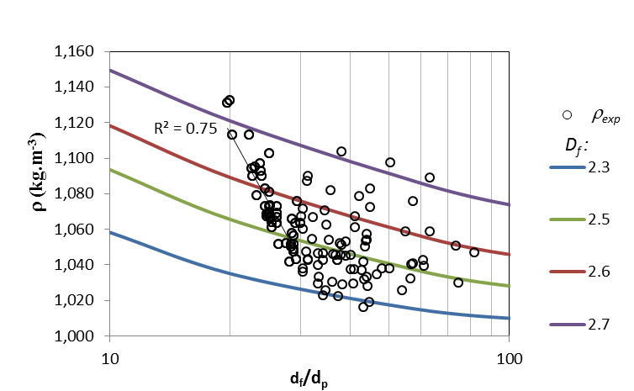

**(b)**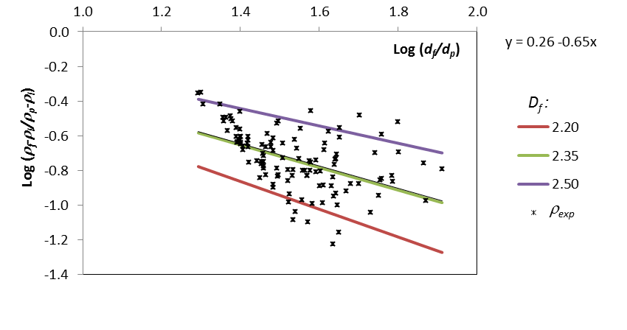

Figure 8 – (a) Changes of calculated density (), determined from fractal dimension of individual aggregates, with the *df*/*dp* ratio, using Equation 5. The coloured curves represent the calculated density for three-dimensional fractal dimensions (*Df*) of 2.3, 2.5, 2.6 and 2.7. (b) *Log-log* plot of density measurements against the *df*/*dp* ratio using Equation 11.

*3.2 Settling velocity*

Figure 9-a, presents the discrete distribution of aggregate velocities during sedimentation. In general, the measured velocities of the selected 118 slow-settling Al-kaolin aggregates ranged from 1.0x10-4 to 2.0x10-3 ± 3x10-5 m·s-1. It was verified that 75% of the aggregates had settling velocities in the range of 3x10-4 to 5x10-4 ± 3x10-5 m·s-1 and 10% of the aggregates settled at a velocity greater than 1x10-3 m·s-1, which is equivalent to the settling rate expected for a sphere of 170 m size and *f* of 1,300 kg·m-3, far lower than the average floc size of 360 m. However, 15% of the aggregates settled with velocity of less than 2x10-4 m·s-1. On average, the settling velocity for Al-kaolin aggregates was found to be 3.5x10-4 m·s-1 (i.e. 30 m· day-1), which is slower than common values adopted for hydraulic loading rate of conventional settling tanks (around 4.6x10-4 m·s-1, i.e. 40 m· day-1), explaining why those large aggregates can be dragged out of sedimentation tanks. Also, settling velocities here measured for Al-kaolin aggregates were considerably lower than those measured by Vahedi and Gorczyca (2012), probably due to the denser primary material (lime) used to form flocs; and much lower than those measured by Johnson et al. (1996), who have studied far lower flocs sizes.

The intrinsic characteristic of slow-settling Al-kaolin aggregates here investigated certainly influences the average values presented and contributes to the observed difference, once the focus was on slow settling of large aggregates. Furthermore, aggregates have far from the ideal impermeable spheres assumed for Stokes’ law simplification and this can also explain such behaviour, as previously mentioned.

It is clear from Figure 9-b that Re values calculated from experimental measurements are lower than those back-calculated from Stokes’ law for spheres using a drag coefficient (Cd) equal to 24/Re. The overestimation for Re of large latex spheres (< 160 m) was also observed by Chakraborti and Kaur (2014), who concluded that greater deviation may be expected as particle size increases, probably due to an increase in drag coefficient with relatively large-particle Re number compared to the value used in Stokes’ law. Here, those effects on drag coefficient are likely more significant, as fractal aggregates were calculated individually. Furthermore, fractal aggregates formed from kaolin primary particles arise from more complex mechanisms, such as hydrodynamic effects, than those formed from latex spheres, and so, the observed deviation for Re is even higher than those reported by Chakraborti and Kaur (2014).

As observed above for fractal dimension and density, Al-kaolin aggregates with similar size can have different settling velocities. This is also in agreement with results reported by Vahedi and Gorzzyka (2012), who observed several settling velocities for one aggregate size. Figure 9-b also shows that most Re values were less than 0.2, thus making the Stokes’ law modified by a shape factor applicable as presented by Wang (1988) and also used by Vahedi and Gorczyca (2012).

**(a)** 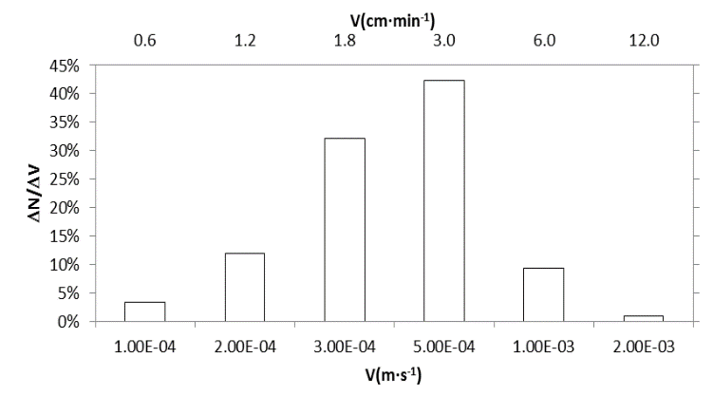

**(b)**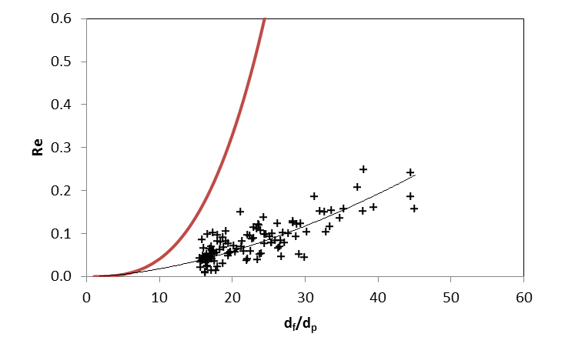

Figure 9 – (a) Discrete distribution for settling velocities of Al-kaolin aggregates with measured average size ranging from 150 to 450 ± 1.3 m and (b) calculated dimensionless Reynolds number (Re) from experiments and back-calculated Re values from Stokes’ Law (continuous red line) against dimensionless aggregate size (*df*/*dp*).

Figure 10 shows the experimental results, based on settling velocities (*V*) and normalised sizes (*df/dp*). Coloured continuous lines describe the relation *V* ≈ (*df/dp)2*, limited by the range of 5 ≤ */* ≤ 35 kg·m-3, as Equation 7. The best fit lines in black refer to the minimum least square relation between aggregate velocity and size for two subset of data: i) the entire set of data, drawn in continuous black line, where the slope is 0.73 (*V* ≈ (*df/dp)0.73* ); ii) the subset limited by the average size 100 ≤ *d* ≤ 200 m, dashed line, where the slope is 1.30 (*V* ≈ (*df/dp)1.30* ). It is clear that experimental velocities of Al-kaolin aggregates, for average size (*d*) within 150 to 450 ± 1.3 m, are predominant (95%) encased within the limits of the lines 5 ≤ */* ≤ 35 kg·m-3 (with slope of 2) using Equation 7, i.e. in the shape factor interval of 2 ≤ ** ≤ 14. A * *value equal to one would be expected for perfectly spherical-shape and impermeable aggregates, settling in accordance with Stokes’ law for Re < 1, i.e. at drag coefficient of 24/Re. This means that assumptions based on Stokes’ law do not represent Al-kaolin large aggregates and settling velocities were over-predicted from 2 to 14 fold. Using the raw data published by Tambo and Watanabe (1979) for primary particles of clay-aluminium of 3.5 m size, Bushell et al. (2002) found a drag and structure factor coefficient of 5.42, which derives from actual velocities lower than the Stokes’ law prediction. Therefore, aggregates took on non-spherical shapes resulting in increased drag force and, consequently, slow settling rates compared to spherical particles, as pointed by Bushell et al. (2002).

According to the Stokes’ law, terminal velocity of settling aggregates is proportional to size squared, as given by Equation 7. Results of the analysis here have shown that density and fractal dimension can be related in a wide range of size, and therefore, multiple settling velocities were observed for a given floc size. For the entire population of the aggregates, the experimental velocity was found to vary with size to the power of 0.73 (black line in Figure 10), which agrees with results presented by Tambo and Watanabe (1979), who found values between 0.5 and 1.0. However, for the average size range of 100 – 200 m, the exponent for size is found to be 1.30 (dashed black line in Figure 10), in accordance to the exponent given by *Df – 1*, presented by Vahedi and Gorczyca (2012).

Therefore, it is important to note that the shape factor, here used to encase experimental values in the border limit of Stokes law’s theoretical settling velocities, comprises a wide range of simplifications over porosity, permeability, size and shape. In general, results have shown that fractal aggregates settled slowly for Stokes’ law to apply, and large aggregates may behave differently for the same size.

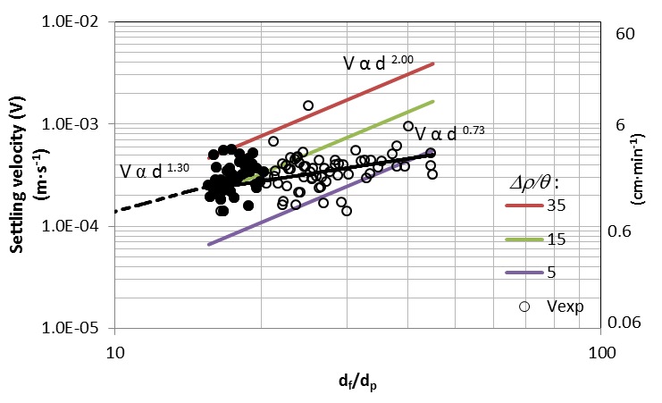

Figure 10 - Settling velocities for Al-kaolin fractal aggregates against dimensionless size (*df*/*dp*). Coloured lines represent the limits of */* with *V* ≈ (*df/dp)2*from Equation 7. Continuous black line represents the best fit for all measured data, and dashed line is the best fit for a subset of aggregates size.

Figure 11 shows the relationship between Reynolds number (Re) and drag coefficient (Cd), determined from experimental results as described by Equations 6 and 8, respectively. The inversely proportional relation between Cd and Re was confirmed, and a proportionality constant of 56 was determined from the line fitted, Tambo and Watanabe (1979) calculated the proportionality constant of 45 for *Ψ* of 0.80, confirming that deviation from sphericity leads to a higher drag coefficient, despite the fact that both shape and orientation of aggregates in flow affect results, as pointed by Bushell et al. (2002).

Results in Figure 11 also confirmed that for Al-kaolin aggregates, the impact of aggregation of non-sphere primary particles of 10 m median on the hydrodynamics resulted in the increase of drag forces, when compared with perfect spheres of same density settling according to Stokes’ law. The results, discussed in previous paragraphs, indicated that Al-kaolin aggregates are asymmetrical, as the three-dimension fractal dimension presented in Figure 7 were found to be independent of size, or sphericity (*Ψ*) and far from spherical shape (*Ψ* = 0.58) with aspect ratio of about 2.7. Therefore, these aggregates may spin or wobble as they settle, as also mentioned by Bushell et al. (2002).

In general, results presented here suggest that settling velocity of Al-kaolin large fractal aggregates is influenced by shape, density, porosity as well as size and that these features may change the equilibrium configuration between the forces acting on the particle during its sedimentation, namely: gravity and drag forces.

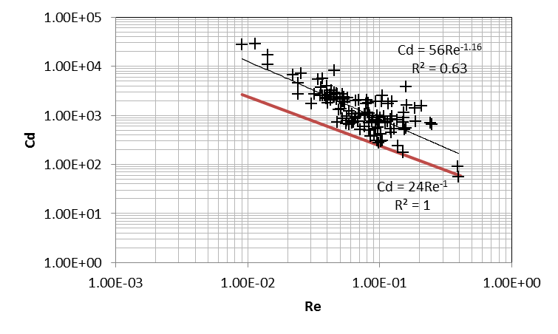

Figure 11 – Drag coefficient determined from experimental results. Black line is the best fit to experimental data whilst red line was determined using drag coefficient (Cd) of 24/Re for Re < 1.

**Conclusions**

In this paper, large slow-settling Al-kaolin fractal aggregate’s features and Re number were determined using a non-intrusive image technique, and so, they differ from values reported in other studies on obtaining aggregates characteristics from sedimentation. This approach avoids the assumption of an explicit relationship between drag coefficient and aggregate size.

It was found that Al-kaolin large aggregates may exhibit different settling velocities for the same size and the velocities based on Stokes’ law do not represent well large aggregates, where settling velocities were over-predicted from 2 to 14 fold.

The impact of aggregation of non-sphere kaolin primary particles of 10 m median on Al-kaolin aggregate hydrodynamics results in the increase of the drag force, when compared with perfect spheres of same density, settling in accordance with Stokes’ law. The inversely proportional relation between Cd and Re was confirmed, and a proportionality constant of 56 (Cd = 56/Re) was determined graphically, compared to the Stokes’ relation of 24/Re.

Therefore, it was found that Al-kaolin large, heterodisperse and multi-shape aggregates can settle sufficiently slowly for Stokes-type expressions to apply. Despite the previously relation between size and velocity proposed by some authors have been confirmed, the asymmetrical shape and the size-density relatively independence here verified for large aggregates may play an important role on Al-kaolin large aggregates with slower settling velocities. Evidently, more research is needed in order to better understand the complex mechanisms behind the settling rates of large fractal aggregates, such as those referring to the effect of permeability on drag force.

**Acknowledgements**

Rodrigo B. Moruzzi is grateful to São Paulo Research Foundation (Fundação de Amparo à Pesquisa do Estado de São Paulo—FAPESP) Grant 2017/19195-7, to CNPq for fellowship Grant 301210/2018-7 for financial support and to University College London for the academic visitor contract.

**References**

Aparício, P., Pérez-Bernal, J. L., Galán, E., Bello, A., 2004. kaolin fractal dimension. Comparison with other properties. Clay Minerals. v. 39, p. 75-84.

Bushell, G. C., Yan, Y. D., Woodfield, D., Raper, J. U. D. Y., Amal, R. O. S. E., 2002. On techniques for the measurement of the mass fractal dimension of aggregates. Advances in Colloid and Interface Science, 95(1), 1-50.

Chakraborti R.K., Kaur J., 2014. Noninvasive Measurement of Particle-Settling Velocity and Comparison with Stokes’ Law. Journal of Environmental Engineering. 5;140(2):04013008.

Chakraborti, R.K., Atkinson, J.F., Van Benschoten, J.E., 2000. Characterization of alum floc by image analysis, Environmental Science and Technology 34, 3969–3976.

Chakraborti, R.K., Gardner, K.H., Atkinson, J.F., Van Benschoten., J.E., 2003. Changes in fractal dimension during aggregation. Water Res, 37, 873–883.

Gregory, J., 1997. The density of particle aggregates. Water Science and Technology, v. 36, n. 4, p. 1-13.

Jarvis, P., Jefferson, B., Gregory, J., Parsons, S.A., 2005. A review of floc strength and breakage. Water Res., 39, 3121–3137.

Jiang Q, Logan B.E., 1991. Fractal dimensions of aggregates determined from steady-state size distributions. Environmental Science & Technology, 25(12):2031-8.

Johnson, C.P., Li, X., Logan, B.E., 1996. Settling velocities of fractal aggregates. Environ. Sci. Technol., 30, 1911-1918.

Johnson, M., Peakall, J., Fairweather, M., Biggs, S., Harbottle, D., & Hunter, T. N., 2016. Characterization of multiple hindered settling regimes in aggregated mineral suspensions. Industrial & Engineering Chemistry Research, 55(37), 9983-9993. ISSN 0888-5885.

Li, T., Zhu, Z., Wang, D., Yao, C., Tang, H., 2006. Characterization of f loc size, strength and structure under various coagulation mechanisms. Power Technology, 168, 104-110.

Moruzzi, R. B., da Silva, P. G., Sharifi, S., Campos, L. C., & Gregory, J., 2019. Strength assessment of Al-Humic and Al-kaolin aggregates by intrusive and non-intrusive methods. Separation and Purification Technology, 217, 265-273.

Moruzzi, R. B., de Oliveira, A. L., da Conceição, F. T., Gregory, J., & Campos, L. C., 2017. Fractal dimension of large aggregates under different flocculation conditions. Science of the Total Environment, 609, 807-814.

Moruzzi, R.B., Bridgeman, J. and Silva, P.A.G., 2020. A combined experimental and numerical approach to the assessment of floc settling velocity using fractal geometry. Water Science and Technology.

Moruzzi, R.B., Silva, P. A. G., 2018 Reversibility of Al-kaolin and Al-Humic aggregates monitored by stable diameter and size distribution. Brazilian Journal of Chemical Engineering, v. 35, n. 3, p. 1029-1038.

Oliveira, A.L.de, Moreno, P., Silva, P.A.G. da, Julio, M.D., Moruzzi, R.B., 2015. Effects of the fractal structure and size distribution of flocs on the removal of particulate matter. Desalination and Water Treatment. DOI:10.1080/19443994.2015.1081833. Taylor & Francis, 1-12.

Tambo, N., Watanabe, Y., 1979. Physical characteristics of flocs—I. The floc density function and aluminium floc. Water Research, v. 13, n. 5, p. 409-419.

Vahedi, A., Gorczyca, B., 2012. Predicting the settling velocity of flocs formed in water treatment using multiple fractal dimensions, Water Res. 46, 4188 – 4194.

Vahedi, A., Gorczyca, B., 2014. Settling velocities of multifractal flocs formed in chemical coagulation process. Water Research, v. 53, p. 322-328.

Wang, R. F. T., Brooks, N. H., Koh, R. C., 1988. Laboratory analysis of settling velocities of wastewater particles in seawater using holography. Environmental Quality.

Yu, W., Gregory, J., Campos, L. C., & Graham, N., 2015. Dependence of floc properties on coagulant type, dosing mode and nature of particles. Water Research, 68, 119-126.

Yukselen, M.A., Gregory, J., 2004. The reversibility of floc breakage, Int. J. Mineral Process. 73, 251–259.

Zbik, M.; Smart, St.C. R., 1998. Nanomorphology of kaolinites: comparative SEM and AFM studies. Clays and Clay Minerals. v. 46. n.2, p. 153-160.