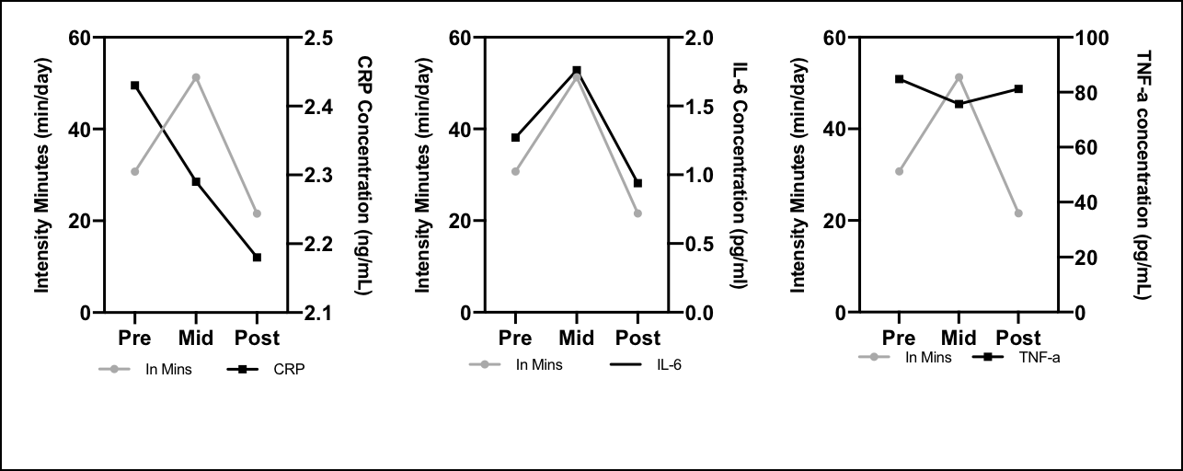

**Figure 3.** Garmin device measured ‘intensity minutes’, alongside markers of chronic inflammation CRP, IL-6 and TNF- α.