Use of Emergency Ambulance Services for Heart Attack and Stroke over the COVID-19 Lockdown
Jenny Lumley Holmes, Simon Brake, Mark Docherty, Richard Lilford*, Sam Watson

Jennifer Lumley-Holmes, Clinical Audit Manager, West Midlands Ambulance Service, jenny.lumleyholmes@wmas.nhs.uk
Simon Brake, Chief Innovation & Engagement Officer, University of Warwick, s.brake@warwick.ac.uk
Mark Docherty, Executive Director of Nursing and Clinical Commissioning, West Midlands Ambulance Service, mark.docherty@wmas.nhs.uk
Richard Lilford (0000-0002-0634-984X), Professor of Clinical Health, University of Birmingham, r.j.lilford@bham.ac.uk
Samuel Watson, Associate Professor, University of Warwick, s.watson.1@warwick.ac.uk

* Corresponding Author: Richard Lilford, Murray Learning Centre, University of Birmingham, Edgbaston B15 2TT, United Kingdom r.j.lilford@bham.ac.uk @rjlilford

The authors declare no conflicts of interest.

It is widely reported that attendance at Accident and Emergency (A&E) departments in the UK has declined precipitously since ‘lockdown’ on the 23 March 2020. Anecdotal reports have suggested that heart attacks and strokes have ‘vanished from hospitals’ (Washington Post, 20 April 2020), and that such patients ‘delay seeking help’ (Guardian, 16 April 2020). ST-segment elevation myocardial infarction (STEMI) and stroke are conditions where hospital treatment is highly effective. We therefore tracked ambulance callouts for these conditions spanning the emergence of the COVID-19 pandemic.
We analysed daily figures for these two conditions, which are routinely recorded by ambulance crews, for the West Midlands Ambulance Service University NHS Foundation Trust, the second largest such service in the UK.
Callouts for these two conditions are shown in Figure 1 by week, covering October 1st 2018 to April 18th 2020. We tested for the presence of a structural break in the time series of annually differenced weekly admissions (using a linear model with AR (1) errors). There was little evidence for such a break in either the STEMI (year-on-year change in mean callouts associated with lockdown: -9.1, 95%CI: [-21.8, 3.6], p=0.17) or stroke (-21.7 [-47.6, 4.2], p=0.11).
Figure 1. Time Series of Weekly Callouts for STEMI and Stroke
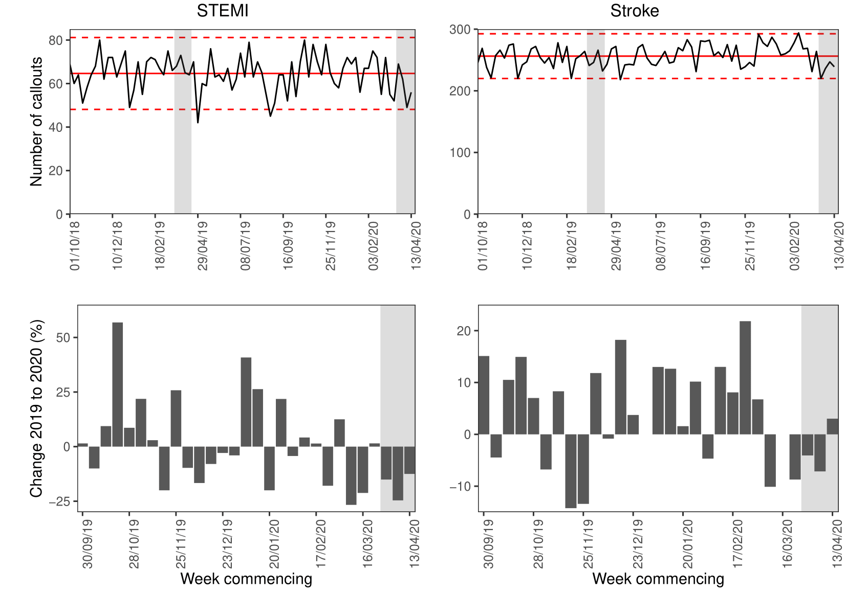
Top panel: Number of weekly callouts for STEMI (left) and stroke (right) with mean (solid red) and two standard deviation (dashed red) lines marked.
Bottom panel: Proportionate year-on-year change in weekly callouts for STEMI (left) and stroke (right).
Shaded grey areas indicate weeks of the year 13 to 16 corresponding to lockdown period in the United Kingdom in 2020 up to 19/04/2020.

These data do not confirm a drop in ambulance callouts for our two tracer conditions. Although we cannot exclude such an effect, we can say that any effect must be of small magnitude. The COVID-19 pandemic may be associated with negative collateral health effects, but we find no evidence that people are reluctant to call an ambulance when they experience symptoms of stroke or heart attack.

Acknowledgements:
We would like to thank Fergus Hamilton (North Bristol NHS Trust), Peter Chilton (University of Birmingham) and Gavin Perkins (University of Warwick) for their contributions to this article.
RL is supported by the National Institute for Health Research (NIHR), Applied Research Collaboration West Midlands (ARC WM). Views expressed are not necessarily those of the NHS, the NIHR or the Department of Health and Social Care

