Submission to: Ecological Research (Special Issue)
Article Type: ORIGINAL ARTICLE
The effect of species extinctions on island biogeographic patterns
Thomas J. Matthews^{1, 2}, Ludwig K. T. Leidinger³, Juliano Sarmento Cabral³
¹GEES (School of Geography, Earth and Environmental Sciences) and the Birmingham Institute of Forest Research, The University of Birmingham, Birmingham, B15 2TT
²CE3C – Centre for Ecology, Evolution and Environmental Changes/Azorean Biodiversity Group and Univ. dos Açores – Depto de Ciências e Engenharia do Ambiente, PT-9700-042, Angra do Heroísmo, Açores, Portugal.
³Ecosystem Modeling, Center for Computational and Theoretical Biology, University of Würzburg, 97074 Würzburg, Germany
*Correspondence: Thomas J. Matthews, School of Geography, Earth and Environmental Sciences, University of Birmingham, Birmingham, B15 2TT, UK
Email: txm676@gmail.com
Running header: Extinctions and island biogeography
Word count: abstract = 224 words; main text = 3504 words; 1 Table; 2 Figures; 51 references
Keywords
Island biogeography, extinction, species–area relationship, beta-diversity, functional diversity, simulation

Abstract
The study of island systems has provided the basis of much of what we understand about a number of biogeographic patterns. However, islands have also suffered numerous extinctions as a result of human activities. The extent to which these extinctions have influenced the many different patterns we study as island biogeographers, and thus what we consider to be ‘natural’, is largely unknown. Here, we use a simulation approach to illustrate the impacts of anthropogenic extinctions on various macroecological and biogeographical patterns on islands. We simulated an archipelago consisting of five islands and filled these islands with a realistic set of species, each possessing four functional traits. Using this dataset, we then calculated a number of biogeographic patterns, including the slope of the island species–area relationship, functional richness and beta-diversity (taxonomic and functional). The next stage of the simulation modelled the colonization of the archipelago by humans, represented by a 50% reduction in the carrying capacity of the archipelago and by an associated wave of species extinctions. When the extinction simulation process was finished, the various metrics were re-calculated. The results illustrate that all the analyzed patterns are affected to some degree by the human-induced loss of species. Overall, our results highlight how the extinction of species as a consequence of human actions on islands can influence our interpretation of ‘natural’ island biogeography patterns.

Introduction
It is well known that island taxa are highly threatened by human actions, and more than 60% of known terrestrial extinctions since 1500CE have been island endemic species (Heinen, van Loon, Hansen, & Kissling, 2017; Hume, 2017; Kreft, Jetz, Mutke, & Barthlott, 2008; Steadman, 1996, 2006; Whittaker & Fernández-Palacios, 2007; Whittaker, Fernández-Palacios, Matthews, Borregaard, & Triantis, 2017). The study of island systems has provided the basis of much of what we understand about a number of biogeographic patterns, such as island species–area relationships (ISARs), nestedness and beta-diversity, and assembly rules (Darlington, 1957; Diamond, 1975; MacArthur & Wilson, 1967; Triantis, Guilhaumon, & Whittaker, 2012; Warren et al., 2015; Whittaker & Fernández-Palacios, 2007). However, it is difficult to conceive that the recent extinction of huge numbers of species (e.g. up to 2000 bird species on Pacific islands following human colonisation; Steadman, 1996, 2006) has not substantially altered the form of these patterns. For example, Steadman (2006, p.479) argues that the slopes of the ISAR (z) of birds on archipelagos in Oceania were likely very low (e.g. 0 – 0.1) before the arrival of humans, and are now considerably higher due to subsequent extinctions and the fact that some species are more likely to have survived human impacts on the larger, more mountainous islands. Thus, is it possible that a considerable amount of island biogeography theory has been built on the analysis of incomplete datasets and erroneous inference?
This possibility has been recognized by some (e.g. Steadman, 2006; Whittaker & Fernández-Palacios, 2007; Sobral et al. 2016; see Helmus, Mahler, & Losos, 2014, for a similar argument based on alien species), and the extent to which “anthropogenic extinctions affect estimates of speciation and natural extinction on island systems” is considered one of the fifty most fundamental current questions in island biogeography (Patiño et al., 2017, p. 969). However, generally speaking examination of this possibility has been limited, due in part to the lack of appropriate data (but see Steadman, 2006; Sobral et al. 2016). That is, it is difficult (potentially impossible), even on archipelagos with detailed palaeoecological surveys, to be sure that all recently extinct species of a given taxon (e.g. birds) have been discovered in the fossil record.
Here, to circumvent empirical data limitations we use a simulation approach to illustrate and explore the impacts of anthropogenic extinctions on various macroecological and biogeographical patterns on islands. Our simulation model can be used to generate post-hoc hypotheses that can be tested in future studies using simulations and / or empirical data.

Materials and Methods
Archipelago simulation and the species-filling process
First, a mainland pool of 300 bird species (the choice of taxon is arbitrary; the term birds is used simply because the modelled traits make most sense in the context of birds) was simulated. Each species in the pool had four independent traits: body size, dispersal ability, beak shape, and physiological tolerance. Body size values were drawn from a gamma distribution with shape and scale parameters set to 1 (i.e. a larger proportion of relatively smaller bodied species; Blackburn & Gaston, 1994). Dispersal ability values were drawn from a beta distribution with the shape parameters set to 0.9 and 1.4 (producing a slightly higher frequency of poor dispersers relative to good dispersers; Paradis, Baillie, Sutherland, & Gregory, 1998; Sutherland, Harestad, Price, & Lertzman, 2000), and beak shape values were drawn from a uniform distribution with minimum and maximum values of 1 and 8, respectively. This range of beak shape values is arbitrary but can be imagined as a spectrum from long thin type bills to short wide type bills. Physiological tolerance values were drawn from a uniform distribution with minimum and maximum values of 0.001 and 1, respectively, and higher values represented wider physiological tolerances (i.e. more generalist species). Varying the parameters of these four distributions within reasonable bounds did not change the overall results (not shown).
Second, an archipelago consisting of five islands was simulated. Each of the five islands was given an area (10, 20, 40, 80 and 100 area units), which determined its respective species carrying capacity (k). In this simulation, a very simple definition of species carrying capacity is used, whereby k is the equilibrium number of species on an island. k was calculated using the power ISAR model with the five island area values, and the c and z parameters set to 20 and 0.25 (both being values observed in empirical island systems; see Matthews, Guilhaumon, Triantis, Borregaard, & Whittaker, 2016), respectively. This approach generated k values of 36, 43, 51, 60 and 64 in order of increasing island area.
The archipelagic biota was assembled in four distinct phases. First, each island received a random subset of the mainland species pool, with the probability of colonization determined by species dispersal ability. The number of species per island was determined by an island’s respective k. Second, island species speciated cladogenetically with a probability determined by species physiological tolerance. This probability was calculated by multiplying a species’ physiological tolerance value (between 0.001 and 1) by 0.1. This approach thus assumes that generalist species have a greater chance of cladogenetic speciation, and is based on the idea that generalist species can colonize, and survive in, multiple habitats on an island and thus are more likely to undergo local adaptation and/or have their populations split by vicariance (e.g. families with broader climatic niches have been shown to have higher diversification rates; Gómez-Rodríguez, Baselga, & Wiens, 2015). A successful speciation event resulted in an additional sister species to a given original species. For characterization of the sister species, trait values were drawn from normal distributions with the values of the original species as means and standard deviations 0.8 for size and beak traits, and 0.1 for dispersal and tolerance. The original species that remained on the island represented the mainland form (without trait evolution).
Third, each species, including the novel radiations, on each island was given opportunity to disperse to another island. The species-specific dispersal trait directly determined the probability to disperse. In the event of dispersal, the destination island was drawn randomly from the list of islands, including the original island. Thus, spatial arrangement of the islands within the archipelago was not explicitly accounted for (but see Cabral, Weigelt, Kissling, & Kreft, 2014, for the effects of spatial arrangement on biodiversity components). For this intra-archipelagic dispersal phase, we did not consider the mainland species pool, since we assumed it sufficiently isolated from the archipelago. Additionally, a major proportion of mainland species was already represented within the archipelago. Fourth, species on islands competed for space. If the number of species on an island exceeded k, species were removed from the island until the number was within limits. The decision of which species to remove was based on the functional similarity between species on a given island (Darwin’s naturalization hypothesis). For this, Euclidean distances between all species were calculated using three functional traits (body size, dispersal probability, beak shape). Physiological tolerance was not included here because we wanted to keep one functional trait unrelated to competitive exclusion. The sorted pairwise distances were then used to identify the two species on the island most similar to each other. Of this pair, one species was selected randomly and removed from the island. This process repeated until species numbers reached k. To simplify the biota assembly process, it is assumed there is no natural extinction on the archipelago. That is, the simulation is simply a species filling process, with the aim of providing each island with a set of species with realistic distributions of the four traits.
Species extinctions following human colonization
The next stage of the simulation models the effects of archipelago colonization by humans (referred to below as ‘post-human colonization’), resulting in a wave of human-induced species extinctions. Following human colonization, the carrying capacity of the archipelago was reduced by 50%. It should be noted that this reduction in carrying capacity is not due to a 50% reduction in area (as k was originally generated using the ISAR); rather, it is simply an easy way of ensuring that half of the archipelago’s species went extinct following human colonization (a value that is empirically realistic with respect to certain oceanic archipelagos; e.g. Steadman, 2006). The exact cause of extinction is not modelled and could be due to a range of causes, such as habitat loss, introduction of invasive species and/or hunting (Whittaker & Fernández-Palacios, 2007). The analyses were repeated using extinction percentages of 30% and 70% to test the effect of extinction severity on the results. The extinction process was simulated using four approaches. First (Extinction1), the ith island is selected and a species remaining on the island is chosen, with the probability of being chosen weighted by body size; it being assumed that larger-bodied species have a greater risk of being driven extinct by humans (Duncan & Blackburn, 2007; Petchey & Gaston, 2002a; Whittaker & Fernández-Palacios, 2007). This species is then lost from the ith island. If the species is a single island endemic (SIE; i.e. it is only present on the ith island) then the extinction is a global extinction and the species is removed from the archipelago’s species list; if it is not a SIE, it is simply removed from the ith island’s species list. Again, to simplify the simulation process no further inter-island dispersal or dispersal from the mainland, and thus no rescue effect or re-colonization is assumed to take place. This is not entirely unrealistic given that the impacts of humans occur at such fast rates that rescue effects are likely to have minimal effects on extinction risk (Steadman, 2006). The simulation algorithm then moves on to the next island and so on, until the number of species in the archipelago has been reduced by 50%. If the number of species on an island is reduced to 1, the island cannot lose any more species (i.e. the richness remains at 1); this is to ensure that most of the various metrics can be calculated. As the above extinction process results in each island losing roughly the same number of species, it means that the smaller species-poor islands lose a larger proportion of species. This is expected as smaller islands are predicted to support smaller populations of species (MacArthur & Wilson, 1967), and thus any human impact is more likely to result in extinction. For example, the impact of human hunting on a species is more likely to result in extinction if that species’ population was small to begin with. In addition, larger islands likely have more refugia where species can hide from human activities (Steadman, 2006).
Second (Extinction2), the extinction process follows that outlined for Extinction1 but there is an additional step undertaken when the ith island is selected. After being chosen, a random value (1 or 0) was drawn from a binomial distribution, with the probability of success (1; here, extinction) being inversely weighted by island area. If a 0 was drawn, the process skipped to the next island, and so on. Thus, Extinction2 is similar to Extinction1 but there is an even greater effect of island area on extinction.
Third (Extinction3), instead of iterating across islands until the 50% threshold is met, here we randomly select a species from the archipelago pool, with the probability of being selected being determined by body size. A random island on which this species occurred is then selected, and this population made to go extinct. This process is then repeated until the 50% target has been reached. Extinction3 characterizes a situation whereby a (mostly large-bodied) species was discovered on island and driven (i.e. hunted) to extinction, and then later was discovered on another island and driven extinct there. Thus, it assumes human impacts (i.e. hunting) are not dependent on island area or loss of resources (which can affect other species independently of body size). Fourth (Extinction4), we re-run Extinction3 but the island selection is inversely weighted by island area (i.e. if a species occurs on multiple islands, the population on the smallest of these islands has the greatest probability of being chosen for extinction).
The simulations and subsequent analyses were undertaken four times, once for each of Extinction1, Extinction2, Extinction3 and Extinction4.
Island biogeography patterns
After the two main stages of the simulation had been run (i.e. the island filling process and the human-driven species extinctions), a set of island biogeographic metrics were calculated. First, a distance matrix and functional dendrogram were constructed for each individual island and for the whole archipelago. For each island (or for the archipelago), three traits (i.e. beak shape, dispersal ability and physiological tolerance) of the species on the island were standardized to have a mean of 0 and a standard deviation of 1. The species-by-standardized trait matrix for a given dataset was then converted into a distance matrix using Euclidean distance, and the distance matrix was subject to a cluster analysis (UPGMA method) to create a dendrogram (Petchey & Gaston, 2002b). Dendrograms were plotted using the ‘phytools’ R package (Revell, 2012). As stated above, for the main analyses only three traits (beak shape, dispersal ability and physiological tolerance) were used to generate the distance matrices and dendrograms. This was because body size was directly used in the four extinction processes (i.e. species extinction was weighted by body size). However, we re-ran the analyses after including body size in the construction of the distance matrices and dendrograms as a sensitivity test.
Using the simulated species lists for each island and the functional distance matrices and dendrograms, four metrics were calculated: i) the functional richness of each island and the archipelago (the multidimensional volume of trait space defined by using a convex hull volume; Villéger, Mason, & Mouillot, 2008), calculated using the FD R package (Laliberté, Legendre, & Shipley, 2014); ii) taxonomic and functional beta-diversity (multi-site, Jaccard index), calculated using the BAT R package (Cardoso, Rigal, & Carvalho, 2014); iii) the z value of the non-linear power ISAR model (using the function S= cA^{z}; where S = island richness, A= island area, and c and z = free parameters) calculated using the five islands and the sars R package (Matthews, Triantis, Whittaker, & Guilhaumon, 2019); and iv) Stone & Roberts' (1990) C-score (i.e. checker board score) calculated using the EcoSimR R package (Gotelli, Hart, & Ellison, 2015). As used here, the C-score is the matrix-wide average of Stone & Roberts’ (1990) C-score metric. The C-score provides a measure of the randomness of the distributions of two or more species; the larger the C-score the more segregated the species are (Stone & Roberts, 1990). The standardized effect size of the C-score was calculated using the Curveball null algorithm (1000 null matrices; Gotelli et al., 2015). Taxonomic and functional beta-diversity were also partitioned into replacement and richness difference components (Cardoso, Rigal, Carvalho, Fortelius, et al., 2014).
The above process was ran using the pre- and post-human colonization datasets, and in each case the simulation was repeated 50 times and mean metric values calculated. Welch two sample t-tests were used to determine whether the post-human colonization metric values significantly differed from the pre-colonization values. Due to the use of multiple tests, a Bonferroni correction was applied to the P-values from the t-tests (0.05 / 6 = 0.008). This procedure was then repeated four times, once each using datasets generated using the Extinction1, Extinction2, Extinction3 and Extinction4 processes.
The simulation and analyses were undertaken using R (Version 3.5.3; R Core Team, 2019). The full R code to run the simulation and the various analyses is provided in a GitHub repository (txm676/ Extinction_simulation).
Results
A functional dendrogram for the largest island is provided as Figure 1. The species that were driven extinct (using Extinction1) on the largest island following human colonization are marked (see Fig. 1).
When Extinction1 was applied, it was evident that the extinction of species resulted in changes to the various measured community properties. The mean values (of 50 replications) of the four sets of metrics for the pre- and post-human colonization datasets are provided in Table 1. In the post-human colonization datasets, mean functional richness was slightly lower at the archipelago level, but more so on the individual islands, particularly the smaller islands (Table 1). The mean slope of the SAR was found to increase quite considerably as a result of the extinctions (from 0.25 to 0.72). Mean taxonomic and functional multi-site beta-diversity both increased a statistically significant amount following the extinction process, and for both metrics, the relative contribution of the replacement and richness difference components of overall beta-diversity switched following the extinctions (Table 1). Prior to human colonization the replacement component represented the larger proportion of overall beta-diversity, while the largest proportion after human colonization was the richness difference component. The C-score was lower in the post-colonization archipelago, indicating a greater tendency towards species aggregation.
The results using Extinction2 were very similar to those generated using Extinction1 (Table S1 in Supporting Information S1). In contrast, when Extinction3 was used there was less change in certain metrics between the pre- and post-human colonization datasets (Table S2 in Supporting Information S1). Functional richness still declined, but to a smaller extent, and taxonomic and functional beta-diversity (and the partition values) values were similar (although still significantly different). The slope of the ISAR and the average C-Score values did not significantly differ. The results using Extinction4 were similar to those generated using Extinction3 despite this approach linking extinction probability to island area; the slope of the ISAR was not that much higher between the pre- and post-human colonization datasets, although here the difference was significant (Table S3 in Supporting Information S1).
When the analyses were re-run using extinction percentages of 30% and 70% (and Extinction1) the results were similar, although the effects were more pronounced for the 70% case, and less pronounced for the 30% case; the t-test P-values remained significant and the t-values had the same signs (i.e. positive or negative), in both cases (Tables S4 and S5 in Supporting Information S1). When body size was included as a trait for calculating the functional metrics (e.g. functional richness), there was, as expected, a larger drop in functional richness (both at the archipelago and island level). The other results were similar to those described above (Table S6 in Supporting Information S1).
Discussion
Overall, the results of this simulation highlight how the extinction of species as a result of human actions on islands can influence our interpretation of ‘natural’ island biogeography patterns. An overview of the general findings of the simulations is provided as Figure 2.
The loss of functional richness, at both the island and archipelago level, is worrying and provides a warning of the potential impacts of the on-going extinction crisis on island ecosystem functioning. This is concerning, given that islands provide ecosystem services for an estimated 500 million people globally (Weigelt, Jetz, & Kreft, 2013). In our main analyses, we excluded body size from the calculation of functional richness as it was the main trait used in the simulated extinction processes (i.e. we assumed larger bodied species were more at risk from human-driven extinction). Thus, it would not have been surprising to observe large decreases in functional richness following extinctions. However, even without body size we still observed decreases in functional richness, particularly on the smaller islands (Table 1). The latter observation is due to the fact that the proportion of extinctions on smaller islands was simulated to be higher than on the larger islands (when implementing Extinction1 and Extinction2), also resulting in a steeper ISAR (see also Steadman, 2006). This is expected based on theoretical arguments and empirical findings in the literature. First, populations are expected to be smaller on small islands (MacArthur & Wilson, 1967). This will increase natural extinction rates, but will also result in elevated human-driven extinctions. Second, smaller islands will have fewer refugia for species to escape from human activities (e.g. steep mountain sides; Steadman, 2006).
When human impacts were modelled without any dependence on area (i.e. Extinction3), the slope of the ISAR, as expected, did not significantly change; there was also little change in the other metrics. Interestingly, even when accounting for island area in this extinction process (Extinction4) there was little change in the metrics; the ISAR slope of the post-human colonisation dataset was significantly larger than the pre-human colonisation dataset slope, but the magnitude of difference was much smaller than in the case of Extinction1 and Extinction2. These results imply that, to observe the large increase in ISAR slope predicted by theory, it is necessary, when modelling extinction, to include impacts above simply the direct effects of hunting, and to more directly model the dependency of human-driven extinction on island area. It is worth noting here that, when calculating probabilities based on the inverse of island area (used in Extinction2 and Extinction4), we simply used the formula: 1 – (A / sum(A)), where A is a vector of island areas. This approach may not result in big enough probability differences between islands (i.e. it represents a conservative decrease in extinction with area), and future studies of this nature should test alternative approaches for deriving probabilities from island areas.
While we excluded body size from our functional richness calculations to account for our simulation process, in the real world, larger-bodied species are known to be more at risk of human-driven extinction on islands (see Duncan & Blackburn, 2007; Petchey & Gaston, 2002a; Whittaker & Fernández-Palacios, 2007). Thus, it is likely that on real islands the loss of functional richness will be greater than that found here in our main analyses (see also Table S5).
The loss of large-bodied species on islands is particularly worrying given that larger species (within a given taxonomic group) tend to be on a higher trophic level and their loss is more likely to trigger trophic cascades (Brook, Sodhi, & Bradshaw, 2008; Brose, Williams, & Martinez, 2006). As such, these results highlight the need for a greater focus on increasing our understanding of the long-term consequences of human impacts on island ecosystem functioning. In addition, they provide support for an expanded research agenda within the emerging field of functional (island) biogeography (Violle, Reich, Pacala, Enquist, & Kattge, 2014; Whittaker et al., 2014).
The observed increase in beta-diversity (both taxonomic and functional) makes sense as the smaller islands lose a larger proportion of species during the extinction process (in Extinction1 and Extinction2). This will lead to greater richness differences between islands, resulting in the steeper observed SAR (in line with the argument of Steadman, 2006) and higher beta-diversity. This also explains why the richness difference component becomes the dominant component of overall beta-diversity, for both metrics. The decrease in the C-score metric following the extinction process, and thus a seemingly greater tendency toward species aggregation, may seem at odds with the observed increase in beta-diversity. However, as stated above, the increase in beta-diversity is driven by an increase in the richness difference component; species replacement actually reduces (Table 1). Thus, the two results are not necessarily at odds. It should also be noted that the matrix-wide average of the C-score can be difficult to interpret if the matrix contains a mix of segregated, aggregated and random species pairs (Gotelli et al., 2015); such a situation cannot be accurately described by a single metric value. The reduction in species replacement between islands also suggests that human-driven extinctions are resulting in increased biotic homogenization (see Cassey, Lockwood, Blackburn, & Olden, 2007).
Based on these results it seems likely that many previous island biogeography studies have misinterpreted ecological patterns on islands as a result of past extinctions; given that we know large numbers of extinctions have taken place on islands (Hume, 2017; Steadman, 2006; Whittaker et al., 2017). The simulation method employed here is purposefully simplistic and it is likely that different researchers attempting the same task would tweak certain aspects of both the initial species filling process and the simulation of extinctions. Indeed, to simplify matters the speciation process modelled here does not account for the different modes of speciation we know exist on islands (see Emerson & Patiño, 2018 for a review of terminology related to speciation modes), and natural extinction and rescue effects are presumed to be non-existent. Nevertheless, our framework successfully depicts within-island radiation with trait evolution in one of the splitting species (see Cabral, Wiegand, & Kreft, 2019). Furthermore, rather than developing a comprehensive mechanistic simulation model of island biota (see e.g. Cabral, Whittaker, Wiegand, & Kreft, 2019; Cabral, Wiegand, & Kreft, 2019; see also Leidinger & Cabral, 2017, for a review on island models and Cabral, Valente, & Hartig, 2017, for a review of mechanistic models in biogeography), the idea was instead to present a simple but effective method for mirroring the process of human-driven species extinctions on islands.
In the absence of empirical data, it is impossible to verify the results of simulations. However, this is true of all pure simulation studies in ecology and biogeography, and does not mean such studies are unable to provide useful information (see Cabral et al., 2017; Cabral, Whittaker et al., 2019). In many cases, suitable data to answer questions of interest are not available at the present time, and in some cases will not be available for the foreseeable future. For example, in our case obtaining accurate lists of extinct species at an island-scale within an archipelago would require substantial resources for paleontological excavations, and even then, it is not guaranteed that the bones of extinct species will have been preserved (Hume, 2017). Thus, often simulations are the only tool available to ecologists and biogeographers interested in these types of questions. Simulations can also be useful in the process of developing theory and testing / validating the thinking behind theory development (e.g. testing whether understanding of how a system operates is in fact correct). An example of this process can be seen in the reasoning underpinning the General Dynamic Model of Island Biogeography (Whittaker, Triantis, & Ladle, 2008) and how this has been updated following recent simulation studies (e.g. Borregaard, Matthews, & Whittaker, 2016; Cabral, Whittaker et al., 2019).
That is not say that we should not focus on improving simulation models, and ensuring they are as realistic as possible. In particular, future island-extinction simulation studies may be able to expand on our approach through more detailed (and more realistic) modelling of i) carrying capacity of the island and its link to species body mass distributions (see how carrying capacity varies with species-specific body mass of individuals in Cabral & Kreft, 2012; Cabral, Wiegand, & Kreft, 2019), ii) taxon differences (e.g. in regard to competition and extinction risk), iii) dispersal, including different modes of dispersal (Agnarsson, Cheng, & Kuntner, 2014; Cottee-Jones, Matthews, & Whittaker, 2016), iv) a link between dispersal ability and speciation probability (Claramunt, Derryberry, Remsen, & Brumfield, 2011; Agnarsson et al., 2014), v) correlated traits (e.g. the known correlation between body size and dispersal ability, at least for certain avian groups; Paradis et al., 1998; Sutherland et al., 2000), vi) different initial starting conditions (e.g. the number of islands and the ISAR parameters used to set island species carry capacities; Matthews, Rigal, Triantis, & Whittaker, 2019), and vii) the role of intra-archipelago configuration and spatial structure (Cabral et al., 2014; Gascuel, Laroche, Bonnet-Lebrun, & Rodrigues, 2016; Matthews et al., 2019). Finally, it would also be interesting to assess how the simulated communities are affected by our decision, when removing species due to competition during the initial island filling phase, to randomly select a species (from a pair of species that are the most similar to each other in respect to the three traits) to remove. An interesting alternative approach would be to retain the functionally most unique of the two species (e.g. the species with the largest mean pair-wise Euclidean distance across all pair-wise comparisons), assuming that these functionally unique species would have the least niche overlap and thus less likely to be the subject of competitive exclusion. In previous mechanistic models, functional uniqueness emerged as a selected characteristic during within-island radiations (Cabral, Wiegand, & Kreft, 2019). In fact, even with our simple simulation framework presented here, the selection of functional uniqueness emerged at the archipelagic level, with an increased beta diversity between islands after human pressure and thus after imposing stronger implicit competition within the retained natural area.
Notwithstanding these suggestions for future research, we believe that the overall general conclusions presented here (i.e. that extinctions have altered the form of various biogeographical patterns; see Fig. 2) will be relatively robust to the nuances of the specific simulation method. As such, these results highlight the exigent need for further studies, based on the use of empirical data where possible, focused on elucidating the impact of recent extinctions on island biogeographic patterns and advancing our understanding of ‘island biogeography in the Anthropocene’ (Helmus et al., 2014). The results of our simulations can act as a catalyst in this regard by providing a set of post-hoc hypotheses that can be used as the basis of future simulation studies and studies involving empirical data.

ACKNOWLEDGEMENTS
J Sadler, R Matthews and R Whittaker reviewed an earlier version of this idea. F Rigal answered a query regarding the modelling of trait space. E Butler provided support during the writing up phase. Y Kubota kindly invited us to submit the paper to as part of the special issue.

References
Agnarsson, I., Cheng, R.-C., & Kuntner, M. (2014). A multi-clade test supports the intermediate dispersal model of biogeography. PLoS ONE, 9, e86780.
Blackburn, T. M., & Gaston, K. J. (1994). Animal body size distributions: patterns, mechanisms and implications. Trends in Ecology & Evolution, 9, 471-474.
Borregaard, M. K., Matthews, T. J., & Whittaker, R. J. (2016). The general dynamic model: towards a unified theory of island biogeography? Global Ecology and Biogeography, 25, 805-816.
Brook, B. W., Sodhi, N. S., & Bradshaw, C. J. A. (2008). Synergies among extinction drivers under global change. Trends in Ecology & Evolution, 23, 453-460.
Brose, U., Williams, R. J., & Martinez, N. D. (2006). Allometric scaling enhances stability in complex food webs. Ecology Letters, 9, 1228-1236.
Cabral, J. S., & Kreft, H. (2012). Linking ecological niche, community ecology and biogeography: insights from a mechanistic niche model. Journal of Biogeography, 39, 2212-2224.
Cabral, J. S., Valente, L., & Hartig, F. (2017). Mechanistic simulation models in macroecology and biogeography: state-of-art and prospects. Ecography, 40, 267-280.
Cabral, J. S., Weigelt, P., Kissling, W. D., & Kreft, H. (2014). Biogeographic, climatic and spatial drivers differentially affect α-, β- and γ-diversities on oceanic archipelagos. Proceedings of the Royal Society B: Biological Sciences, 281, 20133246.
Cabral, J. S., Whittaker, R. J., Wiegand, K., & Kreft, H. (2019). Assessing predicted isolation effects from the general dynamic model of island biogeography with an eco-evolutionary model for plants. Journal of Biogeography, 46, 1569-1581.
Cabral, J. S., Wiegand, K., & Kreft, H. (2019). Interactions between ecological, evolutionary and environmental processes unveil complex dynamics of insular plant diversity. Journal of Biogeography, 46, 1582-1597.
Cardoso, P., Rigal, F., & Carvalho, J. C. (2014). BAT - Biodiversity Assessment Tools, an R package for the measurement and estimation of alpha and beta taxon, phylogenetic and functional diversity. Methods in Ecology and Evolution, 6, 232-236.
Cardoso, P., Rigal, F., Carvalho, J. C., Fortelius, M., Borges, P. A. V., Podani, J., & Schmera, D. (2014). Partitioning taxon, phylogenetic and functional beta diversity into replacement and richness difference components. Journal of Biogeography, 41, 749-761.
Cassey, P., Lockwood, J. L., Blackburn, T. M., & Olden, J. D. (2007). Spatial scale and evolutionary history determine the degree of taxonomic homogenization across island bird assemblages. Diversity and Distributions, 13, 458-466.
Claramunt, S., Derryberry, E. P., Remsen, J. V., & Brumfield, R. T. (2011). High dispersal ability inhibits speciation in a continental radiation of passerine birds. Proceedings of the Royal Society B: Biological Sciences, 279, 1567-1574.
Cottee-Jones, H. E. W., Matthews, T. J., & Whittaker, R. J. (2016). The movement shortfall in bird conservation: accounting for nomadic, dispersive and irruptive species. Animal Conservation, 19, 227-234.
Darlington, P. J. (1957). Zoogeography: the geographical distribution of animals. New York: Wiley.
Diamond, J. M. (1975). Assembly of species communities. In M. L. Cody & J. M. Diamond (Eds.), Ecology and evolution of communities (pp. 342-444). Cambridge, Massachusetts: Harvard University Press.
Duncan, R. P., & Blackburn, T. M. (2007). Causes of extinction in island birds. Animal Conservation, 10, 149-150.
Emerson, B. C., & Patiño, J. (2018). Anagenesis, cladogenesis, and speciation on islands. Trends in Ecology & Evolution, 33, 488-491.
Gascuel, F., Laroche, F., Bonnet-Lebrun, A.-S., & Rodrigues, A. S. L. (2016). The effects of archipelago spatial structure on island diversity and endemism: predictions from a spatially-structured neutral model. Evolution, 70, 2657-2666.
Gómez-Rodríguez, C., Baselga, A., & Wiens, J. J. (2015). Is diversification rate related to climatic niche width? Global Ecology and Biogeography, 24, 383-395.
Gotelli, N. J., Hart, E. M., & Ellison, A. M. (2015). EcoSimR: null model analysis for ecological data: R Package version 0.1.0. Retrieved from https://cran.r-project.org/web/packages/EcoSimR/index.html.
Heinen, J. H., van Loon, E. E., Hansen, D. M., & Kissling, W. D. (2017). Extinction-driven changes in frugivore communities on oceanic islands. Ecography, 41, 1245-1255.
Helmus, M. R., Mahler, D. L., & Losos, J. B. (2014). Island biogeography of the Anthropocene. Nature, 513, 543-546.
Hubbell, S. P. (2001). The unified neutral theory of biodiversity and biogeography. Princeton: Princeton University Press.
Hume, J. P. (2017). Extinct birds. London: Bloomsbury.
Kreft, H., Jetz, W., Mutke, J., Kier, G., & Barthlott, W. (2008). Global diversity of island floras from a macroecological perspective. Ecology Letters, 11, 116-127.
Leidinger, L., & Cabral, J. S. (2017). Biodiversity dynamics on islands: Explicitly accounting for causality in mechanistic models. Diversity, 9, 30.
MacArthur, R. H., & Wilson, E. O. (1967). The theory of island biogeography. Princeton: Princeton University Press.
Matthews, T. J., Guilhaumon, F., Triantis, K. A., Borregaard, M. K., & Whittaker, R. J. (2016). On the form of species–area relationships in habitat islands and true islands. Global Ecology and Biogeography, 25, 847–858.
Matthews, T. J., Rigal, F., Triantis, K. A., & Whittaker, R. J. (2019). A global model of island species–area relationships. Proceedings of the National Academy of Sciences, 116, 12337-12342.
Matthews, T. J., Triantis, K., Whittaker, R. J., & Guilhaumon, F. (2019). sars: an R package for fitting, evaluating and comparing species–area relationship models. Ecography, 42, 1446-1455.
Paradis, E., Baillie, S. R., Sutherland, W. J., & Gregory, R. D. (1998). Patterns of natal and breeding dispersal in birds. Journal of Animal Ecology, 67, 518-536.
Patiño, J., Whittaker, R. J., Borges, P. A. V., Fernández-Palacios, J. M., Ah-Peng, C., Araújo, M. B., . . . Emerson, B. C. (2017). A roadmap for island biology: 50 fundamental questions after 50 years of The Theory of Island Biogeography. Journal of Biogeography, 44, 963-983.
Petchey, O. L., & Gaston, K. J. (2002a). Extinction and the loss of functional diversity. Proceedings of the Royal Society of London. Series B: Biological Sciences, 269, 1721-1727.
Petchey, O. L., & Gaston, K. J. (2002b). Functional diversity (FD), species richness and community composition. Ecology Letters, 5, 402-411.
R Core Team. (2019). R: a language and environment for statistical computing (Version 3.4.3). Vienna, Austria: R foundation for statistical computing. Retrieved from https://www.R-project.org/
Revell, L. J. (2012). phytools: an R package for phylogenetic comparative biology (and other things). Methods in Ecology and Evolution, 3, 217-223.
Sobral, F. L., Lees, A. C. & Cianciaruso, M. V. (2016). Introductions do not compensate for functional and phylogenetic losses following extinctions in insular bird assemblages. Ecology Letters, 19, 1091-1100.
Steadman, D. W. (1996). Human-caused extinction of birds. In M. L. Reaka-Kudla, D. E. Wilson, & E. O. Wilson (Eds.), Biodiversity II : understanding and protecting our biological resources (pp. 139-162). Washington DC, USA: Joseph Henry Press.
Steadman, D. W. (2006). Extinction and biogeography of tropical Pacific birds. Chicago: University of Chicago Press.
Stone, L., & Roberts, A. (1990). The checkerboard score and species distributions. Oecologia, 85, 74-79.
Sutherland, G. D., Harestad, A. S., Price, K., & Lertzman, K. P. (2000). Scaling of natal dispersal distances in terrestrial birds and mammals. Conservation Ecology, 4, 16.
Triantis, K. A., Guilhaumon, F., & Whittaker, R. J. (2012). The island species–area relationship: biology and statistics. Journal of Biogeography, 39, 215-231.
Villéger, S., Mason, N. W. H., & Mouillot, D. (2008). New multidimensional functional diversity indices for a multifaceted framework in functional ecology. Ecology, 89, 2290-2301.
Violle, C., Reich, P. B., Pacala, S. W., Enquist, B. J., & Kattge, J. (2014). The emergence and promise of functional biogeography. Proceedings of the National Academy of Sciences USA, 111, 13690-13696.
Warren, B. H., Simberloff, D., Ricklefs, R. E., Aguilée, R., Condamine, F. L., Gravel, D., . . . Thébaud, C. (2014). Islands as model systems in ecology and evolution: prospects fifty years after MacArthur-Wilson. Ecology Letters, 18, 200-217.
Weigelt, P., Jetz, W., & Kreft, H. (2013). Bioclimatic and physical characterization of the world’s islands. Proceedings of the National Academy of Sciences USA, 110, 5307 – 15312.
Whittaker, R. J., & Fernández-Palacios, J. M. (2007). Island biogeography: ecology, evolution, and conservation (2nd ed.). Oxford: Oxford University Press.
Whittaker, R. J., Triantis, K. A., & Ladle, R. J. (2008). A general dynamic theory of oceanic island biogeography. Journal of Biogeography, 35, 977-994.
Whittaker, R. J., Fernández-Palacios, J. M., Matthews, T. J., Borregaard, M. K., & Triantis, K. A. (2017). Island biogeography: taking the long view of nature’s laboratories. Science, 357, eaam8326.
Whittaker, R. J., Rigal, F., Borges, P. A. V., Cardoso, P., Terzopoulou, S., Casanoves, F., . . . Triantis, K. (2014). Functional biogeography of oceanic islands and the scaling of functional diversity in the Azores. Proceedings of the National Academy of Sciences USA, 111, 13709–13714.

TABLES
Table 1 A set of metrics (mean values of 50 simulation runs) calculated using the two sets of data: those corresponding to the archipelago pre- and post-colonization by humans. The proportion of species at the archipelago level that went extinct following human colonization was 50%. Extinction was modelled using the Extinction1 process (see text). Species and functional richness were calculated for the whole archipelago and then for each of the islands individually (values in parentheses in increasing order of island area). For the smallest islands post-colonization, in some of the runs functional richness could not be calculated due to insufficient number of species (<3); these cases were removed when calculating the mean. Taxonomic and functional beta-diversity were also partitioned into replacement and richness difference components (values presented in parentheses in that order). The checker board (C) score is provided; SES = standardized effect size. The results of the t-tests comparing the pre- and post-colonization metrics values are also provided; a t-test was not undertaken comparing species richness pre- and post-human colonization as we manually reduced this. For functional richness, the t-values relates to comparisons of the archipelago values. For taxonomic and functional beta-diversity, the t-values relate to the comparison of overall beta-diversity. All P-values were significant at the alpha level employed (0.008).
Metric | Pre-human colonization | Post-human colonization | t-value (P)
Species richness | 147 (36, 43, 51, 60, 64) | 73 (4, 11, 19, 28, 33) | NA
Functional richness | 33 (20, 22, 24, 25, 26) | 24 (1, 8, 12, 15, 17) | 9.7 (< 0.01)
Taxonomic beta-diversity | 0.82 (0.64, 0.17) | 0.93 (0.46, 0.47) | -30.1 (< 0.01)
Functional beta-diversity | 0.56 (0.43, 0.14) | 0.73 (0.31, 0.42) | -32.1 (< 0.01)
Slope of the SAR (z) | 0.25 | 0.72 | -80.9 (< 0.01)
C-score | 1.09 (SES = 0.28) | 0.84 (SES = 0.77) | 33.3 (< 0.01)

FIGURES
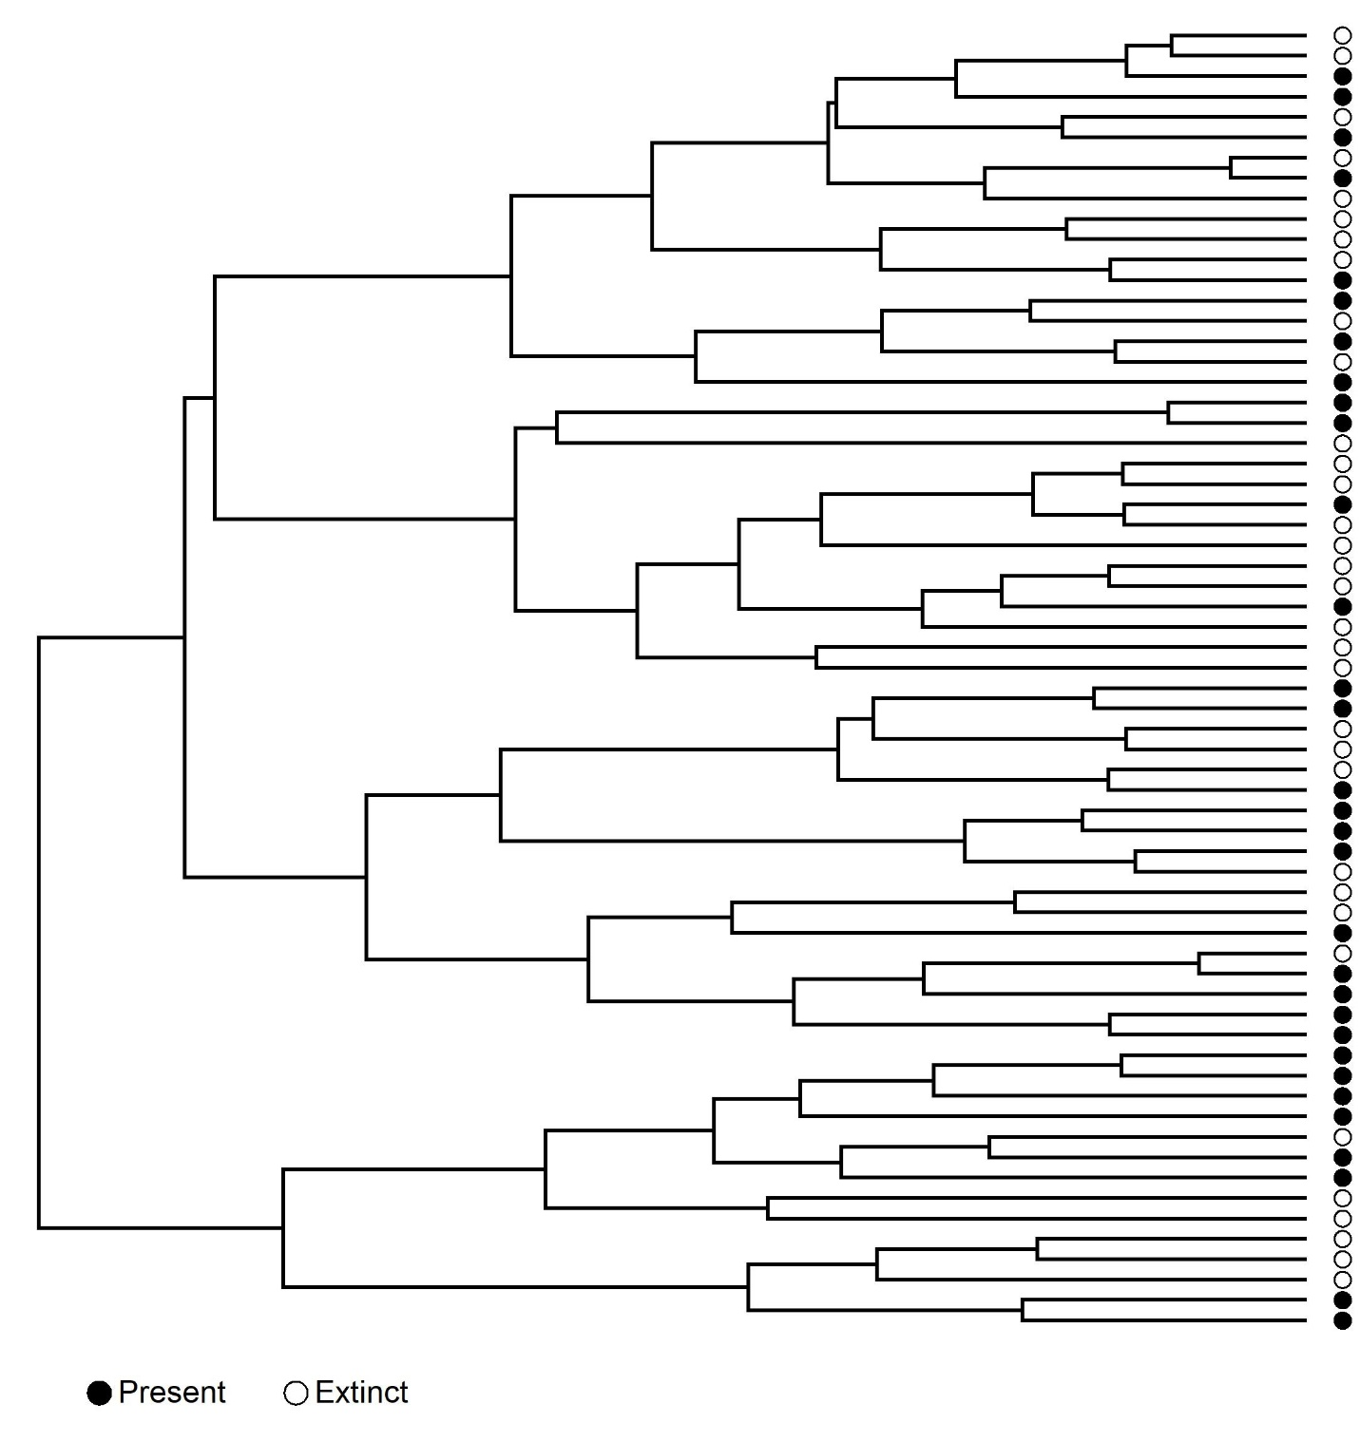
Fig. 1. An example functional dendrogram calculated from a single simulation run using trait values (beak shape, dispersal ability and physiological tolerance) from the full set of species on the largest island pre-human colonization. Following human colonization, the species (tips) that go extinct are marked with a white circle, whilst those that remain are marked with a black circle. Extinction was modelled using the Extinction1 process (see text) and 50% of species went extinct.

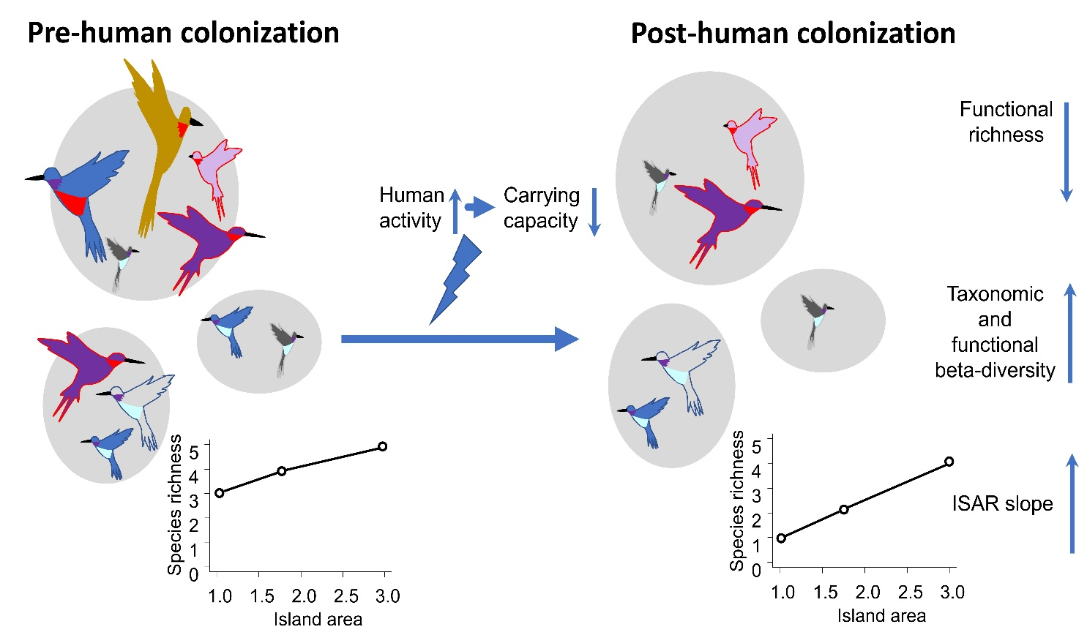
Fig. 2. A schematic summary of the main results (when using Extinction1 and Extinction2), illustrating the change in the various biogeographical patterns from the pre-human colonization scenario (left-hand side) to the post-human colonization scenario (right-hand side). Grey circles are islands, and the birds represent species of different sizes present on the islands. The ISAR for the set of islands is shown at the bottom. The loss of predominantly large-bodied species following human colonization leads to a reduction in functional richness, and the greater proportional loss of species on smaller islands leads to greater beta-diversity and an increase in the slope of the island species–area relationship (ISAR).

