**A study to design the locations of reversible traction substations for minimizing power losses of DC railways**

Zhongbei Tian, Tamer Kamel, Pietro Tricoli

Department of Electric, Electrical and Systems Engineering,

University of Birmingham   
Birmingham, United Kingdom  
Tel.: +44 / (0) 121 414 7522  
E-Mail: z.tian@bham.ac.uk

# Acknowledgements

This work has been developed a part of the project E-LOBSTER. This project has received funding from the European Union’s Horizon 2020 research and innovation programme under grant agreement No 774392

# Keywords

«Rail vehicle», «Regenerative power», «DC power supply», «Energy system management»

# Abstract

With the increasing concern about the energy and environmental sustainability, energy reduction for railway systems is becoming more significant. This paper evaluates the typical electrification scheme of DC-fed railway systems and proposes a new scheme with inverters for DC railways. With inverters, the regenerated energy by braking trains can be transferred to the distribution network. The design of the locations of inverting substations for minimising power losses is optimised based on a DC railway line.

# Introduction

DC-fed railway systems are widely used in many cities across the world. With the development of controllable power electronic devices, new technologies, for example, reversible substations and storage devices are introduced into the DC traction power systems. The installation of additional controllable power electronic devices brings various benefits including power balance, system robustness, fault controls and energy savings.

Reducing power losses for DC railways have been a popular topic to study. The methods to reduce power losses of DC railways mainly focus on the train-driving pattern and operation timetable optimization [1-4]. These methods proposed cooperative train control strategies to improving the recuperation of regernative braking energy, but ignored the effect of the electrical power flow analysis on the regeneartive enegy usage. Numerous literature has studied the modelling and simulation of DC railway systems [5-7]. The energy flow within the DC railway network with regenerating trains is evaluated in [8], which indicates the effect of the train operation on traction substation energy consumption and regenerative braking energy recuperation. A method based on Monte Carlo Algorithm solves the system energy optimization with the consideration of power flow analysis of non-reversible railway network [9]. However, the energy saving performance depends on the accuracy of multiple trains operation.

With reversible substations, the surplus regenerative braking energy can be converted to AC, used by the loads on the AC network. The design specification of inverting substations for railway traction power systems is introduced in [10, 11]. A hybrid simulation method integrating train motion and reversible traction substation system is proposed to analyze the transient and steady state of the network in [12]. The inverter operation characteristics of traction substations are optimized by Brute Force algorithm in [13]. The financial cost is reduced by 16.8% by installing inverters parallelly with rectifier substations and the cost is reduced by additional 5.4% by optimizing the inverter operating characteristics. Although the concept of reversible traction substations has been introduced for a long time, the performance of recovering regenerative braking power by controlled inverters has not been fully studied.

This paper is organized as follows: Section 2 reviews the non-reversible railway power network and proposes several future railway electrification networks towards the concept of smart grids. Section 3 compares the power and energy performance of various installation scenarios of inverting substations with different train operations. Section 4 presents the best design from the case study and summaries the conclusion.

# Electrification schemes for DC railways

## Non-reversible Feeding Scheme

A typical scheme for the electrification of DC railways is shown in Figure 1[14]. The railway line is fed by a number of traction substations distributed along the track approximately every 2 km. The DC voltage level is variable for each specific installation, but recurrent values are 600 V (trams and metro systems), 750 V (trams, metro systems and railways), 1500 V (metro systems and railways) and 3000 V (railways). The sections of the DC electrification can be isolated (single-end and dual-end feeding) or more commonly interconnected (mesh feeding as in Figure 1), albeit sectioning is always possible to enable the disconnection of faulty sections. The DC supply voltage is generated by transformer rectifier substations that convert AC power from a medium voltage (MV) bus bar (11 kV or 15 kV in the example of Figure 1) into DC power. These units are typically formed by three-winding transformers, whose secondary windings feed two 12-pulse rectifiers connected in parallel on the DC side.

In addition to the railway electrification network, railways need power for their auxiliary systems and station loads. This can be taken from the same network, but it is often taken from other networks of the distribution system operator (DSO), especially for low-voltage loads, e.g. 400 V in Figure 1. This network is connected to the MV network of the DSO and it is often a different node from that of the traction power. Therefore, this low voltage network, which in the following will be called local network for its limited extension, can be considered independent from the railway electrification network. The local network can feed a number of loads of various customers and can host renewable energy sources, energy storage and charging stations of electric vehicles (EVs).



Figure 1. Typical electrification scheme for DC railways

## Proposed Feeding Scheme

In Figure 2, an inverter is added parallelly with the conventional rectifier substation, which allows the surplus regenerative braking energy back to MV AC grid. The surplus regenerative braking energy can support the loads on MV AC network or be fed back to HV AC network. The inverting can also provide additional traction power to trains when the railway network is overloaded.

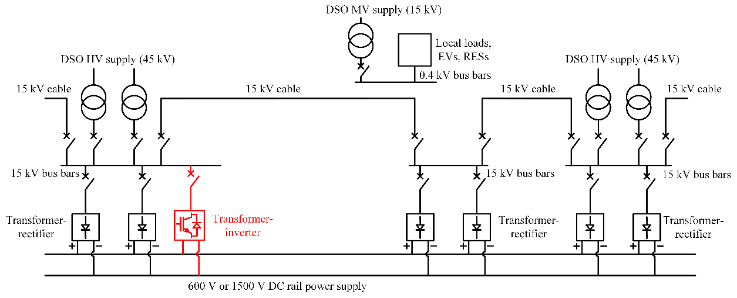

Figure . Electrification scheme for DC railways with inverting substations

Figure 3 to Figure 4 show innovative electrification schemes with installation of a new smart Soft-Open Point (sSOP) device interconnecting railway electrification and power distribution networks [15]. The new schemes can improve the energy-saving and power-balancing performance. In Figure 3, the power converter is connected to the railway electrification system on the rail power supply to the local distribution network and to the energy storage. Therefore, it is a three-way converter with DC/DC/AC output. In particular, the three individual converter modules are DC/DC (DC-bus to rail), DC/DC (DC-bus to storage) and DC/AC (DC-bus to grid). On the grid side, an isolation transformer is generally necessary to electrically isolate the local grid from the railway electrification network. The three ends can support each other according to the loads. The usage of surplus energy from renewable energy sources and regenerative braking energy will be improved.

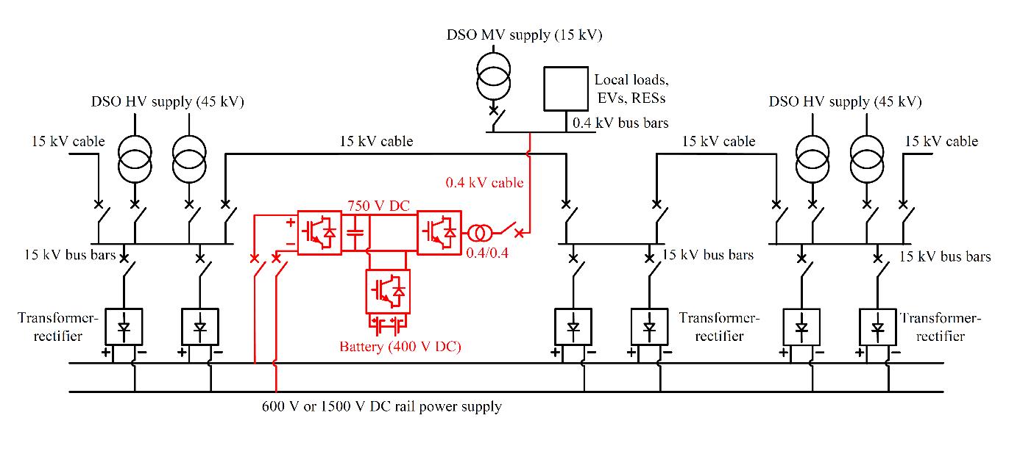

Figure . Connection of the sSOP to balance railway and local grids

In Figure 4, the power converter is connected to the MV network of the railway electrification system to a DC bus bar that interfaces the SOP with the railway, energy storage, local loads and renewable energy sources. Therefore, it is a four-way converter with DC/DC/AC/AC output. In particular, the four individual converter modules are, DC/DC (DC-bus to storage), DC/DC (DC-bus to railway), DC/AC (DC-bus to 15 kV busbar connected to DSO HV supply 1) and DC/AC (DC-bus to 15 kV busbar connected to DSO HV supply 2). The DC bus is shared with local charging stations for EVs (e.g. parking lots around the railway) and local renewable power generators (e.g. photovoltaic panels on the roof of stations). ). It is worth noting that the connection of the sSOP can be done at only one site by taking advantage of the existing circuit breakers for the sectioning of the 15 kV cable. In this case, by connecting the two DC/AC modules to the input and output of the circuit breaker, there is no need to deploy any additional cable, with significant savings on the installation costs. The sSOP can be operated when the circuit breaker is open and can be bypassed by closing the circuit breaker after the sSOP has been de-energised. In addition to the benefits presented in Figure 3, this scheme can balance the HV feeders of the distribution grid and the converter operates more similarly to a SOP.

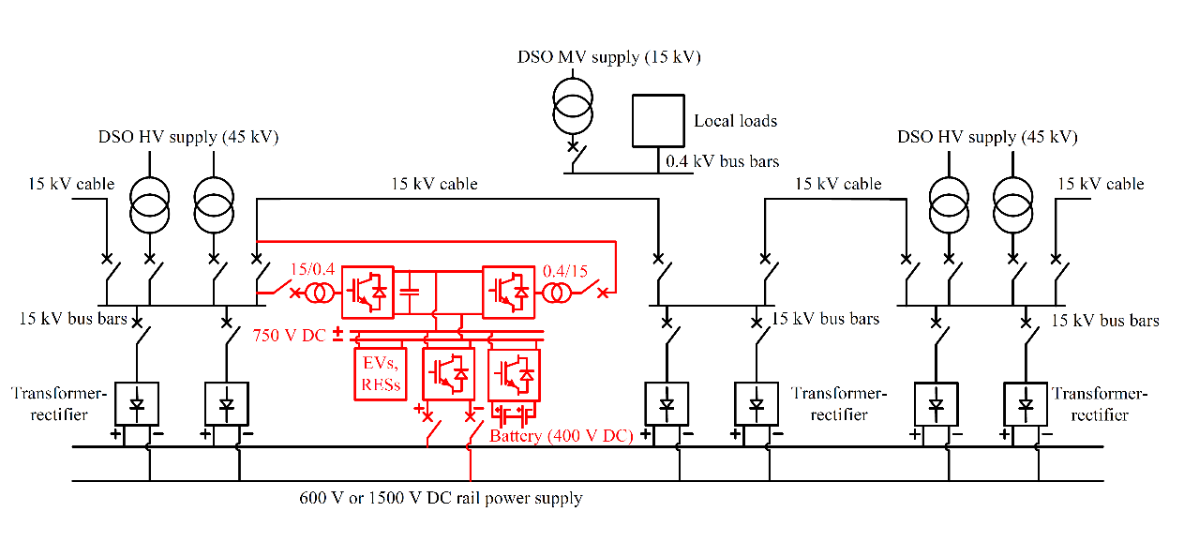

Figure 4. Connection of the sSOP to balance railway and DSO grids

# Power and energy analysis of TPSS

This section investigates in more details the power of the traction power substation (TPSS) and the impact on the presence of an additional converter enabling energy regeneration to the distribution grid. The train operation characteristics should be considered in evaluating the energy consumption, which affect the average power consumption and losses on the electrification system. This paper presents a case study on a typical metro line, which is around 14 km with 20 stations and 5 traction substations. The rated voltage of the traction substation is 1500 V, and the rated power is 6.6 MW. The headway time is 120 s during peak period, and 600 s during off-peak time. The energy evaluation with different headway times have been conducted.

## Headway of 120 s

Figure 5 shows the power of each substation during a time interval equal to the headway (120 s). The power diagrams are periodic of the headway time at steady state. The instantaneous power of the TPSS is significantly variable due to the different operating conditions of the trains and the different position on the line. Additionally, the power of all TPSS is always positive as diodes do not allow any regenerative braking back to the 15 kV power distribution grid. The instantaneous power of some TPSS even exceeds the rated power, even if only for few tens of seconds. This is acceptable, as all TPSS can be overloaded for a short period of time. The heaviest overload is 156% for substation 4, which can be considered of mild level. For comparison, in the UK typical duty classes of TPSS are class F (120% overloading for 60 minutes, 150% for 5 minutes and 300% for 1 minute) class G (177.5% for 60 minutes, 283% for 5 minutes and 382.9% for 1 minute) and class H (100% for 60 minutes, 150% for 1 minute).

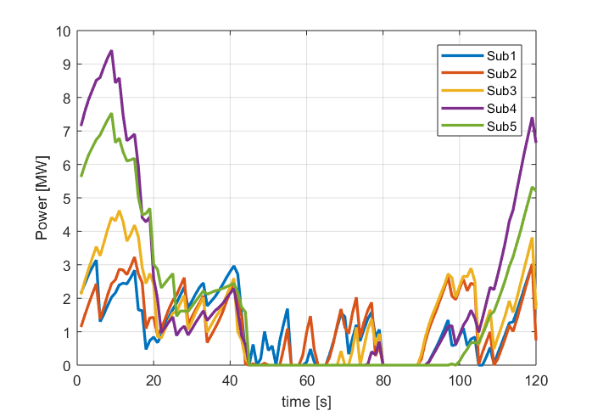

Figure . Power of each traction substation

In order to compare better the actual loading of TPSS, Table I shows the maximum, minimum and average power of each substation. All the substations have some instants where do not supply any power to the trains. This is normal for DC traction system, as trains are powered mainly by the two adjacent substations. Therefore, this situation occurs more often for the TPSS closer to the two ends of the line. The table also shows that the maximum power is several times higher the average power, with factors between 278% and 444%.

Table I Maximum, minimum and average power of each TPSS

|  |  |  |  |
| --- | --- | --- | --- |
| **No.** | **Maximum power**  **[MW]** | **Minimum power**  **[MW]** | **Average power**  **[MW]** |
| **1** | 3.14 | 0 | 1.13 |
| **2** | 3.23 | 0 | 1.22 |
| **3** | 4.62 | 0 | 1.41 |
| **4** | 9.41 | 0 | 2.12 |
| **5** | 7.54 | 0 | 1.83 |

The energy consumption has been calculated for the non-reversible electrification scheme and when one of the TPSS is reversible for the presence of the sSOP, as shown in Table II. The number 0 means that no TPSS are reversible (baseline case), whereas 1 means that TPSS 1 is reversible and so on. The table has the following rows:

*Es* = Energy supplied by all the substations to the traction system within the headway time

*Ps*,*mean* = Average power supplied by all the substations within the headway time

*Es*,*loss* = Energy losses of all the substations

*Et*,*loss* = Energy losses of the electrification system (overhead supply and return rails)

*Ploss*,*mean* = Average power losses (substation and electrification) within the headway time

*Etraction*,*demand* = Energy required by all the train to accelerate and coast

*Etraction* = Energy actually drawn by all the train to complete the journey

*Ebraking*,*available* = Energy available from all the train for regenerative braking

*Ebraking* = Energy actually regenerated by trains

*ηregen* = Efficiency of regenerative braking, calculated as *Ebraking* */ Ebraking*,*available*

Table II shows that when the sSOP is located at TPSS 5 the line achieves the lowest energy consumption of 235 kWh and the highest regeneration efficiency of 99%. The performance when the sSOP is located at TPSS 4 is very close to the best one, where the energy consumption is 237 kWh and the regeneration efficiency is 99%. With the introduction of one sSOP, the efficiency of regeneration is improved for all the configurations. Table II also shows the energy flow within the railway network.

Table II Energy consumption with a sSOP installed at one of the TPSS

|  |  |  |  |  |  |  |  |
| --- | --- | --- | --- | --- | --- | --- | --- |
| Location of the sSOP |  | 0 | 1 | 2 | 3 | 4 | 5 |
| Headway | [s] | 120 | 120 | 120 | 120 | 120 | 120 |
| *Es* | [kWh] | 257 | 251 | 251 | 250 | 237 | **235** |
| *Es*,*rectified* | [kWh] | 257 | 257 | 257 | 258 | 264 | 262 |
| *Es*,*inverted* | [kWh] | 0.0 | -5.9 | -6.3 | -8.1 | -27.2 | -26.7 |
| *Es*,*loss* | [kWh] | 7.7 | 8.0 | 8.0 | 8.2 | 9.4 | 9.3 |
| *Et*,*loss* | [kWh] | 11.0 | 11.3 | 11.3 | 11.5 | 10.7 | 10.7 |
| *Etraction*,*demand* | [kWh] | 450 | 450 | 450 | 450 | 450 | 450 |
| *Etraction* | [kWh] | 450 | 450 | 450 | 450 | 450 | 450 |
| *Ebraking*,*available* | [kWh] | 273 | 273 | 273 | 273 | 273 | 273 |
| *Ebraking* | [kWh] | 248 | 254 | 255 | 257 | 270 | 271 |
| η*regen* | [%] | 91% | 93% | 93% | 94% | 99% | 99% |

Figure 6 and Figure 7 describe and compare how the power curves of TPSS are affected for the presence of one sSOP atthe TPSS 1 and TPSS 5. The regenerative power of the sSOP depends on the control scheme of the power converter. In this simulation, there is a fixed linear voltage regulation characteristic for the converter. The analysis of the various configuration shows that installing sSOP does not affect the positive power output from each substation. When the sSOP is around TPSS 1, the maximum regenerative power is around 2.5 MW. The maximum regenerative power of the sSOP is around 5 MW, when the sSOP is installed at TPSS 5. The sSOP switching on time at TPSS 5 is 43 s, which is longer than 16 s at TPSS 1.

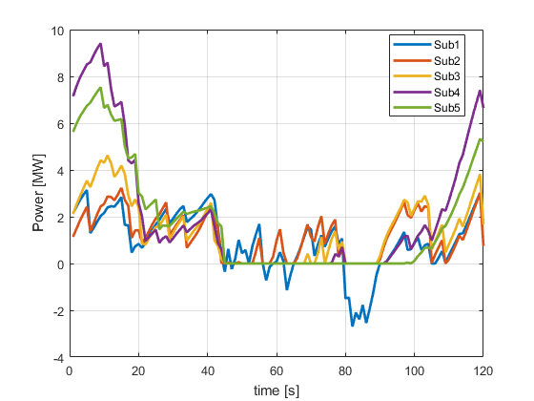

Figure . Instantaneous power of TPSS when sSOP is at TPSS 1

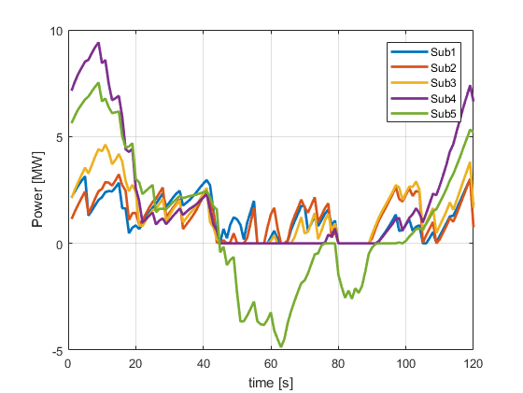

Figure . Instantaneous power of TPSS when sSOP is at TPSS 5

## Headway of 600 s

The power and energy performance is recalucated for the headway time of 600 s. Figure 8 shows the power of each substation during a time interval equal to the headway (600 s). The maximum of the TPSS is around 2.5 MW, which is lower the maximum power in Figure 5. There is some time that all substations export zero power. All substations are blocked is because there is surplus regenerative power which cannot be used by traction.

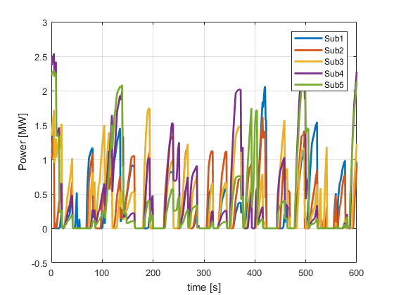

Figure 8. Power of each traction substation

Table III shows the maximum, minimum and average power of each substation. The average power from TPSS 1, 2, 3 and 5 is close, and the maximum average power is from TPSS 4. The maximum instant power also occurs at TPSS 4. Both the maximum and average power from all TPSS in Table III are lower than the results in Table I, which is due to the longer headway time.

Table III Maximum, minimum and average power of each TPSS

|  |  |  |  |
| --- | --- | --- | --- |
| **No.** | **Maximum power**  **[MW]** | **Minimum power**  **[MW]** | **Average power**  **[MW]** |
| **1** | 2.06 | 0 | 0.31 |
| **2** | 1.62 | 0 | 0.34 |
| **3** | 1.74 | 0 | 0.37 |
| **4** | 2.54 | 0 | 0.46 |
| **5** | 2.30 | 0 | 0.36 |

Table IITable IV shows that when the sSOP is located at TPSS 4 the line achieves the lowest energy consumption of 236 kWh and the highest regeneration efficiency of 100%. The regeneration efficiency is improved by 29%. The substation energy consumption is reduced from 309 to 236 kWh by 23.6%. The performance when the sSOP is located at TPSS 3 is close to the best one, where the energy consumption is 240 kWh and the regeneration efficiency is 99%. With the introduction of one sSOP, the efficiency of regeneration is improved for all the configurations.

Table IV Energy consumption with a sSOP installed at one of the TPSS

|  |  |  |  |  |  |  |  |
| --- | --- | --- | --- | --- | --- | --- | --- |
| Location of the sSOP |  | 0 | 1 | 2 | 3 | 4 | 5 |
| Headway | [s] | 600 | 600 | 600 | 600 | 600 | 600 |
| *Es* | [kWh] | 309 | 252 | 244 | 240 | **236** | 244 |
| *Es*,*rectified* | [kWh] | 309 | 310 | 310 | 310 | 311 | 312 |
| *Es*,*inverted* | [kWh] | 0.0 | -58.0 | -65.6 | -70.0 | -74.5 | -67.3 |
| *Es*,*loss* | [kWh] | 9.3 | 12.4 | 12.8 | 13.0 | 13.3 | 12.9 |
| *Et*,*loss* | [kWh] | 7.4 | 10.2 | 9.9 | 9.6 | 9.1 | 9.6 |
| *Etraction*,*demand* | [kWh] | 450 | 450 | 450 | 450 | 450 | 450 |
| *Etraction* | [kWh] | 450 | 450 | 450 | 450 | 450 | 450 |
| *Ebraking*,*available* | [kWh] | 273 | 273 | 273 | 273 | 273 | 273 |
| *Ebraking* | [kWh] | 194 | 257 | 265 | 269 | 273 | 265 |
| η*regen* | [%] | 71% | 94% | 97% | 99% | 100% | 97% |

The instantaneous power of TPSS when sSOP is at TPSS 4 is shown in Figure 9. The sSOP switching on time is 242 s during the operation time of 600 s., which accounts for 40%. The maximum power from sSOP is around 4.5 MW.

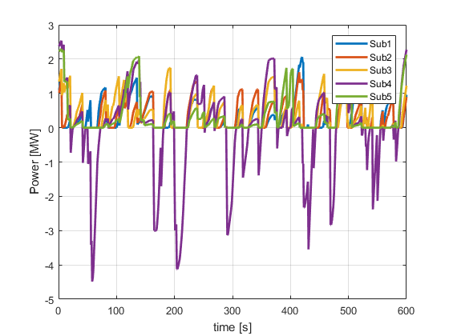

Figure . Instantaneous power of TPSS when sSOP is at TPSS 4

# Conclusion

From the case study presented in this paper, installing the controllable converter can improve the recuperation of the regenerative braking energy from trains and reduce the overall substation energy consumption. The total substation energy consumption can be reduced by up to 23.6%. The energy-saving performance is determined by the location of converter and the train operation strategies. From the case study in Section 4, the best location of the reversible traction substation should be at TPSS 4 with the consideration of both peak and off-peak time. The regenerative braking energy is fed back to the MV AC network. Further work should study the effective usage of regenerative braking energy within the AC network.

# References

[1] S. Su, T. Tang, X. Li, and Z. Gao, "Optimization of Multitrain Operations in a Subway System," *IEEE Transactions on Intelligent Transportation Systems,* vol. 15, no. 2, pp. 673-684, 2014.

[2] S. Su, T. Tang, and C. Roberts, "A Cooperative Train Control Model for Energy Saving," *IEEE Transactions on Intelligent Transportation Systems,* vol. PP, no. 99, pp. 1-10, 2014.

[3] X. Yang, A. Chen, X. Li, B. Ning, and T. Tang, "An energy-efficient scheduling approach to improve the utilization of regenerative energy for metro systems," *Transportation Research Part C: Emerging Technologies,* vol. 57, pp. 13-29, 2015.

[4] N. Zhao, C. Roberts, S. Hillmansen, Z. Tian, P. Weston, and L. Chen, "An integrated metro operation optimization to minimize energy consumption," *Transportation Research Part C: Emerging Technologies,* vol. 75, pp. 168-182, 2017.

[5] M. Z. Chymera, A. C. Renfrew, M. Barnes, and J. Holden, "Modeling Electrified Transit Systems," *IEEE Transactions on Vehicular Technology,* vol. 59, no. 6, pp. 2748-2756, 2010.

[6] P. Arboleya, G. Diaz, and M. Coto, "Unified AC/DC Power Flow for Traction Systems: A New Concept," *IEEE Transactions on Vehicular Technology,* vol. 61, no. 6, pp. 2421-2430, 2012.

[7] P. Arboleya, B. Mohamed, and I. El-Sayed, "DC railway simulation including controllable power electronic and energy storage devices," *IEEE Transactions on Power Systems,* vol. PP, no. 99, pp. 1-1, 2018.

[8] Z. Tian *et al.*, "Energy evaluation of the power network of a DC railway system with regenerating trains," *IET Electrical Systems in Transportation,* vol. 6, no. 2, pp. 41-49, 2016.

[9] Z. Tian, P. Weston, N. Zhao, S. Hillmansen, C. Roberts, and L. Chen, "System energy optimisation strategies for metros with regeneration," *Transportation Research Part C: Emerging Technologies,* vol. 75, pp. 120-135, 2017.

[10] T. Suzuki, "DC power-supply system with inverting substations for traction systems using regenerative brakes," *Electric Power Applications, IEE Proceedings B,* vol. 129, no. 1, pp. 18-26, 1982.

[11] B. Mellitt, Z. S. Mouneimne, and C. J. Goodman, "Simulation study of DC transit systems with inverting substations," *Electric Power Applications, IEE Proceedings B,* vol. 131, no. 2, pp. 38-50, 1984.

[12] G. Zhang, Z. Tian, P. Tricoli, S. Hillmansen, and Z. Liu, "A new hybrid simulation integrating transient-state and steady-state models for the analysis of reversible DC traction power systems," *International Journal of Electrical Power & Energy Systems,* vol. 109, pp. 9-19, 2019/07/01/ 2019.

[13] G. Zhang, Z. Tian, P. Tricoli, S. Hillmansen, Y. Wang, and Z. Liu, "Inverter Operating Characteristics Optimization for DC Traction Power Supply Systems," *IEEE Transactions on Vehicular Technology,* vol. 68, no. 4, pp. 3400-3410, 2019.

[14] R. D. White, "DC electrification supply system design," in *7th IET Professional Development Course on Railway Electrification Infrastructure and Systems (REIS 2015)*, 2015, pp. 1-29.

[15] W. Cao, J. Wu, N. Jenkins, C. Wang, and T. Green, "Operating principle of Soft Open Points for electrical distribution network operation," *Applied Energy,* vol. 164, pp. 245-257, 2016/02/15/ 2016.