This is the author accepted manuscript
The final published version can be found at
https://doi.org/10.1016/j.jssc.2019.121080

The importance of ionic radii in determining the structure obtained for sodium transition metal sulfates: tuning structure through transition metal and selenate doping

E. H. Driscoll^{1*}, L. L. Driscoll¹ and P. R. Slater^{1*}
¹School of Chemistry, The University of Birmingham, B15 2TT, United Kingdom.

Correspondence to:
Prof Peter Slater/ Elizabeth Driscoll
School of Chemistry,
The University of Birmingham,
B15 2TT,
United Kingdom.

Abstract

Materials with the alluaudite structure have been attracting increasing interest due to recent reports of promising performance of Na_{2+2x}Fe_{2-x}(SO₄)₃ as a sodium-ion battery cathode material. In previous work, we highlighted how selenate doping could be utilised to expand the range of alluaudite phases that can be synthesised, and proposed an ionic size relationship to determine whether an alluaudite (Na_{2+2x}M_{2-x}(SO₄)_{3-y}(SeO₄)_{y}) or 2-1-2 (Na₂M(SO₄)_{2-y}(SeO₄)_{y}) (M=Co, Mn, Ni) phase would form from dehydration of the initial Na₂M(SO₄)_{2-y} (SeO₄)_{y}.2H₂O precursor. In this paper, we extend this work to investigate mixed transition metal (Fe-Ni, Mn-Co and Mn-Ni) systems to confirm the applicability of our proposed ion size-structure relationship. In agreement with these prior studies, the smaller transition metal ions (Co and Ni) naturally adopt the Na₂M(SO₄)₂ (2-1-2) structure, while the larger transition metal ions (Fe and Mn) adopt the alluaudite-type structure. By exploiting the ion size design relationship, an Fe-containing 2-1-2 composition has been successfully synthesized with the aid of Ni-doping. Furthermore, for the Co, Ni systems, it has been shown that by co-doping with Mn, the synthesis of Co, Ni containing alluaudite phases can be synthesised with lower selenate doping levels than required previously. Thus, this work further illustrates the ability to exploit cation sizes to direct the structure obtained for these sulfate/selenate systems, which allows the design of novel compositions for potential future cathode material applications. We also report the characterisation of the related Na₂Cu(SO₄)_{2-y}(SeO₄)_{y} phases, which adopt a different structure, most likely attributed to the Jahn-Teller nature of the Cu²⁺.

Keywords: Sodium ion, Sulfate, Selenate, Alluaudite, Crystal structure

Introduction
Na-ion batteries (NIBs) in recent years have witnessed a renaissance as a potential technology for large scale storage grid applications. Although this type of battery was initially investigated in parallel to the Li-ion, the latter proved more favourable due to the resulting higher energy density. The discovery and commercialization of the Li-ion batteries (LIBs) in the early 1990’s saw the establishment of the portable electronics industry, and in more recent times the electrification of vehicles. However, this widespread use has led to the price of Li increasing¹ - with reports of current Li reserves possibly being depleted within this century². Thus, interest in NIBs has been renewed in recent years, due to the higher natural abundance of Na.^{3,4}
As with the research focus in LIB cathodes from LiCoO₂⁵ to LiFePO₄⁶, polyanion-based frameworks (PO₄³⁻, SO₄²⁻) for NIBs have been widely reported. The inclusion of the polyanion group has the added advantage, via the inductive effect of the polyanion, of increasing the redox potentials. Of particular interest, in recent years, has been the alluaudite structure after reports of the highest Fe²⁺/Fe³⁺ redox couple observed for a sulfate system, Na₂Fe₂(SO₄)₃, which has a potential of 3.8 V against Na metal.⁷ The alluaudite structure is an open 3D framework with the general formula of AA’BM₂(XO₄)₃, where the A sites are partially occupied with Na⁺, while the B and M sites are the transition metal ion sites. It is a 3D framework structure (Figure 1), where the 3D network forms from 2D sheets of MO₆ octahedral units bonded to the XO₄ tetrahedral units, with these 2D sheets connected via the tetrahedral units.
Fe
Na
S
Figure 1: Crystal structure of Na_{2.5}Fe_{1.75}(SO₄)₃ which adopts the alluaudite-type structure.
Further studies showed that “Na₂Fe₂(SO₄)₃” had a tendency to form off-stoichiometric systems i.e. Na_{2+2x}Fe_{2-x}(SO₄)₃ with a secondary impurity phase of vanthoffite Na₆Fe(SO₄)₄ observed for the ideal “Na₂Fe₂(SO₄)₃” composition.⁸ Further work has also shown similar non-stoichiometric behaviour for the Mn ⁹ and Co ¹⁰ analogue phases. It is worth noting, that the alluaudite structure is not limited to the inclusion of the sulfate substituent alone, with molybdate¹¹ and numerous phosphate-based^{12–20} systems having also been studied for NIB cathode applications. Furthermore, mixed polyanion systems have also been investigated; e.g. sulfate doping onto the phosphate site in Na_{x}Fe_{y}(PO₄)_{3-z}(SO₄)_{z} to tune the voltage.²¹
Another group of materials that has attracted recent interest as potential battery materials are the 2-1-2 bimetallic sulfates, Na₂M(SO₄)₂ (M = divalent cation)²². The structure of these materials consist of two distorted transition metal octahedra (hence the naming of these as bimetallic sulfates) which are bridged together through a sulfate tetrahedron.²² The crystal structure of these phases, as exemplified by Na₂Co(SO₄)₂ is shown in Figure 2. These systems are typically formed from dehydration of their equivalent tetrahydrate phases, Na₂M(SO₄)₂.4H₂O (M = Co, Fe), with the Fe-analogue being shown to be electrochemically active.²³ Nevertheless, the difficulty in synthesising this Fe system is shown by previous studies by Barpanda et al. who were unable to synthesise this 2-1-2 phase from dehydration of the dihydrate, Na₂Fe(SO₄)₂.2H₂O.²⁴
Co
Na
S
Figure 2: Crystal structure of the bimetallic sulfate 2-1-2 system, Na₂Co(SO₄)₂.
As highlighted above, the synthesis of these 2-1-2 phases or alluaudite phases typically involves the initial synthesis of the equivalent sodium transition metal sulfate hydrate precursor, before the subsequent dehydration to form either the 2-1-2 or the alluaudite phase.^{23,25–28,29}
In prior work, we investigated the effect of selenate doping in Na₂M(SO₄)₂.2H₂O (M= Mn, Co, Ni), and examined the products formed on dehydrating these systems.²⁵ This work showed that, for the simple sulfate systems, the 2-1-2 structure was observed for smaller divalent transition metals ions (Co and Ni), while the larger divalent transition metal ions (Mn, Fe) led to the formation of an alluaudite-phase, along with some Na rich impurities (due to the higher Na content in the precursor; 2:1 Na:M, compared to a ratio closer to 1:1 expected for alluaudite). The results from selenate doping led to some interesting observations. While all attempts to dehydrate the Na₂Fe(SO₄)_{2-y}(SeO₄)_{y}.2H₂O phases resulted in amorphous products (attributed to a redox side reaction between the Fe and the selenate), the dehydration of the Mn, Co, Ni samples were all successful and showed the formation of a high Na content alluaudite phase, Na₃M_{1.5}(SO₄)_{3-z}(SeO₄)_{z} (M=Mn, Co, Ni), with the amount of selenate needed to obtain a phase pure alluaudite phase increasing as the size of the transition metal decreased.²⁵ Significantly, this led to the first report of a Ni-based alluaudite sulfate/selenate phase, as well as higher Na contents than previously achieved in prior sulfate-based alluaudite structure studies. The crystal structure changeover from 2-1-2 to the alluaudite on selenate doping is thought to be related to the spatial requirements for the larger selenate compared to sulfate. In the 2-1-2 structure, as previously mentioned, each metal octahedron has one edge-sharing linkage to a tetrahedron while there is corner-sharing to the rest of the tetrahedra. For the alluaudite structure, considering the bonding interactions of each metal octahedron to the tetrahedra alone, all 6 tetrahedra are corner-sharing to the metal octahedron. The corner-sharing means that the larger selenate units are positioned further away in the alluaudite than the 2-1-2 structure, thus favouring the alluaudite structure on selenate doping. These features also account for the structure changeover in the simple sulfate systems on changing the transition metal, with larger transition metals favouring the alluaudite structure.
Through consideration of the level of selenate content that was required to stabilise the alluaudite phase, an ion size relationship (sum of M²⁺ radius and average S⁶⁺/Se⁶⁺ radius) was proposed to dictate which structure (2-1-2 or alluaudite) was formed (Figure 3).
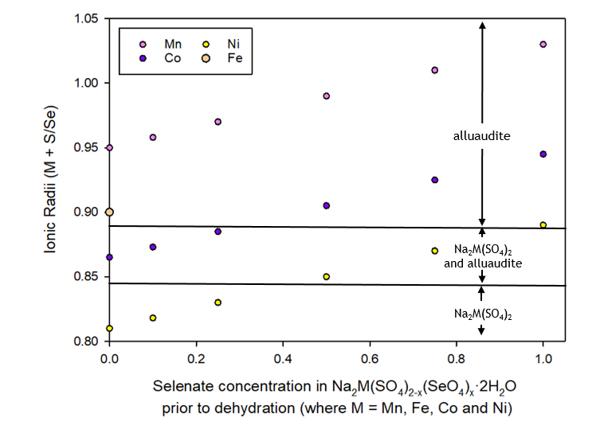
Figure 3: Plot of sum of the ionic radii of M and the weighted average ionic radius of S/Se (where M = Mn, Fe, Co and Ni) vs selenate content in the starting dihydrate. Note only the undoped (no selenate) Fe phase resulted in a crystalline product after dehydration, therefore only one data point is available for this series. Reproduced with permission from the Journal Solid State Chemistry, 2018, 258, 64–71.
While single transition metal systems were considered in this previous publication, we extend this work to the investigation of mixed transition metal systems, in order to confirm whether the above size relationship still holds true. Furthermore, while the previous work concentrated on the stabilisation of the alluaudite-type structure, we also investigate here whether it is possible to make use of this size relationship to design new 2-1-2 phases. We therefore report an investigation of the phases formed on the dehydration of the following mixed transition metals system Na₂M(SO₄)_{2-y}(SeO₄)_{y}.2H₂O (M = Ni/Fe, Co/Mn, Ni/Mn) to determine whether a 2-1-2, alluaudite or mixed phase system is observed. We also report for the first time the phases formed on selenate doping into equivalent Na₂Cu(SO₄)₂.2H₂O systems.

Experimental

This synthesis method was the same as that used previously, involving the formation of Na₂M(SO₄)_{2-y}(SeO₄)_{y}.2H₂O before subsequent heating to dehydrate.²⁵ For the formation of 0.5 g (mixed-metal) Na₂M_{1-x}M’_{x}(SO₄)_{2-y}(SeO₄)_{y}.2H₂O phases, stoichiometric amounts of Na₂SO₄, Na₂SeO₄ and MSO₄.$x$H₂O (M / M’ = Co, Ni, Fe and Cu; $x$ being equal to: 1 for Mn; 6 for Ni, and 7 for Fe and Co, and 5 for Cu) were weighed accurately and dissolved in 20 mL of deionised water and stirred at 60°C for 30 min. To prevent the oxidation of Fe²⁺, 20 mg of L-ascorbic acid was added to the mixtures. Samples were heated overnight at either 100-110$℃$ (compositions without Ni) or 130$℃$ (Ni containing compositions) to obtain the dihydrate precursor.
For the dehydration of these Na₂M_{1-x}M’_{x}(SO₄)_{2-y}(SeO₄)_{y}.2H₂O phases, samples were heated in alumina crucibles up to 350$℃$ (300°C for Cu) in air at a rate of 0.5$℃$ min⁻¹ and held at this temperature for 12 hours, with the exception of the Fe and Cu containing samples, where dry N₂ was used instead.
The sample purity and structure determination were evaluated using powder X-ray diffraction. Structure refinements were carried out using the GSAS suite of programs using structural models from our previous study²⁵.

Results
Through a low temperature heat treatment, the resulting dehydrated products of Na₂M(SO₄)_{2-y}(SeO₄)_{y}.2H₂O systems have been previously shown to form a 2-1-2 Na₂M(SO₄)₂ system, an alluaudite-type phase, or a mixture of these two phases dependent on the transition metal size and the selenate content. Thus, with no selenate doping, the 2-1-2 structure is adopted by the smaller transition metals ions (Co and Ni), while the alluaudite structure is adopted for the larger transition metals (Mn, Fe). Through selenate doping, a structure transformation from the 2-1-2 to the alluaudite-type is observed for both Co and Ni with higher levels of selenate doping required for the smaller Ni. Here the results for the mixed transition metal systems are presented and discussed.

Phases formed on dehydration of Na₂Fe_{1-x}Ni_{x}(SO₄)₂.2H₂O
The dehydration of Ni-doped Na₂Fe_{1-x}Ni_{x}(SO₄)₂.2H₂O was the first system to be investigated and the resulting XRD patterns are presented in Figure 4, with cell parameters and phase fractions from Rietveld refinement shown in Table 1. Due to issues with the stability of the Fe²⁺ in conjunction with selenate²⁵, only the sulfate endmember samples were investigated. The XRD data for the lowest level of Ni-doping (x = 0.1) was best fit using the off-stoichiometric alluaudite Na_{2+2x}M_{2-x}(SO₄)₃ phase, with Na rich vanthoffite (Na₆M(SO₄)) impurity phase and a small fraction of a 2-1-2 phase, thus suggesting no incorporation of Ni at this dopant level. A similar scenario was obtained for the x = 0.25 sample, albeit with a reduced alluaudite phase fraction and potentially a low level of Ni incorporation into this phase when considering the obtained unit cell parameters. With increasing Ni content, the 2-1-2 phase fraction increases as expected, such that for x > 0.5, a phase pure 2-1-2 sample is obtained. Thus, this doping strategy shows that a range of mixed Ni/Fe systems with the 2-1-2 structure can be obtained, which may offer interesting electrochemical properties as Na ion cathode materials.

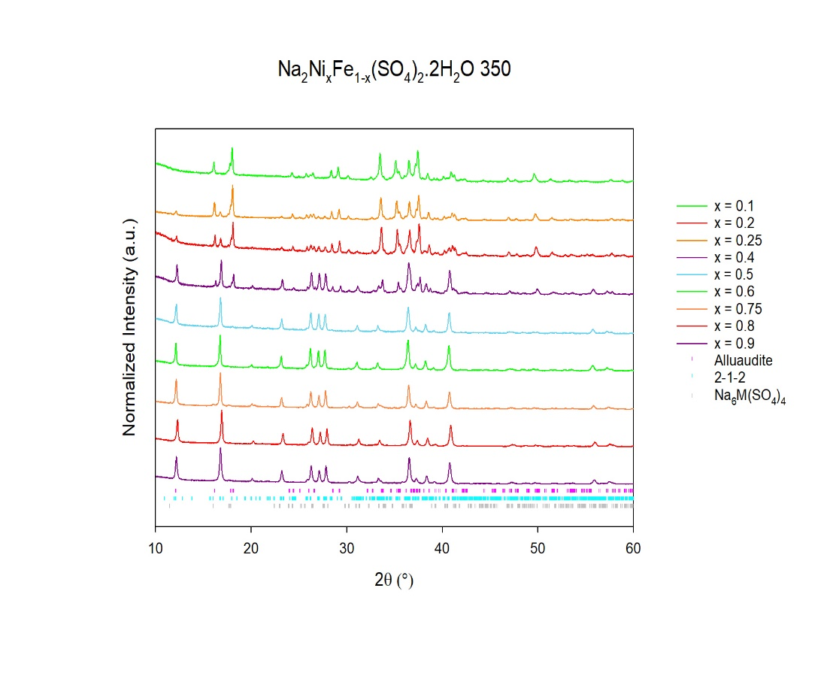
x = 0.9
x = 0.1
Figure 4: XRD patterns obtained after dehydration of Na₂Fe_{1-x}Ni_{x} (SO₄)₂.2H₂O (Co Kα) showing a change from mainly alluaudite (0.1 $\text{≤}$ x $\text{≤}\text{ 0.25}$; low Ni content) to 2-1-2 phase (0.5 $\text{≤}$ x $\text{≤}$0.9; high Ni content).

Table 1: Unit cell parameters and phase fractions of the phases formed on dehydration of Na₂Fe_{1-x}Ni_{x} (SO₄)₂.2H₂O.
Dopant Level (x) | a  ($\dot{A}$) | b  ($\dot{A}$) | C  ($\dot{A}$) |  | $$α$$  ($°$) | $$β$$  ($°$) | $$γ$$  ($°$) | Cell Volume (${\dot{A}}^{3}$) | Phase | % Wt fraction | Ref.
0 | 12.65027(15) | 12.76546(14) |  | 6.51011(7) | 90.0 | 115.5394(4) | 90.0 | 948.573(19) | Alluaudite | N/A | 30
0.1 | 23.30(4) | 10.31(2) |  | 17.35(3) | 90.0 | 99.4(1) | 90.0 | 4111(6) | 2-1-2 | 3
 | 12.6592(5) | 12.7685(5) |  | 6.5176(2) | 90.0 | 115.506(2) | 90.0 | 950.83(8) | Alluaudite | 80
 | 9.9699 (2) | 9.265(2) |  | 8.251(2) | 90.0 | 113.45(1) | 90.0 | 680.2(2) | Na₆M(SO₄)₄ | 17
0.25 | 23.301(5) | 10.280(2) |  | 17.396(4) | 90.0 | 99.15(2) | 90.0 | 4114(8) | 2-1-2 | 17
 | 12.6394(5) | 12.7372(5) |  | 6.5022(2) | 90.0 | 115.417(2) | 90.0 | 945.49(8) | Alluaudite | 70
 | 9.697(2) | 9.257(2) |  | 8.242(2) | 90.0 | 113.48(1) | 90.0 | 678.6(2) | Na₆M(SO₄)₄ | 13
0.5 | 23.320(1) | 10.2927(5) |  | 17.409(1) | 90.0 | 99.172(3) | 90.0 | 4125.1(4) | 2-1-2 | 97
 | 12.648(5) | 12.732(4) |  | 6.502(2) | 90.0 | 115.26(4) | 90.0 | 947.0(5) | Alluaudite | 3
0.75 | 23.265(1) | 10.275(6) |  | 17.381(1) | 90.0 | 99.059(4) | 90.0 | 4103.2(4) | 2-1-2 | 100
1 | 23.196(2) | 10.2577(9) |  | 17.339(2) | 90.0 | 98.932(6) | 90.0 | 4075.6(7) | 2-1-2 | 100 | 25

Phases formed on dehydration of Na₂Co_{x}Mn_{1-x}(SO₄)_{2-y}(SeO₄)_{y}.2H₂O

x = 0.25
The XRD patterns for the lowest Co doping (M = Co_{0.25}Mn_{0.75}) level examined are shown in Figure 5. For all selenate contents, the alluaudite structure was observed, with some Na₆M(SO₄)₄ impurity observed for the sulfate endmember (y = 0). The resulting refined unit cell parameters are shown in Table 2.
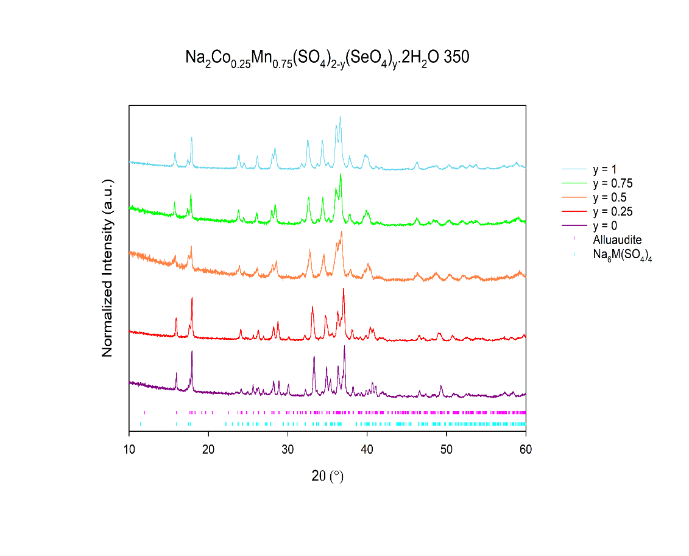
y = 0
y = 1
Figure 5: XRD patterns obtained after dehydration of Na₂Co_{0.25}Mn_{0.75}(SO₄)_{2-y}(SeO₄)_{y}.2H₂O (Co Kα) showing the formation of an alluaudite phase for all selenate doped compositions.
Table 2: Unit cell parameters and phase fractions of the phases formed on dehydration of Na₂Co_{0.25}Mn_{0.75}(SO₄)_{2-y}(SeO₄)_{y}.2H₂O.
Dopant Level (y) | a  ($\dot{A}$) | b  ($\dot{A}$) | c  ($\dot{A}$) | $$α$$  ($°$) | $$β$$  ($°$) | $$γ$$  ($°$) | Cell Volume  (${\dot{A}}^{3}$) | Phase | %
0 | 9.767(1) | 9.294(1) | 8.297(1) | 90.0 | 113.371(8) | 90.0 | 691.4(1) | Na₆M(SO₄)₄ | 16
 | 11.5299(8) | 12.8853(8) | 6.5532(4) | 90.0 | 95.186(5) | 90.0 | 969.6(2) | Alluaudite | 84
0.25 | 11.575(1) | 12.955(1) | 6.6061(5) | 90.0 | 95.504(6) | 90.0 | 986.1(2) | Alluaudite | 100
0.5 | 11.632(3) | 13.045(3) | 6.660(1) | 90.0 | 95.69(1) | 90.0 | 1005.6(5) | Alluaudite | 100
0.75 | 11.638(2) | 13.079(2) | 6.686(8) | 90.0 | 95.855(9) | 90.0 | 1012.4(3) | Alluaudite | 100
1 | 11.663(1) | 13.137(1) | 6.7258(7) | 90.0 | 96.086(7) | 90.0 | 1024.7(3) | Alluaudite | 100

x = 0.5
For 50:50 Co:Mn, the alluaudite phase was also shown to be present for all selenate contents. The resulting XRD data and refined unit cell parameters are shown in Figure 6 and Table 3, respectively.

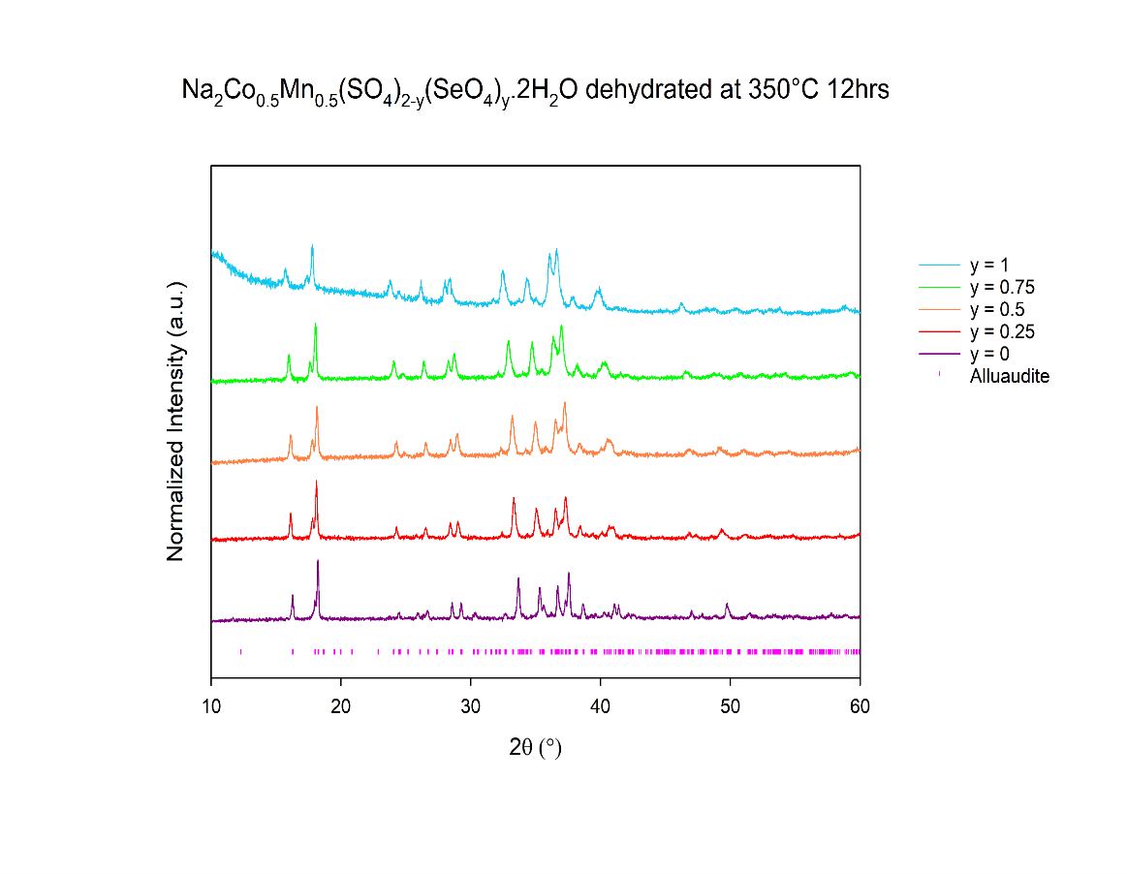
y = 1
y = 0
Figure 6: XRD patterns obtained after dehydration of Na₂Co_{0.5}Mn_{0.5}(SO₄)_{2-y}(SeO₄)_{y}.2H₂O (Co Kα) showing the formation of an alluaudite phase for all compositions.
Table 3: Unit cell parameters of the alluaudite phase formed on dehydration of Na₂Co_{0.5}Mn_{0.5}(SO₄)_{2-y}(SeO₄)_{y}.2H₂O.
Dopant Level (y) | a  ($\dot{A}$) | b  ($\dot{A}$) | c  ($\dot{A}$) | $$α$$  ($°$) | $$β$$  ($°$) | $$γ$$  ($°$) | Cell Volume  (${\dot{A}}^{3}$) | Phase | %
0 | 11.490(2) | 12.815(1) | 6.5281(8) | 90.0 | 95.37(1) | 90.0 | 957.0(3) | Alluaudite | 100
0.25 | 11.529(2) | 12.889(2) | 6.5808(8) | 90.0 | 95.66(1) | 90.0 | 973.1(3) | Alluaudite | 100
0.5 | 11.560(2) | 12.949(2) | 6.6189(8) | 90.0 | 95.84(1) | 90.0 | 985.6(3) | Alluaudite | 100
0.75 | 11.605(1) | 13.019(1) | 6.6637(7) | 90.0 | 96.05(1) | 90.0 | 1001.2(3) | Alluaudite | 100
1 | 11.634(2) | 13.083(2) | 6.704(1) | 90.0 | 96.24(2) | 90.0 | 1014.4(5) | Alluaudite | 100

x = 0.75
Increasing the level of cobalt further also led to the alluaudite phase being obtained. In this case, the sulfate endmember (x = 0) showed the presence of some Na₆M(SO₄)₄ impurity, while this impurity was eliminated on selenate doping (Figure 7, Table 4).
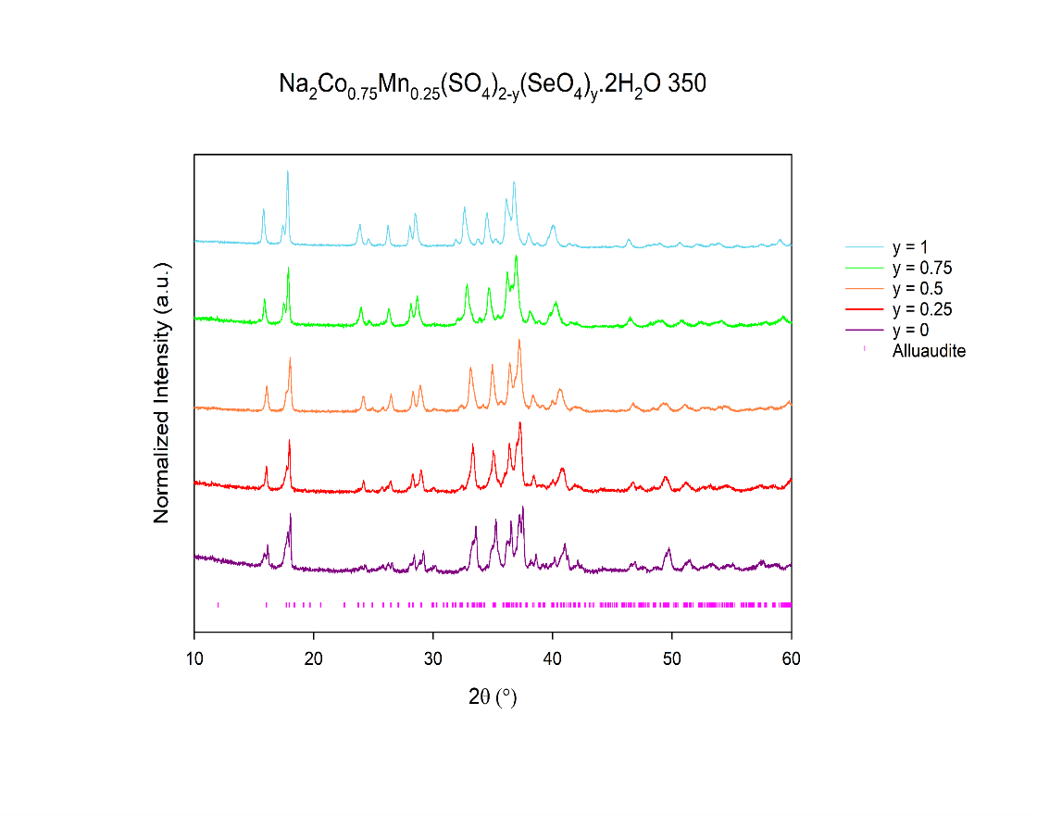
y = 0
y = 1
Figure 7: XRD patterns obtained after dehydration of Na₂Co_{0.75}Mn_{0.25}(SO₄)_{2-y}(SeO₄)_{y}.2H₂O (Co Kα) showing the formation of an alluaudite phase for all compositions.
Table 4: Unit cell parameters of the alluaudite phase formed on dehydration of Na₂Co_{0.75}Mn_{0.25}(SO₄)_{2-y}(SeO₄)_{y}.2H₂O.
Dopant Level (y) | a  ($\dot{A}$) | b  ($\dot{A}$) | c  ($\dot{A}$) | $$α$$  ($°$) | $$β$$  ($°$) | $$γ$$  ($°$) | Cell Volume  (${\dot{A}}^{3}$) | Phase | %
0 | 11.492(1) | 12.761(1) | 6.5305(7) | 90.0 | 95.827(8) | 90.0 | 952.8(3) | Alluaudite | 80
 | 9.749(2) | 9.250(5) | 8.286(4) | 90.0 | 113.18(2) | 90.0 | 686.9(4) | Na₆M(SO₄)₄ | 20
0.25 | 11.522(2) | 12.830(2) | 6.5532(8) | 90.0 | 95.69(1) | 90.0 | 964.0(3) | Alluaudite | 100
0.5 | 11.551(1) | 12.890(1) | 6.5950(6) | 90.0 | 95.898(8) | 90.0 | 976.8(3) | Alluaudite | 100
0.75 | 11.587(1) | 12.961(2) | 6.388(7) | 90.0 | 96.10(1) | 90.0 | 991.3(3) | Alluaudite | 100
1 | 11.6122(9) | 13.0112(10) | 6.6729(5) | 90.0 | 96.255(7) | 90.0 | 1002.2(2) | Alluaudite | 100

Phases formed on dehydration of Na₂Ni_{x}Mn_{1-x}(SO₄)_{2-y}(SeO₄)_{y}.2H₂O (x = 0.25, 0.5, 0.75)
x = 0.25 and 0.5
For Ni contents, x = 0.25 and 0.5, the sulfate endmember was shown to consist of a phase mixture, with the alluaudite-type phase becoming more dominant with increasing selenate content, as shown by the XRD data (Figure 8, 9). In particular, for the lower Ni content (x = 0.25), a phase pure alluaudite was obtained for y ≥0.5 (Table 5). However, for the higher Ni content (x = 0.5), mixed (alluaudite and 2-1-2) phases were obtained throughout, with the phase fraction of the alluaudite phase increasing as the selenate content increased, such that for y = 1 the PXRD pattern shows mainly alluaudite (Table 6).
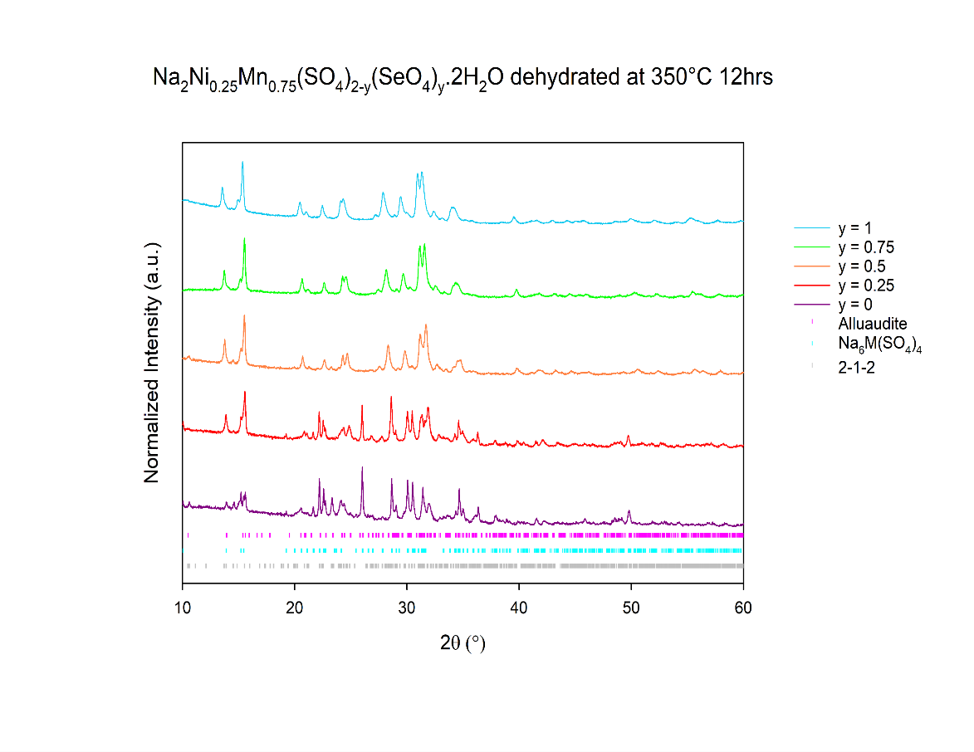
y = 0
y = 1
Figure 8: XRD patterns obtained after dehydration of Na₂Ni_{0.25}Mn_{0.75}(SO₄)_{2-y}(SeO₄)_{y}.2H₂O (Cu Kα) showing formation of phase pure alluaudite for y$≥$0.5.

Table 5: Refined unit cell parameters of the phases formed on dehydration of Na₂Ni_{0.25}Mn_{0.75}(SO₄)_{2-y}(SeO₄)_{y}.2H₂O
Dopant Level (y) | A  ($\dot{A}$) | b  ($\dot{A}$) | c  ($\dot{A}$) | $$α$$  ($°$) | $$β$$  ($°$) | $$γ$$  ($°$) | Cell Volume (${\dot{A}}^{3}$) | Phase | % Wt fraction
0 | 23.34(4) | 10.32(1) | 17.35(3) | 90.0 | 98.33(9) | 90.0 | 4135(5) | 2-1-2 | 13
 | 9.741(2) | 9.300(1) | 8.278(1) | 90.0 | 113.207(7) | 90.0 | 689.2(2) | Na₆M(SO₄)₄ | 64
 | 11.532(5) | 12.875(6) | 6.562(4) | 90.0 | 95.26(7) | 90.0 | 970.2(8) | Alluaudite | 23
0.25 | 9.747(2) | 9.320(2) | 8.287(1) | 90.0 | 113.153(7) | 90.0 | 692.2(2) | Na₆M(SO₄)₄ | 40
 | 11.574(2) | 12.937(3) | 6.589(1) | 90.0 | 95.51(3) | 90.0 | 982.1(4) | Alluaudite | 60
0.5 | 11.597(1) | 13.015(1) | 6.6444(7) | 90.0 | 95.75(1) | 90.0 | 997.8(3) | Alluaudite | 100
0.75 | 11.629(2) | 13.096(2) | 6.6952(8) | 90.0 | 95.94(1) | 90.0 | 1014.2(3) | Alluaudite | 100
1 | 11.648(1) | 13.124(1) | 6.7182(6) | 90.0 | 96.11(1) | 90.0 | 1021.1(3) | Alluaudite | 100

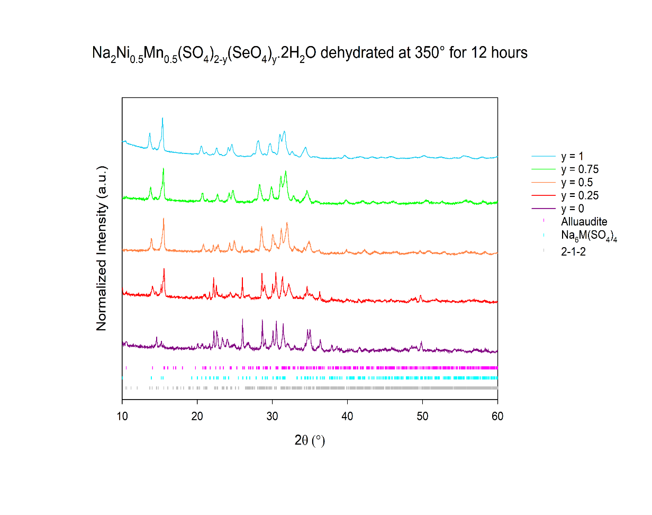
y = 0
y = 1
Figure 9: XRD patterns obtained after dehydration of Na₂Ni_{0.5}Mn_{0.5}(SO₄)_{2-y}(SeO₄)_{y}.2H₂O (Cu Kα) showing increasing alluaudite phase fraction with increasing selenate content.
Table 6: Refined unit cell parameters of the phases formed on dehydration of Na₂Ni_{0.5}Mn_{0.5}(SO₄)_{2-y}(SeO₄)_{y}.2H₂O.
Dopant Level (y) | a  ($\dot{A}$) | B  ($\dot{A}$) | c  ($\dot{A}$) | $$α$$  ($°$) | $$β$$  ($°$) | $$γ$$  ($°$) | Cell Volume (${\dot{A}}^{3}$) | Phase | % Wt fraction
0 | 23.231(5) | 19.283(2) | 17.350(3) | 90.0 | 99.20(1) | 90.0 | 4111(1) | 2-1-2 | 12
 | 9.733(2) | 9.289(3) | 8.273(2) | 90.0 | 113.19(1) | 90.0 | 688.5(1) | Na₆M(SO₄)₄ | 85
 | 11.499(5) | 12.759(5) | 6.461(4) | 90.0 | 95.49(6) | 90.0 | 943.6(7) | Alluaudite | 3
0.25 | 9.747(2) | 9.319(2) | 8.281(1) | 90.0 | 113.180(8) | 90.0 | 691.5(2) | Na₆M(SO₄)₄ | 48
 | 11.554(3) | 12.762(3) | 6.511(2) | 90.0 | 95.79(4) | 90.0 | 955.2(5) | Alluaudite | 52
0.50 | 9.746(3) | 9.333(4) | 8.288(3) | 90.0 | 113.19(2) | 90.0 | 693.0(4) | Na₆M(SO₄)₄ | 21
 | 11.588(2) | 12.876(2) | 6.584(1) | 90.0 | 95.90(2) | 90.0 | 977.1(4) | Alluaudite | 79
0.75 | 23.456(5) | 10.295(2) | 17.533(3) | 90.0 | 98.96(2) | 90.0 | 4182(1) | 2-1-2 | 4
 | 11.615(1) | 12.958(1) | 6.6342(6) | 90.0 | 96.13(1) | 90.0 | 992.8(2) | Alluaudite | 96
1 | 23.270(2) | 10.339(7) | 17.43(1) | 90.0 | 97.85(6) | 90.0 | 4153(4) | 2-1-2 | 2
 | 11.652(1) | 13.016(1) | 6.6767(7) | 90.0 | 96.27(1) | 90.0 | 1006.6(5) | Alluaudite | 98

x = 0.75
On increasing the Ni content further (x = 0.75), the 2-1-2 phase was shown to be present for lower selenate levels (y≤0.25), with the alluaudite-type structure observed for higher selenate levels (y ≥ 0.5) (Figure 10, Table 7). For the sulfate endmember, an Na₆M(SO₄)₄ impurity phase was found to be present.
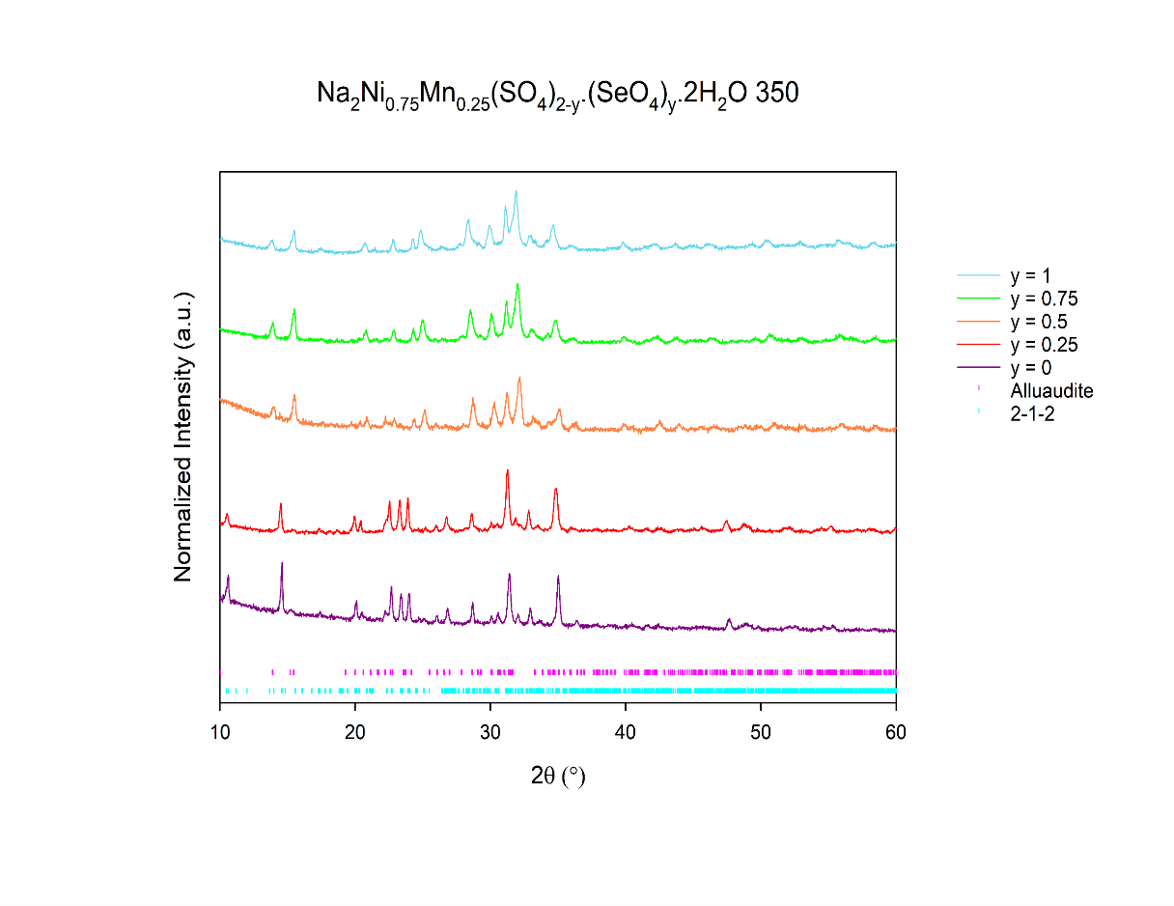
y = 1
y = 0
Figure 10: XRD patterns obtained after dehydration of Na₂Ni_{0.75}Mn_{0.25}(SO₄)_{2-y}(SeO₄)_{y}.2H₂O (Cu Kα) showing the phase change from 2-1-2 to alluaudite with increasing selenate.
Table 7: Refined unit cell parameters of the phases formed on dehydration of Na₂Ni_{0.75}Mn_{0.25}(SO₄)_{2-y}(SeO₄)_{y}.2H₂O. * denotes refinement whereby the main phase has been refined only and does not take into account secondary phases.
Dopant Level (y) | a  ($\dot{A}$) | b  ($\dot{A}$) | c  ($\dot{A}$) | $$α$$  ($°$) | $$β$$  ($°$) | $$γ$$  ($°$) | Cell Volume  (${\dot{A}}^{3}$) | Phase | %
0 | 23.286(4) | 10.285(2) | 17.386(4) | 90.0 | 99.14(1) | 90.0 | 4111(1) | 2-1-2 | 74
 | 9.738(4) | 9.284(6) | 8.279(4) | 90.0 | 113.15(3) | 90.0 | 688.1(4) | Na₆M(SO₄)₄ | 26
0.25* | 23.380(5) | 10.306(3) | 17.457(6) | 90.0 | 98.95(1) | 90.0 | 4155(2) | 2-1-2 | *
0.5 | 11.560(3) | 12.780(3) | 6.538(1) | 90.0 | 96.04(2) | 90.0 | 960.6(6) | Alluaudite | 100
0.75 | 11.593(3) | 12.847(3) | 6.584(1) | 90.0 | 96.21(2) | 90.0 | 974.7(6) | Alluaudite | 100
1 | 11.566(1) | 12.857(1) | 6.6023(9) | 90.0 | 96.45(2) | 90.0 | 975.4(2) | Alluaudite | 100

Alternative Structure Systems: Phases formed on dehydration of Na₂Cu(SO₄)_{2-y}(SeO₄)_{y}.2H₂O

Oxoanion studies involving the intermediate dihydrate products were previously investigated by Driscoll et al. for the metals Mn, Fe, Co, Ni and Cu²⁹, with the corresponding dehydration products and structure types studied albeit without the successful determination of the Cu-analogue structure²⁵. At the time, the resulting structure of the Cu product remained unresolved, although a recent report by Kovrugin et al. has now successfully identified the structure of this phase (Figure 11)³¹. Therefore, using this structural model, we have reinvestigated the phases obtained from dehydration of Na₂Cu(SO₄)_{2-y}(SeO₄)_{y}.2H₂O. The resulting XRD patterns (Figure 12) indicate that all phases are isostructural with the previously reported Na₂Cu(SO₄)₂, illustrating no change in structure on selenate doping for this system. The refined unit cell parameters for all phases are given in Table 8, and show, as expected, increasing unit cell parameters with increasing selenate content. The different structure adopted by this system is most likely related to the fact that Cu²⁺ is a Jahn Teller ion. This leads to the adoption of a tetragonal pyramidal coordination with an additional two longer bonds (Figure 11).³¹
S
Na
Cu
Figure 11: Crystal structure of Na₂Cu(SO₄)₂.

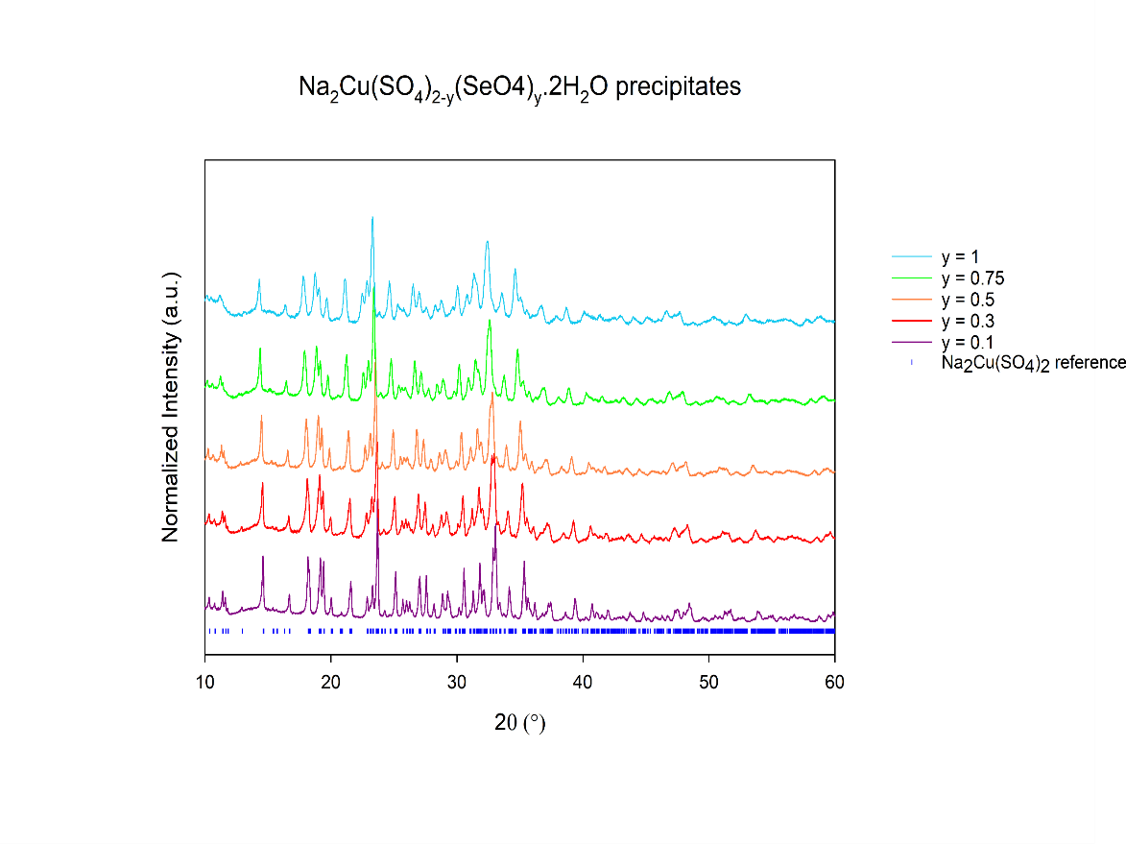
y = 0.1
y = 1
Figure 12: XRD patterns of Na₂Cu(SO₄)_{2-y}(SeO₄)_{y} (y = 0.1 upto 1) (Cu Kα).
Table 8: Refined unit cell parameters of Na₂Cu(SO₄)_{2-y}(SeO₄)_{y} (x = 0.1 upto 1) using the structural mode reported by Kovrugin et al.³¹
Dopant Level (y) | a  ($\dot{A}$) | b  ($\dot{A}$) | c  ($\dot{A}$) | $$α$$  ($°$) | $$β$$  ($°$) | $$γ$$  ($°$) | Cell Volume (${\dot{A}}^{3}$)
0.1 | 8.9808(3) | 15.5684(4) | 10.1634(3) | 90.0 | 107.087(2) | 90.0 | 1358.30(9)
0.3 | 9.0023(7) | 15.615(1) | 10.2026(9) | 90.0 | 107.117(6) | 90.0 | 1370.7(3)
0.5 | 9.0307(4) | 15.6667(7) | 10.2455(4) | 90.0 | 107.149(5) | 90.0 | 1385.12(8)
0.75 | 9.0698(8) | 15.739(1) | 10.3016(9) | 90.0 | 107.175(6) | 90.0 | 1405.0(3)
1 | 9.112(1) | 15.816(2) | 10.360(1) | 90.0 | 107.171(9) | 90.0 | 1426.5(4)

Discussion

Previous work had shown that the metal ionic radii and selenate content influenced the structure obtained on dehydration of Na₂M(SO₄)_{2-y}(SeO₄)_{y}.2H₂O (M = Mn, Co and Ni) samples: in particular the 2-1-2 phase was observed for the smaller transition metals ions, while the alluaudite-type structure for the larger ions. On selenate doping, there was a tendency for all systems to adopt the alluaudite structure, with the selenate content required to obtain this structure depending on the size of the transition metal. This led to us to propose a relationship based on the combined ionic radii of the metal ion and weighted average S/Se ionic radii. In this work, we have extended these studies to mixed transition metal systems, allowing us to update this size relationship plot as shown in Figure 13. The results from these new mixed systems further confirms the ionic radii sum relationship, as the compositions from this study fit within the boundaries reported previously. Thus, this work confirms that we are able to predict which structure is formed using this relationship plot, and so it can be potentially exploited to design new alluaudite or 2-1-2 phases. We do note this ionic structure relationship is limited to metals which prefer octahedral geometry, as the Cu series does not form the alluaudite-type structure upon selenate doping but rather adopts a different structure altogether, most likely correlated with the fact that Cu²⁺ is a Jahn Teller ion.

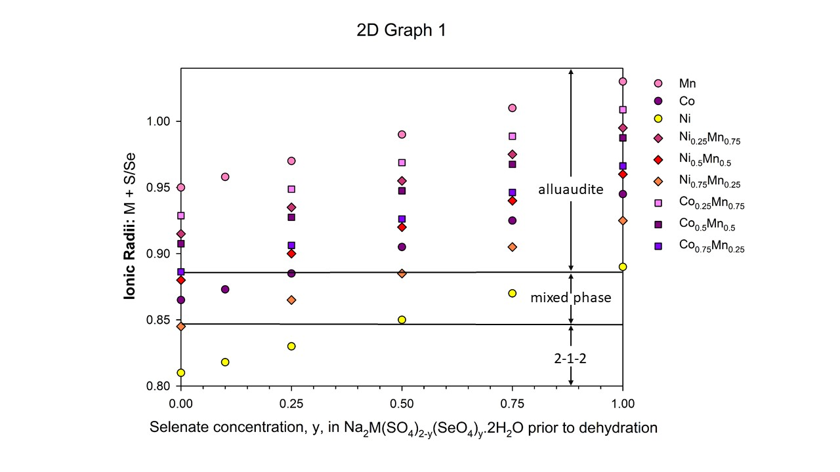
Figure 13: Revised plot of sum of the weighted average ionic radii of M and the weighted average ionic radius of S/Se (where M = Mn, Fe, Co and Ni) vs selenate content. Increasing the transition metal ionic radii, and/or increasing the selenate content, leads to the alluaudite-type structure becoming more favoured.
The variation of cell volumes for both the alluaudite and 2-1-2 phases against level of selenate doping are shown in Figure 14 and Figure 15. Both plots show a general increase in cell volume with the increase in selenate content. The alluaudite cell volumes show similar cell parameter increase in gradients for all series, consistent with a uniform increase in cell size on selenate doping. For the 2-1-2 and Cu series (Figure 16), a similar percentage increase is also observed, confirming the selenate incorporation.

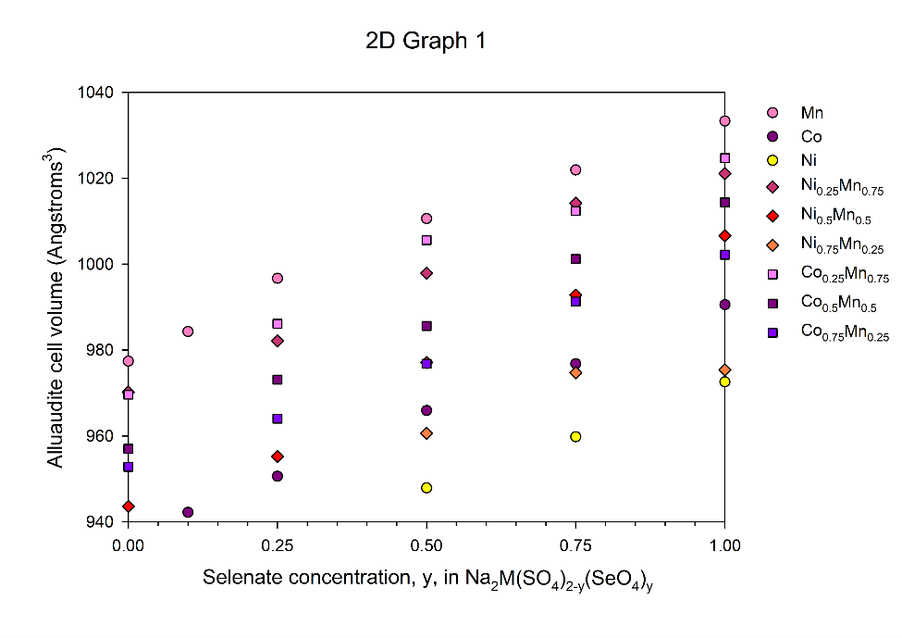
Figure 14: Variation in cell volumes with selenate content for the alluaudite phases.
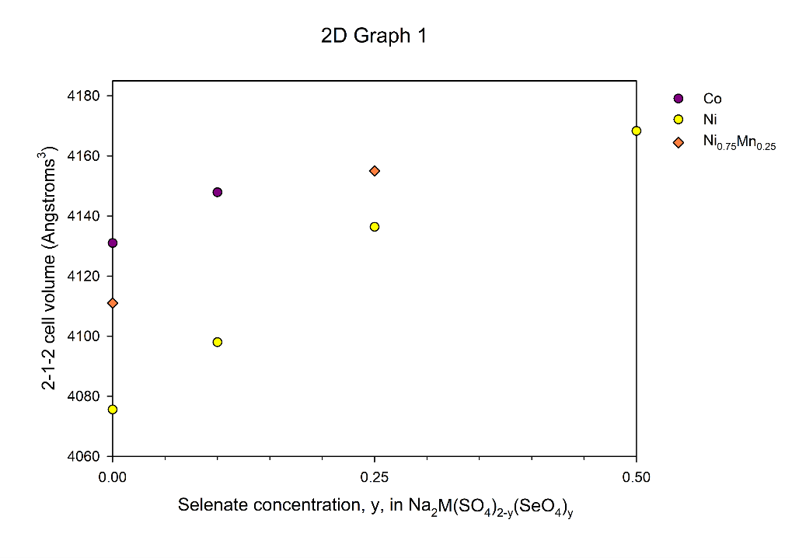
Figure 15: Variation in cell volumes with selenate content for 2-1-2 samples. (Refined unit cell parameters with a phase weight percent less than or equal to 4% have not been included in this plot).

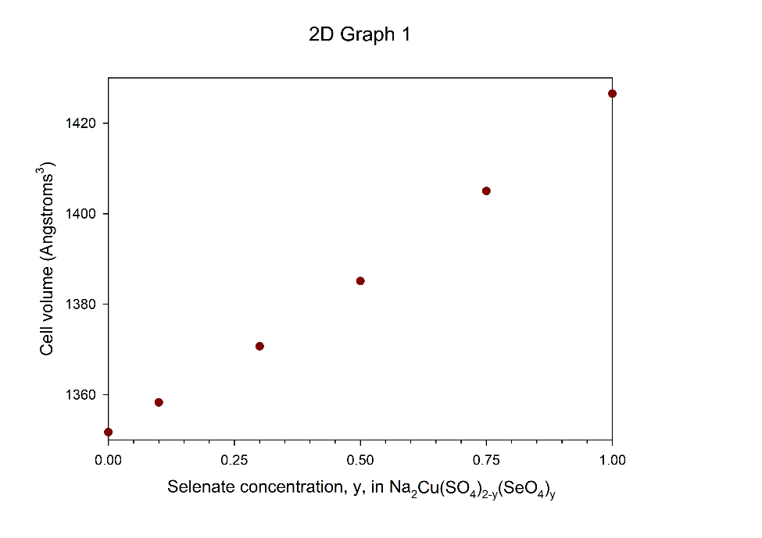
Figure 16: Variation in cell volumes with selenate content for Na₂Cu(SO₄)_{2-y}(SeO₄)_{y}. Sulfate endmember cell volume value from ref [³¹].

Conclusions
The results validate our earlier proposal of the relationship between structure of Na₂M(SO₄)_{2-y}(SeO₄)_{y} samples and the sum of the transition metal and weighted average S/Se ion radius, showing that this relationship extends to mixed transition metal systems (Figure 13). In particular the alluaudite structure is obtained for large ionic radii sums, while the 2-1-2 structure forms for small ionic radii sums. Thus the former can be obtained by either increasing the transition metal site size (e.g. Fe, Mn incorporation) and/or selenate doping, while smaller transition metals (e.g. Ni incorporation) and no selenate doping favours the latter. Overall, this established size relationship within these sodium transition metal (Fe, Mn, Co, Ni) sulfate systems provides the ability to effectively tune the material to the desired structure. However, we note the relationship only applies to metal ions in the octahedral geometry, since the related Cu containing systems are shown to adopt a different structure, most likely related to the Jahn Teller nature of Cu²⁺, where Cu adopts a tetragonal pyramid geometry with the addition of two elongated bonds to oxygen below the base. In this system, no change in structure is observed on selenate doping.
Acknowledgements
We would like to thank the University of Birmingham for funding (scholarships to EHD, LLD)

References
1 T. Brown, A. Walters, N. Idoine, G. Gunn, R. A. Shaw and D. Rayner, Br. Geol. Surv., 2016, 39.
2 C.-X. Zu and H. Li, Energy Environ. Sci., 2011, 4, 2614–2624.
3 E. H. Driscoll, L. L. Driscoll and P. R. Slater, in Encyclopedia of Inorganic and Bioinorganic, 2019, doi.org/10.1002/9781119951438.eibc2686.
4 S. Roberts and E. Kendrick, Nanotechnol. Sci. Appl., 2018, 11, 23–33.
5 K. Mizushima, P. C. Jones, P. J. Wiseman and J. B. Goodenough, Mater. Res. Bull., 1980, 15, 783–789.
6 A. K. Padhi, K. S. Nanjundaswamy, J. B. Goodenough and R. L. Batteries, J. Electrochem. Soc., 1997, 144, 1188–1194.
7 P. Barpanda, G. Oyama, S. I. Nishimura, S. C. Chung and A. Yamada, Nat. Commun., 2014, 5, 1–8.
8 G. Oyama, S. ichi Nishimura, Y. Suzuki, M. Okubo and A. Yamada, ChemElectroChem, 2015, 2, 1019–1023.
9 D. Dwibedi, R. B. Araujo, S. Chakraborty, P. P. Shanbogh, N. G. Sundaram, R. Ahuja and P. Barpanda, J. Mater. Chem. A, 2015, 3, 18564–18571.
10 D. Dwibedi, R. Gond, A. Dayamani, R. B. Araujo, S. Chakraborty, R. Ahuja and P. Barpanda, Dalt. Trans., 2017, 46, 55–63.
11 J. Gao, P. Zhao and K. Feng, Chem. Mater., 2017, 29, 940–944.
12 K. Trad, D. Carlier, L. Croguennec, A. Wattiaux, M. Ben Amara and C. Delmas, Chem. Mater., 2010, 22, 5554–5562.
13 K. Trad, D. Carlier, L. Croguennec, A. Wattiaux, M. Ben Amara and C. Delmas, Inorg. Chem., 2010, 49, 10378–10389.
14 D. Harbaoui and M. M. S. Sanad, 2017, 3, 13051–13061.
15 D. Liu and G. T. R. Palmore, ACS Sustain. Chem. Eng., 2017, 3, 3–8.
16 R. Essehli, I. Belharouak, H. Ben Yahia, K. Maher, A. Abouimrane, B. Orayech, S. Calder, X. L. Zhou, Z. Zhou and Y. Sun, Dalt. Trans., 2015, 44, 7881–7886.
17 J. Kim, H. Kim and S. Myung, J. Mater. Chem. A, 2017, 96, 22334–22340.
18 W. Huang, B. Li, F. Saleem, X. Wu and J. Li, Chem. Eur. J., 2015, 21, 851–860.
19 W. M, X. Liu, Y. Zhao, S. Liu, H. Liu, Y. Dong, Q. Kuang and Q. Fan, J. Solid State Chem., 2018, 22, 891–898.
20 D. Marinova, V. Kostov, R. Nikolova, R. Kukeva, E. Zhecheva and R. Stoyanova, 2015, 22287–22299.
21 J. Lu, S. Nishimura and A. Yamada, Chem. Mater., 2017, 29, 3597–3602.
22 W. Adam Phelan, O. T. Sweeney, A. M. Fry, N. Drichko, M. A. Siegler and T. M. McQueen, J. Solid State Chem., 2014, 222, 129–135.
23 M. Reynaud, G. Rousse, A. M. Abakumov, M. T. Sougrati, G. Van Tendeloo, J.-N. J.-N. Chotard and J.-M. J.-M. Tarascon, J. Mater. Chem. A, 2014, 2, 2671–2680.
24 P. Barpanda, G. Oyama, C. D. Ling and A. Yamada, Chem. Mater., 2014, 26, 1297–1299.
25 L. L. Driscoll, E. Kendrick, K. S. Knight, A. J. Wright and P. R. Slater, J. Solid State Chem., 2018, 258, 64–71.
26 D. M. Marinova, E. N. Zhecheva, R. R. Kukeva, P. V. Markov, D. D. Nihtianova and R. K. Stoyanova, J. Solid State Chem., 2017, 250, 49–59.
27 D. M. Marinova, R. R. Kukeva, E. N. Zhecheva and R. K. Stoyanova, Phys. Chem. Chem. Phys., 2018, 20, 12755–12766.
28 D. Marinova, V. Kostov, R. Nikolova, R. Kukeva, E. Zhecheva, M. Sendova-Vasileva and R. Stoyanova, J. Mater. Chem. A, 2015, 3, 22287–22299.
29 L. L. Driscoll, E. Kendrick, A. J. Wright and P. R. Slater, J. Solid State Chem., 2016, 242, 103–111.
30 S. Nishimura, Y. Suzuki, J. Lu, S. Torii, T. Kamiyama and A. Yamada, Chem. Mater., 2016, 28, 2393–2399.
31 O. Mentré, C. Masquelier, O. I. Siidra, M. Colmont, D. O. Nekrasova, S. Y. Stefanovich and V. M. Kovrugin, Cryst. Growth Des., 2018, 19, 1233–1244.

