The increasing dynamic, functional complexity of bio-interface materials

B. Santos Gomes,‡ B. Simões,‡ and P. M. Mendes*
School of Chemical Engineering, University of Birmingham, Birmingham, B15 2TT, UK.
Telephone: +44 (0) 121 414 5343; Telefax: +44 (0) 121 414 5324;
‡These authors contributed equally to this review; E-mail:p.m.mendes@bham.ac.uk.

In nature, interfacial molecular interactions are at the heart of all biological processes that are greatly mediated by a diversity of stimuli. Inspired by natural molecular responsive mechanisms and our increased capability to manipulate matter at molecular level, a new generation of bio-interface materials is being developed that possess responsiveness towards various external stimuli. In this review, we discuss emerging methods for imparting surfaces with dynamic properties and how these in turn are introducing increased functional complexity at the bio-interface. We examine how recent advances are becoming important in providing new insights on cell behaviour, allowing progress in the regenerative medicine and tissue engineering fields, providing new opportunities to address the intricate issues associated with biofouling and opening the door to on-demand sensing devices and highly effective delivery, bioseparation and bioelectrocatalytic systems. Although progress is being made, the review also highlights that current methods are still limited in their capability to impart complex functionality onto the bio-interface to fully address the current challenges in biotechnology and biomedicine. Exciting prospects include incorporation at the bio-interface of full reversibility of interactions, a broad repertoire of multi-responsiveness and bidirectional actuation as well as the capability to implement developed systems into practical use.

1. Introduction

Nature has been a permanent creative source of inspiration for conceiving novel synthetic materials with tailored properties and functions. From the development of nylon to mimic the functionality of silk and the invention of Velcro inspired by the burrs of plants to the more recent advances on synthetic gecko-inspired adhesives and lotus leaf-inspired self-cleaning materials, the structure, form and function of nature materials are being emulated to create a wide-range of high-performance materials for the benefit of human beings. With living organisms exhibiting the prevalent characteristic of responding to a multitude of stimuli (including temperature, pH, chemicals, pressure, magnetic and electric fields), an invaluable source of examples exists for us to hold on to develop materials with stimuli-responsive properties. Indeed, the search for improved functionalities to meet current needs has led to the introduction of the concepts of stimuli-responsiveness borrowed from biological systems into synthetic materials. In this context, active and switchable bio-interfaces have made rapid advances in recent years due to their relevance in many biotechnological and biomedical applications.^{1, 2} It includes their use to understand and control mammalian^{3, 4} and bacterial cells, ^{5, 6} as dynamic tools for bioseparation,⁷ biosensing⁸ and bioelectrocalatysis⁹ and as responsive nanomaterials for cancer therapy,^{10, 11} and smart cancer theranostics.¹²
The creation of stimuli-responsive interfaces between synthetic materials and biological systems is providing the unprecedented ability to modulate biomolecular interactions, emulating, thus, aspects of the transient interactions that are central to all biological processes, including signal transduction, cell differentiation, enzyme catalysis and inhibition and DNA replication and transcription.^{13, 14} These transient interactions, which can involve, for instance, protein-protein, protein-ligand, protein-DNA interactions, are initiated by a broad variety of chemical and physical stimuli and can comprise intracellular relocalizations, chemical modifications and structural rearrangements.¹⁵ Several new techniques have recently emerged for deciphering mechanistic details of these dynamic transient interactions, comprising in vivo and in vitro studies.¹⁶⁻¹⁸ The increased knowledge brought up by these studies, together with the emerging advances on controlling biomolecular interactions, can open important prospects in the development of advanced discovery tools for identification of targets suitable for therapeutic intervention in a broad range of disease conditions.
With the increased experimental capability to manipulate and characterize matter at the molecular level, and concomitant advances in molecular modelling and simulations, stimuli-responsive mechanisms are being creatively incorporated into bio-interfaces to dynamically control their properties and functionalities (Figure 1). Owing to their capability for temporal regulation of molecular interactions, stimuli-responsive bio-interfaces have been devised to mimic the dynamic characteristics of the natural extracellular matrix (ECM), leading to new efforts to understand and control cell behaviour.^{3, 19} Although the developed strategies remain far from capturing the complex ECM-cell interactions encountered in vivo, they are providing new insights on how cells respond to temporal variations in their environment and how they can be manipulated at the bio-interface to engender desired cellular responses. The latter has important implications on the control of regenerative processes and repair of damaged tissues. Furthermore, a paradigm shift from static to dynamic molecular interactions at bio-interfaces is providing an unprecedented opportunity for developing active bio-interfaces to understand⁵ and prevent⁶ bacterial adhesion. Stimuli-responsive bio-interfaces are also regarded as ideal platforms for on-demand precise drug release inside the human body²⁰ and sensing platforms with the capability to detect binding events only when required.⁸ Incorporation of redox active molecules, such as proteins and enzymes, at the bio-interface, in which their activity can be tuned on-demand upon application of an external stimulus, is offering new possibilities to modulate electron-transfer processes and bioelectrocatalysis.²¹
Herein, emerging advances of stimuli-responsive bio-interfaces are reviewed and their role from tuning molecular interactions to induce the desired response is highlighted. To begin with, we aim to delve into aspects of stimuli choice, diversity and capability to induce a particular response. From there on, the review is primarily organized according to the properties imparted to the bio-interface rather than around the form of stimuli used for their activation. Key achievements and challenges associated with the development of active, dynamic biointerface materials for modulating biomolecule capture and release, bioelectrocatalysis, cell behaviour and bacterial adhesion are discussed. Our aim is that by looking at the field from a functional perspective, we can bring to light key factors contributing to specific properties on dynamic bio-interfaces and discuss which hurdles still prevail in terms of harnessing molecular designs, surface molecular tailoring and switching mechanisms to achieve highly desired functions. At present, advances are largely confined to academic settings, and in this review we shed light on key design aspects that need to be considered to drive the emerging developments from the laboratory to the end user.

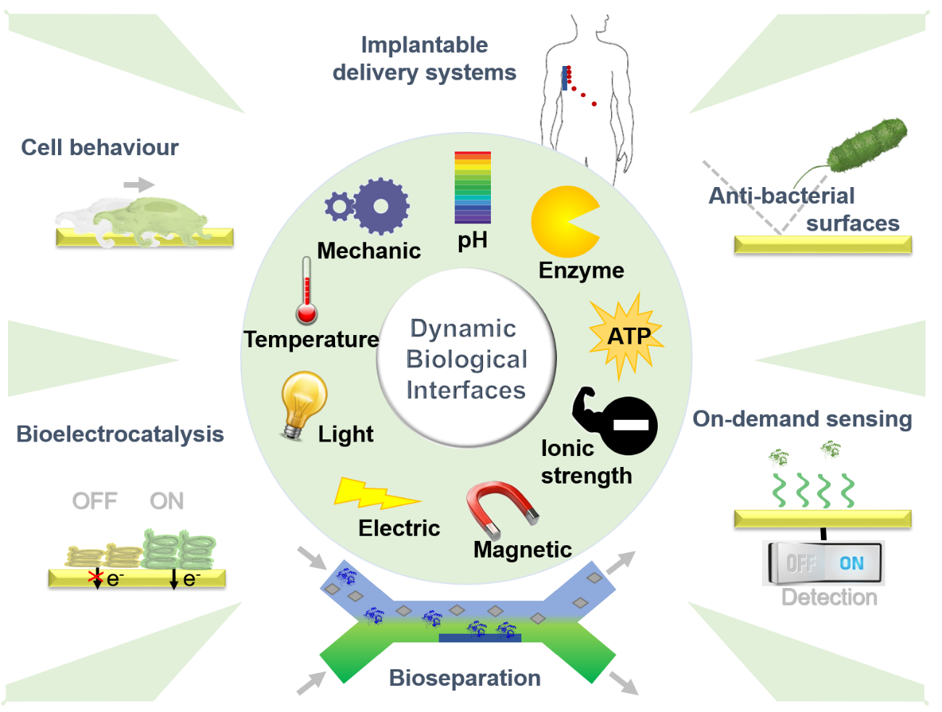
Figure 1 - Scheme illustrating the broad range of stimuli that have been explored to develop dynamic biological interfaces for a numerous of biological and medical applications.

2. Stimuli choice, diversity and capabilities

Two main paths can be taken for a stimulus to induce changes in the bio-interfacial interactions between material surfaces and biological systems. One is the stimulus to act on the biological system,^{22, 23} whereas the other relies on eliciting a change in the material surface.^{1, 21} While both strategies have been demonstrated with success, the latter has been extensively explored since it affords wider biomedical and biotechnological applicability, while potentially avoiding complex and time-consuming processes related with the re-engineering of biological systems. The capability to tune the chemical properties of a surface material depends on an intimate interplay between molecular composition, arrangement and topography within the first few nanometers of the surface, and also location and type of stimulus. It is based on such premises that material surfaces have been developed that can trigger molecular interaction changes at the bio-interface using a wide range of stimuli. These stimuli include electric potential and field,²⁴ magnetic field,^{25, 26} mechanical force,^{6, 27} light,^{28, 29} temperature,^{30, 31} pH,^{32, 33} ionic strength³⁴ and the presence of molecules such as adenosine triphosphate (ATP),³⁵ carbohydrates³⁶ and enzymes.^{37, 38} Self-assembled monolayers (SAM),²⁴ polymeric systems,³⁹ molecular imprinting⁴⁰ and nanopatterning techniques⁴¹⁻⁴³ are proving instrumental for the rational design of stimuli-responsive surfaces.
With the first developments being focused on single-stimulus responsive property of the bio-interface, the field has been witnessing a growing interest in the concept of bio-interfaces with responsiveness to multiple stimuli.^{44, 9, 45} Although the presence of a bio-interface with single-responsive attributes is well capable of meeting the needs of many biotechnological and biomedical applications, the possibility of combining two or more stimuli enhances the bio-interface capability, versatility and applicability while bringing us closer to mimic complex natural systems. Emerging systems are showing that multi-stimuli-encoded bio-interfaces are able to induce synergetic effects⁴⁴ and program electrochemical output signals using “OR” and “AND” logic gate concepts.⁹
All different stimuli have their own strengths and limitations, and depending on the applicability of the dynamic bio-interface, some can be more effective than others in triggering a particular response. Thus, by defining the requirements of the application, the necessary control over bio-interactions and the environment in which the stimuli-responsive material needs to perform, identification of the most effective stimulus (or stimuli) for development of a responsive bio-interface is possible. The stimuli should be non-invasive and can, for instance, be restricted by the conditions required for normal biological functions. In the design of stimuli-responsive materials for in vivo drug delivery, one can consider the use of non-invasive endogenous stimulus (e.g. pH or specific enzymes) but where one needs to address the sensitivity of the system to low cue concentrations and the capability of the system to deal with fluctuations in the endogenous cues in different patients. On the other hand, while an external stimulus mitigates such fluctuations, the strong source intensity (e.g. magnetic field or light) required for system activation in the body restricts their use in eventual clinical applications. Thus, the judicious selection of stimuli in the design of stimuli-responsive delivery systems is critical and where we are currently witnessing the introduction of more advanced non-invasive external stimuli, such as near-infrared (NIR) radiation,⁴⁶ to address some of the challenges.
In another example, if the purpose is to better understand or control cell behaviour in vitro, since cells function under a narrow pH and ionic strength range, other stimuli such as temperature,⁴⁷ electrical potential⁴ or light²⁸ are more adequate. In certain settings, one can take advantage of native stimuli provided by cells (i.e. endogenous stimulus), such as cell-secreted enzymes (e.g. matrix metalloproteinases³⁷ and alkaline phosphatase³⁸) or pH changes due to production of acids resulting from bacterial metabolism³³ to devise cell-responsive bio-interfaces with highly desired autonomous functionality. Addressability, mode of actuation and spatial control are characteristics associated with all different stimuli that can be also determinant in the appropriate stimulus selection (Table 1).

Table 1 – Addressability, mode of actuation, spatial resolution and switchable entities associated with a particular stimulus.
Stimulus | Addressability | Actuation | Spatial Control | Examples of switchable entities
pH | Easy | Contact | No | Poly(acrylamide-co-acrylic acid) (P(AAm-co-AAc))⁷; Poly(methacrylic acid) (PMAA)⁴⁸
Temperature | Easy | Remote | No | Poly(N-isopropylacrylamide) (PNIPAM)⁴⁹
Mechanical | Advanced | Remote | No | Polydimethylsiloxane (PDMS)⁶
Optical | Intermediate | Remote | Yes | O-Nitrobenzyl derivatives⁵⁰; Spiropyran⁵¹; Azobenzene⁵²
Magnetic | Advanced | Remote | Yes | Magnetic structures²⁵ and particles²⁶
Electrical | Advanced but with multiple individually addressability | Remote | Yes - Nanoscale | Hydroquinone–quinone redox couple¹⁹; Charged molecular entities⁵³; Poly(3,4-ethylenedioxy thiophene) (PEDOT) ⁵⁴; Polypyrrole (PPy)⁴⁰

Together with other chemical stimuli, the benefits of pH-driven bio-interface changes include easy addressability and the possibility to directly affect the binding affinity of the surface material for biomolecules in solution.⁷ Temperature is also easy to control and apply, but in contrast with chemical stimuli, it relies on remote actuation, which gives the possibility to tune biomolecular interactions without altering the solution composition. Temperature-controlled bio-interfaces have been relying mainly on the reversible, sharp phase transition behaviour of thermo-responsive polymers, namely PNIPAM.^{30, 31} Mechanical stimuli, such as stretching and compression, open up the possibility to induce mechanical movements and reversibly tune geometrical structures of bio-interfaces.⁶ Local stimulation is generally not possible with chemical, thermal or mechanical stimuli, and thus if spatial control is required, optical, electrical and magnetic stimuli are able to meet such demands. While optical stimulus can be considered more convenient than electrical stimulus, the latter allows for easy creation of multiple individually addressable switchable nanoregions on the same surface.⁵⁵ On the other hand, while light as a stimulus is independent on the material used, an electrical and magnetic stimulus requires an electrically conducting and magnetic substrate material, respectively. Irreversible photocleavage of o-nitrobenzyl derivatives⁵⁰ and reversible photo-triggered isomerization of spiropyran⁵¹ and azobenzene⁵² moieties are photoreactions commonly used to achieve photo-switchable bio-interfaces. Electrically responsive surfaces operate generally under similar trigger-induced modifications as photo-switchable surfaces, where the hydroquinone–quinone redox couple,¹⁹ charged molecular backbones⁵³ or end groups⁵⁶ and conductive polymers, such as PEDOT,⁵⁴ feature prominently as the switching units.

3. Autonomous capabilities

While most developed stimuli-responsive systems are unidirectional as they require repetitive on–off switching of external stimuli to induce bidirectional action, non-unidirectional, autonomous systems are less explored, but may offer unique opportunities as self-beating pacemakers, drug release systems synchronized with human biorhythms and autonomous mass transport systems, mimicking, for instance, the capillary blood flow or the intestine-like peristaltic pumping motion. Self-oscillating polymer gels have been at the centre of such efforts, where the chemical energy of the Belousov–Zhabotinsky (BZ) reaction is converted into mechanical energy to generate periodic volume or shape changes. In particular, Yoshida and co-workers^{50, 51} have developed a self-oscillating cross-linked gel composed of PNIPAM with covalently bound ruthenium tris(2,2′-bipyridine) (Ru(bpy)₃) as the BZ catalyst. The BZ reaction generates autonomous and rhythmical redox oscillations from the oxidized Ru(III) state to the reduced Ru(II) state, which induces a periodic swelling-deswelling of the gel upon its immersion in an aqueous acidic solution containing the substrates for the BZ reaction. Recent improvements on the functions of self-oscillating polymer systems ranges from enhanced - but still modest - swelling-deswelling amplitudes (i.e. in the range of 100 μm)⁵⁷ and oscillation frequencies (i.e. in the order of 0.5 Hz)⁵⁸ to achieving autonomously self-propelled motion,⁵⁹ autonomous transport,⁵⁷ and unidirectional control of self-oscillating waves.⁶⁰ The emphasis thus far has been on modifications of the internal structure of the BZ gels that are expected, together with hierarchical integration, to continue to drive the next level of complexity and function, such as time-asymmetrical responses or capability to adapt to external signals. However, if these out-of-equilibrium systems are to progress from proof-of-concept to biomedical technological solutions, the feedback-controlled systems will need to be designed to be biocompatible, sustain long lasting stability and operation in biological environments and utilise substrates at biologically relevant concentrations.

4. Capture and release of bioactive molecules at the material interface

4.1. Controlled release for in vivo drug delivery systems

One of the most well-demonstrated behaviours in dynamic synthetic surfaces is their capability to immobilize and/or release bioactive molecules on demand. Indeed, this capability is embedded in many examples of stimuli-responsive nanoparticles for controlled drug release that are promising nanoconstructs for theranostics.⁶¹ However, it is important to highlight that on nanoparticle design, not only the incorporation of stimuli-responsive mechanisms needs to be considered, but also particle size and charge, shape and flexibility since they play a key role in vivo distribution, stability and targeting ability, and in their toxicity and elimination.⁶² While significant progress has been made with respect to nanoparticles capability for drug encapsulation and responsiveness to various endogenous and exogenous stimuli,⁶³⁻⁶⁵ in which pH has been widely explored as a stimulus, their clinical translation remains challenging. These hurdles are reflected in the very limited number of stimuli-responsive nanoparticles that have reached clinical trial (e.g. ThermoDox). One of the key challenges is how to achieve controlled release in vivo with precise spatiotemporal control. The use of an external stimulus (e.g. temperature, magnetic field, ultrasound, light or electrical) provides better control to achieve it, but their efficacy has been hindered by the limited depth of penetration in tissue. These difficulties are starting to be tackled by designing nanoparticles that rely on the synergetic effect of endogenous and exogenous stimuli.⁴⁶ However, in vitro and in vivo studies would be needed to ascertain the clinical viability of such strategy. Thus, future efforts should be directed at understanding and establishing high efficacy of stimuli-responsive nanoparticles in vivo and indeed their suitability to be introduced in the human body (i.e. biodistribution, toxicity, and degradation).^{66, 67} Nanoparticle features such as robustness and maximum function, while obeying to minimal design principles, are expected to play key roles in meeting this challenge. A more extensive discussion on this subject is available elsewhere.^{68, 69}
Capture and release capabilities have been also explored for creating implantable systems with controlled on-demand release properties. In this setting, an electrical stimulus is highly suited for externally and precisely controlling the release of therapeutics in the body, and this is reflected in the considerable focus being given to the development of electro-responsive polymer-based implantable delivery systems.^{70, 71} Furthermore, the use of an electrical stimulus allows delivery in sites of difficult access to other stimuli-responsive delivery systems, namely the brain and the eye. As an example, by emulating the natural release process of neurotransmitters in the retina, PPy-based molecularly imprinted polymer films have been created for the retinal neurotransmitter glutamate to chemically stimulate retinal neurons.⁴⁰
There are several aspects to consider when designing a switchable drug release interface. The system should be compatible with surrounding tissues, able to accommodate a high drug loading, have an efficient and highly controllable release process and perform under a diverse portfolio of drugs. In order to address such requirements, conductive polymers are being recently integrated with structured surfaces to sustain high drug loading and fabricate high effective electrochemical surface areas. The latter promotes the speed and extent of ion movement into and out of the polymer, allowing more precise and higher responsiveness. Three-dimensionally ordered macroporous PPy inverse opal thin films are shown to enhance drug loading capacity and provide not only sustained release but also pulsatile release triggered by electrical stimulation.⁷² The active release of the drug – corticosteroid hormone - incorporated into the polymer occurs due to a change in charge and volume caused by the movement of ions during electrical stimulation. The system offers the possibility to fine-tune the dosage required, depending on the disease state and patient’s needs. With similar proviso in mind, anodized aluminium oxide (AAO) membranes, which exhibit high density arrays of uniform and parallel nanopores, are able to incorporate large amounts of drugs for the release during extended periods of time.²⁰ By electropolymerizing PPy doped with dodecylbenzenesulfonate anions (PPy/DBS) onto the top and upper side wall of the AAO membrane, the pore of the membrane can be open or closed upon switching of redox states (oxidation vs reduction), allowing on-off drug release. These and many other examples reported in the literature^{70, 71} illustrate how, in particular, electro-responsive polymer films can be imparted with controlled and responsive molecular transporting abilities for tunable implantable delivery systems. However, endogenous biomolecule interference, biodegradability and efficacy in vivo are still aspects which need due consideration.

4.2. In vitro bioseparation systems

Bioseparation processes, which might entail extraction of proteins, peptides, DNA and antibodies at low concentration from complex biological fluids, should be conceived taking into consideration simplicity of operation, cost-effectiveness and performance in mild conditions. Thus, stimuli-responsive surfaces possess prominent advantages over conventional materials for inclusion in biomolecule sorting processes typically involving a series of sequential steps. By switching ON and OFF their affinity for the target molecule, in response to a stimulus, responsive surfaces allow higher capture and sequential elution of target molecules in organic solvent-free conditions. Furthermore, stimuli-responsiveness holds the innate merits of easy regeneration and prolonged reusability.
In order to meet the design criterion of simplicity of operation, temperature- and pH-responsive surfaces have been the most widely investigated responsive surfaces for integration in bioseparation processes by relying mainly on their capability to control hydrophobic and electrostatic interactions.⁷³ For instance, a cyclodextrin-grafted pH-responsive poly(ethylene glycol)-block-poly(acrylic acid) immobilised on an azobenzene-terminated SAM is able to reversibly expose a negative or neutral charge depending on the pH, inducing the capture or release of the positively charged protein cytochrome c.⁵² Whereas these systems, which are based on non-specific interactions, are able to meet some of the bioseparation end uses, the remaining challenge today is to promote a high degree of selectivity while creating a fully reversible system. In order to achieve this goal, an ingenious chemomechanical sorting system has been devised to catch and release target biomolecules from a solution mixture.⁷ Inspired from the ability of vesicle-carrying kinesins and dyneins to shuttle different biomolecule cargos along the microtubule network, a microfluidic system has been built to facilitate a bilayer fluid flow and accommodate bendy pH-responsive polymeric P(AAm-co-AAc) microscopic fins functionalised with a pH-sensitive, thrombin-specific aptamer (Figure 2). In such system, depending on the pH, the P(AAm-co-AAc) hydrogel is present either in its deprotonated form, which is capable of swelling and absorbing water or protonated form, which results in expelling of the water and hydrogel contraction. Based on such volume changes, at pH 7.2, the aptamer-decorated microfins are able to protrude into the top solution, exposing a high affinity aptamer for thrombin binding, leading to its capture. In acidic conditions, the hydrogel contracts into the bottom layer and simultaneously the aptamer undergoes denaturation, resulting in the release of the captured thrombin molecules into the bottom fluidic layer. Future efforts should continue to address the need for cost-effective bioseparation processes, wherein on-demand, fast reversibility of binding at the bio-interface can provide both high purity and high yield separations. Other notable features need to be kept in mind when developing future capture and release systems, namely their capability to selectively capture the target in complex biological medium and perform high-endurance switching cycles, while maintaining continuous high levels of performance.

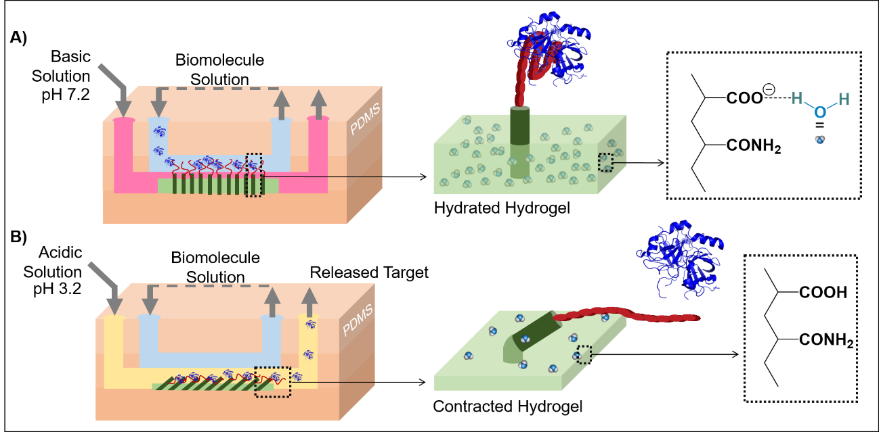
Figure 2 - (A) Biphasic microfluidic chamber showing the capture of thrombin in the top channel using aptamer-decorated hydrogel P(Aac-co-Aam) microfins that swell at pH 7.2.⁷ (B) Thrombin is released in the bottom channel due to the contraction of the hydrogel at pH 3.2 and denaturation of the aptamer.

4.3. In vitro and in vivo on-demand sensing

On-demand specific capture of biomolecules on surfaces provides the opportunity for detecting only when required. Many different stimuli-responsive surfaces have been described that can be used for on-demand sensing, where different biomolecules, including proteins, can be selectively immobilised by using electricity,⁵³ temperature,³⁰ and light⁵⁰ as a stimulus. For instance, an electro-switchable surface based on the response of a charged molecular backbone on the structure of a mixed SAM can dramatically alter the specific binding activity of a surface-tethered ligand (biotin) to a protein (neutravidin) in solution.⁵³
While control over selective immobilization can be readily achieved, attaining reversibility of binding is not trivial. Overcoming such challenge opens the opportunity for developing reagentless, durable and reusable biosensors. In order to attain these capabilities, a PNIPAM polymer has been conjugated with an anti-cardiac troponin T (cTnT) antibody immobilised on a gold surface to mediate ON and OFF antibody binding.⁸ When PNIPAM is in a collapsed globular conformation at 37 °C, the recognition site of the antibody is exposed and available for binding, thus yielding the cTnT – anti-cTnT complex and an increase in Faradaic impedance at the sensing surface. By reducing the temperature to 25 °C, the PNIPAM adopts an extended coil conformation pushing the cTnT from the surface, allowing the regeneration of the immune-sensor. Despite its importance in the design of high-performance sensors, development of surfaces with effective temporary selective immobilization of biological entities and their release for reusability purposes is still in its infancy stage. Long-term switching capability and stability within complex biological environments (e.g. serum or blood) and signal amplification are certainly other crucial, but challenging, aspects at play in high performance sensing that have been barely investigated to date. Only when we meet these different capabilities, we will be able to witness their practical applicability in the real-time monitoring of biological processes in cell culture systems, biomarker detection for disease diagnosis or integration in medical devices or biomaterials for in vivo implantation.

5. Tunable bioelectrocatalysis at the interface for in vitro, in situ and in vivo applications

Aside from allowing capture and release of biomolecules, a further developed capability of stimuli-responsive surfaces is to enable manipulation of the activity of redox species. It can be used to reversibly activate and deactivate bioelectrocatalysis, establishing a novel foundation for construction of electrochemical biosensors and biofuel cells for use as, for example, on-demand power sources for implantable electronic devices.⁷⁴ In such settings, it becomes essential to use an endogenous stimulus, in the form of, for instance, variations in physiological conditions, including concentration levels of biochemical substances (e.g. biomarkers). However, while feasibility has been demonstrated by transducing a biochemical input signal (e.g. urea and ethyl butyrate) into pH changes that activate/deactivate the bioelectrocatalytic glucose oxidation,⁷⁵ there is still a long way to go to fully develop and utilise these internally regulated devices for long term in vivo operation. Fundamental aspects regarding selectivity, precise manipulation, reversibility and stability are yet to be investigated and from which future improvements and progress will evolve.
In addition to their impact on bioelectrochemical systems, signal-triggered bioelectrocatalysis may also provide the basis for the development of platforms for biocomputing, information storage and processing, and signal transduction and amplification.⁷⁶ Over the past two decades, a variety of electrode surfaces have been devised that are able to control either the activity of electron mediators or redox enzymes by different stimuli, including light,⁷⁷ magnetic field,⁷⁸ temperature,⁷⁹ pH⁸⁰ and mechanical stress.²⁷ Recently, the unique physical and electrochemical properties of graphene nanosheets have been combined with the thermo-responsive polymer PNIPAM to mediate the activity of the immobilised enzyme cholesterol oxidase.⁷⁹ The switchable sulfonated graphene-PNIPAM donor-acceptor interface acts as a zip, wherein hydrogen bonding creates a coalescence of the interface at 20ºC that inhibits the diffusion of the substrate cholesterol for the catalytic enzyme reaction. At 40ºC, the hydrogen bonding is broken, opening the zip with consequent increase in permeability and access of the cholesterol oxidase to its substrate. In another notable work, polyelectrolyte multilayer architectures have been fabricated that expose or conceal the enzyme alkaline phosphatase by mechanical stretching, in a similar manner to those mechanisms involved in proteins during mechanotransduction.²⁷
Further increase in complexity has been achieved by integrating dual-signal bioelectrocatalysis.^{9, 81} An emerging example is the generation of a triarm block copolymer, which contains the thermo-responsive PNIPAM and pH-sensitive poly-N,N-diethylaminoethylmethacrylate (PDEAEMA) units, for controlling the activity of the enzyme glucose oxidase (GOx). In the ON state (pH 4 and 20ºC), the triarm block copolymer-based film with the embedded GOx is highly hydrophilic due to hydrogen bonding formation and, as a result, the enzyme can catalyse glucose due to its easy diffusion through the film. In the OFF state (pH 8 and 40ºC), the overall polymer structure becomes hydrophobic, supressing the interaction between the enzyme and its substrate.
Dual-signal bioelectrocatalysis has been also applied to build Boolean logic gates (i.e. “OR” and “AND”) based on enzymatic communications to deliver logic operations (Figure 3).⁹ This has been achieved by forming two graphene-based compartments, one containing acrylamide copolymerised with light-responsive spiropyran methacrylate molecular units poly(Aam-co-SPMA) with embedded pyrroloquinoline quinone (PQQ)-dependent glucose dehydrogenase (GDH) and the other comprising a temperature-responsive amine-terminated PNIPAM assembled with cholesterol oxidase (ChOx). The graphene surfaces are initially modified with an anionic surfactant, sodium dodecyl benzene sulfonate to inhibit aggregation of the individual nanosheets and promote the assembly of the enzymes and responsive polymers. The catalytic activity of both compartments depends on the capability of the substrates to diffuse through the responsive films. In a similar manner as described for an example above,⁷⁹ the mechanism in the temperature-responsive compartment relies on the reversible formation of hydrogen bonding between sulfonate groups of graphene and amino groups of the PNIPAM. In the case of the light-responsive compartment, the isomerisation of the spiropyran form into the merocyanine form (generated by UV irradiation) induces volume and polarity differences. While the spiropyran functionalised polymer forms a densely packed film, the charge-separated open-ring merocyanine functionalised polymer increases the permeability of the membrane, allowing the substrate to access the immobilised enzyme, thus facilitating electrobiocatalysis. An “OR” gate can be created by placing both compartments side by side, where either light or temperature can generate an electrochemical signal. If both compartments are on the top of each other, the system behaves as an “AND” gate, where an electrochemical signal is only generated when the substrates are allowed to diffuse through both compartments (UV light and 40ºC). Stimuli-responsive interfaces have been driving and will continue to drive progress in the development of more complex biocatalytic and signal-processing systems, which not only have important technological implications but also provide new opportunities to elucidate electron-transport pathways and mechanisms in living organisms. We are though at the proof-of-concept stage and the interfacing of tunable bioelectrocatalysis systems with biological environments or coupling with living organisms are yet to be addressed.
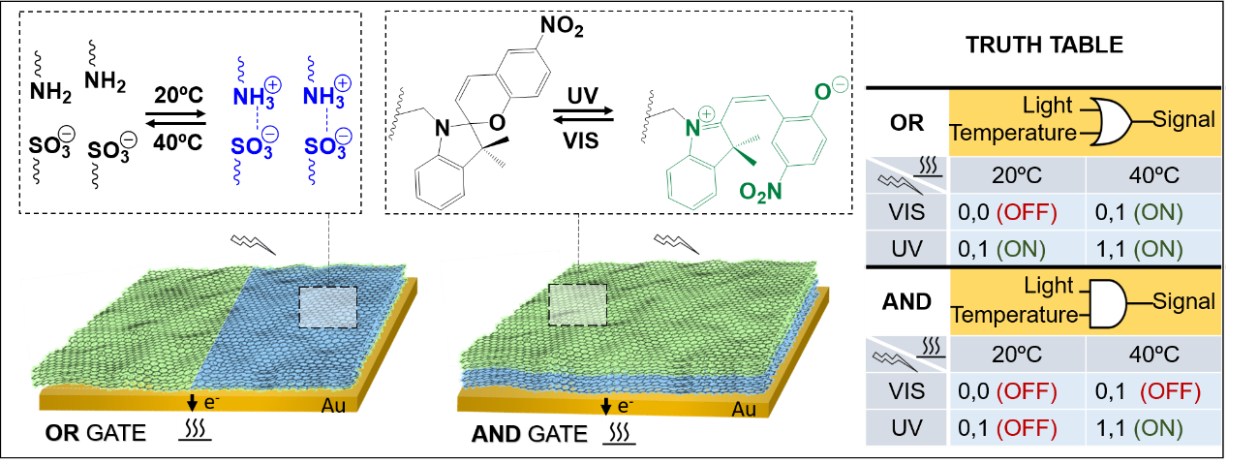

Figure 3 - Schematic illustrating two different model systems, which allow building an “OR” gate (left) and an “AND” gate (right) using both temperature change and light irradiation. The truth table shows all the input and output possibilities.⁹

6. Modulation and understanding of cell behaviour in vitro or in vivo settings

Cell-ECM interactions are complex and comprise highly dynamic bidirectional processes. Cells interact with and respond to ECM cues and subsequently remodel their surroundings by applying forces or synthesizing and degrading ECM. Cell-ECM interactions are responsible for cellular processes such as adhesion, migration, survival and proliferation. Thus, understanding and harnessing the bidirectional communication between cell and ECM is essential in approaches to regenerate tissue structure and function as well as to regulate disease processes. Although the reproduction of all of these dynamic features in a synthetic system is currently out of reach, initial efforts in this direction have been taken and they rely mainly on the capability of controlling cell adhesion, proliferation and detachment events. Among other uses, scaffolds with such capabilities provide a mean of targeting in vivo loco-regional regeneration of damaged tissues, wherein the regeneration is regulated by a stimulus.⁸²

6.1 Cell adhesion modulation via non-specific interactions

Dynamic cell adhesion–detachment modulation has been accomplished by harnessing non-specific interactions³¹ and specific interactions⁴ between cell membrane receptors, namely integrins and ECM proteins or short peptide sequences recognized by cell surface receptors. Stimuli-responsiveness, targeting the formation and disruption of weak, non-specific interactions, has been mainly implemented to facilitate the capture of cells and their efficient release.^{31, 83, 84} Since circulating tumour cells are present in blood in low abundance, this approach is quite valuable for cancer cell enrichment, isolation and detection. With this proviso in mind, PNIPAM thermo-responsive nanostructured surfaces have been developed to reversibly capture and release target cancer cells by combining switchable hydrophobic interactions and topographic interactions (Figure 4A).³¹ In this example, silicon-nanopillars, which are modified with PNIPAM, allow 3D interfacial contact with the protrusions of the cancer cells, enhancing the cell-capture performance. At 37°C, the PNIPAM-coated silicon nanopillars attract a BSA-biotin conjugate via hydrophobic interactions. Cancer cells, which overexpress the epithelial cell adhesion molecule (EpCAM) on their surface, are then immobilised via streptavidin and a biotinylated anti-EpCAM antibody. At 20ºC, the PNIPAM-BSA interactions are disrupted, causing desorption of the BSA-biotin conjugate and the release of highly viable cells. Aiming at the same application, pH-dependent reversible, covalent bonds between surface-tethered boronic acids and diols present in the carbohydrate chains of glycoproteins and glycolipids in the cell membrane can be taken advantage of to create a simplified responsive surface for capturing and releasing cancer cells, where surface recyclability is possible.⁸⁵ However, while boronic acids provide some selectivity for cancer cells, which display glycans at different levels or with fundamentally different structures than those observed on normal cells, glycan specificity using such synthetic carbohydrate receptors is still insufficient at this stage.

6.2 Cell adhesion modulation via specific interactions

Non-specific interactions can be manipulated and exploited for regulating cell adhesion and detachment, but a finer control over cell behaviour can be reached by targeting the switching of specific interactions between material surfaces and cells. Whole ECM proteins are large, making them difficult to engineer or manipulate for incorporation in stimuli-responsive surfaces for controlling specific interactions. In contrast, peptide sequences can provide a simplified system, in which their functionality can be easily switched ON and OFF by applying an external stimulus. In this regard, the control of the activity of the surface-tethered cell adhesive peptide arginine-glycine-aspartic acid (RGD) has been widely demonstrated using diverse stimuli, such as temperature,^{86, 87} electrical potential,^{4, 56} and light.^{28, 88} The RGD sequence is the recognition site of a large number of adhesive ECM proteins, and a third of the integrin cell adhesion receptors are known to bind to this sequence. RGD sequence has been immobilised on various substrates, such as hydrogels,⁸⁶ gold,⁴ silicon,⁵⁶ glass²⁸ or quartz⁸⁸ and shown to be modulated to promote or inhibit cell adhesion. Two main approaches have been followed to control cell adhesion using the RGD peptide. The first one consists on taking advantage of non-covalent interactions to capture the RGD peptide on the surface, thus promoting cell adhesion, which is then followed by the breakage of the non-covalent interactions using external stimulation to release the RGD peptide and, subsequently, the attached cells. The second approach relies on masking or unmasking the RGD peptide using stimuli-responsive components presented on the modified surface. In this scenario, small changes in the conformation/orientation of the RGD peptide on the surface are able to modulate the availability and potency of the RGD sites for cell surface receptors.
Regarding the first approach, thermo-responsive recognition sites have been formed via molecular imprinting on PNIPAM-based hydrogels to specifically recognize the RGD peptide (Figure 4B).⁸⁶ The presence of PNIPAM allows that specific recognition sites are formed at 37ºC but then disrupted at 20ºC. Consequently, the collapse of the PNIPAM hydrogel at 37ºC allows specific binding of the RGD peptide and promotion of cell adhesion, while its swelling at 20ºC triggers the release of the RGD peptide and subsequent cell detachment.
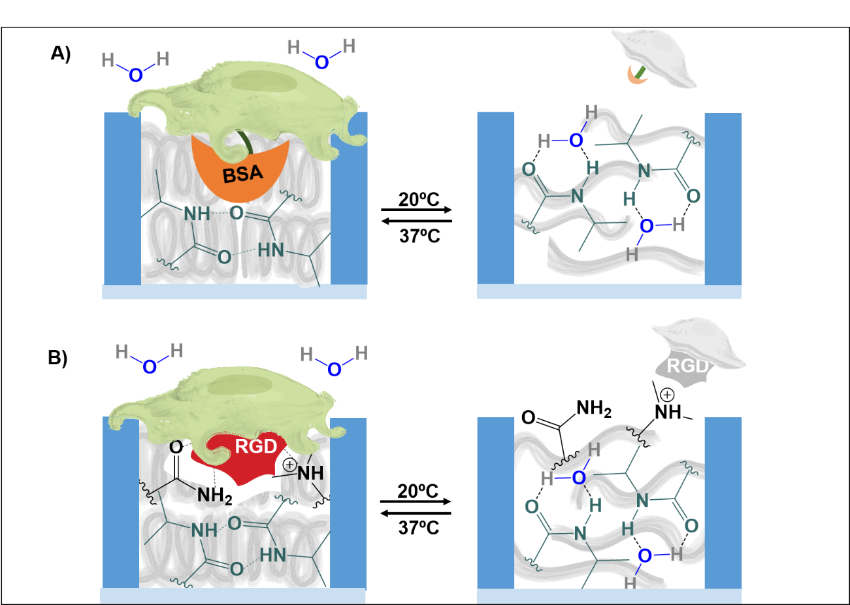
Figure 4 - Illustration of two approaches for cell adhesion-detachment regulation. Both use the temperature-responsive hydrogel PNIPAM, which at high temperatures exhibits hydrophobic properties and it is presented in a collapsed morphology that excludes solvent, while at low temperatures it is hydrophilic and is presented in an extended, solvent-swelled conformation. (A) BSA-biotin conjugate works as an anchor between the cell and the PNIPAM via hydrophobic interactions contributing to cell attachment. Under an extended conformation, interactions between BSA and the hydrogel are disrupted, resulting on the release of the cells. (B) RGD molecules are molecular imprinted into the hydrogel providing cell attachment. The extension of the hydrogel changes the organization of the recognition sites, releasing RGD molecules and cells.

In order to open the possibility for spatial control, capturing and releasing of the RGD peptide has been achieved by using azobenzene moieties to create reversible, self-assembled supramolecular host-guest systems on surfaces (Figure 5A).⁸⁸ A surface-tethered α-cyclodextrin (α-CD) is able to bind an azobenzene moiety functionalised with the RGD peptide (Azo-RGD) in the trans configuration, thus promoting cell attachment, while irradiation of the surface with UV light induces isomerization to the cis configuration, resulting in the release of Azo-RGD and cells. In this and other examples,^{86, 88} cell detachment is accompanied by a simultaneous release of a RGD peptide derivative or other components from the surface. The integrity of the surface is sacrificed during the switching and the cells released bear non-natural cell-surface components.
Ideally, control over cell adhesion and release should occur due to promotion and disruption of integrin-RGD interactions. With this purpose in mind, electrically-responsive surfaces, which open the opportunity for high level of spatial and temporal controllability, have been developed to manipulate the RGD accessibility to cells, taking advantage of charged molecular backbones⁴ or end groups.⁵⁶ RGD exposure or concealment is based on the capability of it being protrude from or immersed into the non-adhesive background (e.g. oligo(ethylene glycol)) of a mixed monolayer. For instance, positively charged lysines have been functionalised with an end glycine-arginine-glycine-aspartate-serine (GRGDS) recognition motif peptide and harnessed to induce its folding on the surface upon an application of a negative electrical potential (Figure 5B).⁴ These electrical-responsive surfaces are able to control cell adhesion by switching from a cell-resistant under a negative potential (RGD concealed) to a cell-adhesive (RGD exposed) state under open circuit conditions.
Yet, the stimuli-responsive interface should have the capacity to control adhesion in a reversible manner in order to more closely recapitulate the dynamic cell-ECM interactions and enable innovative applications in cell engineering where transplantation could occur without the presence of a biodegradable scaffold. Towards this end, surface-immobilised RGD peptides have been developed that can be presented or shielded by the collapse or swelling of thermo-responsive polymer brush films based on 2-(2-methoxyethoxy)ethyl methacrylate (MEO2MA).⁸⁷ Remarkably, the thermo-responsive surfaces allow disruption of the integrin-RGD interactions and release of the cells by a decrease in temperature from 37ºC to 23ºC. However, it is important to highlight that the effective disruption is dependent on the RGD surface density, where higher densities hinder cell detachment. The limitation is that a compromise needs to be found between high enough density to promote attachment and proliferation and low enough density for rapid cell release, preventing thus the desired high cell densities required in tissue engineering settings.
Photo-driven motions involving cis-trans isomerization of the azobenzene can be also employed to mask and unmask RGD peptide and regulate its interactions with cell-surface integrins using either polymer⁸⁹ or SAM^{28, 90} surfaces. Interestingly, a RGD-coupled azobenzene mixed SAM can reversibly switch, to a certain extent, cell adhesion within a time scale of seconds as monitored by single-cell force spectroscopy (Figure 5C).²⁸ During cycles of trans–cis–trans isomerization, the cells are shown to be more strongly attached to the RGD-coupled azobenzene mixed SAM under visible light (trans configuration) than under UV irradiation (cis configuration). More recently, push-pull-substituted azobenzene molecules, which carry an electron withdrawing nitro substituent in one ring and an electron donating methyl group in the other ring, are coupled with integrin ligand c(RGDfK) headgroups to modulate cell adhesion via nanoscale oscillations.⁹⁰ The presence of RGD push–pull azobenzene oscillations under continuous visible irradiation leads to a reinforcement of cell adhesion, which can be interpreted as the result of cell adhesion stimulation via mechanical forces. This is a very interesting example on stimuli-responsive surfaces, where molecular structured surfaces are being built to convert an initial macroscopic light stimulus into a nanomechanical stimulus to induce a cell response.
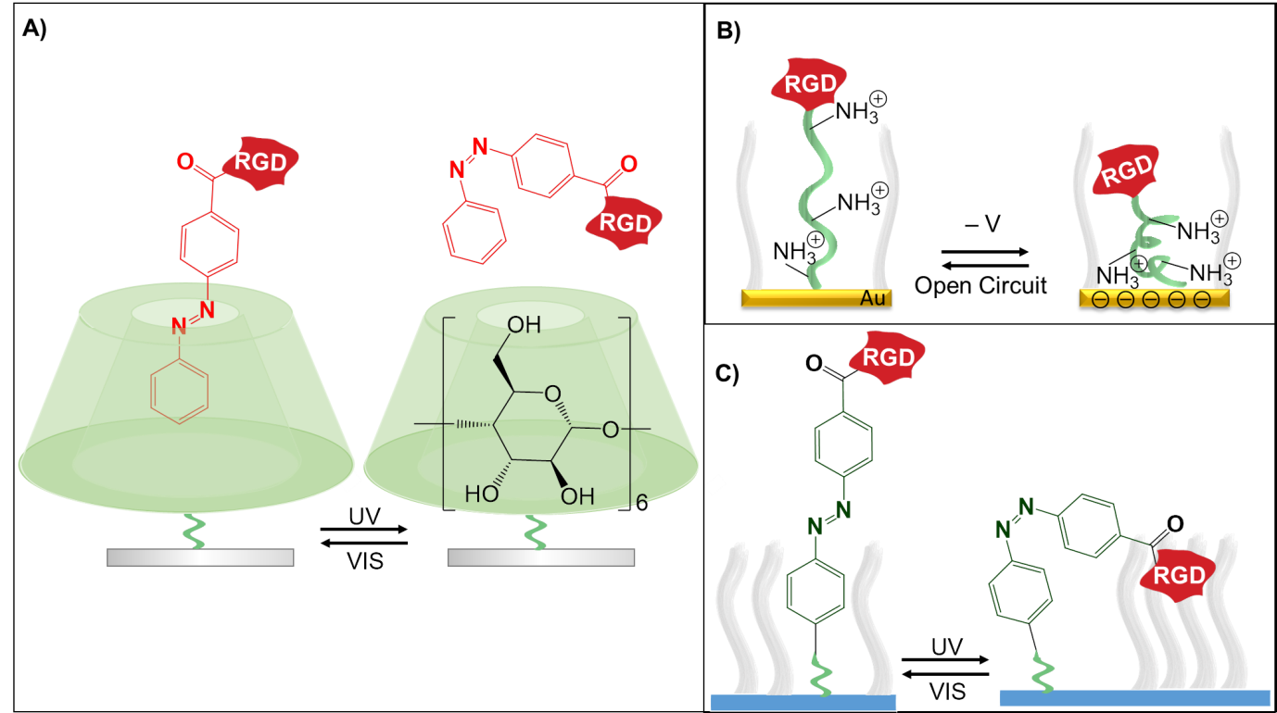
Figure 5 - Representation of three approaches for cell adhesion-detachment regulation based on the availability of RGD on the surface. (A) is based on the capture and release of RGD, while (B) and (C) are based on masking and unmasking of RGD. (A) The α-cyclodextrin captures the azobenzene in trans conformation, while releases it when in cis conformation. The capture and release of the RGD at the surface controls the cell adhesion and detachment, respectively. (B) Under open circuit, the extended conformation of the oligolysine allows RGD exposure, promoting cell adhesion. The positively charged oligolysine folds under a negative voltage, making the RGD unavailable for cell attachment. (C) The trans configuration of the azobenzene makes the RGD accessible to support cell adhesion, while the cis conformation conceals the RGD into the surrounding molecules.

Reversible control
of cell adhesion has so far mainly been limited to switching
adhesion by use of thermoresponsive materials, such as poly( N -
isopropylacrylamide),
[ 10,11 ]
which are ill-suited for local and rapid
switching at high spatial resolution. In contrast, light-induced
switching of cell adhesion could prove to be powerful in control-
ling cell adhesion at high spatial and temporal resolution.
Reversible control
of cell adhesion has so far mainly been limited to switching
adhesion by use of thermoresponsive materials, such as poly( N -
isopropylacrylamide),
[ 10,11 ]
which are ill-suited for local and rapid
switching at high spatial resolution. In contrast, light-induced
switching of cell adhesion could prove to be powerful in control-
ling cell adhesion at high spatial and temporal resolution.
While peptide sequences are easy to manipulate, steps in the direction of developing stimuli-responsive surfaces involving control over specific interactions between whole ECM proteins and cell membrane receptors have been taken. For instance, this behaviour has been achieved by combining, as in many emergent stimuli-responsive surface systems, switchable components with nanotopography. By incorporating nanopatterns within PNIPAM thermo-responsive polymer brush surfaces, fibronectin is able to selectively adsorb into the polymer free confined areas.⁹¹ The exposure of fibronectin at 37ºC supports the attachment and proliferation of cells, while a reduction in temperature to 25ºC allows their readily detachment. Although cellular detachment is shown not to deplete all fibronectin incorporated into the nanopatterned surface, the cell release is expected to be accompanied by fibronectin desorption.
While proof-of-concept examples exist on the use of UV light to control cell adhesion, this type of stimulus can potentially cause cell and tissue damage. Thus, in order to prevent such negative side effects, NIR radiation has been investigated to modulate ECM protein-cell membrane receptor interactions and shown to control cell detachment without affecting cellular integrity.⁵⁴ This capability has been demonstrated by culturing mesenchymal stem cells on NIR-sensitive PEDOT-coated substrates using serum-containing medium to promote their attachment and proliferation. Upon NIR exposure, stem cells are detached and shown to maintain their intrinsic characteristics as well as multilineage differentiation capacities. The disruption of the interactions between ECM proteins and integrin transmembrane receptors by heat generated from the photothermal effect of PEDOT is proposed to be responsible for the cell release.

6.3 Studies of cell behaviour

In addition to their role in modulating cell adhesion and detachment, stimuli-responsive surfaces are also under investigation to regulate cell growth factor secretion⁹² and understanding the complex regulatory processes of cell migration.^{3, 19} In the latter, photoactivatable and well-defined nanopatterned substrate provides the opportunity to precisely tune cell-substrate interactions in a spatiotemporal manner to analyse collective cell migration.³ The nanopatterned surface consists of gold nanoparticles that are arrayed in a regular manner with defined nanometer spacing and functionalised with cyclic RGD peptides and polyethylene glycol (PEG) moieties, which are linked to a glass substrate by photocleavable 2-nitrobenzyl ester moieties. PEG acts as a shielding layer, in which the RGD ligand only becomes available for promoting cell adhesion and migration when PEG is photocleaved by near-UV irradiation. On these nanopatterned surfaces, HeLa cells are first confined in photo-irradiated micro-regions, and then migration is promoted by a second photocleavage of the surrounding regions. In contrast to their collective migration behaviour on homogenous substrates, the HeLa cells are shown to change their migration phenotype and gradually lose their cell-cell contacts and become disconnected on the nanopatterned substrate. This study provides unprecedented evidence that cell-ECM interactions are an important factor regulating the decision of cells to migrate collectively or individually. Patterned electro-responsive surfaces can also be used to create a dynamic environment and trigger precise local cell migration. By employing the hydroquinone–quinone redox couple and electrochemically switching the cell-free regions from an inert to an adhesive migrating state, valuable insights into how initial pattern geometry and RGD ligand affinity and density affect migration velocity are being provided (Figure 6).¹⁹ Interestingly, this study reveals a new behaviour of cell migration memory related with cells capability to remember their initial state, which influences their velocity and focal adhesion patterns when they move off from the initial adhesion location to newly formed RGD presenting regions.

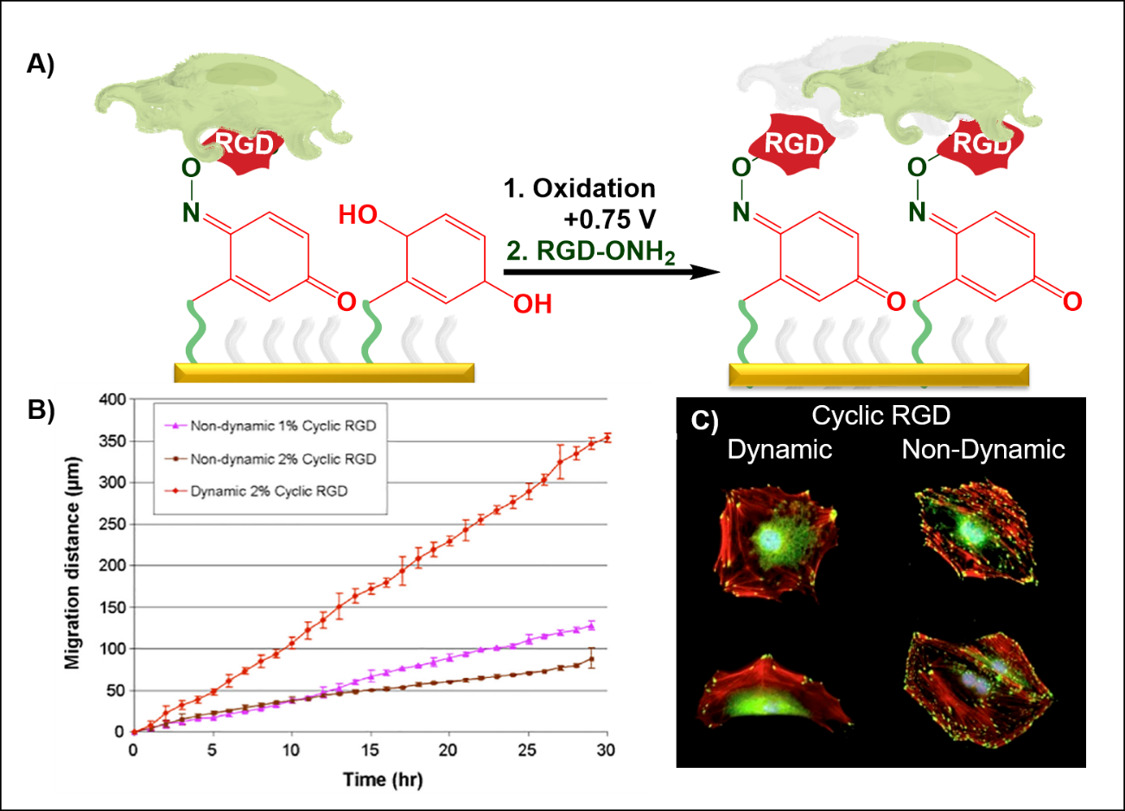

Figure 6 - (A) Representation of an electro-responsive SAM for understanding cell mobility. Following oxidation of the hydroquinone into a reactive quinone, oxyamine-tethered RGD is immobilized on the surface, allowing real-time monitoring of cell migration. (B) Dynamic conditions, relatively to non-dynamic, show a faster cell migration. (C) Fibroblasts under dynamic conditions show focal adhesion complexes (as shown in green by labelling the paxillin protein) that are more transient and localized at the periphery, compared with non-dynamic conditions where stable focal adhesion complexes are distributed throughout the cell body. Data reproduced from.¹⁹

The first steps have been taken to develop switchable surfaces that can interact in a dynamic manner with cells, however the approaches are at research stage and limited to simple functions (e.g. regulate cell adhesion or detachment). In order to fully realise their potential for in vitro cell studies and as scaffolds for tissue engineering and regenerative medicine applications, more sophisticated stimuli-responsive interfaces, including with reversibility and multiple cues, are needed. They should more closely capture the complexity of the native ECM while also having the ability to work in complex biological media. The ability of scaffolds to regulate different biological cues at different times may open up the opportunity to drive stem cells toward specific fates^{93, 94} or promote particular cellular processes, at different stages, in tissue development.⁹⁵

7. Fine-tuning anti-bacterial effects for in vitro and in vivo settings

Bacterial cells have propensity to colonize abiotic surfaces, resulting in the formation of structured, multicellular communities known as biofilms. Biofilms are often implicated in human infections, clogging of pipes, reduction of heat transfer in heat exchangers and cooling towers and fouling of ship hulls causing increased fluid resistance and fuel consumption. Since they affect adversely many human activities, prevention or eradication of biofilms has been a topic of intensive research over the past decades. Although progress has been made, our understanding of the molecular mechanisms of bacterial adhesion and biofilm formation is not completely unravelled and strategies are still subject to limitations in terms of their long-term resistance to bacterial adhesion. Bacterial adhesion and biofilm formation are intricately regulated by the interplay between bacteria and the abiotic surface, and thus, the emerging capability to provide abiotic surfaces with dynamic properties is opening up a whole new dimension of design possibilities to understand and combat biofouling.
Non-specific interactions play a pivotal role in the initial phase of bacterial adhesion to material surfaces that eventually leads to the formation of biofilms. These interactions are reversible and stimuli-responsive surfaces have been introduced for their monitoring and regulation. To control the early stages of bacterial adhesion by electrically switching the physicochemical properties of the surface between an attractive (i.e. negatively charged surface) and a repellent (i.e. hydrophobic surface) state, well-defined, two-component SAMs comprising 11-mercaptoundecanoic-acid (MUA) and mercaptoethanol (MET) on gold have been designed and developed (Figure 7A).⁵ The MUA acts as the functional and switchable entity, whereby the MUA-containing SAM undergoes conformational changes upon attraction of the carboxylic acid charged end group to the substrate surface by an applied electrical potential. The reversible surface-reorganisation results in either straight chains with carboxylate anions exposed at the surface (i.e. negatively charged surface) or bent chains, exposing the alkyl chains at the surface (hydrophobic surface). By taking advantage of the fast switching capability of the system (i.e. seconds), this dynamic platform is able to monitor in real-time the transition from reversible to irreversible bacterial adhesion, thereby providing a valuable tool for furthering our understanding of the mechanism underlying such relevant transition in biofilm development. Changes in the electrostatic properties of pH-responsive mixed polymer brushes consisting of positively charged polymers based on dimethylaminoethyl methacrylate and negatively charged polymers based on 3-acrylamidebenzene boronic acid have been also demonstrated to be suitable for reversibly switching the surfaces between bacteria-adherent and bacteria-resistant states within the first 30 minutes of incubation.⁹⁶ Longer incubation times are not described, but a transition from a reversible to an irreversible state is expected for extended periods of incubation.
If possible, dynamic, anti-bacterial surfaces should be devised that could permanently stop bacteria from reaching an irreversible state. Advances in this direction have been made by creating micro-wrinkling surfaces based on the elastomer PDMS that can be stretched and relaxed in response to mechanical strain (Figure 7B).⁶ Inspired by the mechanical frustration of sedentary marine organisms, commonly known as echinoderms, which present mobile, spiny microstructures to prevent the bio-fouling of their surfaces, the periodically wrinkled PDMS elastomer substrates undergo exposure to continuous cyclic mechanical stimulus to inhibit and dislodge bacteria that are reversibly bound to the surface. Significant reduction in bacterial attachment was obtained in the first day of culture, with a decline thereafter.
While some research studies have been harnessing the reversible aspects of initial bacterial adhesion for actively mitigating biofouling, more intensive efforts have been focused on designing stimuli-responsive surfaces with multi-functionality for integrated biocidal activity and bacteria release.⁹⁷ Conventional bactericidal surfaces can be quite effective at killing bacteria but they suffer from accumulation of dead bacteria, which not only degrades biocidal activity but also provides a conditioning layer for further bacterial attachment. Thus, it is desired to remove or release bacteria from the surface once they are killed to maintain long-term biocidal activity. Using mainly thermo-responsive polymers, such as PNIPAM,⁴⁹ and pH-responsive polymers, such as PMAA,⁴⁸ stimuli-responsive surfaces have been developed that incorporate a kill and release strategy. In particular, the synergistic effects of combining nanotopography with stimuli-responsive polymers enable the construction of surfaces with effective biocidal and fouling-release functionalities.^{48, 49} In one example, silicon nanowire arrays modified with the PMAA pH-responsive polymer are able to serve as a reservoir for the controllable loading and release of a natural anti-microbial lysozyme (Figure 7C).⁴⁸ By switching step-wise the environmental pH, the nanostructured responsive surface is able to load the lyzozyme (pH 4), release it for bacteria killing (pH 7) and release dead bacteria (pH 10). While this and other examples illustrate how the introduction of stimuli-responsive mechanisms can lead to surfaces with enhanced anti-bacterial properties, there are still limitations in the current surfaces for on-demand killing and releasing of bacteria related to low cyclic capability. Effective switching performance is maintained over 2-3 cycles.^{48, 49, 98} Apart from the urge for anti-bacterial surfaces with faster killing and release mechanisms that can be performed over large number of times, their broader application is hampered by limited biocompatibility and requirement for multi-step fabrication procedures.
While different stimuli-responsive-based concepts have been investigated to prevent bacterial adhesion and biofilm formation, the long-term control is still out of reach. The challenges to achieve it depend on the extent to which effective dynamic properties can be maintained in the designed materials when those are exposed to the complex regulatory network systems in bacteria and their secreted compounds. This points to the importance of establishing design rules based on our understanding of sensing mechanisms and downstream cellular responses in bacteria. Therefore, the knowledge being generated in bacterial sensing mechanisms⁹⁹⁻¹⁰¹ should play a more central role in guiding the future design of high performance anti-fouling materials.
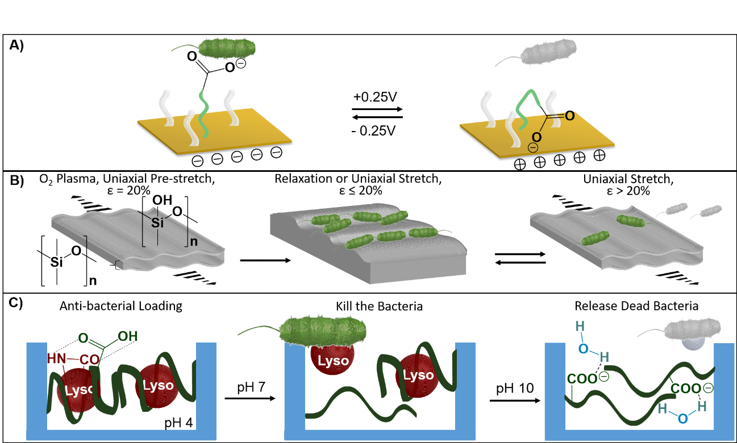
Figure 7 - Representation of different approaches to control bacterial adhesion. (A) The applied voltage at the gold substrate repeals the anionic head group, allowing bacterial adhesion, or attracts it to the surface, forcing the bacteria out of the surface. (B) The PDMS surface treated with simultaneous O₂ plasma and uniaxial stretching forms permanent wrinkles that under dynamic strain induce biofilm reduction. (C) The pH-responsive PMMA under acidic conditions allows the anti-bacterial lysozome absorption in the interstitial spaces, while under neutral pH the deprotonated carboxilic acids release the lysozome, killing the bacteria. Under basic pH conditions, the full deprotonated PMMA becomes hydrophilic, resulting in the release of dead bacteria.

8. Summary and outlook

Controlling the interfacial chemical and physical properties to modulate biomolecule capture and release processes at engineered interfaces forms a crucial foundation for the development of on-demand biosensors, high-performance delivery systems and bioseparation platforms. Stimuli-responsive capabilities are also opening the door to the development of highly complex bioelectrocatalytic systems,⁹ which are highly valuable for various technological applications and further our understanding of fundamental biocatalytic processes. The development of dynamic surfaces to control cell adhesion and detachment is paving the way for the design of cell culture supports in cell sheet engineering without the need for harsh cell releasing methods, such as enzymatic digestion or mechanical manipulation.^{83, 84} In addition to the impact in the production of cell sheets that can be used to repair or regenerate tissue, material surfaces with the capability to dynamically modulate cell attachment and detachment are finding utility in the realms of cell enrichment and isolation for downstream detection of diseases³¹ and understanding fundamental mechanisms of cell adhesion and migration.¹⁹ Despite progress over recent years, application areas such as cell-based regenerative therapy would benefit from stimuli-responsive surfaces that would better meet, on one hand, rapid promotion of cell adhesion and proliferation, and on the other, rapid release of intact cells without affecting the underlying switchable adhesive matrix. Engineering of dynamic behaviour at the bio-interface for understanding fundamental cellular processes has only begun and significant efforts are still required to more closely recreate the complexity of the highly dynamic, multi-responsive three-dimensional ECM and incorporate the intricate feedback loops that exist in vivo between ECM and cells.
To date, mainly due to the complexity of the adhesion process, anti-bacterial surfaces are not able to persistently resist bacteria attachment. Yet, important clues^{6, 102} are emerging. A mutual active and permanent interplay between bacteria and the abiotic surface is necessary to continuously inhibit and disrupt bacterial surface adhesion and growth. This requirement is well suited with the potential attributes that stimuli-responsive can possess, and thus, future research on the development of stimuli-responsive surfaces with long-term antibacterial efficiency are expected to embed more characteristics of continuous triggered actuation or autonomous adaptation. Surface materials with multi-functionalities are also highly desired, namely one that could effectively inhibit bacterial adhesion but concomitantly promote mammalian cell adhesion.
Another central challenge in the field lies in the ability to translate the successful laboratory-based systems to industrial or clinically useful systems. In order to address the current lack of translation, future material designs need to pay more attention to aspects such as long-lasting effective operation in vitro and in vivo, scalability and cost, in which simple-in-preparation and robust-in-operation should be carefully considered.
The ground-breaking research we are witnessing today is only the first generation of dynamic bio-interfaces. It is anticipated that, in the future, bio-interfaces will exhibit superior properties in terms of reversibility, multiple stimuli-responsiveness, reusability and adaptability to surrounding environments in order to address the current unmet biological, biotechnological and medical needs. Another opportunity that has so far remained overlooked is the possibility of harnessing stimuli not only to manipulate synthetic interfaces but directly biological or biologically derived interfaces or systems, including cells, tissues and organs. For instance, the design and engineering of biological systems with the inherent artificial ability to be tuned by an external stimulus opens unprecedented opportunities for spatial-temporal control over the system behaviour.¹⁰³ The scope of opportunities in the field and impact is tremendous, wherein the use of stimuli-responsive mechanisms is poised to become an essential, integral component in the engineering of synthetic and biological materials and systems.

9. Acknowledgements
The authors acknowledge financial support of this work by the EPSRC (EP/K027263/1) and ERC (Consolidator Grant 614787).

10. References

1. P. M. Mendes, Chem. Soc. Rev., 2008, 37, 2512-2529.
2. P. M. Mendes, Chem. Soc. Rev., 2013, 42, 9207-9218.
3. Y. Shimizu, H. Boehm, K. Yamaguchi, J. P. Spatz and J. Nakanishi, PLoS One, 2014, 9, e91875.
4. M. Lashkor, F. J. Rawson, A. Stephenson-Brown, J. A. Preece and P. M. Mendes, Chem. Commun., 2014, 50, 15589-15592.
5. A. Pranzetti, S. Mieszkin, P. Iqbal, F. J. Rawson, M. E. Callow, J. A. Callow, P. Koelsch, J. A. Preece and P. M. Mendes, Adv. Mater., 2013, 25, 2181-2185.
6. A. K. Epstein, D. Hong, P. Kim and J. Aizenberg, New J. Phys., 2013, 15, 13.
7. A. Shastri, L. M. McGregor, Y. Liu, V. Harris, H. Nan, M. Mujica, Y. Vasquez, A. Bhattacharya, Y. Ma, M. Aizenberg, O. Kuksenok, A. C. Balazs, J. Aizenberg and X. He, Nat. Chem., 2015, 7, 447-454.
8. M. Ashaduzzaman, A. Anto Antony, N. A. Murugan, S. R. Deshpande, A. P. Turner and A. Tiwari, Biosens. Bioelectron., 2015, 73, 100-107.
9. O. Parlak, S. Beyazit, B. Tse-Sum-Bui, K. Haupt, A. P. F. Turnera and A. Tiwari, Nanoscale, 2016, 8, 9976-9981.
10. H. K. Patra, R. Imani, J. R. Jangamreddy, M. Pazoki, A. Iglic, A. P. F. Turner and A. Tiwari, Sci. Rep., 2015, 5, 9.
11. H. Gao, Y. Bi, J. Chen, L. Peng, K. Wen, P. Ji, W. Ren, X. Li, N. Zhang, J. Gao, Z. Chai and Y. Hu, ACS Appl. Mater. Interfaces, 2016, 8, 15103-15112.
12. H. K. Patra, N. Ul Khaliq, T. Romu, E. Wiechec, M. Borga, A. P. F. Turner and A. Tiwari, 2014, 3, 526-535.
13. P. Tompa, Chem. Soc. Rev., 2016, 45, 4252-4284.
14. O. Keskin, N. Tuncbag and A. Gursoy, Chem. Rev., 2016, 116, 4884-4909.
15. M. Ghitti, G. Musco and A. Spitaleri, in Protein Conformational Dynamics, eds. K. L. Han, X. Zhang and M. J. Yang, Springer-Verlag Berlin, Berlin, 2014, vol. 805, pp. 271-329.
16. M. K. Janowska, K. P. Wu and J. Baum, Sci. Rep., 2015, 5, 10.
17. J. Rudolph, Nat. Rev. Cancer, 2007, 7, 202-211.
18. I. Petta, S. Lievens, C. Libert, J. Tavernier and K. De Bosscher, Mol. Ther., 2016, 24, 707-718.
19. E. J. Lee, W. Luo, E. W. Chan and M. N. Yousaf, PLoS One, 2015, 10, e0118126.
20. G. Jeon, S. Y. Yang, J. Byun and J. K. Kim, Nano Lett., 2011, 11, 1284-1288.
21. P. B. Wan and X. D. Chen, ChemElectroChem, 2014, 1, 1602-1612.
22. J. Hyun, W. K. Lee, N. Nath, A. Chilkoti and S. Zauscher, J. Am. Chem. Soc., 2004, 126, 7330-7335.
23. Z. Megeed, R. M. Winters and M. L. Yarmush, Biomacromolecules, 2006, 7, 999-1004.
24. E. Cantini, X. Y. Wang, P. Koelsch, J. A. Preece, J. Ma and P. M. Mendes, Acc. Chem. Res. , 2016, 49, 1223-1231.
25. J. Pivetal, D. Royet, G. Ciuta, M. Frenea-Robin, N. Haddour, N. M. Dempsey, F. Dumas-Bouchiat and P. Simonet, J. Magn. Magn. Mater., 2015, 380, 72-77.
26. T. R. Polte, M. Y. Shen, J. Karavitis, M. Montoya, J. Pendse, S. Xia, E. Mazur and D. E. Ingber, Biomaterials, 2007, 28, 2783-2790.
27. D. Mertz, C. Vogt, J. Hemmerle, J. Mutterer, V. Ball, J. C. Voegel, P. Schaaf and P. Lavalle, Nature Mater., 2009, 8, 731-735.
28. L. F. Kadem, M. Holz, K. G. Suana, Q. Li, C. Lamprecht, R. Herges and C. Selhuber-Unkel, Adv. Mater., 2016, 28, 1799-1802.
29. J. J. Giner-Casares, M. Henriksen-Lacey, I. Garcia and L. M. Liz-Marzan, Angew. Chem. Int. Ed., 2016, 55, 974-978.
30. Q. Yu, P. Shivapooja, L. M. Johnson, G. Tizazu, G. J. Leggett and G. P. Lopez, Nanoscale, 2013, 5, 3632-3637.
31. H. L. Liu, X. L. Liu, J. X. Meng, P. C. Zhang, G. Yang, B. Su, K. Sun, L. Chen, D. Han, S. T. Wang and L. Jiang, Adv. Mater., 2013, 25, 922-927.
32. T. Wei, Q. Yu, W. Zhan and H. Chen, Adv. Healthcare Mater., 2016, 5, 449-456.
33. J. Gensel, T. Borke, N. Pazos Perez, A. Fery, D. V. Andreeva, E. Betthausen, A. H. E. Muller, H. Mohwald and E. V. Skorb, Adv. Mater., 2012, 24, 985-+.
34. N. Srinivasan, M. Bhagawati, B. Ananthanarayanan and S. Kumar, Nat. Commun., 2014, 5, 1-8.
35. S. Wang, X. Cai, L. Wang, J. Li, Q. Li, X. Zuo, J. Shi, Q. Huang and C. Fan, Chem. Sci., 2016, 7, 2722-2727.
36. G. Pan, B. Guo, Y. Ma, W. Cui, F. He, B. Li, H. Yang and K. J. Shea, J. Am. Chem. Soc., 2014, 136, 6203-6206.
37. M. P. Lutolf, J. L. Lauer-Fields, H. G. Schmoekel, A. T. Metters, F. E. Weber, G. B. Fields and J. A. Hubbell, Proc. Natl. Acad. Sci. U. S. A., 2003, 100, 5413-5418.
38. M. Zelzer, L. E. McNamara, D. J. Scurr, M. R. Alexander, M. J. Dalby and R. V. Ulijn, J. Mater. Chem., 2012, 22, 12229-12237.
39. J. J. Richardson, M. Bjornmalm and F. Caruso, Science, 2015, 348
40. N. Paul, M. Muller, A. Paul, E. Guenther, I. Lauermann, P. Muller-Buschbaum and L.-S. M. C., Soft Matter, 2012.
41. D. Y. Xia, Z. Y. Ku, S. C. Lee and S. R. J. Brueck, Adv. Mater., 2011, 23, 147-179.
42. R. Glass, M. Moller and J. P. Spatz, Nanotechnology, 2003, 14, 1153-1160.
43. T. Lohmuller, D. Aydin, M. Schwieder, C. Morhard, I. Louban, C. Pacholski and J. P. Spatz, Biointerphases, 2011, 6, MR1-MR12.
44. A. Osypova, D. Magnin, P. Sibret, A. Aqil, C. Jerome, C. Dupont-Gillain, C. M. Pradier, S. Demoustier-Champagne and J. Landoulsi, Soft Matter, 2015, 11, 8154-8164.
45. K. Kaniewska, M. Karbarz and Z. Stojek, Electrochim. Acta 2015, 179, 372-378.
46. X. N. An, A. J. Zhu, H. H. Luo, H. T. Ke, H. B. Chen and Y. L. Zhao, ACS Nano, 2016, 10, 5947-5958.
47. T. Okano, N. Yamada, H. Sakai and Y. Sakurai, J. Biomed. Mater. Res., 1993, 27, 1243-1251.
48. T. Wei, Q. Yu, W. J. Zhan and H. Chen, Adv. Healthc. Mater., 2016, 5, 449-456.
49. Q. Yu, J. Cho, P. Shivapooja, L. K. Ista and G. P. Lopez, ACS Appl. Mater. Interfaces, 2013, 5, 9295-9304.
50. S. V. Wegner, O. I. Sentürk and J. P. Spatz, 2015, 5, 1-7.
51. R. Blonder, E. Katz, I. Willner, V. Wray and A. F. Buckmann, J. Am. Chem. Soc., 1997, 119, 11747-11757.
52. P. Wan, Y. Chen, Y. Xing, L. Chi and X. Zhang, Langmuir, 2010, 26, 12515-12517.
53. C. L. Yeung, P. Iqbal, M. Allan, M. Lashkor, J. A. Preece and P. M. Mendes, 2010, 20, 2657-2663.
54. J. You, J. S. Heo, Y. Choi, Kim, H. O., J. Kim, T. Park, B. Kim, H. Kim and E. Kim, ACS Nano, 2013, 7, 4119-4128.
55. P. Parthasarathy, P. M. Mendes, E. Schopf, J. A. Preece, J. F. Stoddart and Y. Chen, J. Nanosci. Nanotechnol., 2009, 9, 650-654.
56. C. C. A. Ng, A. Magenau, S. H. Ngalim, S. Ciampi, M. Chockalingham, J. B. Harper, K. Gaus and J. J. Gooding, Angew. Chem. Int. Ed., 2012, 51, 1-6.
57. Y. Murase, S. Maeda, S. Hashimoto and R. Yoshida, Langmuir, 2009, 25, 483-489.
58. D. Suzuki, T. Kobayashi, R. Yoshida and T. Hirai, Soft Matter, 2012, 8, 11447-11449.
59. S. Maeda, Y. Hara, T. Sakai, R. Yoshida and S. Hashimoto, Adv. Mater., 2007, 19, 3480-+.
60. K. Homma, T. Masuda, A. M. Akimoto, K. Nagase, K. Itoga, T. Okano and R. Yoshida, Small, 2017, 13, 8.
61. H. M. Chen, W. Z. Zhang, G. Z. Zhu, J. Xie and X. Y. Chen, Nat. Rev. Mater., 2017, 2
62. S. C. Baetke, T. Lammers and F. Kiessling, Br. J. Radiol., 2015, 88, 12.
63. H. Hatakeyama, Chem. Pharm. Bull., 2017, 65, 612-617.
64. F. Y. Li, J. X. Lu, X. Q. Kong, T. Hyeon and D. S. Ling, Adv. Mater., 2017, 29, 30.
65. M. X. Zhou, K. K. Wen, Y. Bi, H. R. Lu, J. Chen, Y. Hu and Z. F. Chai, Curr. Top. Med. Chem., 2017, 17, 2319-2334.
66. M. Björnmalm, K. J. Thurecht, M. Michael, A. M. Scott and F. Caruso, ACS Nano, 2017, 11, 9594-9613.
67. S. R. MacEwan and A. Chilkoti, Angew. Chem.-Int. Edit., 2017, 56, 6712-6733.
68. A. Sneider, D. VanDyke, S. Paliwal and P. Rai, Nanotheranostics 2017, 1, 1-22.
69. J. Wang, W. Tao, X. Chen, O. C. Farokhzad and G. Liu, Theranostics, 2017, 7, 3915-3919.
70. Y. Zhao, A. C. Tavares and M. A. Gauthier, J. Mater. Chem. B, 2016, 4, 3019-3030.
71. D. Uppalapati, B. J. Boyd, S. Garg, J. Travas-Sejdic and D. Svirskis, Biomaterials, 2016, 111, 149-162.
72. A. Seyfoddin, A. Chan, W. T. Chen, I. D. Rupenthal, G. I. Waterhouse and D. Svirskis, Eur. J. Pharm. Biopharm., 2015, 94, 419-426.
73. R. A. Lorenzo, A. M. Carro, A. Concheiro and C. Alvarez-Lorenzo, Anal. Bioanal. Chem., 2015, 407, 4927-4948.
74. E. Katz, S. Minko, J. Halamek, K. MacVittie and K. Yancey, Anal. Bioanal. Chem., 2013, 405, 3659-3672.
75. T. K. Tam, J. Zhou, M. Pita, M. Ornatska, S. Minko and E. Katz, J. Am. Chem. Soc., 2008, 130, 10888-+.
76. M. Pita, M. Privman and E. Katz, Top. Catal., 2012, 55, 1201-1216.
77. I. Willner, M. Liondagan, S. Marxtibbon and E. Katz, J. Am. Chem. Soc., 1995, 117, 6581-6592.
78. I. Willner and E. Katz, Angew. Chem.-Int. Edit., 2003, 42, 4576-4588.
79. O. Parlak, A. P. F. Turner and A. Tiwari, Adv. Mater., 2014, 26, 482-486.
80. H. Yao, Q. Gan, J. Peng, S. Huang, M. Zhu and K. Shi, Sensors, 2016, 16
81. O. Parlak, M. Ashaduzzaman, S. B. Kollipara, A. Tiwari and A. P. F. Turner, ACS Appl. Mater. Interfaces, 2015, 7, 23837-23847.
82. H. K. Patra, Y. Sharma, M. M. Islam, M. J. Jafari, N. A. Murugan, H. Kobayashi, A. P. F. Turner and A. Tiwari, Nanoscale, 2016, 8, 17213-17222.
83. M. Hirose, O. H. Kwon, M. Yamato, A. Kikuchi and T. Okano, Biomacromolecules, 2000, 1, 377-381.
84. M. Yamato, C. Konno, M. Utsumi, A. Kikuchi and T. Okano, Biomaterials, 2002, 23, 561-567.
85. H. Liu, Y. Li, K. Sun, J. Fan, P. Zhang, J. Meng, S. Wang and L. Jiang, J. Am. Chem. Soc., 2013, 135, 7603-7609.
86. G. Pan, Q. Guo, Y. Ma, H. Yang and B. Li, Angew. Chem. Int. Ed., 2013, 52, 1-6.
87. S. Desseaux and H. Klok, Biomacromolecules, 2014, 15, 3859-3865.
88. Y. Gong, C. Li, J. Yang, H. Wang, R. Zhuo and X. Zhang, Macromolecules, 2011, 44, 7499-7502.
89. A. Goulet-Hanssens, K. L. W. Sun, T. E. Kennedy and C. J. Barrett, Biomacromolecules, 2012, 13, 2958-2963.
90. L. F. Kadem, K. G. Suana, M. Holz, W. Wang, H. Westerhaus, R. Herges and C. Selhuber-Unkel, Angew. Chem.-Int. Edit., 2017, 56, 225-229.
91. Q. Yu, L. M. Johnson and G. P. López, Adv. Funct. Mater., 2014, 24, 3751-3759.
92. A. M. Wan, S. Inal, T. Williams, K. Wang, P. Leleux, L. Estevez, E. P. Giannelis, C. Fischbach, G. G. Malliaras and D. Gourdon, J. Mater. Chem. B, 2015
93. T. P. Kraehenbuehl, P. Zammaretti, A. J. Van der Vlies, R. G. Schoenmakers, M. P. Lutolf, M. E. Jaconi and J. A. Hubbell, Biomaterials, 2008, 29, 2757-2766.
94. Y. Wei, X. J. Mo, P. C. Zhang, Y. Y. Li, J. W. Liao, Y. J. Li, J. X. Zhang, C. Y. Ning, S. T. Wang, X. L. Deng and L. Jiang, ACS Nano, 2017, 11, 5915-5924.
95. D. M. Salvay and L. D. Shea, Mol. Biosyst., 2006, 2, 36-48.
96. X. H. Xiong, Z. Q. Wu, Q. Yu, L. L. Xue, J. Du and H. Chen, Langmuir, 2015, 31, 12054-12060.
97. Q. Yu, Z. Q. Wu and H. Chen, Acta Biomater., 2015, 16, 1-13.
98. Y. S. Dong, X. H. Xiong, X. W. Lu, Z. Q. Wu and H. Chen, J. Mater. Chem. B, 2016, 4, 6111-6116.
99. I. Gushchin, I. Melnikov, V. Polovinkin, A. Ishchenko, A. Yuzhakova, P. Buslaev, G. Bourenkov, S. Grudinin, E. Round, T. Balandin, V. Borshchevskiy, D. Willbold, G. Leonard, G. Büldt, A. Popov and V. Gordeliy, Science, 2017, 356
100. A. Persat, Curr. Opin. Microbiol., 2017, 36, 1-6.
101. G. Alsharif, S. Ahmad, M. S. Islam, R. Shah, S. J. Busby and A. M. Krachler, Proc. Natl. Acad. Sci. U. S. A., 2015, 112, 5503-5508.
102. A. Grinthal and J. Aizenberg, Chem. Mat., 2014, 26, 698-708.
103. T. Sohka, R. A. Heins, R. M. Phelan, J. M. Greisler, C. A. Townsend and M. Ostermeier, Proc. Natl. Acad. Sci. USA, 2009, 106, 10135-10140.

