Addressing future rail network performance challenges through effective structural health monitoring
Jenna Davis¹, Patrick Vallely^{2, 3}, Mayorkinos Papaelias³, Zheng Huang³
¹Network Rail Consulting, Washington D.C., U.S.
²Network Rail Infrastructure Limited, Baskerville House, UK
3School of Metallurgy and Materials, The University of Birmingham, UK

Contact Author: Jenna Davis, jenna.davis@networkrailconsulting.com

Abstract
The fact that critical structural components such as rails and crossings are randomly loaded increases the degree of uncertainty when trying to estimate their remaining service lifetime. Maintenance decisions are predominantly based on the feedback received from inspection engineers coupled with empirical knowledge that has been gained over the years. The use of structural degradation models is too risky due to the uncertainty arising from the variable dynamic loads sustained by the rail track. The use of structural health monitoring techniques offers significant advantages over conventional approaches. First of all, it is non-intrusive and does not interrupt normal rail traffic operations. Secondly, defects can be detected and evaluated in real-time whilst their evolution can be monitored continuously enabling maintenance to be scheduled in advance and at times where the need for rail network availability at the section concerned is at its lowest. This paper analyses the potential risks and benefits of a gradual shift from traditional inspection approaches to advanced structural health monitoring techniques.
Keywords: Inspection, Maintenance, Railroads, Structural Health Monitoring, Operational Efficiency

Introduction
Operational efficiency is one of the key performance indicators for all railroad systems. Infrastructure inspection and maintenance engineers are tasked with the responsibility of ensuring the reliability, availability, maintainability and safety of the railroad network. However, as rolling stock traffic density increases throughout the network, inspection and maintenance opportunities become less readily available. Inspection and maintenance activities normally take place at night when there is little or no train movement to avoid disruption of normal railroad network operation. In addition, conventional inspection methodologies fail to deliver the efficiency required for the optimisation of maintenance decisions, particularly with respect to track renewals, due to their defect detection sensitivity and level of resolution limitations¹⁻².
There is a strong need to increase rail transport capacity, improve efficiency and reduce operational cost. The construction of new rail lines and upgrades are inadequate to address the increasing rail transport demand at global scale. Particular focus needs to be placed on rail network bottlenecks, e.g. junctions, where structural integrity deterioration of rails and crossings can result into severe disruption.
Defects on rails can present themselves in various forms including rail head wear and Rolling Contact Fatigue (RCF), sub-surface flaws in the head, web or foot arising from contact, bending and lateral stresses, or foot corrosion. Severe rail defects (e.g. 1A or 1B class) need to be replaced immediately or soon after detection. Certain defect types may be clamped until the rail section affected has been replaced. An Emergency Speed Restriction (ESR) of 20 MPH is normally applied for all rolling stock travelling over the damaged rail section until the necessary maintenance has been carried out. ESRs imposed cause delays to normal traffic incurring additional costs to the rail infrastructure manager since rolling stock operators need to be reimbursed.
Severely damaged crossings can also result in significant delays and disruption in heavily travelled parts of the network. Replacement costs of a single defective crossing can exceed several tens of thousands of £. Over a twelve-month period, Network Rail reported 20 defective crossings in the Wembley area alone. Manual and automated inspection systems are employed for the evaluation of defects present in rails and crossings but no RCM technology has been commercially deployed yet. The authors of the paper in collaboration with other researchers have been developing and testing novel RCM techniques based on the use of high-frequency acoustic emission sensors.

Experimental Methodology
The hardware architecture of the customised RCM system consists of the following basic components apart from the aforementioned acoustic emission sensors, accelerometers and triggering equipment; a) pre-amplifiers manufactured by PAC, b) main amplifiers manufactured by Krestos Limited or PAC, c) four-channel hub manufactured by Agilent, d) two Agilent 2531A four-channel USB cards and e) a PC for logging, storing and analysing the acoustic emission and vibration signals acquired. The customised software running on the PC has been written in LabVIEW ® and MATLAB® and is capable of both logging and analysing the datasets acquired. The photograph in Figure 1 shows the main hardware of the customised RCM system³.
The amplitude of the output signal produced by acoustic emission sensors is only a few mV and therefore needs to be amplified. The amplification is achieved by the use of a pre-amplifier and amplifier which amplify the analogue signal prior to digitisation by the Data Acquisition Card (DAQ). the pre-amplifier has an analogue band-pass filter built-in that can filter the signal from 100-1000 kHz, which is the operating frequency range for the R50α acoustic emission sensor.
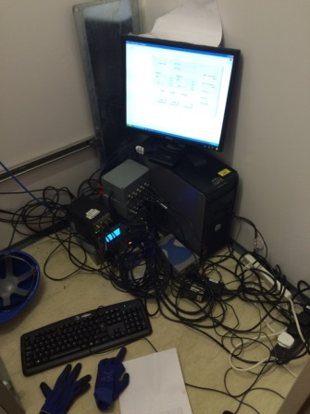
Figure 1: The customised RCM system used for high frequency AE measurements³.

Results and Discussion
The key findings and main conclusions drawn from the measurements carried out in the field on two different crossings on the West Coast Mainline (near Wembley Stadium- direction to Birmingham) and on Chiltern rail line (near Hatton Railway Station – direction to Birmingham). The Wembley crossing was evaluated visually before the measurements were carried out. No damage was identified from the visual inspection in any part of the crossing. The results of the AE tests carried out also support the findings of the visual inspection as there is no indication of any crack growth in the signals analysed. The maximum allowable train speed at the Wembley crossing is 100 MPH. The line is used by both passenger and freight trains.

In the case of the Hatton crossing from the visual inspection carried out surface damage is evident (cracking and lipping). No emergency speed restrictions have been set at the Hatton crossing by the route manager so trains pass with speeds up to 100 MPH. This is also a mixed line being used by both passenger and freight trains. Analysis of the AE measurements obtained from the Hatton crossing suggests that damage growth does occur when train passes. Damage evolution has been assessed as limited when lighter passenger or freight carriages pass over the crossing. However, there is evidence of faster damage evolution when heavier axle loads are involved. This leads us to conclude that for the Hatton crossing, damage, at this stage at least, can be classified as moderate.

Track circuits are being used in both lines tested. The Wembley crossing is part of an electrified line whilst the Hatton crossing is part of a conventional line. In both cases there was no interference caused by the AE sensors on the track circuits. Furthermore, no problems were caused by the return current in the electrified line to the AE system thanks to the satisfactory insulation provided by the ceramic plate of the AE sensors and Araldite adhesive used to attach the sensors on the crossing. The installation of the entire system was completed in about an hour during night time while traffic had stopped.

The photographs in figure 3 show the measurement setup at the Wembley crossing. The sensors were attached on the crossing of interest using Araldite since magnetic hold-downs are not an option in this case.

Araldite provides the adhesive strength to keep the AE sensors mounted on the surface of the crossing during testing as well as the level of additional electrical insulation required. Furthermore, it provides the required coupling quality enabling good transmissibility of the stress waves produced from any crossing defects growing during loading from the wheel and axle loads sustained.

Araldite enables long term adhesion of the sensors. It provides consistent coupling quality over extended measurement periods and over a wide range of environmental conditions including hot or cold weather, wet or snowy conditions and solar ray exposure. Araldite is a two-component epoxy adhesive which is inexpensive, commercially available at hardware stores, and safe to handle. It cures relatively fast enabling the installation of the AE sensors within a few minutes. It also has good resistance to any vibration related damage.

- 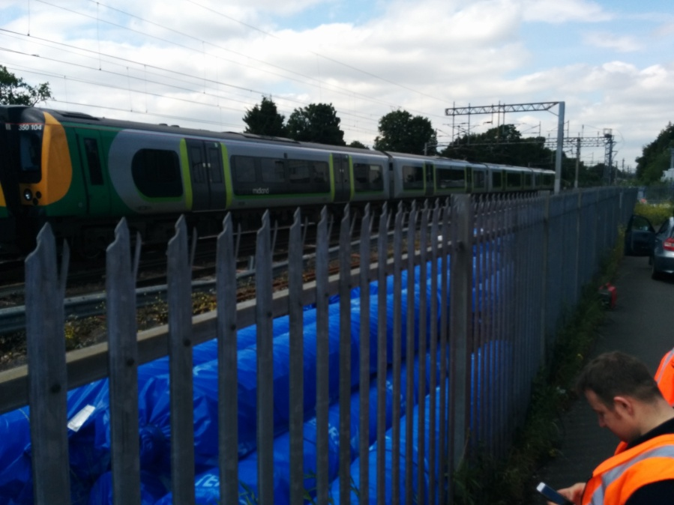

- 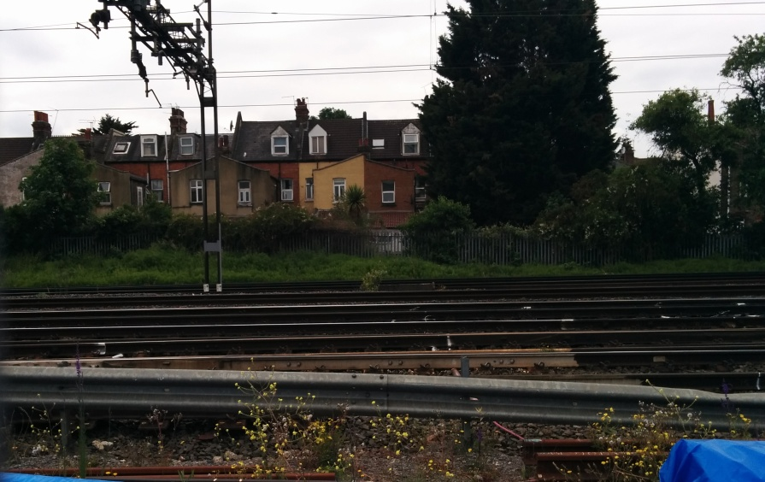
Instrumented crossing

Figure 2: Photographs showing a) indicative traffic at the instrumented Wembley crossing, and b) the monitored crossing location.

The photographs in figure 4 show the measurement setup at Hatton crossing. The installation of the AE sensors was done in the same way as for Wembley.

- 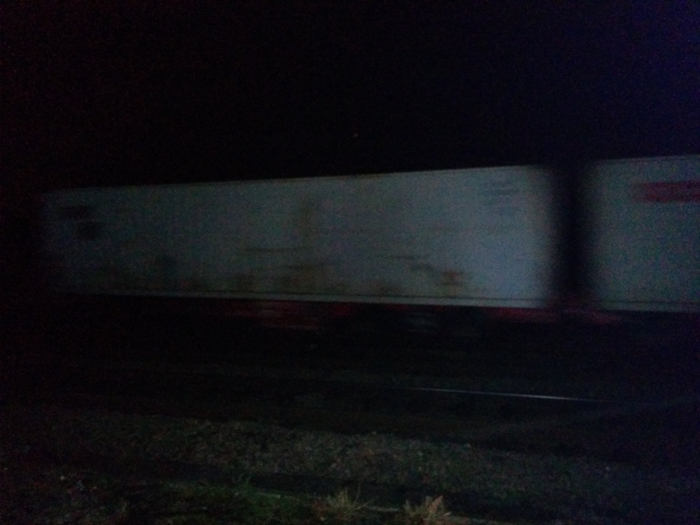

- 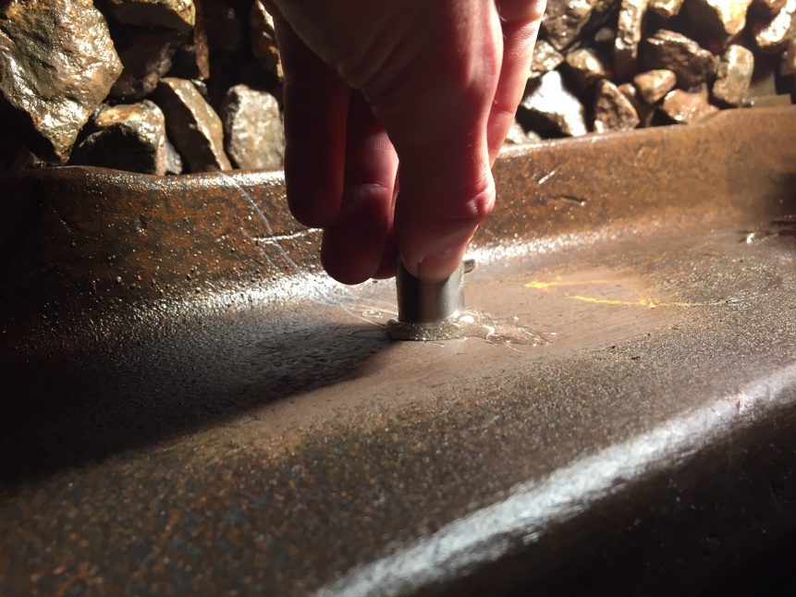

Figure 3: Photographs showing: a) the indicative traffic at the instrumented Hatton crossing and b) AE sensor installation with Araldite.

To analyse the AE data collected from the two instrumented crossings a template-based correlation processing method has been used. This methodology enables us to accurately differentiate AE signals from different sources such as impact, deformation and crack growth. Although the signal acquired is affected by a number of factors, signals generated by the same source mechanism are similar and can thus be correlated to each other. If the signal features generated by a propagating defect are known in advance, the relevant template can be used to identify all those segments from the original waveform which are similar to it. These segments with the same feature are very likely to be generated by the defect. Therefore, correlation analysis can be used as a powerful tool not only to identify the presence of defect, but also to effectively discriminate signals generated by different sources of AE. There are two vital parts in correlation analysis: the template and the feature used in the correlation processing approach. Templates are of great importance to achieve accurate and reliable results in correlation analysis. They normally consist of a set of signals which correspond to specific defect signatures under controlled environment, such as train speed, bogie geometry and wagon weight, etc. In this application, templates need to be carefully selected from the test data generated on cast manganese steel samples in the laboratory. The schematic in figure 4 shows the 4 steps involved in correlation processing.

Filter the original signal
Select proper window size and overlap
Calculate cross-correlation & MSC
Calculate the PSE for each window
Figure 4: Correlation processing procedure.

Below we discuss in more detail the steps followed during the correlation processing procedure to analyse AE data and obtain the required information.
- Filtering the signal
The frequency band of interest lies between 100 to 250 kHz. Although the pre-amplifier has the analogue band-pass filter built-in, the energy of the low frequency signals from spurious sources can still be high enough to appear in the spectrum. As a result, the collected data need to be filtered again to remove the low frequency contents.
- Selecting window size and overlap
The raw data are divided into a number of segments which is determined by the value of the window size and overlap. The more segments employed, the better resolution can be achieved. However, there is a trade-off between the accuracy and computing time. The window size generally covers the duration of a complete impact signal, while 50% overlap is sufficient.
- Calculating the PSE for each window
As crossing loading is dynamic, i.e. each wheel passing loads the crossing potentially causing further damage, PSE is used to estimate the power of it at different frequencies. PSE is calculated via Welch’s method, which is based on the concept of periodogram spectrum estimates. By breaking the time series into segments with overlap, a modified periodogram is performed for each segment and then averaging of these results is carried out to produce the estimate of the power spectral density. The PSE for each segment is normalised, so that the calculation is based on the distribution of the PSE, while the energy of individual segments no longer affects the result.
- Calculating the cross-correlation, coherence and frequency distribution
Cross-correlation, coherence and frequency distribution analysis are performed between the template and each window to calculate the similarity. A normalised similarity result is provided after the processing. As suggested, signals that have the same features with the template should lead to higher similarity. Suitable templates have been selected from the tests carried out on cast manganese samples in the laboratory. The templates employed corresponded to different extents of severity. Figure 5 shows the raw AE data set for one of the samples tested indicating crack growth at relatively early stage in every loading cycle.
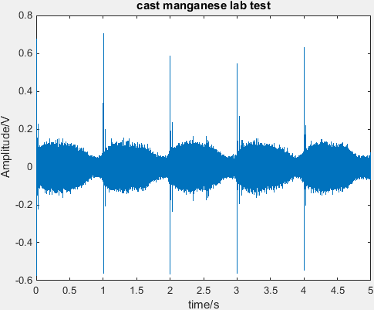
Figure 5: Raw AE data set generated from the laboratory 3-point bending test of one of the cast manganese steel samples.
Figure 6 shows the template selected from the above measurement.
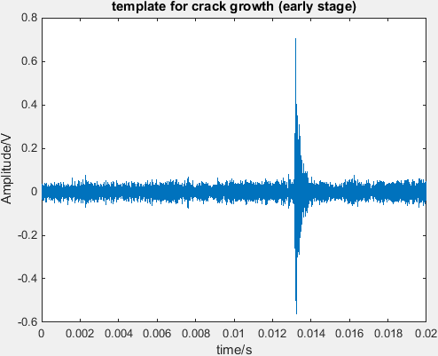
Figure 6: Selected reference template indicative of early stage crack growth.

Wembley measurement results:
As discussed earlier the Wembley crossing is considered to be free from defects so no indication was expected following the analysis based on correlation. The graph in figure 7 shows the raw AE signal obtained from one of the sensors while a passenger train passed over the crossing. The high-amplitude peaks are predominantly from the engine noise causing some sliding of the wheels giving rise to noise. No impact events are visible in the raw AE data predominantly thanks to the band-pass filters.
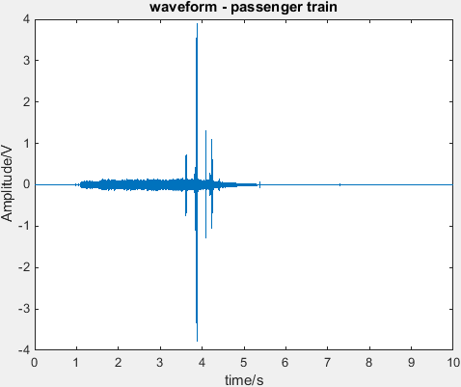
Figure 7: Raw AE signal from passenger train going over the Wembley crossing.
Figure 8 shows the cross-correlation result using the early stage damage template. As it can be seen there is practically no appreciable indication of damage. Further analysis carried out using the moderate stage damage template (figure 9) supports the conclusion that there is no appreciable damage in the Wembley crossing.

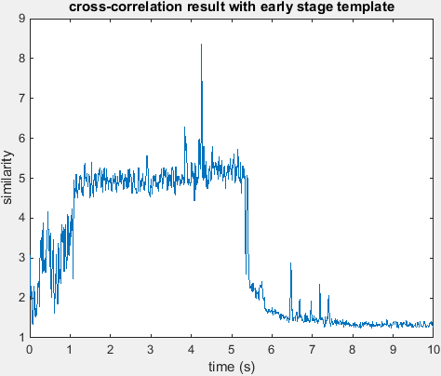
Figure 8: Cross-correlation analysis based on the early stage damage template.

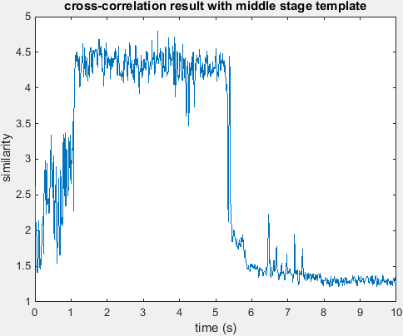
Figure 9: Cross-correlation result based on the moderate-stage damage template. No visible indication is present.
Hatton measurement results:
Both passenger and freight train loading sequences were measured at Hatton crossing. Figure 10 shows the raw AE data set for one of the Chiltern passenger trains loading the instrumented crossing. It can be seen that there are several high-amplitude peaks despite the comparable size and weight of the train to the passenger trains measured at Wembley. Moreover, the gain used for the Hatton measurement has been reduced to 29 db in comparison to 40 db used in Wembley to further decrease environmental noise effects on the raw signal.
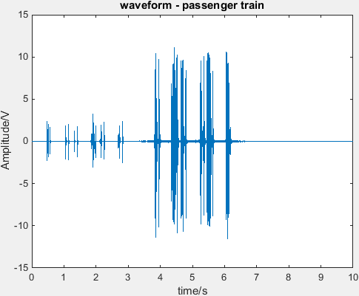
Figure 10: Raw AE data set for Hatton crossing.

The plot in figure 11 shows the correlation results obtained based on the early stage template. There are clear peaks indicative of damage growth occurring. The relatively low amplitude of the peaks in comparison to the Wembley signals is due to the lower amplification used in these tests. The signal comparison should be based on the background level when compared to the peaks.
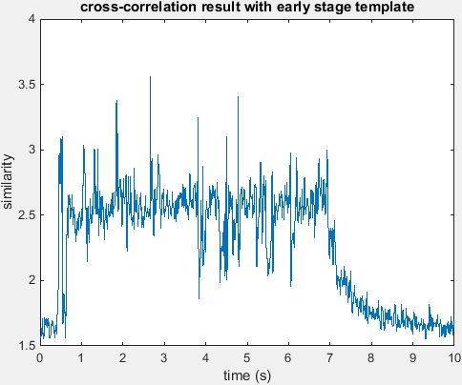
Figure 11: Cross-correlation result based on the early stage damage template showing clear indications of damage growth.

The plot in figure 12 shows the cross-correlation result for moderate stage damage template. A number of peaks are visible indicating a number of damage growth events belonging to this category occurring during this particular loading sequence.
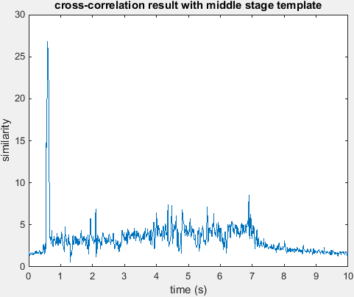
Figure 12: Cross-correlation result based on the middle stage-damage template
The following results shown in figure 13 are related to a loading sequence of the instrumented crossing from a heavy freight train. Each of the wheels periodically loads the crossing. The small peaks indicate the presence of each wheel. The high-amplitude peaks are most likely caused by a wagon fairly heavier than the rest.
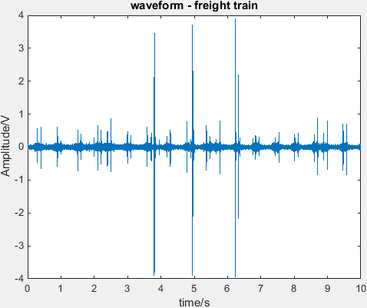
Figure 13: Raw AE dataset for part of a freight train measured at Hatton.
Figure 14 shows the correlation result when using the early stage damage template. Damage growth peaks are again evident practically for every loading cycle.
.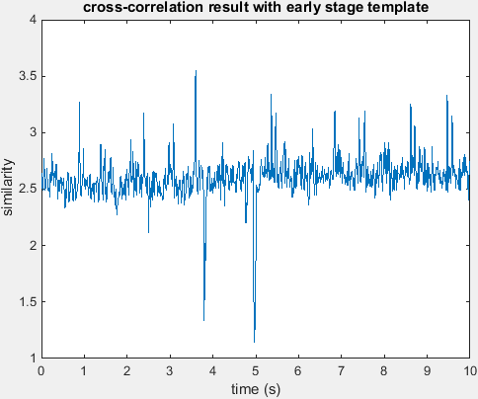
Figure 14: Cross-correlation result using the early-stage template.
Figure 15 shows the cross-correlation result after applying the middle stage template. The smaller peaks disappear, as they are not generated by the middle stage damage mechanism. However, the peak at the 5 sec shows up with high similarity result indicating slightly faster damage evolution during this particular loading event.
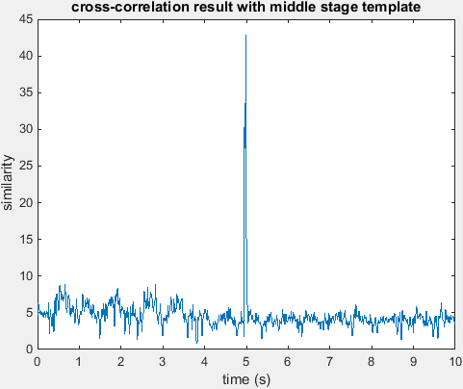
Figure 15: Cross-correlation result based on the middle-stage damage template.
Conclusions
The results of the AE measurements carried out at both instrumented crossings show that the Hatton crossing is mainly at the early stage of crack growth but some moderate crack growth is also evident. The presence of each wheel triggers small crack growth. However, if heavier wagons pass, signals with the feature of middle stage damage growth have been generated. This leads us to conclude that damage should be classified as moderate for this particular crossing. Also spurious signals, such as the impact generated by the wheel-rail interface, can be identified and removed effectively from the original waveform, as their spectral character is different. In the case of the Wembley crossing the results suggest that there was no appreciable damage present at the time of the measurements. AE has proven to be an appropriate methodology for the RCM of railway infrastructure components. The technique can be accordingly be deployed for evaluation of conventional rails in real-time, helping optimise predictive maintenance strategies and increasing network cost-efficiency.
References
- M. Papaelias, C. Roberts, C. L. Davis, “A review on non-destructive evaluation of rails: state of the art and future development”, I. Mech. E. Proceedings, Journal of Rail and Rapid Transit – Part F, Vol. 222, Number F4, December 2008.
- S. Shi, Z. Han, P. Vallely, S. Soua, S. Kaewunruen and M. Papaelias, Quantitative monitoring of brittle fatigue crack growth in railway steel using acoustic emission, Proceedings of the Institution of Mechanical Engineers, Part F: Journal of Rail and Rapid Transit, available online, 2017.
- Zheng Huang, Integrated railway Remote Condition Monitoring, Ph.D. Thesis, The University of Birmingham 2014

