SU-8 Micromachined Cross-Coupled Waveguide Cavity Filter for Sideband Rejection Above 300 GHz

Xiaobang Shang, Hao Yang, Yuvaraj Dhayalan, Michael J. Lancaster
Department of Electronic, Electrical and Systems Engineering, the University of Birmingham
Birmingham, B15 2TT, UK
Email: x.shang@bham.ac.uk
Hui Wang, Peter G. Huggard
Millimetre Wave Technology Group
RAL Space
Rutherford Appleton Laboratory
Harwell Oxford, OX11 0QX, UK
Email: peter.huggard@stfc.ac.uk

Abstract—A 300 GHz waveguide filter, designed to block the unwanted upper sideband from reaching a heterodyne mixer, is presented. This WR-3 filter is based on three cross-coupled TE₁₀₁ resonators. It is designed to have a Chebyshev response, and cross-coupling between first and third resonators provides transmission zeros in the stopband. The filter is fabricated using a multilayered SU-8 micromachining process. The completed filter has a 12 GHz bandwidth with a center frequency of 298.5 GHz: in-band insertion loss is 0.45 dB, with >30 dB rejection of the unwanted sideband. Good agreement between predicted and measured transmissions is obtained.
Keywords—terahertz passive circuits, terahertz filters, SU-8 micromachining, WR-3 waveguide

Introduction
The terahertz spectrum has been actively explored due to its promising applications in medical imaging, security scanning and ultrahigh bandwidth communications. At terahertz frequencies, waveguide is often used as the transmission line connecting antennas and components. As frequency increases, the size of waveguide shrinks proportionally and the tolerances on dimensions become tighter. A WR-3 band waveguide has a cross-sectional dimension of 864 µm × 432 µm. This brings challenges for fabrication, especially for waveguide filters consisting of fine structures which are sensitive to fabrication imperfections. High precision CNC metal machining can make such waveguide structures, however this process has limitations. For example, deep narrow channels and sharp internal corners are very difficult to achieve by conventional machining techniques, such as milling.
SU-8 micromachining has emerged as a feasible technique for fabricating terahertz waveguide circuits. This fabrication technique is a photolighographic based process, and therefore provides an excellent dimensional accuracy, with tolerances within a few µm. Compared with metal machining, the SU-8 process has advantages of high aspect ratio (greater than 20:1), low cost for large size batch production, and a small surface roughness (of the order of tens of nanometers). The SU-8 process has been used previously to demonstrate filters operating at WR-3 band [1-3] and WR-1.5 band [4].
In this paper we report on a third-order cross-coupled waveguide filter manufactured using the SU-8 process. The filter is a potential replacement of Frequency Selective Surface (FSS) filters used in space borne radiometers to block signals in the undesired upper sideband from reaching the heterodyne receivers [5]. An ideal filter has negligible insertion loss in the desired lower sideband, approximately 10 GHz in width, and greater than 20 dB rejection of the corresponding upper sideband signals [5]. To approach this with a waveguide cavity filter, cross-coupling between resonant cavities is introduced so that the filter has two transmission zeros within the upper stopband, enabling high rejection over an image band of the radiometer (317.7-325.9 GHz).

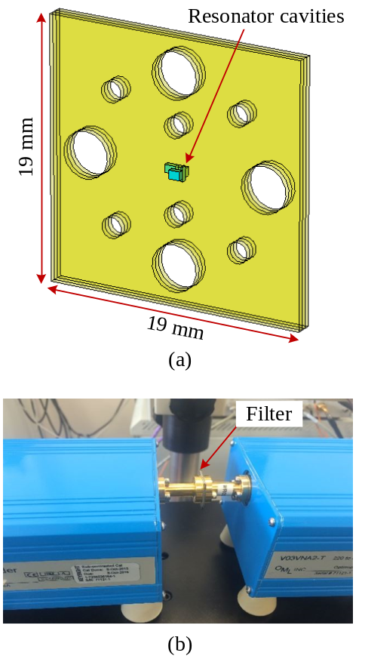

Fig. 1. (a) Illustrative diagram of the WR-3 filter formed of three SU-8 layers. (b) Photograph of the measurement setup.
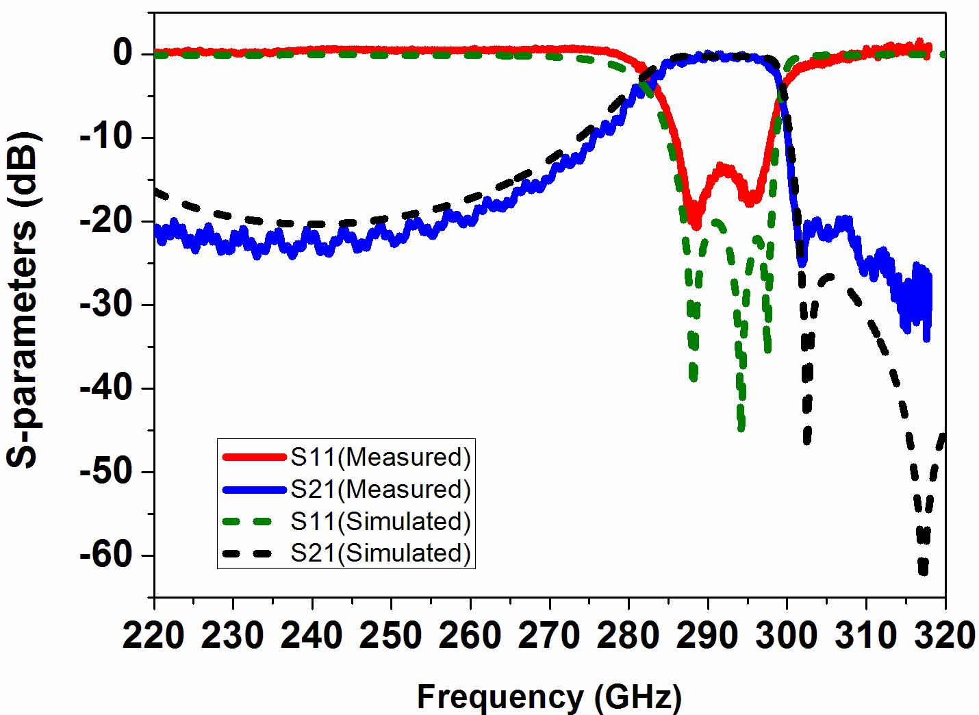

Fig. 2. Measurement and simulation responses of the WR-3 filter. The measured response is shifted downwards by 7 GHz, in order to compare better with simulations.

Wr-3 Waveguide Filter
Fig. 1 (a) shows an illustrative diagram of the filter. The filter structure is formed from three SU-8 layers, each 432 µm thick. Each layer contains one cavity resonator. In Fig. 1 (a) the circular holes are for the fixing screws and alignment pins of the UG-387 flange of the measurement equipment. The filter is designed using the coupling matrix technique. More details about the design of this filter are provided in [6].
The three layers of the filter are fabricated using the SU-8 process. Briefly, the fabrication begins with deposition of liquid SU-8 onto a 4 inch diameter silicon wafer. Prebaking the SU-8 solidifies it sufficiently to permit the UV exposure of the required pattern through a mask. Post exposure baking forms strong cross-linked structures. This is followed by a release from the silicon through development and metalisation using evaporation. A detailed description of the fabrication process can be found in [1 - 4].
During the measurement, the filter is sandwiched between two waveguide flanges of the vector network analyser, and is aligned to them using high precision dowels on the waveguide flanges. Fig. 1 (b) shows the measurement setup. Fig. 2 depicts the measured response of the filter, which is in excellent agreement with simulations. The filter is measured to have a 12 GHz bandwidth with a center frequency of 298.5 GHz. The resulting filter has an average insertion loss of 0.45 dB and a return loss of 15 dB through the whole passband. A 7 GHz increase in the centre frequency from the design value is mainly accounted for by the slightly smaller-than-designed cavities. This can be corrected by remaking the filter using a new mask with modified dimensions.

Conclusion
The design of a WR-3 band waveguide sideband blocking filter with a pair of transmission zeros has been presented. A SU-8 based multilayer micromachining technique has been used to fabricate the filter. Simulated and measured responses are in good agreement. This demonstrates that SU-8 process is capable of producing high performance terahertz waveguide devices operating to beyond 300 GHz.

Acknowledgment
This work was supported by the U.K. Engineering and Physical Science Research Council (grant EP/M016269/1).

References
- X. Shang, M. Ke, Y. Wang, M. J. Lancaster, “WR-3 band waveguides and filters fabricated using SU8 photoresist micromachining technology,” IEEE Transactions on Terahertz Science & Technology, vol. 2, (6), pp. 629-637, 2012
- X. Shang, M. Ke, Y. Wang, M. J. Lancaster, “Micromachined WR-3 waveguide filter with embedded bends,” IET Electronics Letters, vol. 47, (9), pp. 545-547, 2011
- Y. Wang, B. Yang, Y. Tian, R. S. Donnan, M. J. Lancaster, “Micromachined thick mesh filters for millimeter-wave and terahertz applications,” IEEE Transactions on Terahertz Science & Technology, vol. 4, (2), pp. 247-253, 2014
- X. Shang, Y. Tian, M. J. Lancaster, S. Singh, “A SU8 micromachined WR-1.5 band waveguide filter,” IEEE Microwave and Wireless Components Letters, vol. 23, (6), pp. 300-302, 2013
- R. Dickie, R. Cahill, H. Gamble, V. Fusco, P. Huggard, M. Henry, M. Oldfield, P. Howard, N. Grant, Y. Munro, and P. Maagt, “Frequency selective surface beamsplitter for sub-mm wave polarimetric space science instruments,” in 3rd European Conference on Antennas and Propagation (EuCAP), March 2009, pp. 1877-1881
- H. Yang, Y. Dhayalan, X. Shang, M. J. Lancaster, B. Liu, H. Wang, M. Henry, and P. Huggard, “WR-3 waveguide bandpass filters fabricated using high precision CNC machining and SU-8 photoresist technology,” unpublished

