Supplemental Figure 1
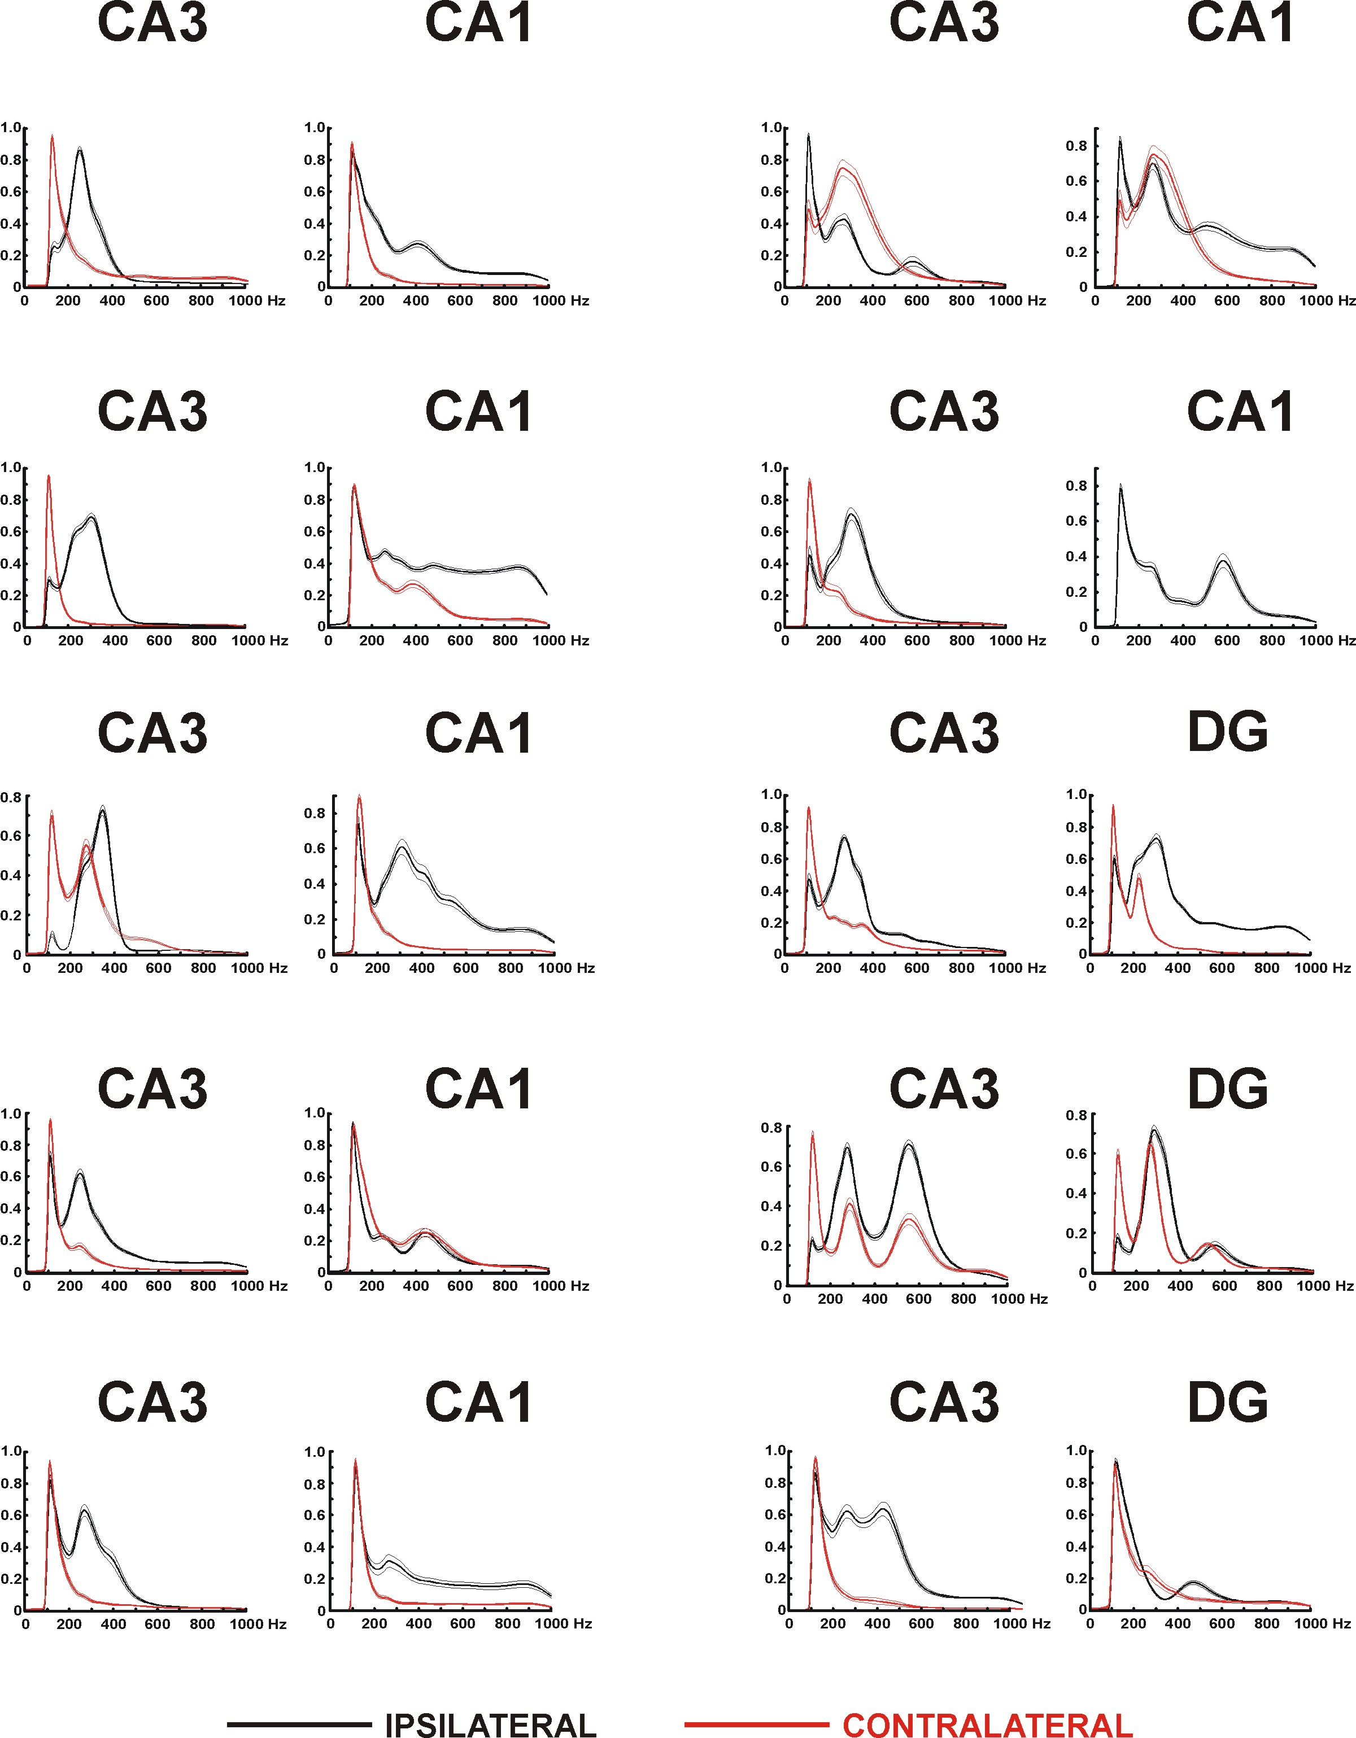
Supplementary figure 1. Average power spectra of interictal discharges for the two regions in each animal (see also Figure 3D). The greatest power in the set of individual spectra for each site in each rat was used to normalise power to avoid complications from variations in signal amplitude related, for instance, to the precise placement of the bipolar electrodes; all measures used in this paper are independent of the absolute values of power so that this normalisation does not affect the results. The ten rats’ CA3 recordings are arranged in to columns with the corresponding second electrode site (CA1 pr DG) to their right. In one case the contralateral CA1 electrode failed (row 2, right). In all cases at least one of the regions shows the distribution of power shifted to higher frequencies in the ipsilateral site, while in all but one case the other region either shows a similar shift or no clear difference between sides. In all cases the incidence of fast ripples was greater in the ipsilateral hippocampus (Figure 5E).
Supplemental Figure 2
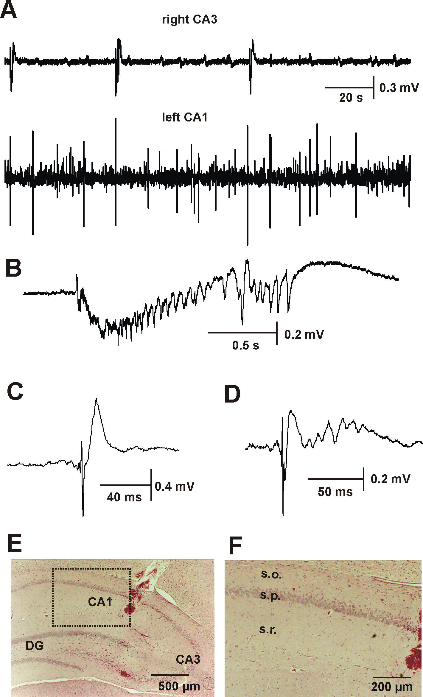
Supplementary figure 2. Histological examination of contralateral hippocampus. Ipsilateral CA3 generated short bursts of repeated epileptiform discharges with superimposed high-frequency activity (>300 Hz; not shown). Activity in contralateral CA1 is characterized by frequent interictal discharges. B: Detail of CA3 activity. C, D: Examples of interictal discharges recorded from the contralateral hippocampus. E: Haematoxylin-Eosin staining showing structure of the contralateral (left) hippocampus with electrode track in CA1 and electrolytic marking of electrode in CA3. F: Detail of morphology of contralateral CA1 area.

