The evolution of polymer wear debris from total disc arthroplasty
D G Eckold, K D Dearn, D E T Shepherd
School of Mechanical Engineering, University of Birmingham, Birmingham B15 2TT, United Kingdom

Abstract
Total disc arthroplasty is an alternative to spinal fusion, aimed at preserving flexibility; these devices typically involve a cobalt chrome molybdenum alloy socket articulating against an ultra-high molecular weight polyethylene (UHMWPE) ball. As with all artificial joints, wear debris is of particular concern due its effect on both implant life and the in vivo biological reactions that can occur.
In this paper, a profile of the UHMWPE wear debris generated from disc arthroplasty, tested on a spine simulator, is built with a combination of SEM image analysis tools. SEM images were analysed by computer vision, which allowed size and shape information to be extracted and images to be categorised by the shared topological features on individual wear particles. The computer visions techniques were based on a Scale Invariant Feature Transform (SIFT) to extract key point data from individual images and a Support Vector Decision Machine (SVM) to filter images based on a series of trained parameters. As certain wear particle morphology is predominantly produced by a particular wear regime, grouping wear particles by morphology and size made it possible to infer the relative rates of various wear regimes responsible for wear debris generation. By sampling synovial lubricant at intervals throughout the tribological test, the predominant wear regimes and particle sizes were tracked over the course of the implant life. Wear debris samples were taken at 12 intervals over a 5 million cycle test.
The majority of debris was found to be 0.88 µm in equivalent circle diameter, with an aspect ratio (defined as the major over the minor diameter of the smallest possible encompassing ellipse of the debris) of 1.55. There was a decreasing trend in average particle size as the number of cycles increased. During the early stages of the test, adhesion and abrasion were dominant in forming particle morphologies, however after 2 million cycles; particles generated as a result of fatigue became the major particle morphology.
Keywords: Total Disc Arthroplasty, UHMWPE, Polymer Wear Debris, Particle morphology, SEM, Machine Learning

Introduction
Ultra-high molecular weight polyethylene (UHMWPE) is a common choice for joint arthroplasty as a bearing counter-face, in part due to its low chemical reactivity and tribological properties. Current Total Disc Replacements (TDRs) such as the SB Charité and PRODISC-L (DePuy Synthes Spine, Raynham, MA, USA) both make use of a CoCrMo (Cobalt Chrome Molybdenum alloy) on a UHMWPE bearing. This tribological combination is the obvious choice for TDRs given the long standing and successful use in hip and knee arthroplasty, where it was found that older, less active patients were best served by metal-on-polymer (MoP) implants [1]. Interest in wear debris has grown over the years as their various adverse effects have been further understood, that can reduce implant life, and induce unwanted biological reactions within the body [2,3]
For example the wear debris from UHMWPE on metal joint replacements, particularly those in the size range of 0.1-1.0 µm, have been shown to cause aseptic loosening of implanted devices [4]. In addition to the effects on bone, debris has been shown to induce short-term fibrosis and histiocytic reactions within the spinal column in in vivo animal studies [5]. There have therefore been numerous studies which focused on the quantification, characterisation and compatibility of wear debris generated from hip and knee implants, both from in vitro and in vivo wear debris [6–8]. Studies have found the majority of UHMWPE debris exists in the range of 0.1 – 1 µm, with low instances of particles greater than 10 µm in size. A summary of the results of several studies in this area are shown in Table 1.
It is important, therefore to characterise generated wear debris to ensure implant designs and material choices minimise the formation, and release into periprosthetic tissue, the debris morphologies that correlate with the adverse biological reactions outlined above. There are various methods to characterise wear debris. Scanning electron micrographs provide excellent qualitative information of wear particles, and with the aid of computer vision techniques, can also provide quantitative analysis. The methods and analysis gained through computer vision can range in degrees of sophistication [9–12], from simple area and aspect ratio measurements to machine learning and object recognition. A further benefit of this is that by classifying debris by morphology, the wear regime can often be inferred [13].
Retrieval studies of Charité disc replacements have shown the main form of wear within the articulating cup is abrasion and adhesion [14]. It is important to ensure in vitro simulations mirror what is found in vivo for their results to remain meaningful. This paper, therefore, investigates the nature of debris produced in an in vitro simulation of a TDR implant, using SEM micrographs analysed with computer vision techniques. The efficiency of assessing the debris images has been greatly increased, using a Scale Invariant Feature Transform (SIFT) to extract key point data from individual images and a Support Vector Decision Machine (SVM). The SVM was trained to filter images of debris into appropriate morphologies, using wear particles generated from idealised adhesion and abrasion tests. The debris morphology assessment tool is then used to examine how debris changes over the course of a 5 million cycle endurance test. The debris is compared against UHMWPE debris generated in a reciprocating tribometer, using test parameters that would predominately run in specific wear regimes.

Table 1: A comparison of UHMWPE wear debris from hip and knee implants, based on the work of Nine et al. [8]. Note: AFM = Atomic Force Microscope, (FEG) SEM = (Field Emission Gun) Scanning Election Microscope, IR = infrared, EDX/EDS = Energy-Dispersive X-ray Spectroscopy, TEM = Tunnelling Electron Microscope.
Type | Source | Shape | Size | Instrument
Mobile bearings [9] | knee joint  simulator | elongated, fibril like, and spherical | 0.2 – 0.8 µm | AFM, SEM
Revision surgery of THRs [15] | periprosthetic tissues | cylindrical, slice  and spherical | 0.1 – 10 µm and  > 10 µm | SEM, IR, EDX/EDS
Mobile bearing [16] | hip joint simulator | round, flake, stick, and twig | Frequently occurs within  range of 1 – 30 µm, but overall size range is 0.1  – 320 µm | SEM, EDS
Revision surgery of THRs [17] | periprosthetic tissues | elongation, 1.29  ± 0.13, 1.35 ±  0.29 and  circularity, 0.97  ± 0.07, 0.93 ±  0.09 | ECD, 18.5 ±  5.29 nm and  21.2 ± 8.01 nm | FEGSEM, EDS,  IR
Revision surgery of THRs [18] | periprosthetic tissues | rounded, fibril, and flake | < 35%, 30 nm and 0.1 – 0.99  µm, rest are  > 1µm | FEGSEM, EDS
Revision surgery of THRs [19] | periprosthetic tissues | rounded,  flattened, and flakes or fibrils | 87.9 % < 1 µm | TEM, SEM
Hip joint [20] | periprosthetic tissues | rounded, beads, fibrils, flakes | ECD range is from 0.48 to  0.95 µm | SEM,  Micro-Raman spectrometry
Hip joint [21] | periprosthetic tissues of THRs | Fibril, platelet | Most of  particles, 0.1 –  0.5 µm and very few > 10 µ | SEM

Materials and Methods

In vitro wear debris
In vitro wear debris was generated by Moghadas [22], using a Charité (DePuy Spine, Raynham, MA, USA) TDR implant which has two CoCrMo alloy endplates articulating with a UHMWPE core (Figure 1). The study involved long term wear tests where the lubricant containing wear debris was replaced at 12 intervals over 5 million cycles. The tests were conducted using a Bose ElectroForce Spinal Disc Fatigue/Wear system (Bose Corp., ElectroForce Systems Group, Eden Prairie, Minnesota, USA). The implant was run in a bath of 30g/L calf bovine serum lubricant (Sera Laboratories Int, West Sussex, United Kingdom) according to BS ISO standard 18192-1:2011 [23]. The lubricant samples were taken at the following cycle counts: 0.25, 0.75, 1, 1.25, 1.5, 1.75, 2, 2.25, 2.5, 3, 4 and 5 million cycles. The bovine serum samples were refrigerated at 4°C until the debris was isolated and analysed.
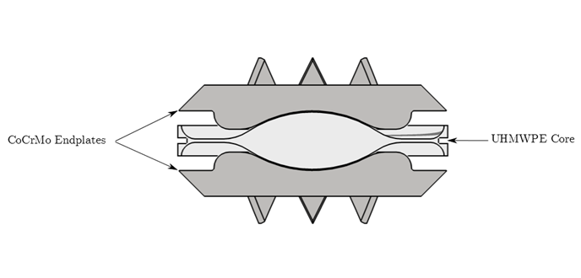
Figure 1: An illustration of the cross section of a Charité implant

Bovine serum digestion and filtration
The isolation of debris was performed using the method presented in BS ISO 17853:2011 [24]. A volume of 10 ml of bovine serum containing debris was mixed with hydrochloric acid, 32% w/w, using a vortex mixer and this was then incubated at 50 °C for 1 hour in a water bath. From the digested bovine serum 0.5 ml was diluted into 100 ml of analytical grade methanol, (Fisher Scientific UK Ltd, Loughborough, United Kingdom) and vacuum filtered through 0.1 µm Nuclepore filters (Whatman International Ltd, Maidstone, United Kingdom). The filter was cut with a scalpel to 2 mm x 2 mm squares and fixed to an SEM stub with copper tape, and allowed to dry in a desiccator for 24 hours. The filters were splutter coated with gold for 60 seconds at 30 mA using an Agar automatic splutter coater (Agar Scientific, Elektron Technology UK Ltd, Essex, United Kingdom). Silver conductive paint (RS components Ltd, Northants, United Kingdom) was dabbed on an edge to create a conductive bridge between the coated surface and the SEM stub.

High frequency reciprocating rig (HFRR)
For the purpose of finding abrasion and adhesion training debris, a High Frequency Reciprocating ball on disc tribometer (PCS Instruments, London, United Kingdom) using a steel ball on UHMWPE disc was used in two scenarios and in deionised and filtered water to prevent contamination (Figure 2). The scenarios were designed to deliberately induce either abrasion or adhesion in a simplified manner to allow for the identification of these wear debris morphologies [25,26]. The two scenarios were: a roughened ball of roughness Ra = 0.5 µm run at 20 Hz over a short time period (20 minutes) and a 0.05 µm roughness ball at 25 Hz for 4 hours.

The surface roughnesses of the balls were measured before testing using an Alicona Infinite Focus optical 3D micro coordinate system (Alicona Imaging GmbG, Raaba/Graz, Austria). Both sets of conditions were run in 1 ml of lubricant comprising of ultra-pure deionised water (Resistivity: > 18 MΩ-cm, Inorganic content: < 2 ppb). The lubricant, containing debris, was vacuum filtered using the same type of 0.1 µm filters and prepared for SEM and imaged in the same way as the in vitro implant samples outlined above.

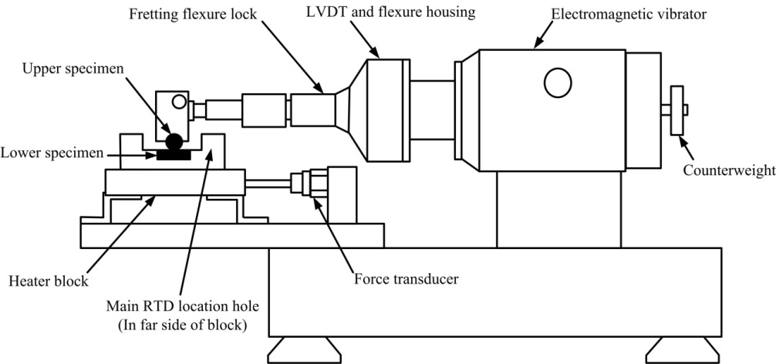 | 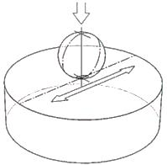
(a) | (b)
Figure 2: Schematics of (a)the mechanical unit of high-frequency reciprocating rig (HFRR) (b) the kinematics of the HFRR

Scanning electron microscopy
Scanning electron microscopy was performed on a FEI 235 duel beam FIB-SEM (FEI, Hillsboro, Oregon, USA) using the electron column with an acceleration voltage of 10-12 kV and the ‘though lens detector’ on UHR mode. Once a particle was found and good focus was achieved, high quality images were created using a 26 second scan with no averaging. A total of 480 images were taken of the wear debris, 40 of each lubricant sample in addition to 20 training images from the HFRR tests.

Image analysis
Images were analysed in MATLAB (MathWorks, Natick, Massachusetts, USA) using the Image Processing Toolbox. The size, aspect ratio, and wear particle morphology were calculated using the VLFeat library [27]. The size and shape of the particles were assessed by examining the region properties of the foreground of a binary image of the particles, created using a Sobel edge detection algorithm, to segment the particles from the background areas. Particle size was determined using Equation 1 given below, and aspect ratio was then calculated following ASTM F1877-05 [28]. The total number of particles was also calculated using Equation 2, with the mass lost taken directly from Moghadas [22].

ECD = $\sqrt{\frac{4×p}{π}×{\left(\frac{m}{s}\right)}^{2}}$ (1)

where p is the number of white pixels in the binary image, m is the magnification and s is the length of the scale bar in pixels.

$n_{tot}=n_{s}×\frac{m}{\sum{V×ρ}}$ (2)
where n_{tot} is the total number of particles, n_{s} is the number of particles in each sample, m is the mass lost, V is the sum of volumes of particles in each sample and ρ is the density of UHMWPE

The VLFeat Library, an open-source implementation of image analysis tools published under the BSD license, was used to analyse the morphology of the debris. VLFeat includes a method of generating descriptors of an image though SIFT [29]. SIFT was selected as it is a generic feature detector/descriptor that excels at generating consistent descriptors invariant of scale, and is robust to illumination and viewpoint differences. The descriptors have the form of a 128 dimension vector, with the Euclidean distance between a pair of descriptors being a measure of how similar the key points they represent are. The visualisation of a selection of descriptors is shown in Figure 3. Using these descriptors, SEM images were classified by a SVM [30]. This was also included in the VLFeat library and is a supervised machine learning algorithm.

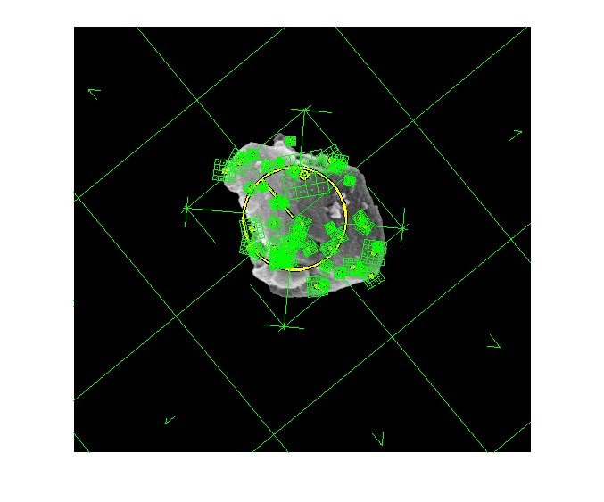
Figure 3: A wear Particle showing a selection of Sift Descriptors and Frames

The SVM was used to classify images into the following categories of wear debris, examples are shown in figure 4:
- Figure 4a & 4b – shows debris generated by adhesion – Images of adhesive wear debris are taken from the HFRR test using high speed and a smooth ball (can be of any size)
- Figure 4c & 4e– shows debris generated by abrasion – Images of abrasive wear are taken from the HFRR test using a roughened ball (typically medium sized {between 1 and 10 μm}, with a low aspect ratio)
- Figure 4f & 4g – shows Spherical debris – Training images of micro-spheres are taken from in vitro simulation debris images, chosen based on clarity of image (focus, contrast and brightness) and the obviousness of belonging to that specified morphological class (typically very small {less than 1 μm}).
- Figure 4h & 4i – Fibril debris – Training images of fibrils are taken from in vitro simulation debris images chosen based on clarity of image (focus, contrast and brightness) and the obviousness of belonging to that specified morphological class (typically medium to large {greater than 10 μm}, and of high aspect ratio)
- Figure 4j & 4k – Sheet/Flake debris – Training images of sheet/Flakes are taken from in vitro simulation debris images chosen based on clarity of image (focus, contrast and brightness) and the obviousness of belonging to that specified morphological class. (typically medium sized {between 1 and 10 μm}, with a high aspect ratio)

The SVM was trained with 10 images of each classification. Training images for abrasion and adhesion were selected from the debris generated by the HFRR; the other classifications were trained using images of debris produced by the spinal simulator. To guide the machine learning algorithm the following steps were taken. Firstly: the background of the training images were stripped to prevent image matching based on features not part of the wear particle; The SIFT descriptors for each of the training images were created. The SVM classifier used a ‘bag of words’ method— such that by comparing descriptors with a generic vocabulary instead of direct comparisons, computation time was greatly reduced (the problem becomes O(n) in complexity). The training image descriptors were grouped by a k-means algorithm and this generated a mean value for each cluster of descriptors. The SVM then compared how a class of debris matched between the descriptors of individual training images, and the general vocabulary of the SVM. The SVM required separate calibration for each class of debris, as it was a binary classification system. To classify unknown SEM images of wear debris, SIFT descriptors were extracted and compared to the SVM vocabulary. The SVM then decided if a given image belonged to the current class it has been trained in or not.

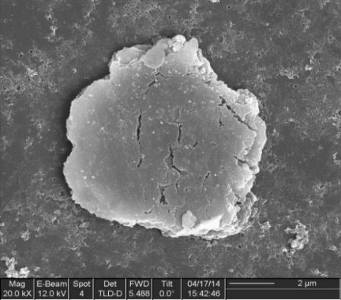
(a) | (b) | (c)
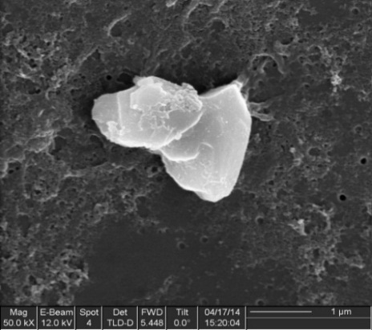 | 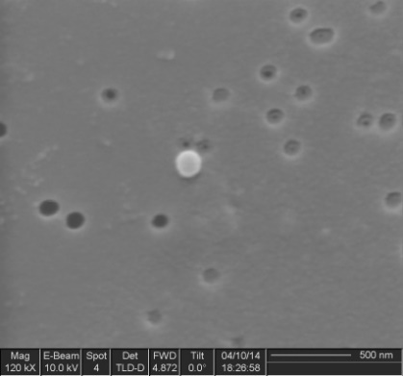
(d) | (e) | (f)
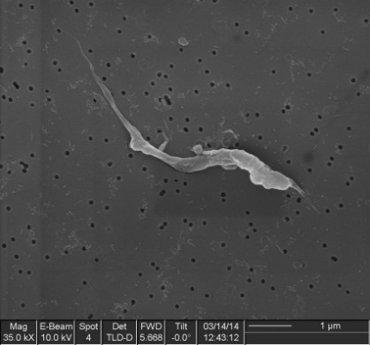 |  | 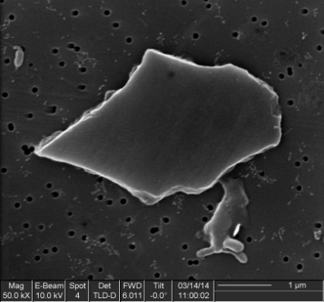
(g) | (h) | (i)
 | (j)
Figure 4: Example particles for training of (a) and (b) Adhesion, (c) and (d) Abrasion, (e) and (f) Sphere, (g) and (h) Fibril, and, (i) and (j) Flake.

Results

Size distributions
Figure 5 shows the total distribution for particle ECDs over all the samples, from 0.25 million to 5 million cycles. It can be seen that the size of the particles follow a log-normal distribution, the mode of particles has an ECD of 0.88 µm. Therefore the most common size for UHMWPE particles from a spinal implant simulation are within the 0.1 - 1 µm range, which has been found to be most problematic in biological systems [4,5] — a total of 33 % of the debris were sub-micron. The largest particle found was 46.3355 µm in diameter, the minimum found was 0.1480 µm.

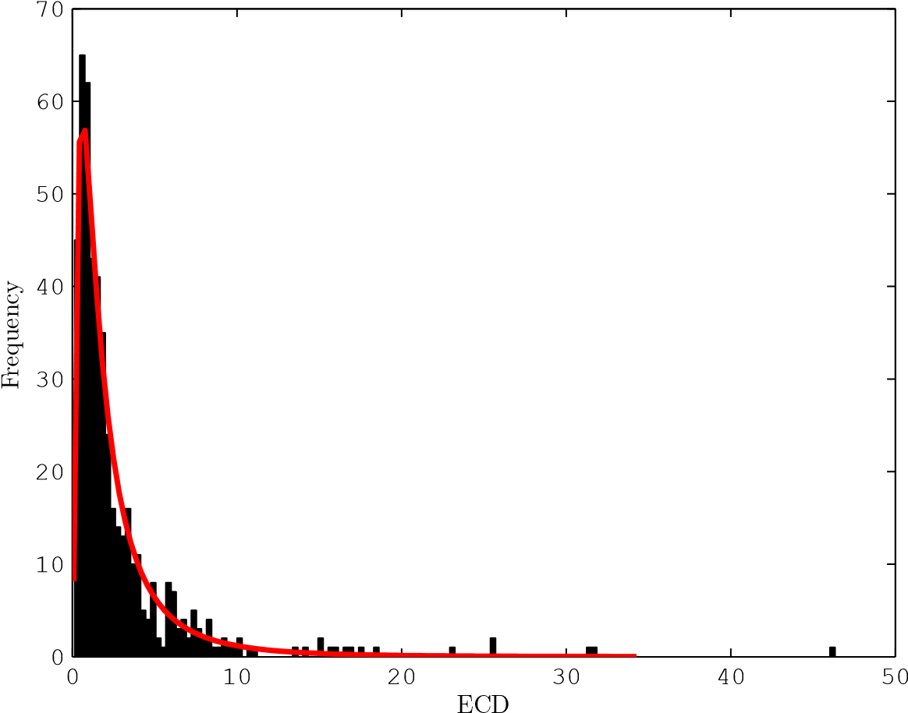
Figure 5: Size distribution of all samples combined. Mode = 0.88 µm, mean ± SEM = 2.89 ± 0.20 µm

Figure 6 shows the individual distributions of debris particle size at the various cycle counts. It can be seen that there is a general decreasing trend in mean particle size as the number of cycles increased, shown in Figure 7. The total amount of particles that were 0.1 µm or more in diameter, released after all 5 million cycles was 1.56 × 10¹⁰. The number of particles released is shown to exponentially increase per million cycles, shown in Figure 8.

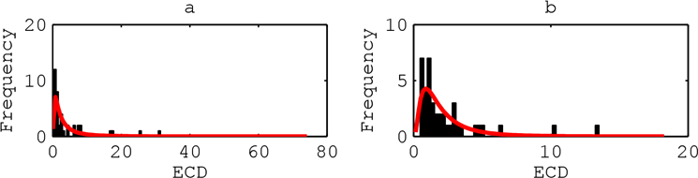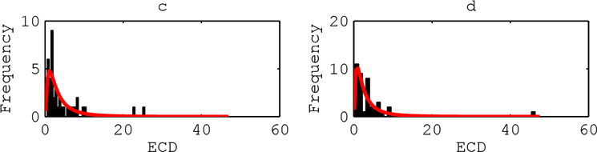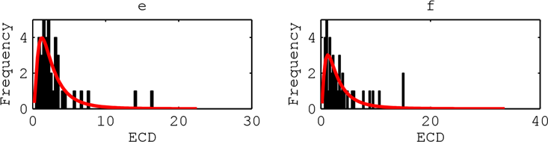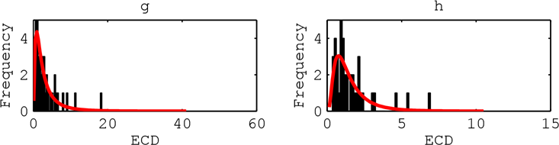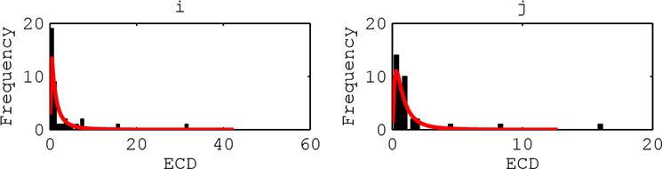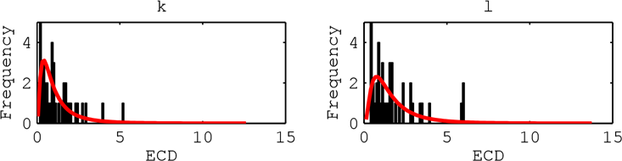

Figure 6: Size distributions of wear debris. (a) 0.25 million cycles (b) 0.75 million cycles (c) 1 million cycles (d) 1.25 million cycles (e) 1.5 million cycles (f) 1.75 million cycles (g) 2 million cycles (h) 2.25 million cycles (i) 2.5 million cycles (j) 3 million cycles (k) 4 million cycles (l) 5 million cycles

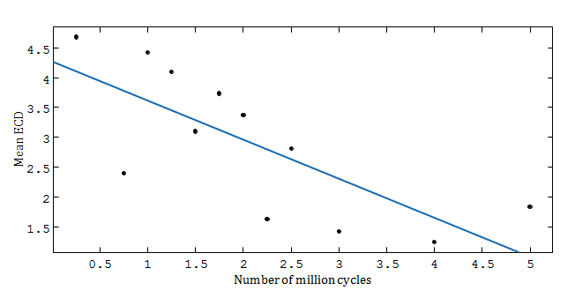
Figure 7: Mean size distribution of particles showing a negative trend over increasing number of cycles. R²=0.5628, f(x) = −0.6565x + 4.275

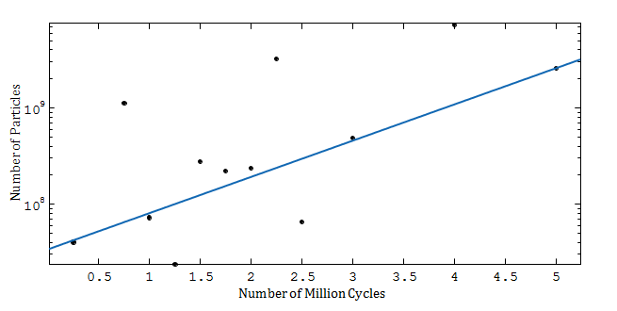
Figure 8: Number of particles over 0.1 µm released into each sample of lubricant, showing an exponential trend over increasing number of cycles. R² = 0.8323, fx = 3.347 × 10⁷e^{0.8688}

Aspect ratio of the debris
The distribution of the aspect ratio for all particles is shown in Figure 9, and the individual distributions are shown in Figure 10. The majority of the collected debris has an aspect ratio that falls between 1 and 3 (83%), and follow a log-normal distribution.
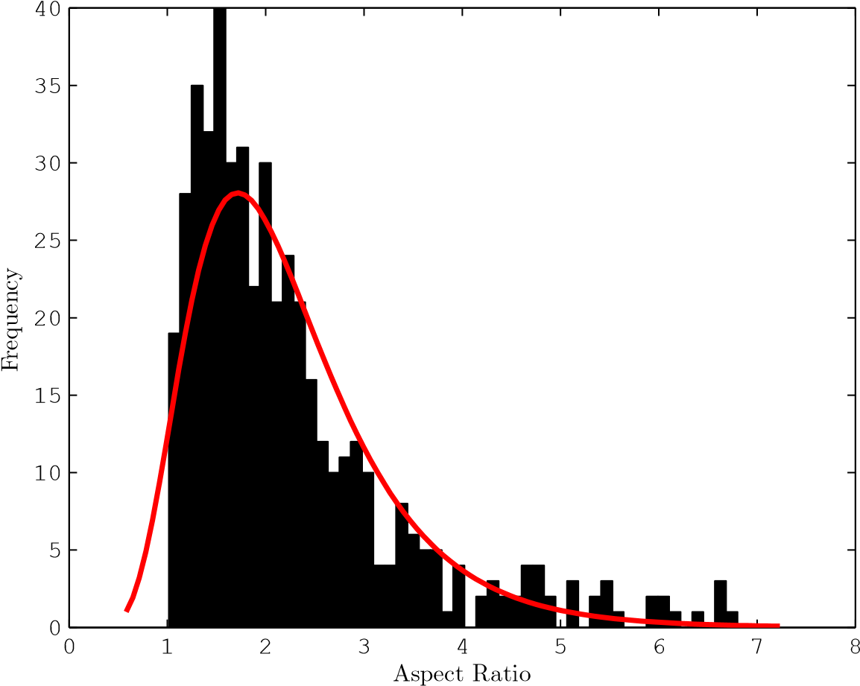
Figure 9: Aspect ratio distribution of all samples combined. Mode = 1.55, mean ± SEM = 2.25 ± 0.05

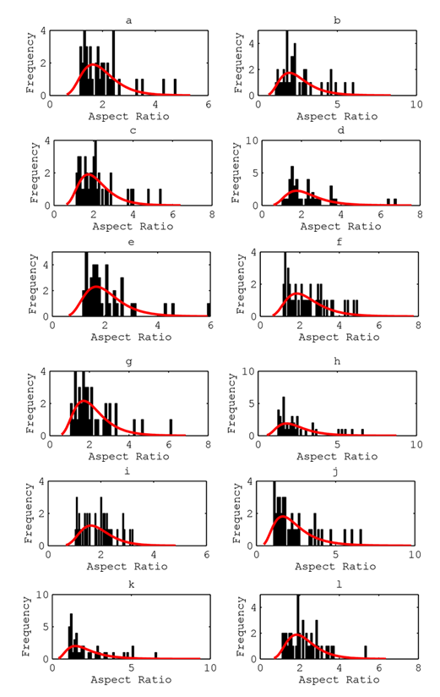
Figure 10: Aspect ratio distributions of wear debris (a) 0.25 million cycles (b) 0.75 million cycles (c) 1 million cycles (d) 1.25 million cycles (e) 1.5 million cycles (f) 1.75 million cycles (g) 2 million cycles (h) 2.25 million cycles (i) 2.5 million cycles (j) 3 million cycles (k) 4 million cycles (l) 5 million cycles
The relationship between particle size and aspect ratio is shown in the density map given in Figure 11. A delta shaped trend can be clearly observed, with small and large particles having fewer instances of large aspect ratios. Particles between 1 µm and 10 µm in diameter show the greatest range in aspect ratio. This is a behaviour that has been observed previously in knee implants despite the differences in the kinematics of the arthroplasty [9,31].
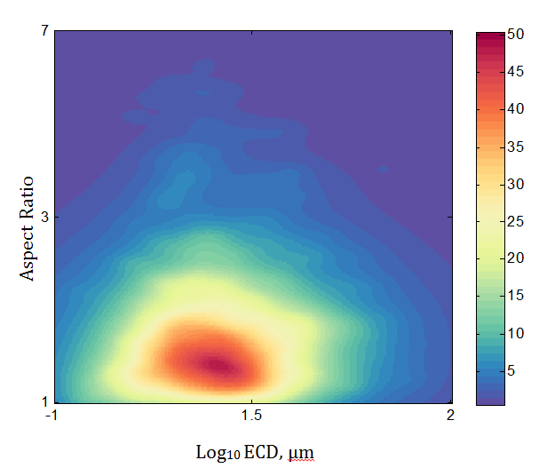
Figure 11: Density map of 500 data-points showing relationship between aspect ratio and Equivalent Circle Diameter (ECD)
.

Debris morphology
The debris particles taken from TDR simulation tests comprised a wide variety of morphologies. These will have been shaped by both the complicated kinematics of the implant device and the material properties of the frictional surfaces. Table 2 summarises the observed debris extracted from the lubricant from each interval of the endurance test.
Table 2: The observed debris, extracted from the lubricants at the defined stage of the endurance tests. Also listed are the debris morphologies that were found to be most dominant.
Cycles | Debris present | Dominant Debris
1 M | Fibril, Adhesion, Abrasion,  Flake | Fibril, Abrasion
2M | Fibril, Adhesion, Abrasion,  Flake | Fibril, Adhesion
3 M | Fibril, Adhesion, Sphere,  Abrasion | Fibril, Sphere
4 M | Fibril, Sphere, Flake, Abrasion | Sphere, Fibril
5 M | Fibril, Sphere, Abrasion | Fibril, Abrasion

Discussion
This study has examined the attributes of UHMWPE debris created in a spinal implant simulation, and the distributions of such debris geometry. From the size distributions shown in Table 1, the UHMWPE debris from the spinal simulator was somewhat in agreement with that of other TJRs [9,15–21]. However it is difficult to make direct comparisons as test, sample preparation and assessment methodologies and equipment vary between research groups [8]. Additionally, it has been found that in vitro and explant studies produce greatly different morphologies or size distributions [8]. However the morphology of wear scars of explanted Charité cores [14] match the debris found in this study. The measured aspect ratios are also similar to other reported values [6-9]. Additionally a study on the size, aspect ratio and roundness of debris from periprosthetic tissue of SB Charité III TDRs found very similar ECD and aspect ratio distributions [32,33]. This validates both the kinematics of in vitro simulations of TDRs using a Bose ElectroForce Spinal Disc Fatigue/Wear system—in part validating other studies using the same procedure, such as those conducted by Moghadas [34] or Xin [35], and the observational algorithms used to generate this data.
This study suffers from the same limitations found in other studies that use an SEM to characterise debris. These limitations include the large time requirement needed to image and analyse a large quantity of debris. The current study’s use of a SIFT and SVM algorithms have taken steps to reduce this time. Some debris, particularly those of high aspect ratio, being prone to clumping together, despite efforts to ensure debris was dispersed. An additional issue with high aspect ratio particles is they can bend and curve back on themselves, resulting in a lower reported aspect ratio. By using an acidic digestion technique, and using 0.1 µm filters, both the metallic debris, and those smaller than 100 nm are lost. It is difficult to compare studies of debris, as different characterisation methodologies can have large influences on the results.
However, the most common debris present in total in all 5 million cycles was fibril debris (Figure 4h/i). This form of debris is sometimes associated with ploughing wear that has been gouged from the UHMWPE surface [25,26]. This ploughing is associated with abrasive wear. It can also be attributed to the entrainment and ‘rolling’ of other debris as particles pass through the contact zone, leading to deformation and the formation of long ‘string-like’ fibrils. Other debris appears to vary in frequency and is dependent on the number of cycles that have passed. During the initial cycles, adhesion (Figure 4a/b) and abrasion (Figure 4c/d) debris are abundant. As the wear test continued their numbers decreased. This is consistent with a running-in period and importantly matches the wear damage found on explanted Charité cores [14].
The use of the HFRR to generate training images did not incorporate the effects of cross-shear. Whilst this has been shown to have a significant effect on the amount of wear produced, [36] study showed that morphology of the wear track possessed similar features that were associated with adhesion/ abrasion for both reciprocating and double elliptical sliding. Ipso facto as the wear tracks are similar so to must be the debris. They found evidence that fatigue was the differentiating factor between the tracks. The HFRR generated debris was judged to display enough of the characteristic properties of these classes of wear debris (adhesion and abrasion) to allow for the correct classification.
After 2 million cycles had elapsed, small spheres below 1 µm in diameter began to form (Figure 4e/f); with their frequency increasing as more cycles elapsed. Spherical particles can be associated with the exfoliation of the contact surfaces as a result of fatigue [37,38]. The increase in occurrence of spherical particles of small diameter coincided with the general decrease in average ECD. It is these sub-micron spheres that are most likely to cause an inflammatory response [2,4]. Examination of periprosthetic tissue samples from revision surgeries of lumber TDRs show evidence of macrophage activation in wear debris containing tissue samples, indicative of inflammation [33,39]. It was found that although the mean particle size decreased as the wear test progressed, the UHMWPE cores that generated the wear debris had a constant mass loss of 12.0 ± 1.4 mg/million cycles [22]. Since the volume of material lost remained constant, the number of wear particles released, as the individual size of the wear debris decreased exponentially. [36]

Conclusions
This paper has investigated the nature of debris produced from an in vitro simulation of a TDR implant, using SEM micrographs analysed with computer vision techniques. Being able to measure and then correlate debris generated during in vitro simulation is a vital step to understand and eventually mitigating against tribological failure of implanted devices. The general conclusions from this study are:
- Using an integrated debris morphology assessment tool that combined a Scale Invariant Feature Transform (SIFT) to extract key point data from individual images and a Support Vector Decision Machine (SVM) to filter images, increased the efficiency of assessing the debris images.
- The majority occurrence of debris was fibril in morphology. This implied that a combination of micro-machining wear, and/or entrainment of debris between the bearing surfaces had occurred.
- Debris showed a decreasing trend in size as the wear test progressed, and was mainly fibril/ spherical in morphology
- Abrasion and adhesion predominately occurred before 2 million cycles, between 2- 5 million cycles small spherical particles (associated with fatigue and entrainment) become more prevalent.
- Debris morphology matches that found in reclamation studies.
- Measured UHMWPE debris is predominantly of a size that is known to cause inflammation and possibly osteolysis. The modal equivalent circle diameter of the debris was 0.88 μm and the mean ± SEM was 2.89 ± 0.20 µm.
Acknowledgements
The high frequency tribometer used in this research was obtained, through Birmingham Science City: Innovative Uses for Advanced Materials in the Modern World (West Midlands Centre for Advanced Materials Project 2), with support from Advantage West Midlands (AWM) and part funded by the European Regional Development Fund (ERDF). This study was also supported by the Engineering and Physical Sciences Research Council (grant no: EP/J500367/1).

References
[1] I. Milošev, S. Kovač, R. Trebše, V. Levašič, V. Pišot, Comparison of ten-year survivorship of hip prostheses with use of conventional polyethylene, metal-on-metal, or ceramic-on-ceramic bearings., J. Bone Joint Surg. Am. 94 (2012) 1756–63. doi:10.2106/JBJS.J.01858.
[2] E. Ingham, J. Fisher, Biological reactions to wear debris in total joint replacement, Proc. Inst. Mech. Eng. Part H J. Eng. Med. 214 (2000) 21–37.
[3] W.H. Harris, The problem is osteolysis, Clin. Orthop. Relat. Res. 311 (1995) 46–53.
[4] T.R. Green, J. Fisher, J.B. Matthews, M.H. Stone, E. Ingham, Effect of size and dose on bone resorption activity of macrophages by in vitro clinically relevant ultra high molecular weight polyethylene particles, J. Biomed. Mater. Res. 53 (2000) 490–497. doi:10.1002/1097-4636(200009)53:5<490::AID-JBM7>3.0.CO;2-7.
[5] B.W. Cunningham, N.J. Hallab, N. Hu, P.C. McAfee, Epidural application of spinal instrumentation particulate wear debris: a comprehensive evaluation of neurotoxicity using an in vivo animal model, J. Neurosurg. Spine. 19 (2013) 336–350. doi:10.3171/2013.5.SPINE13166.
[6] A. Kobayashi, W. Bonfield, Y. Kadoya, T. Yamac, M.A.R. Freeman, G. Scott, et al., The size and shape of particulate polyethylene wear debris in total joint replacements, Proc. Inst. Mech. Eng. Part H J. Eng. Med. 211 (1997) 11–15.
[7] M. Topolovec, I. Milošev, A. Cör, R.D. Bloebaum, Wear debris from hip prostheses characterized by electron imaging, Cent. Eur. J. Med. 8 (2013) 476–484.
[8] M.J. Nine, D. Choudhury, A.C. Hee, R. Mootanah, N.A.A. Osman, Wear Debris Characterization and Corresponding Biological Response: Artificial Hip and Knee Joints, Materials (Basel). 7 (2014) 980–1016. doi:10.3390/ma7020980.
[9] L.G. Gladkis, H. Timmers, J.M. Scarvell, P.N. Smith, Detailed three-dimensional size and shape characterisation of UHMWPE wear debris, Wear. 270 (2011) 455–463.
[10] G.W. Stachowiak, P. Podsiadlo, Characterization and classification of wear particles and surfaces, Wear. 249 (2001) 194–200.
[11] S. Raadnui, Wear particle analysis - utilization of quantitative computer image analysis: a review, Tribol. Int. 38 (2005) 871–878.
[12] P. Podsiadlo, G.W. Stachowiak, Scale-invariant analysis of wear particle surface morphology I: Theoretical background, computer implementation and technique testing, Wear. 242 (2000) 160–179. doi:10.1016/S0043-1648(00)00416-6.
[13] A.A. Reda, R. Bowen, V.C. Westcott, Characteristics of particles generated at the interface between sliding steel surfaces, Wear. 34 (1975) 261–273.
[14] S.M. Kurtz, A. van Ooij, R. Ross, J. de Waal Malefijt, J. Peloza, L. Ciccarelli, et al., Polyethylene wear and rim fracture in total disc arthroplasty, Spine J. 7 (2007) 12–21. doi:http://dx.doi.org/10.1016/j.spinee.2006.05.012.
[15] E. Zolotarevova, G. Entlicher, E. Pavlova, M. Slouf, D. Pokorny, F. Vesely, et al., Distribution of polyethylene wear particles and bone fragments in periprosthetic tissue around total hip joint replacements, Acta Biomater. 6 (2010) 3595–3600.
[16] S.B. Wang, S.R. Ge, H.T. Liu, X.L. Huang, Wear behaviour and wear debris characterization of UHMWPE on alumina ceramic, stainless steel, CoCrMo and Ti6Al4V hip prostheses in a hip joint simulator, in: J. Biomimetics, Biomater. Biomed. Eng., 2010: pp. 7–25.
[17] M. Lapcikova, M. Slouf, J. Dybal, E. Zolotarevova, G. Entlicher, D. Pokorny, et al., Nanometer size wear debris generated from ultra high molecular weight polyethylene< i> in vivo</i>, Wear. 266 (2009) 349–355.
[18] L. Richards, C. Brown, M.H. Stone, J. Fisher, E. Ingham, J.L. Tipper, Identification of nanometre-sized ultra-high molecular weight polyethylene wear particles in samples retrieved in vivo, J. Bone Jt. Surgery, Br. Vol. 90 (2008) 1106–1113.
[19] H. Koseki, T. Matsumoto, S. Ito, H. Doukawa, H. Enomoto, H. Shindo, Analysis of polyethylene particles isolated from periprosthetic tissue of loosened hip arthroplasty and comparison with radiographic appearance, J. Orthop. Sci. 10 (2005) 284–290.
[20] M. Visentin, S. Stea, S. Squarzoni, B. Antonietti, M. Reggiani, A. Toni, A new method for isolation of polyethylene wear debris from tissue and synovial fluid, Biomaterials. 25 (2004) 5531–5537.
[21] J.L. Tipper, E. Ingham, J.L. Hailey, A.A. Besong, J. Fisher, B.M. Wroblewski, et al., Quantitative analysis of polyethylene wear debris, wear rate and head damage in retrieved Charnley hip prostheses, J. Mater. Sci. Mater. Med. 11 (2000) 117–124.
[22] P.M. Mobarakeh, Tribology of ball-and-socket total disc arthroplasty, University of Birmingham, 2012.
[23] ISO, 18192-1:2011(Implants for surgery - Wear of total intervertebral spinal disc prostheses), (2011).
[24] ISO, 17853:2011 (Wear of implant materials - Polymer and metal wear particles - Isolation and characterization), (2011).
[25] G.W. Stachowiak, P. Podsiadlo, Towards the development of an automated wear particle classification system, Tribol. Int. 39 (2006) 1615–1623. doi:10.1016/j.triboint.2006.01.019.
[26] G.P. Stachowiak, G.W. Stachowiak, P. Podsiadlo, Automated classification of wear particles based on their surface texture and shape features, Tribol. Int. 41 (2008) 34–43. doi:10.1016/j.triboint.2007.04.004.
[27] A. Vedaldi, B. Fulkerson, {VLFeat}: An Open and Portable Library of Computer Vision Algorithms, (2008).
[28] ASTM, F1877-05, Stand. Pract. Charact. Part. 14 (2009).
[29] D.G. Lowe, Distinctive image features from scale-invariant keypoints, Int. J. Comput. Vis. 60 (2004) 91–110. doi:10.1023/B:VISI.0000029664.99615.94.
[30] C. Cortes, V. Vapnik, Support-vector networks, Mach. Learn. 20 (1995) 273–297. doi:10.1007/BF00994018.
[31] C.M. Sprecher, E. Schneider, M.A. Wimmer, Generalized size and shape description of UHMWPE wear debris--A Comparison of Cross-linked, Enhanced Fused, and Standard Polyethylene Particles, J ASTM Intern. 1 (2004).
[32] I. Punt, R. Baxter, A. van Ooij, P. Willems, L. van Rhijn, S. Kurtz, et al., Submicron sized ultra-high molecular weight polyethylene wear particle analysis from revised SB Charité III total disc replacements., Acta Biomater. 7 (2011) 3404–11. doi:10.1016/j.actbio.2011.05.010.
[33] S.Y. Veruva, T.H. Lanman, J.E. Isaza, D.W. MacDonald, S.M. Kurtz, M.J. Steinbeck, UHMWPE Wear Debris and Tissue Reactions Are Reduced for Contemporary Designs of Lumbar Total Disc Replacements., Clin. Orthop. Relat. Res. (2014). doi:10.1007/s11999-014-4029-4.
[34] P. Moghadas, A. Mahomed, D.W.L. Hukins, D.E.T. Shepherd, Wear in metal-on-metal total disc arthroplasty., Proc. Inst. Mech. Eng. H. 227 (2013) 356–61. doi:10.1177/0954411912471768.
[35] H. Xin, D.E.T. Shepherd, K.D. Dearn, A tribological assessment of a PEEK based self-mating total cervical disc replacement, Wear. 303 (2013) 473–479. doi:10.1016/j.wear.2013.03.052.
[36] S. Ge, S. Wang, N. Gitis, M. Vinogradov, J. Xiao, Wear behavior and wear debris distribution of UHMWPE against Si3N4 ball in bi-directional sliding, Wear. 264 (2008) 571–578. doi:10.1016/j.wear.2007.05.001.
[37] D. Scott, G.H. Mills, Spherical debris-its occurrence, formation and significance in rolling contact fatigue, Wear. 24 (1973) 235–242.
[38] J.L. Middleton, Vc. Westcott, R.W. Wright, The number of spherical particles emitted by propagating fatigue cracks in rolling bearings, Wear. 30 (1974) 275–277.
[39] I.M. Punt, J.P.M. Cleutjens, T. de Bruin, P.C. Willems, S.M. Kurtz, L.W. van Rhijn, et al., Periprosthetic tissue reactions observed at revision of total intervertebral disc arthroplasty., Biomaterials. 30 (2009) 2079–84. doi:10.1016/j.biomaterials.2008.12.071.

