Decarbonisation of heat using heat pumps: A life cycle assessment study
Neha Mehta, Jonathan Radcliffe
School of Chemical Engineering, University of Birmingham, UK
In order to achieve the worldwide decarbonisation goals, significant reductions in greenhouse gas emissions from heating are required. In the future, electricity is anticipated to supply a large portion of the heat demand currently met by fossil fuels, and heat pumps may play a significant role (Lowes et al., 2020). This is because heat pumps which can convert electricity directly to heat will almost directly reflect the carbon intensity of the electricity they use. However, this reduction in greenhouse gas emissions is dependent on the raw materials used, the source and quantity of electricity consumed for operation and end of life management of heat pumps.
Therefore, this research focuses on the whole life cycle impact assessment of heat pumps. Life cycle assessment is a standardised framework used to evaluate the environmental impacts of products and processes from raw material extraction to end of life management (ISO 14040, 2006; ISO 14044, 2006). The necessary first step towards computing environmental impacts is outlining the stages involved in the production and use of heat pumps, which is being completed through literature survey and discussion with stakeholders (Figure 1). The next stage would be to characterise the environmental impacts of every process/stage. This research informs the development of heat pumps and decarbonisation of heat in an environmentally sustainable manner.
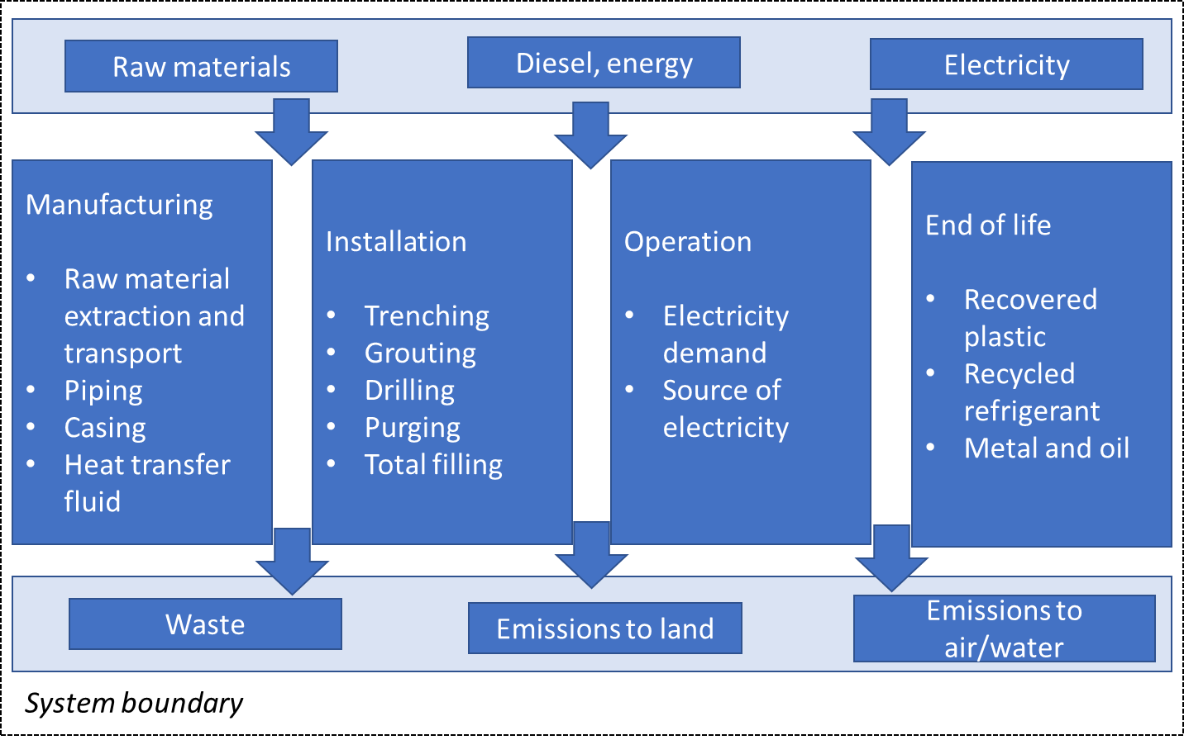
Figure 1. System boundary for calculating life cycle environmental impacts of heat pumps.
References
ISO 14040 (2006). Environmental management-Life cycle assessment. Principles and framework.
ISO 14044 (2006). Environmental management-Life cycle assessment. Requirements and guidelines.
Lowes, R., Rosenow, J., Qadrdan, M., and Wu, J. (2020). Hot stuff: Research and policy principles for heat decarbonisation through smart electrification. Energy Res. Soc. Sci. 70, 101735.

