Prevalence of sarcopenia in Parkinson’s disease: A systematic review and meta-analysis

ABSTRACT
We meta-analysed the sarcopenia prevalence among patients with Parkinson´s disease (PD) in comparison to a control group and tested the effects of age, sex, sarcopenia assessments, and PD progression in the sarcopenia prevalence. The literature search was performed using five databases in March 2022. The prevalence of sarcopenia in patients with PD was 3 times higher than in the control group (OR 3.98). Subgroup analyses showed that among individuals aged ≥ 71 years the higher prevalence of sarcopenia in PD compared to controls (OR 5.32, P=0.08) tended to be higher (P=0.08) than the group <70 years. Regarding PD progression, the prevalence of sarcopenia was not different between individuals scoring <2.5 and >2.5 in the Hoehn and Yahr scale. Patients with PD have a higher probability of developing sarcopenia when compared with the control group and older PD patients trended to have even higher chance of sarcopenia than their older controls.
Keywords: Parkinson's disease, sarcopenia, aged; muscle strength;

Graphical abstract

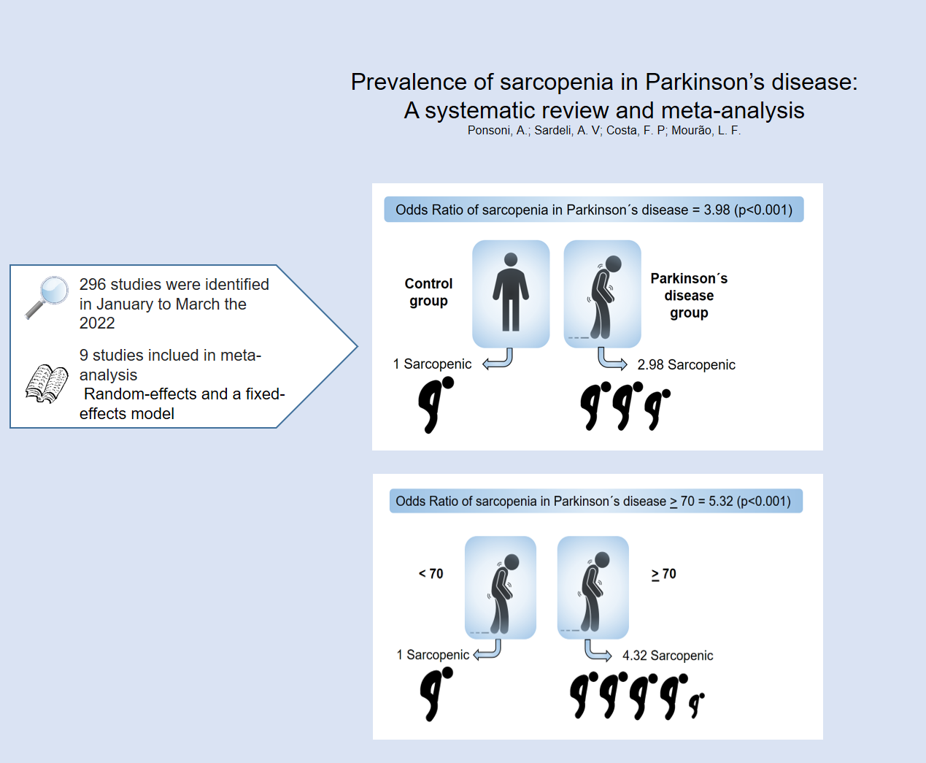

Introduction

Parkinson's disease (PD) is a progressive neurodegenerative movement disorder characterized by the death of dopaminergic neurons in the substantia nigra (SN). ^{1,2} Overall, PD's prevalence increases with age. The prevalence rate is 41 per 100,000 within individuals aged 40–49 years, 107 per 100,000 within 50–59 years, 173 per 100,000 within 55–64 years, 428 per 100,000 within 60–69 years, 1087 per 100,000 within 70–79 years, ³ and there is 2:1 higher incidence of PD in males than in females. ^{4,5}
The diagnosis of PD is essentially clinical, ^{6,7} through the identification of motor disorders such as resting tremor, bradykinesia, rigidity, and postural instability. ⁸ In addition, secondary symptoms may also be present, such as olfactory dysfunction, depression, sleep disorder, cognitive decline, hyponymy, dysarthria, sialorrhea, micrography, freezing festination, ⁹ dystonia, and dysphagia. ¹⁰ Disease progression is evaluated by motor impairment and postural instability, from unilateral and bilateral inability to ambulate, until bed restriction that is usually assessed by Hohen and Yahr scale (H&Y). ^{11–13}
PD progression leads to reduced motor capacity, changes in body composition, decreased physical performance, and an impact on vitality. ¹⁴ These factors have also been observed in sarcopenia following aging. ¹⁵ According to the latest review by the European Working Group on Sarcopenia in Older Persons (EWGSOP) performed in 2018, sarcopenia is characterized by a reduction in muscle mass and consequent loss of strength.¹⁵ The causes of sarcopenia are multifactorial, and the normal aging process increases the risk of sarcopenia. ¹⁵ The prevalence of sarcopenia is approximately 20% in individuals over 70 years of age, while this percentage increases to 50% in people over 80 years of age. ¹⁶ The factors that cause sarcopenia are diverse, and include aging, cognitive decline, lung, cardiac and neurodegenerative diseases. ¹⁷
The prevalence of sarcopenia combined with PD is controversial, varying from 17.2 to 55.7%. ^{18–22} The main reason for this discrepancy might be linked to the different patients’ age in previous studies. A previous systematic review and meta-analysis reported high heterogeneity among studies that evaluated sarcopenia in PD. ²³ These authors verified that the prevalence of sarcopenia in PD was 29%, although this percentage dropped to 17% when only considering studies with a low risk of bias. ²³ Nevertheless, meta-analyses performed by these authors did not consider age as a confounding variable.
Considering that PD preferentially affects older adults, ^{3,24} it is crucial to develop strategies to meet their needs and provide care strategies of individuals with the disease.⁴ However, it is not clear whether the high incidence of sarcopenia among PD patients is caused by the neurodegenerative process, or due to aging which is coincidently more evident as PD aggravates. ^{1,2}
Therefore, our main goal was to determine the prevalence of sarcopenia in patients with PD compared to healthy participants through a meta-analysis of previous studies in the literature. The secondary aim was to analyze the effect of age, the instruments used to identify sarcopenia, and confounding factors such as sex and disease progression, on the prevalence of sarcopenia in PD patients.

Methods

The present systematic review and meta-analysis followed state-of-the-art literature and the recommendations of the Preferred Reporting Items for Systematic Reviews and Meta-Analysis (PRISMA). ²⁵

Selection criteria

The studies selected in the meta-analysis met the following criteria: (1) original studies; (2) studies assessing humans; (3) sarcopenia assessment; (4) studies with patients diagnosed with PD or Parkinsonism; and (5) studies with a control group (non-PD patients). The exclusion criteria were the following: (1) duplicated studies; (2) systematic reviews; letters to the editors, case reports, or conference abstracts; and (3) studies not written in the English language.

Information source

The studies were retrieved from electronic database searches as well as by screening the reference list of the retrieved studies. The studies were searched on PubMed, Scopus, Web of Science, CINAHL, and Embase in January to March 2022.

Search strategy

The search was designed to identify studies that tested the prevalence of sarcopenia in patients with and without Parkinson’s disease. The search strategy combined the following descriptors and boolean operators (AND/OR): (“Parkinson Disease” OR “Parkinsonian Disorders” OR “Parkinsonian Syndrome” OR “Parkinsonian Syndromes” OR “Parkinsonism” OR “Parkinsonian Diseases” OR “Idiopathic Parkinson's Disease” OR “Parkinson's Disease Idiopathic” OR “Parkinson Disease, Idiopathic” OR “Parkinson's Disease”) AND (“Sarcopenia”).

Study selection

The selected studies were combined using Mendeley software, through which duplicates were removed. Two researchers independently evaluated the eligibility criteria of titles and abstracts, while conflicts were resolved by a third researcher. If the abstracts did not present complete information, the studies were entirely inspected.

Data collection process

Data were extracted from former studies following a previously structured protocol through which information such as sample size, age, and sex from participants with PD and the control group were forwarded to a database. The protocol also guided the identification of sarcopenia measurements, and determined the presence or absence of sarcopenia in the PD and control groups. In addition, different instruments for assessing sarcopenia (dual-energy X-ray absorptiometry [DXA] versus bioimpedance analysis [BIA], handgrip dynamo, walking speed, Sarc-F) are listed.
When the required information was not described in the text of the different studies but presented in figures, the data were directly extracted from the respective charts using WebPlotDigitizer software, version 4.2 (San Francisco, CA, USA). The data were extracted independently by two researchers, and divergences were analyzed by a third researcher.

Risk of bias in the included studies

The risk of bias was assessed using the Newcastle–Ottawa Scale ²⁶, which was adapted, with an overall quality score ranging from 0 (minimum) to 9 (maximum). For each article, the following aspects of the risk of bias were considered: 1) selection, 2) comparability, and 3) exposure. Articles with scores of > 7 represented a low risk of bias.²⁶

Statistical analysis

The meta-analysis was performed using the Comprehensive Meta-Analysis (CMA) software, version 3.3.070. The main meta-analysis tested the odds ratios (OR), based on the prevalence of sarcopenia in a given sample of PD patients compared with a control group.
A random-effects model was used when there was significant heterogeneity (P ≤ 0.05), and a fixed-effects model was used when there was no heterogeneity (P > 0.05). Publication bias were analyzed using the Egger test, and a P-value of ≤ 0.05 was considered significant. Subgroup analysis was performed to identify the cause of heterogeneity and inconsistency between studies. For subgroup analyses, we compared age (< 70 versus 71 years), sex (men versus women) and type of sarcopenia assessment (multiple assessments [more than one assessment for sarcopenia] versus single assessments [only one assessment for sarcopenia]). Studies which did not report the type of muscle mass assessment were excluded from this specific subgroup analysis, and studies that included men and women in the same analysis were excluded from the sex subgroup analysis. A second meta-analysis was performed to test the sarcopenia OR comparing the prevalence of sarcopenia in PD patients with < 2.5 versus > 2.5 points on the Hohen and Yahr scale (H&Y). ²⁷
Results

The flow diagram of the literature search is shown in Fig. 1. In total, 9 ^{18–22,28–31} of 296 studies were selected for the meta-analysis. Details of the included studies are presented in Table 1, and all of them scoreed at least 7 in the Newcastle–Ottawa Scale, suggesting low risk of bias (Table 2). Together, these studies had a total of 1015 participants with PD. Of these, 266 were diagnosed with sarcopenia, and 749 were not. The mean age of the participants was 67.8 years with a standard deviation of 4 years. The control group was composed of 1009 healthy individuals with a mean age of 67.3 years and a standard deviation of 4.7 years, in which, 116 had sarcopenia (Table 1). The studies included different instruments for diagnosing sarcopenia, such as BIA, DXA, handgrip dynamometer, walking speed, and Sarc-F. Seven studies ^{20–22,28–31} used multiple instruments for sarcopenia evaluation (BIA, DXA, handgrip dynamometer, walking speed, Sarc-F), one study only used BIA, ¹⁸ and another only used DXA. ¹⁹ The risk of images in the articles included in the meta-analysis range.

Please insert figure 1 here
Please insert table 1 here
Please insert table 2 here

Sacopenia comparison between Parkinson’s and control groups

The meta-analysis showed three times higher prevalence of sarcopenia in PD patients than in controls [OR 3.98 [95% confidence interval (CI): 2.2–7.1] (Fig. 2).

Please insert figure 2 here

To explore the causes of heterogeneity between the studies, we compared the subgroup categories of the main confounding factors. However, no significant difference between any subgroups was found, and there was a significantly higher sarcopenia OR for Parkinson’s disease compared to the control groups within any category tested (Table 3).

Age

There was tendency to higher chance of developing sarcopenia in in patients aged > 71 years compared to ≥ 71 years(P-value = 0.08). The older group has a four-fold higher probability of developing sarcopenia (Table 3).

Please insert table 3 here

Instruments of sarcopenia

In the present meta-analysis, we investigated whether different instruments used to measure sarcopenia could have an impact on the prevalence of sarcopenia. The results revealed no significant difference between multiple versus single assessments of sarcopenia (P = 0.45), with OR of 2.3 (1.6; 3.27) and 3.1 (1.5; 6.24), respectively (Table 3).

Sex

Sex subgroup analysis, did not reveal differences between sarcopenia prevalence in men and women with PD (P = 0.63). The prevalence of sarcopenia in men with PD was 3.66 (2.49–5.38) compared to that in control men, while the equivalent PD for women was 3.82 (2.29–6.36) (Table 3).

Disease progression

There was no significant difference (P = 0.38) in sarcopenia OR between PD patients below 2.5 and above 2.5 on H&Y scale [OR 1.52 (0.59–3.95) ] (Fig. 3).

Please insert figure 3 here

Discussion

The present meta-analysis showed PD patients had three times more chance of being sarcopenic than control individuals. Similarly, the meta-analysis performed by Cai et al. ²³ identified an estimated prevalence of sarcopenia in PD of 29% (95% CI: 0.18–0.40). However, when the authors only analyzed studies with a low risk of bias, the combined prevalence decreased to 17% (95% CI: 0.02–0.33).
The main reason of higher prevalence of sarcopenia in PD is not clear, but some PD symptoms might explain this result. The progression of symptoms such as tremor, rigidity and dyskinesias, contribute to higher energetic expenditure that would ultimately lead to body weight reduction and loss of muscle mass. ³² However, it is also known that PD patients can be undernutrition, ³³ due to metabolic complications and the oropharyngeal dysphagia that reaches 80% of the PD patients. ³⁴
Both the present and previous meta-analysis found high heterogeneity in the results that might be correlated with the pathophysiology of the disease or with aging.
A meta-analysis performed by Shafiee et al. ³⁵ found that inherent aging process without neurological diseases increased the prevalence of sarcopenia from 10% in the age of 40 years, to 20% over 70 years and 50% over 80 years, ¹⁶ contributing to the loss of muscle strength. ³⁶ Thus, we hypothesized that these two factors (ageing and neurological diseases) increase prevalence of sarcopenia in patients with PD, and would result in a vicious cycle that can accelerate neurodegenerative processes in PD. ³⁷ Both aging and PD cause several body and neurological changes that favor an increased risk of sarcopenia, disability, and mortality in old age. ³⁸ For example, changes in body composition that cause a reduction in the physical performance, as well as development of changes in cortical structures that may be associated with increased fat percentage and reduction of thigh muscle mass in patients with PD. ^{36,39}
Some authors have correlated the increased prevalence of sarcopenia with a worsening score on H&Y, ^{20,21} suggesting that H&Y level does not explain the increase in sarcopenia. Although no difference was found between the scores on the scale and increase in sarcopenia, stage 3 was the highest stage evaluated in studies. Thus, it is important to conduct future studies to analyze this correlation and verify whether different H&Y scores may impact the prevalence of sarcopenia in PD.
This study had a few limitations. Considering higher sarcopenia OR among the older group could be explained by the expected longer time of disease, the effect of time of disease in our results should have been tested. However, since the studies did not presented time of PD, we could not test the effect of this confounding factor directly.
In regards to sex difference, it is known that PD affects more men than women ^{4,5} and the incidence of sarcopenia is higher in women, but it is not clear how this disproportion between the groups may have interfered the present results. Althought, we did not find any significant difference between sexes the results could be influenced by ageing in this analysis. Unfortunately, the small number of studies in our analysis did not allow us to run a multivariate analysis, included age as a covariate in sex comparisons.
There are several risks of sarcopenia, such as increased falls, fractures, ⁴⁰ mobility disorders, ⁴¹ difficulty in performing activities of daily living, decreased quality of life with loss of independence or need for long-term care. ⁴² Fortunatly, different exercise training interventions, have been shown to reduce sarcopenia and other symptoms in PD patients. ^{43–45}In this way, assessment of sarcopenia, as well as interventions to prevent and treat PD should be encouraged to improve the prognostic of the disease in these patients.

Conclusion

It is clear now, that PD patients have higher probability of developing sarcopenia when compared with the control group and older PD patients trend to have even higher chance of sarcopenia than their older controls. Thus, strategies to support its assessment, prevention and treatment might be offered to these patients in order to improve the prognostic of the disease.

Declarations of interest
None

References

1. Armstrong MJ, Okun MS. Diagnosis and Treatment of Parkinson Disease: A Review. JAMA. 2020;323(6):548-560. https://doi.org/10.1001/jama.2019.22360
2. Simon DK, Tanner CM, Brundin P. Parkinson Disease Epidemiology, Pathology, Genetics, and Pathophysiology. Clin Geriatr Med. 2020;36(1):1-12. https://doi.org/10.1016/j.cger.2019.08.002
3. Pringsheim T, Jette N, Frolkis A, Steeves TDL. The prevalence of Parkinson’s disease: a systematic review and meta-analysis. Mov Disord. 2014;29(13):1583-1590. https://doi.org/10.1002/mds.25945
4. Hirsch L, Jette N, Frolkis A, Steeves T, Pringsheim T. The Incidence of Parkinson’s Disease: A Systematic Review and Meta-Analysis. Neuroepidemiology. 2016;46(4):292-300. https://doi.org/10.1159/000445751
5. Jurado-Coronel JC, Cabezas R, Ávila Rodríguez MF, Echeverria V, García-Segura LM, Barreto GE. Sex differences in Parkinson’s disease: Features on clinical symptoms, treatment outcome, sexual hormones and genetics. Front Neuroendocrinol. 2018;50:18-30. https://doi.org/10.1016/j.yfrne.2017.09.002
6. Rizzo G, Copetti M, Arcuti S, Martino D, Fontana A, Logroscino G. Accuracy of clinical diagnosis of Parkinson disease: A systematic review and meta-analysis. Neurology. 2016;86(6):566-576. https://doi.org/10.1212/WNL.0000000000002350
7. Zaidel A, Arkadir D, Israel Z, Bergman H. Akineto-rigid vs. tremor syndromes in Parkinsonism. Curr Opin Neurol. 2009;22(4):387-393. https://doi.org/10.1097/WCO.0b013e32832d9d67
8. Keener AM, Bordelon YM. Parkinsonism. Semin Neurol. 2016;36(4):330-334. https://doi.org/10.1055/s-0036-1585097
9. Jankovic J. Parkinson’s disease: clinical features and diagnosis. J Neurol Neurosurg Psychiatry. 2008;79(4):368-376. https://doi.org/10.1136/jnnp.2007.131045
10. Fabbri M, Coelho M, Abreu D, et al. Dysphagia predicts poor outcome in late-stage Parkinson’s disease. Parkinsonism Relat Disord. 2019;64:73-81. https://doi.org/10.1016/j.parkreldis.2019.02.043
11. Hoehn MM, Yahr MD. Parkinsonism: onset, progression and mortality. Neurology. 1967;17(5):427-442. https://doi.org/10.1212/wnl.17.5.427
12. Goetz CG, Poewe W, Rascol O, et al. Movement Disorder Society Task Force report on the Hoehn and Yahr staging scale: status and recommendations. Mov Disord. 2004;19(9):1020-1028. https://doi.org/10.1002/mds.20213
13. Goulart F, Pereira LX. Uso de escalas para avaliação da doença de Parkinson em fisioterapia. Fisioterapia e Pesquisa. 2005;11(1):49-56. https://doi.org/10.1590/fpusp.v11i1.76385
14. Song S, Luo Z, Li C, et al. Changes in Body Composition Before and After Parkinson’s Disease Diagnosis. Mov Disord. 2021;36(7):1617-1623. https://doi.org/10.1002/mds.28536
15. Cruz-Jentoft AJ, Bahat G, Bauer J, et al. Sarcopenia: revised European consensus on definition and diagnosis. Age Ageing. 2019;48(1):16-31. doi:10.1093/ageing/afy169
16. Morley JE. Sarcopenia: Diagnosis and treatment. J Nutr Health Aging. 2008;12(7):452-456. https://doi.org/10.1007/BF02982705
17. Cruz-Jentoft AJ, Baeyens JP, Bauer JM, et al. Sarcopenia: European consensus on definition and diagnosis: Report of the European Working Group on Sarcopenia in Older People. Age Ageing. 2010;39(4):412-423. https://doi.org/10.1093/ageing/afq034
18. Kusbeci O, Colakoglu B, Inci I, Duran E, Cakmur R. Sarcopenia in Parkinson’s disease patients. Neurological Sciences and Neurophysiology. 2019;36:28-32. https://doi.org/10.5152/NSN.2019.10548
19. Lee CY, Chen HL, Chen PC, et al. Correlation between Executive Network Integrity and Sarcopenia in Patients with Parkinson’s Disease. Int J Environ Res Public Health. 2019;16(24):E4884 https://doi.org/10.3390/ijerph16244884
20. Peball M, Mahlknecht P, Werkmann M, et al. Prevalence and Associated Factors of Sarcopenia and Frailty in Parkinson’s Disease: A Cross-Sectional Study. Gerontology. 2019;65(3):216-228. https://doi.org/ 10.1159/000492572
21. Tan AH, Hew YC, Lim SY, et al. Altered body composition, sarcopenia, frailty, and their clinico-biological correlates, in Parkinson’s disease. Parkinsonism Relat Disord. 2018;56:58-64. https://doi.org/ 10.1016/j.parkreldis.2018.06.020
22. Yazar T, Yazar HO, Zayimoğlu E, Çankaya S. Incidence of sarcopenia and dynapenia according to stage in patients with idiopathic Parkinson’s disease. Neurol Sci. 2018;39(8):1415-1421. https://doi.org/ 10.1007/s10072-018-3439-6
23. Cai Y, Feng F, Wei Q, Jiang Z, Ou R, Shang H. Sarcopenia in Patients With Parkinson’s Disease: A Systematic Review and Meta-Analysis. Front Neurol. 2021;12:598035. https://doi.org/10.3389/fneur.2021.598035
24. Pang SYY, Ho PWL, Liu HF, et al. The interplay of aging, genetics and environmental factors in the pathogenesis of Parkinson’s disease. Transl Neurodegener. 2019;8:23. https://doi.org/10.1186/s40035-019-0165-9
25. Liberati A, Altman DG, Tetzlaff J, et al. The PRISMA statement for reporting systematic reviews and meta-analyses of studies that evaluate health care interventions: explanation and elaboration. PLoS Med. 2009;6(7):e1000100. https://doi.org/10.1371/journal.pmed.1000100
26. Modesti PA, Reboldi G, Cappuccio FP, et al. Panethnic Differences in Blood Pressure in Europe: A Systematic Review and Meta-Analysis. PLoS One. 2016;11(1):e0147601. https://doi.org/10.1371/journal.pone.0147601
27. Hoehn MM, Yahr MD. Parkinsonism: onset, progression, and mortality. 1967. Neurology. 1998;50(2):318 and 16 pages following. https://doi.org/10.1212/wnl.50.2.318
28. Tan YJ, Lim SY, Yong VW, et al. Osteoporosis in Parkinson’s Disease: Relevance of Distal Radius Dual-Energy X-Ray Absorptiometry (DXA) and Sarcopenia. J Clin Densitom. 2021;24(3):351-361. https://doi.org/10.1016/j.jocd.2020.07.001
29. Ozer FF, Akın S, Gultekin M, Zararsız GE. Sarcopenia, dynapenia, and body composition in Parkinson’s disease: are they good predictors of disability?: a case-control study. Neurol Sci. 2020;41(2):313-320. https://doi.org/10.1007/s10072-019-04073-1
30. Krenovsky JP, Bötzel K, Ceballos-Baumann A, et al. Interrelation between Sarcopenia and the Number of Motor Neurons in Patients with Parkinsonian Syndromes. Gerontology. 2020;66(4):409-415. https://doi.org/10.1159/000505590
31. Karim A, Iqbal MS, Muhammad T, Qaisar R. Evaluation of Sarcopenia Using Biomarkers of the Neuromuscular Junction in Parkinson’s Disease. J Mol Neurosci. 2022;72(4):820-829. https://doi.org/10.1007/s12031-022-01970-7
32. Ma K, Xiong N, Shen Y, et al. Weight Loss and Malnutrition in Patients with Parkinson’s Disease: Current Knowledge and Future Prospects. Frontiers in Aging Neuroscience. 2018;10. https://doi.org/10.3389/fnagi.2018.00001
33. Barichella M, Cereda E, Madio C, et al. Nutritional risk and gastrointestinal dysautonomia symptoms in Parkinson’s disease outpatients hospitalised on a scheduled basis. Br J Nutr. 2013;110(2):347-353. https://doi.org/10.1017/S0007114512004941
34. Suttrup I, Warnecke T. Dysphagia in Parkinson’s Disease. Dysphagia. 2016;31(1):24-32. https://doi.org/10.1007/s00455-015-9671-9
35. Shafiee G, Keshtkar A, Soltani A, Ahadi Z, Larijani B, Heshmat R. Prevalence of sarcopenia in the world: a systematic review and meta- analysis of general population studies. J Diabetes Metab Disord. 2017;16:21. https://doi.org/10.1186/s40200-017-0302-x
36. Alcazar J, Aagaard P, Haddock B, et al. Age- and Sex-Specific Changes in Lower-Limb Muscle Power Throughout the Lifespan. J Gerontol A Biol Sci Med Sci. 2020;75(7):1369-1378. https://doi.org/10.1093/gerona/glaa013
37. Vetrano DL, Pisciotta MS, Laudisio A, et al. Sarcopenia in Parkinson Disease: Comparison of Different Criteria and Association With Disease Severity. Journal of the American Medical Directors Association. 2018;19(6):523-527. https://doi.org/10.1016/j.jamda.2017.12.005
38. Deer RR, Volpi E. Protein intake and muscle function in older adults. Curr Opin Clin Nutr Metab Care. 2015;18(3):248-253. https://doi.org/10.1097/MCO.0000000000000162
39. Allen NE, Sherrington C, Canning CG, Fung VSC. Reduced muscle power is associated with slower walking velocity and falls in people with Parkinson’s disease. Parkinsonism & Related Disorders. 2010;16(4):261-264. https://doi.org/10.1016/j.parkreldis.2009.12.011
40. Schaap LA, van Schoor NM, Lips P, Visser M. Associations of Sarcopenia Definitions, and Their Components, With the Incidence of Recurrent Falling and Fractures: The Longitudinal Aging Study Amsterdam. J Gerontol A Biol Sci Med Sci. 2018;73(9):1199-1204. https://doi.org/10.1093/gerona/glx245
41. Morley JE, Abbatecola AM, Argiles JM, et al. Sarcopenia with limited mobility: an https://doi.org/10.1016/j.jamda.2011.04.014
42. Bischoff-Ferrari HA, Orav JE, Kanis JA, et al. Comparative performance of current definitions of sarcopenia against the prospective incidence of falls among community-dwelling seniors age 65 and older. Osteoporos Int. 2015;26(12):2793-2802. https://doi.org/10.1007/s00198-015-3194-y
43. de Almeida FO, Santana V, Corcos DM, Ugrinowitsch C, Silva-Batista C. Effects of Endurance Training on Motor Signs of Parkinson’s Disease: A Systematic Review and Meta-Analysis. Sports Med. 2022;52(8):1789-1815. https://doi.org/10.1007/s40279-022-01650-x
44. Peek AL, Stevens ML. Resistance training for people with Parkinson’s disease (PEDro synthesis). Br J Sports Med. 2016;50(18):1158-1158. https://doi.org/10.1136/bjsports-2016-096311
45. Yang Y, Wang G, Zhang S, et al. Efficacy and evaluation of therapeutic exercises on adults with Parkinson’s disease: a systematic review and network meta-analysis. BMC Geriatr. 2022;22(1):813. https://doi.org/ 10.1186/s12877-022-03510-9

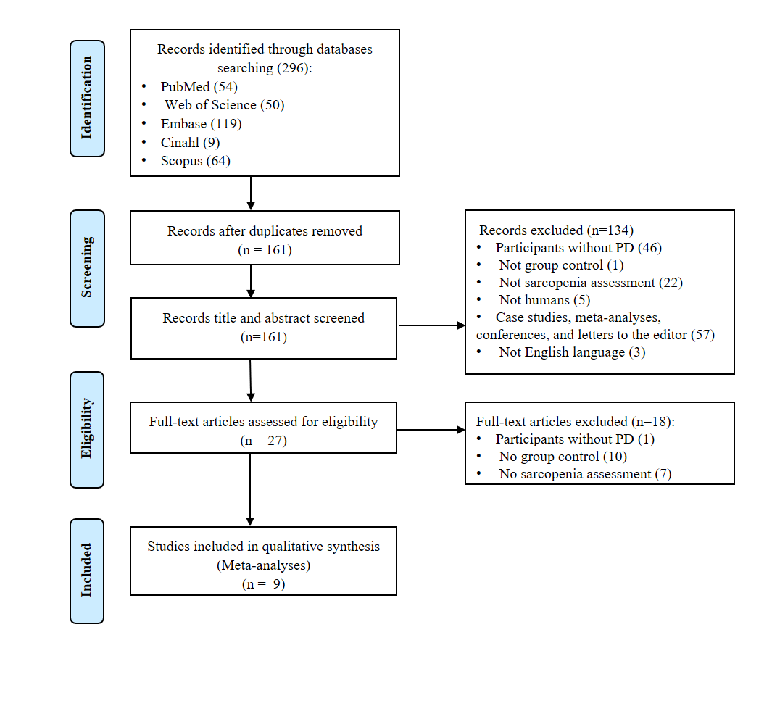
Fig. 1. PRISMA flow diagram for the study selection. PRISMA, Preferred Reporting Items for Systematic Reviews and Meta-Analysis.

Table 1
Characterization of the studies.
Studies | PD Group |  | GC |  | Age (years) |  | Sarcopenia assessment
 | Pdnsa (n =809) | Pdsa (n=266) | Nsa (n=893) | Sa (n=116 ) | PD (Md±SD) | GC (Md±DP)
Karim et al. ³⁰ | 69 | 46 | 73 | 35 | 61.2 (±6.5) | 68.3 (±6.4) | BIA, handgrip dynamometer, walking speed
Krenovsky et al. ²⁹ | 53 | 4 | 30 | 0 | 70 (± 10.1) | 70.8 (±2) | BIA, handgrip dynamometer, walking speed
Küsbeci et al. ¹⁷ | 100 | 30 | 95 | 13 | 63.35 (± 9.01) * 67.37 (±8.47)** | 61.63 (±5.22)* 65.27 (±8.72)** | BIA
Lee et al. ¹⁸ | 52 | 21 | 19 | 0 | 63. 7 (±11. 6) | 60.3 (± 7.6) | DXA
Ozer et al. ²⁸ | 70 | 22 | 85 | 15 | 68 (±5,1) | 67.4 (±5.1) | BIA, DXA, handgrip dynamometer, walking speed, Sarc-F
Peball et al. ¹⁹ | 104 | 58 | 330 | 27 | 73.8 (±5.2) | 75.3 (±7.3) | Handgrip dynam meter, walking speed, Sarc-F
Tan et al. ²⁰ | 93 | 16 | 78 | 8 | 66.0 (± 8.5) | 62.4 (± 8.4) | DXA, handgrip dynamometer, walking speed
Tan et al. ²⁷ | 102 | 26 | 54 | 2 | 68.2 (± 8.8) | 66.5 (± 7.5) | DXA, handgrip dynamometer, walking speed
Yazar et al. ²¹ | 166 | 43 | 129 | 16 | 71.5 (± 5.2)* 72.7 (± 4.4)** | 71.0 (± 3.7) *  71.8 (± 3.1)** | BIA, handgrip dynamometer, walking speed

Legend: Parkinson’s disease (PD), number total (n); GC (Group Control); mean (Md); standard deviation (SD), bioelectrical impedance analysis (BIA), dual-energy X-ray absorptiometry (DXA); (*) women; (**) men; Parkinson’s disease sarcopenia (Pdsa); Parkinson’s disease not sarcopenia (Pdnsa); not sarcopenia (Nsa); Sarcopenia (Sa).

Table 2
Risk of bias in the studies assessed by Newcastle–Ottawa Scale.
 | Karim et al³¹ | Krenovsky et al. ³⁰ | Küsbeci et al. ¹⁸ | Lee et al. ¹⁹ | Ozer et al. ²⁹ | Peball et al. ²⁰ | Tan et al.²¹ | Tan et al.²⁸ | Yazar et al. ²²
Selection
1) Is the case definition adequate? | a | a | a | a | a | a | a | a | a
2) Representativeness of the cases | a | a | a | a | a | a | a | a | a
3) Selection of Controls | c | b | a | b | c | c | a | a | c
4) Definition of Controls | a | a | a | a | a | b | a | a | a
Comparability
5) Comparability of cases and controls on the basis of the design or analysis | a | ab | a | a | ab | ab | a | a | a
Exposure
6) Ascertainment of exposure | a | a | a | a | a | a | a | a | a
7) Same method of ascertainment for cases and controls | a | a | a | a | a | a | a | a | a
8) Non-Response rate | a | a | a | a | a | a | a | a | a
Sum | 7 | 8 | 8 | 7 | 8 | 7 | 8 | 8 | 8
Legend: *one point for low risk of bias; 1a) Yes, with independente*; 2 a) obviously representive series of cases*; 2 b) potential for selection biases or not stated; 3 a) comunity controls*; 3b) hospital controls; 3c) no description; 4 a) no history of disease (enpoint)*; 5 a) study controls for environmental temperature*; 5b) study controls for any additional fator*; 6 a) secure record*; 7 a) yes*; 7b) no; 8 a) Same raye for boht groups*
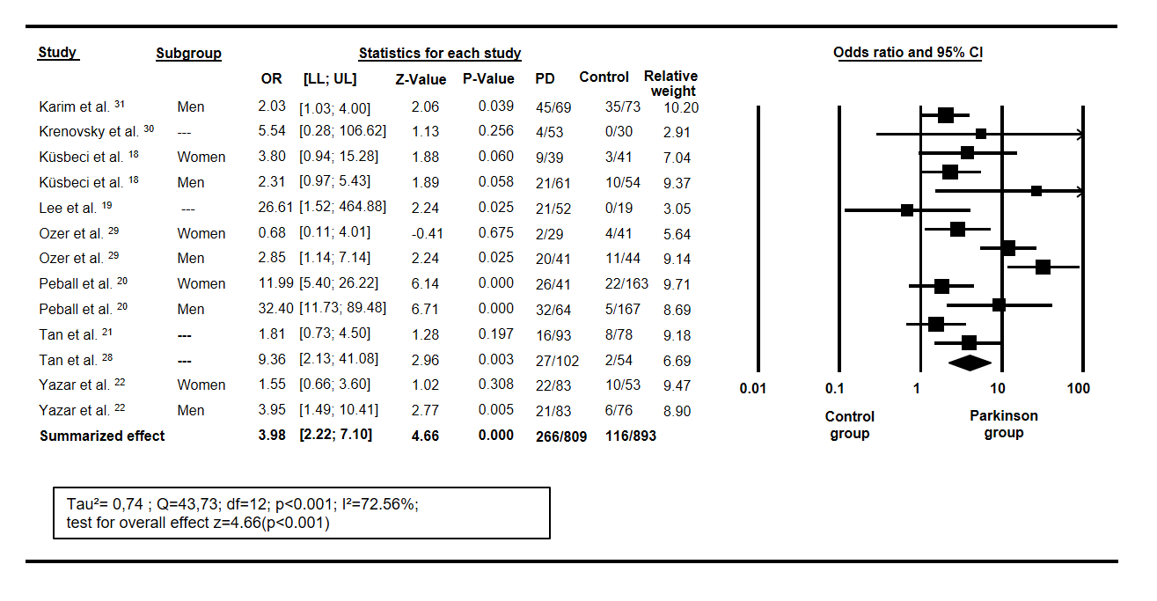
Fig. 2. Forest plot of sarcopenia OR between the Parkinson’s disease and control groups. OR: Odds ratio; LL: 95% confidence interval lower limit; UL: 95% confidence interval upper limit.; df: degrees of freedom; P-value of hypothesis heterogeneity test; I²: inconsistency between studies.

Table 3
Comparison of sarcopenia prevalence in patients with PD regarding age, sex, and sarcopenia assessments.
Subgroup | K | OR [LL; UL] | P-value | P-difference
Overall | 13 | 3.98 [2.23; 7.11] | <0.001 | <0.001
Age
<70yr | 8 | 2.83 [1.76; 4.21] | <0.001 | 0.08
≥71yr | 5 | 5.32 [3.14; 6.61] | <0.001
Sex
Men | 5 | 3.66 [2.49; 5.38] | <0.001 | 0.63
Women | 4 | 3.82 [2.29; 6.36] | <0.001
Sarcopenia Assessment
Multiple assessments | 10 | 2.3 [1.6; 3.27] | <0.001 | 0.45
Single assessment | 3 | 3.1 [1.5; 6.24] | <0.001
Legend: K: number of trials in each subgroup category; OR: odds ratio; LL: lower limit of the 95% confidence interval; UL: upper limit of the 95% confidence interval; P-value ≤ 0.05 represents a significant OR within the subgroup category; P-difference ≤ 0.05 represents a significant difference between subgroups categories.

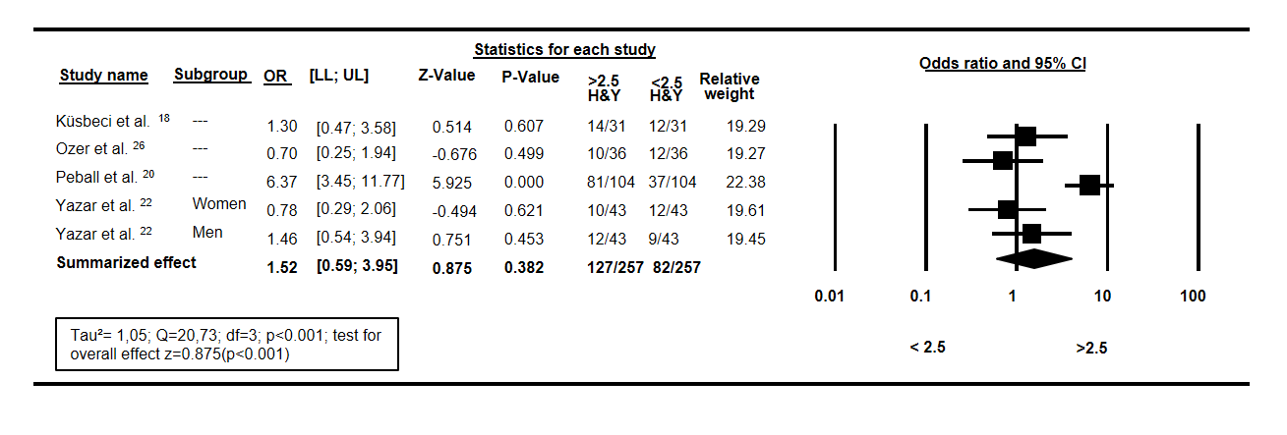
Fig. 3. Forest plot of sarcopenia OR between the Parkinson’s disease in scale H&Y < 2.5 and > 2.5. OR: Odds ratio; LL: 95% confidence interval lower limit; UL: 95% confidence interval upper limit.; df: degrees of freedom; P-value of hypothesis heterogeneity test; I²: inconsistency between studies.

