EHJ VIEWPOINT
“Fit for the Future: Enhancing Clinical Research with Digital Technology”

Dipak Kotecha ^{1,2,3*}; Adam D. DeVore ⁴ and Folkert W. Asselbergs^{3,5}

¹ University of Birmingham Institute of Cardiovascular Sciences, Medical School, Birmingham, B15 2TT, UK;
² Health Data Research UK Midlands, Institute for Translational Medicine, University Hospitals Birmingham NHS Foundation Trust, Birmingham, B15 2GW, UK;
³ Department of Cardiology, Division of Heart & Lungs, University Medical Center Utrecht, Heidelberglaan 8, 3584 CX , Utrecht, the Netherlands;
⁴ Division of Cardiology and Duke Clinical Research Institute, Duke University School of Medicine, Durham, NC 27701, USA;
⁵ Institute of Cardiovascular Science and Institute of Health Informatics, Faculty of Population Health Sciences, University College London, London, NW1 2DA, UK.

Corresponding author: Prof Dipak Kotecha FESC
Institute of Cardiovascular Sciences, Medical School, Vincent Drive, University of Birmingham, Birmingham, B15 2TT, UK; E-mail: d.kotecha@bham.ac.uk

Key words: Clinical trials, Drug development, Heart disease, Cardiovascular medicine, Digital health

Word count: 1474

A new digital paradigm
Digital innovation, and the increasing ability for easier application, are transforming our daily lives. This transformation is being driven by rapid changes in technology but also consumerism. Whilst there is a clear opportunity to apply these innovations to clinical research, advances here have been much slower. There is a need for relevant stakeholders to embrace digital innovation and to balance it with research governance, security of patient information, trustworthiness, and a social license to use these techniques in health research.¹ Changes are required to rapidly accelerate advancements in cardiovascular diseases (and reverse withdrawal of industry investment), based on more efficient cardiovascular outcome trials which remain the bedrock of our discipline. In this viewpoint, we highlight the need for a paradigm change to reinitialise large-scale pragmatic cardiovascular trials. A modern clinical trials pipeline can use digital methods to improve screening and recruitment of participants, the processes within trials, and the ascertainment of outcomes. Patient and public involvement in the design and running of trials can enhance relevance, quality and output.² Without an attempt towards structured change, the increasing burden of administration and high cost³ will render future large-scale evidence generation unfeasible, or restricted to narrow commercial interest. Digital innovation is already helping to fill major evidence gaps and empower stakeholders to deliver new, clinically-relevant trials within the healthcare setting (Graphical Abstract).

Innovations in Screening and Recruitment
Identifying, enrolling and retaining suitable participants for a clinical trial is one of the biggest hurdles to success. Failure to recruit on time occurs in four out of five trials, only half reach their target sample size, and the average dropout rate of 10% is large enough to change clinical intepretation.^{4, 5}
Advances in technology, especially the digitization of patient records, provides an opportunity for a transformational change in how participants are screened. Mass screening is now possible, moving from the traditional, time-consuming approaches of systematic record searching and/or reliance on opportunistic identification. Application of inclusion and exclusion criteria within the electronic health record (EHR) can provide pre-screening lists, reducing time to identify appropriate participants.^{6, 7} This may also reduce bias by broadening recruitment to more diverse patients. Advances in artificial intelligence are not only assisting in data analytics, but could provide a method to stratify those at-risk based on individual interacting comorbidities.⁸ There are many examples today of successfully applying these analytic tools to data from the EHR, including in patients with aortic stenosis.⁹

Digital technologies also permit easier recruitment of participants, for example by using remote e-consent using the patient’s smartphone to avoid unnecessary contact with healthcare services. E-consent processes can support dynamic, rather than a static approach of consent, leading to increased transparency and enabling patients to manage their own consent over time. They can also reduce inconvenience for participants, lower burden for healthcare staff and encourage direct communication between researchers and patients. This not only facilitates trial inclusion, but can provide a ‘matchmaking’ platform for patients/investigators to search for potential study opportunities.

These opportunities come with considerable challenges, including buy-in from regulatory bodies and the public to consent for data access, ensuring active trial participation despite remote enrolment, managing withdrawal of consent, and dealing with data breaches. Results are only as good as the healthcare data they are derived from, and this is variable across the world. Significant investment is necessary to ensure data from EHR are standardized and accurate for screening. Existing healthcare infrastructure to deploy these measures is not available in all countries or even regions, and there is a need for accurate linking of patient identifiers if these innovations are to improve the efficiency of clinical research.¹⁰

Innovations in Trial Processes
Embedding pragmatic clinical trials in routine care is a clear opportunity. ‘Point of Care’ randomisation trials could close the evidential gap of many treatments used in standard care, but which currently demonstrate substantial variation in efficacy across healthcare professionals. Advantages of using routine data are the improved generalisability of results, easier implementation into clinical care pathways, and the decrease in burden of trial administration (including safety outcomes), thereby reducing operational costs. Building a platform for embedding research within routine care allows for efficient serial experiments, or even enable parallel adaptive trials as seen in the COVID-19 pandemic.¹¹ An example of EHR-embedded research are ‘nudging’ trials that aim to improve quality of care through clinical decision support systems.¹²

However, major challenges exist to actually adopt an embedded trial platform that spans multiple hospitals, countries or even different healthcare systems. First, harmonization of clinical care pathways is needed to standardize data collection across sites and ensure high data quality. Exemplars of networks are PCORnet and COSMOS in the US, SwedeHeart in Sweden, and CPRD in the UK. Some of these networks, along with similar initiatives at a local health system level, were developed initially for quality improvement efforts. While distinct from research activity, both may use overlapping infrastructure and data, and could benefit from alignment of activities. Second, a common data model should be adopted to facilitate mapping of collected variables (for example, the Observational Medical Outcomes Partnership [OMOP] Common Data Model). Blinding is technologically feasible, but needs investment of EHR vendors. Regulatory requirements need further adaptation to digital technologies, guiding and allowing novel trial designs in collaboration with industry and healthcare professionals for regulatory approval. For example, the requirements needed from EHR systems to trace changes for an audit trail, without leading to unnecessary burden on healthcare professionals.

Innovations in Outcomes
Another value proposition for the use of digital technology is to facilitate decentralized research activities, where participants can enrol and be followed-up without healthcare visits. The COVID-19 pandemic accelerated both the need, and approvals for these approaches.¹³ Digital tools allow for real-time monitoring of safety events and/or clinical outcomes, for example, wearable sensors to monitor re-occurrence of atrial fibrillation, congestion in heart failure, or smartphone-based geofencing applications to identify hospitalisations. These technologies can be linked with traditional site visits, or allow for fully-remote, real-world follow-up combining patient-reported and EHR data. Recent studies in the cardiovascular space using decentralized designs include the CHIEF-HF trial¹⁴ (canagliflozin vs placebo in heart failure to improve patient-reported outcomes) and DaRe2THINK⁶ (early use of direct anticoagulants vs standard-of-care in atrial fibrillation to prevent thromboembolic events and cognitive decline). Multiple studies in the US and Europe have also used EHR and claims data to passively capture outcomes from real-world care. This lowers the burden of uniform safety data collection on sites, and avoids events being missed if not seen by investigators. One ongoing example is SPIRRIT-HFpEF¹⁵ (spironolactone vs placebo in heart failure with preserved ejection fraction), which is being conducted within a registry to capture heart failure hospitalizations and mortality events.

The use of digital technology in research aims to address unanswered clinical questions more rapidly and efficiently. Regulatory bodies in both the US and Europe are increasingly supporting these approaches for decision making on new cardiovascular therapeutics.¹ However, as a cardiovascular community we must also recognize that certain digital technologies could exacerbate disparities in clinical research. For example, tools that rely on reliable high-speed internet or access to existing commercial technologies (such as smartphones) may inadvertently exclude populations, including those in rural areas or with lower income.

Discussion
We are entering an exciting era in the field of clinical trials using digitalization in healthcare. Imagine the (near and ideal) future, where we can securely screen patients for eligibility across different networks of healthcare providers, guiding the design of pragmatic clinical trials. In this scenario, we can determine feasibility upfront, selecting only those centres with adequate numbers of patients that meet selection criteria, thereby reducing cost substantially. Moreover, embedding dynamic informed consent within online EHR portals, providing legitimate patient engagement, improving patient privacy, and reducing the laborious work of clinical investigators. Case report forms are replaced with automatically populated data extracted from the EHR or registry, enriched with study-specific information to address the research question. Follow-up visits are performed remotely by collecting patient-reported outcomes through smartphones and tablets, activity and physiological measurements using wearables and sensors, and clinical event data via national registries or the EHR.

The digitalization of healthcare will enable the cardiology community to perform pragmatic trials at reduced cost that meet the expectations of regulators, after the initial investment in digital infrastructure and harmonization of workflow across healthcare networks. This will not only promote industry investment in novel treatments within the cardiovascular field, but will also foster investigator-initiated trials to improve management of both common and rare diseases in clinical practice. Finally, embedding clinical trials within routine care has the potential to improve the generalisability and implementation of results by recruiting populations representative of the community. Working towards these common aims now, cardiovascular trials can be ‘fit-for-the-future’ and usher in a new era of evidence generation which is patient-centred and cost-efficient, but retains the robustness of the conventional randomised controlled trial.

Graphical Abstract
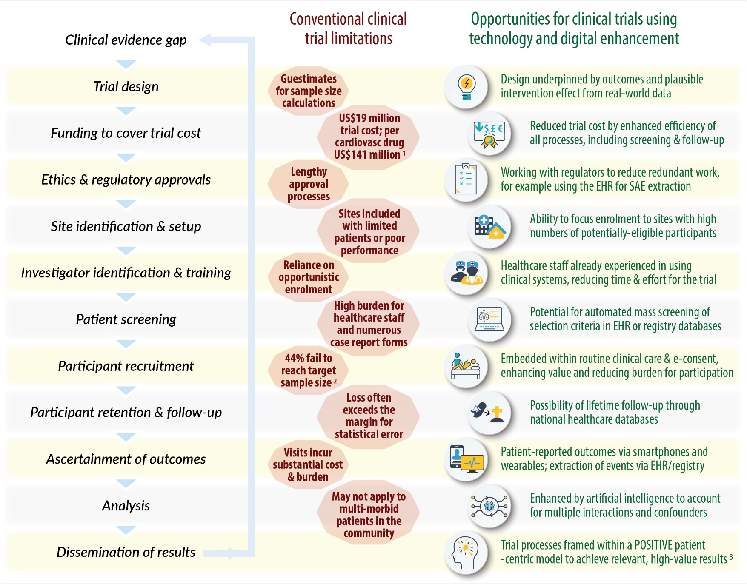

Graphical Abstract legend

Flowchart of clinical trial processes (left), starting with identification of a key evidence gap and the ethical rationale for a controlled clinical trial. In red (centre), major barriers and limitations to successful completion of a clinical trial. In green (right), how digital innovations are currently being used to enhance clinical trials and lead to more cost-efficient and generalisable results.
¹ Based on analysis of 101 new approvals by the US Food and Drug Administration from 2015-2017; Moore et al., 2020.³ ² Based on 151 trials in the UK National Institute for Health Research Health Technology Assessment programme; Walters et al., 2017.⁴ Integrating patient and public involvement throughout the whole research life-cycle, from inception to critical evaluation, as per the PPI-POSITIVE approach; Bunting et al., 2021.²

Acknowledgements
None.

Data Availability Statement

There are no new data associated with this article.

Funding
DK an FWA have received funding from the Innovative Medicines Initiative BigData@Heart (#116074), which receives support from EU Horizon 2020 and the European Federation of Pharmaceutical Industries and Associations (EFPIA). The DaRe2THINK trial is funded by the UK National Institute for Health Research (NIHR130280). The opinions expressed in this article are those of the authors, and do not represent any of the named organisations.

Conflicts of Interest
Prof. Kotecha reports grants from the National Institute for Health Research (NIHR CDF-2015-08-074 RATE-AF; NIHR130280 DaRe2THINK; NIHR132974 D2T-NeuroVascular); British Heart Foundation (PG/17/55/33087, AA/18/2/34218 and FS/CDRF/21/21032); EU/EFPIA Innovative Medicines Initiative (BigData@Heart 116074); European Society of Cardiology supported by educational grants from Boehringer Ingelheim/BMS-Pfizer Alliance/Bayer/Daiichi Sankyo/Boston Scientific, the NIHR/University of Oxford Biomedical Research Centre and British Heart Foundation/University of Birmingham Accelerator Award (STEEER-AF NCT04396418); Amomed Pharma; Protherics Medicines Development; IRCCS San Raffaele/Menarini (Beta-blockers in Heart Failure Collaborative Group NCT0083244); and Pfizer; plus advisory board personal fees from Bayer, Amomed, Protherics Medicines Development and Myokardia; all outside the submitted work. Adam DeVore reports research funding through his institution from the American Heart Association, Biofourmis, Bodyport, Cytokinetics, American Regent, Inc, the NHLBI, Novartis, and Story Health; he also provides consulting services for and/or receives honoraria from Abiomed, AstraZeneca, Cardionomic, InnaMed, LivaNova, Natera, Novartis, Procyrion, Story Health, Vifor, and Zoll; he has also received non-financial support from Abbott for educational and research activities; all outside the submitted work.

References
1. Kotecha D, Asselbergs FW, European Society of Cardiology, BigData@Heart consortium, CODE-EHR international consensus group. CODE-EHR best practice framework for the use of structured electronic healthcare records in clinical research. Eur Heart J. 2022: DOI: 10.1093/eurheartj/ehac426
2. Bunting KV, Stanbury M, Tica O, Kotecha D. Transforming clinical research by involving and empowering patients- the RATE-AF randomized trial. Eur Heart J. 2021;42:2411-2414
3. Moore TJ, Heyward J, Anderson G, Alexander GC. Variation in the estimated costs of pivotal clinical benefit trials supporting the US approval of new therapeutic agents, 2015-2017: a cross-sectional study. BMJ Open. 2020;10:e038863
4. Walters SJ, Bonacho Dos Anjos Henriques-Cadby I, Bortolami O, Flight L, Hind D, Jacques RM, Knox C, Nadin B, Rothwell J, Surtees M, Julious SA. Recruitment and retention of participants in randomised controlled trials: a review of trials funded and published by the United Kingdom Health Technology Assessment Programme. BMJ Open. 2017;7:e015276
5. Walsh M, Srinathan SK, McAuley DF, Mrkobrada M, Levine O, Ribic C, Molnar AO, Dattani ND, Burke A, Guyatt G, Thabane L, Walter SD, Pogue J, Devereaux PJ. The statistical significance of randomized controlled trial results is frequently fragile: a case for a Fragility Index. J Clin Epidemiol. 2014;67:622-628
6. Wang X, Mobley AR, Tica O, Okoth K, Ghosh RE, Myles P, Williams T, Haynes S, Nirantharakumar K, Shukla D, Kotecha D. Systematic approach to outcome assessment from coded electronic healthcare records in the DaRe2THINK NHS-embedded randomised trial. medRxiv. 2022: https://doi.org/10.1101/2022.05.24.22275434 [Accessed: 24 Jun 2022]
7. van Dijk WB, Fiolet ATL, Schuit E, Sammani A, Groenhof TKJ, van der Graaf R, de Vries MC, Alings M, Schaap J, Asselbergs FW, Grobbee DE, Groenwold RHH, Mosterd A. Text-mining in electronic healthcare records can be used as efficient tool for screening and data collection in cardiovascular trials: a multicenter validation study. J Clin Epidemiol. 2021;132:97-105
8. Karwath A, Bunting KV, Gill SK, Tica O, Pendleton S, Aziz F, Barsky AD, Chernbumroong S, Duan J, Mobley AR, Cardoso VR, Slater L, Williams JA, Bruce EJ, Wang X, Flather MD, Coats AJS, Gkoutos GV, Kotecha D. Redefining beta-blocker response in heart failure patients with sinus rhythm and atrial fibrillation: a machine learning cluster analysis. Lancet. 2021;398:1427-1435
9. Sarajlic P, Plunde O, Franco-Cereceda A, Bäck M. Artificial Intelligence Models Reveal Sex-Specific Gene Expression in Aortic Valve Calcification. JACC Basic Transl Sci. 2021;6:403-412
10. Persson R, Sponholtz T, Vasilakis-Scaramozza C, Hagberg KW, Williams T, Kotecha D, Myles P, Jick SS. Quality and Completeness of Myocardial Infarction Recording in Clinical Practice Research Datalink Aurum. Clin Epidemiol. 2021;13:745-753
11. Recovery Collaborative Group, Horby P, Lim WS, Emberson JR, Mafham M, Bell JL, Linsell L, Staplin N, Brightling C, Ustianowski A, Elmahi E, Prudon B, Green C, Felton T, Chadwick D, Rege K, Fegan C, Chappell LC, Faust SN, Jaki T, Jeffery K, Montgomery A, Rowan K, Juszczak E, Baillie JK, Haynes R, Landray MJ. Dexamethasone in Hospitalized Patients with Covid-19. N Engl J Med. 2021;384:693-704
12. Chen Y, Harris S, Rogers Y, Ahmad T, Asselbergs FW. Nudging within learning health systems: next generation decision support to improve cardiovascular care. Eur Heart J. 2022;43:1296-1306
13. Samsky MD, DeVore AD, McIlvennan CK, Granger CB, Granger BB, Hernandez AF, Felker GM, Fonarow GC, Albert NM, Piña IL, Lanfear D, Allen LA. Heart Failure Clinical Trial Operations During the COVID-19 Pandemic: Results From a Multicenter Survey. Circ Heart Fail. 2020;13:e007456
14. Spertus JA, Birmingham MC, Butler J, Lingvay I, Lanfear DE, Abbate A, Kosiborod ML, Fawcett C, Burton P, Damaraju CV, Januzzi JL, Whang J. Novel Trial Design: CHIEF-HF. Circ Heart Fail. 2021;14:e007767
15. Lund LH, Oldgren J, James S. Registry-Based Pragmatic Trials in Heart Failure: Current Experience and Future Directions. Curr Heart Fail Rep. 2017;14:59-70

