Major depressive disorder, generalised anxiety disorder, and their comorbidity: Associations with cortisol in the Vietnam Experience Study

Anna C. Phillips a,*, G. David Batty b,c,d, Catharine R. Gale c, Janet M. Lord d, Wiebke Arlt e, Douglas Carroll a

a School of Sport & Exercise Sciences, University of Birmingham, Birmingham B15 2TT, UK
b Department of Epidemiology & Public Health, University College London, UK
c MRC Epidemiology Resource Centre, University of Southampton, UK
d School of Immunity & Infection, University of Birmingham, UK
e School of Clinical & Experimental Medicine, University of Birmingham, UK
Summary
Objectives: The aim of these analyses was to examine the association of cortisol, dehydroepi- androsterone sulphate (DHEAS), and the cortisol:DHEAS ratio with the diagnoses of major depressive disorder (MDD), generalised anxiety disorder (GAD), and their comorbidity.
Design: This was a cross-sectional study.
Methods: Participants were 4256 Vietnam era US army veterans. From military service files, telephone interviews, and a medical examination, occupational, socio-demographic, and health data were collected. One-year prevalence of MDD and GAD was determined through a diagnostic interview schedule based on the DSM-IV criteria. Contemporary morning fasted cortisol and DHEAS concentrations were determined. Analyses of covariance were run, first with adjustment for age and then additionally adjusting for a range of candidate confounders.
Results: In fully adjusted analyses, there was evidence of lower basal cortisol levels in individuals with MDD and co-morbid MDD and GAD than those with GAD alone or no diagnosis.
Conclusion: This suggests that MDD and its comorbidity can also be characterised by low as well as high cortisol levels. A profitable line of future research might be to examine cortisol and DHEAS levels in more representative samples including older participants and women with and without MDD, GAD, and other psychiatric diagnoses.
Mental health disorders in the general population are common (Kessler et al., 2005a,b). In fact, an estimated 14% of the global disease burden has been attributed to such conditions as depression and anxiety (World Health Organisation, 1992—1994). This is likely to be an underestimate of the true burden of mental health problems as it fails to take into consideration that mental health increases the risk of other health conditions such as communicable and non-communicable diseases, and injuries (Prince et al., 2007). Populations who have been exposed to traumatic events, such as war veterans, have an even higher prevalence of major mental health problems, particularly depressive disorder (MDD) and generalised anxiety disorder (GAD) (Reeves et al., 2005; Gaylord, 2006; Hoge et al., 2006). For example, soldiers assessed a few months after returning from deployment to Afghanistan and Iraq had a GAD prevalence of around 14% and 15%, respectively, and prevalence of MDD of around 17% and 16% (Hoge et al., 2004). As yet, the aetiology of depression and anxiety are not fully understood, although it is generally accepted that chronic exposure to stressful life events has an important role (Thomson and Craighead, 2008).
The hypothalamic pituitary adrenal (HPA) axis is the major neuroendocrine stress response system. Abnormalities in HPA function have been observed in major depressive disorder and have been causally linked to such conditions (Schatzberg et al., 1985; Thomson and Craighead, 2008). A flattened diurnal rhythm for cortisol (Young et al., 1993), and elevated urinary and blood cortisol levels have been observed in several studies of individuals with depression (Lesch et al., 1988; Kathol et al., 1989; Deuschle et al., 1997; Burke et al., 2005). However, the general conclusion that the HPA axis is hyperactive in MDD is based primarily on evidence from provocative stress tests or the administration of dexamethasone (Holsboer et al., 1995). In contrast, studies of basal HPA axis hormone secretion in patients with depression have produced mixed results (Posener et al., 2004). Some have shown no evidence of hypercortisolism, but a more erratic pattern of secretion across the day (Yehuda et al., 1996; Peeters et al., 2004); others have found lower levels of cortisol among those with MDD (Vythilingam et al., 2004; Decker, 2006); and still others, have reported no difference in basal cortisol levels between depressives and controls (Porter et al., 2003). Thus, it seems that the HPA axis dysregulation in MDD is not always observed as hyperactivity.
Less is known about the association between MDD and dehydroepiandrosterone (DHEA), another adrenal cortex hormone. DHEA is a precursor of sex hormones and is present in the circulation, predominantly as its sulphated form dehydroepiandrosterone sulphate (DHEAS). DHEA/DHEAS appears to counterbalance many of the negative effects of cortisol on immunity (Sacco et al., 2002; Hazeldine et al., 2010). For example, it has been shown in vitro that higher cortisol sup- presses neutrophil function and this effect can be overcome by co-incubation with DHEAS (Butcher et al., 2005; Radford et al., 2010). Moreover, our recent studies have shown that DHEAS is able to increase neutrophil superoxide generation via direct activation of the protein kinase C signalling pathway and phosphorylation of NADPH oxidase (Radford et al., 2010). It also appears that the activity of the HPA axis as reflected in the ratio of cortisol to DHEAS is particularly important with regard to health. For example, the cortisol:DHEAS ratio has been found to predict health outcomes better than the level of either hormone alone (Butcher et al., 2005). However, few studies have examined the cortisol:DHEAS ratio in the context of mental disorders. Of the scant research considering the role of DHEA/S, two studies found that lower DHEA was related to MDD diagnosis (Goodyer et al., 1996; Michael et al., 2000). However, some researchers have shown higher DHEA (Heuser et al., 1998) and a higher cortisol:DHEA ratio (Young et al., 2002) among depressed adults whereas, others have found no difference in DHEA or the cortisol:DHEA ratio between those with and without MDD (Porter et al., 2003).
Post-traumatic stress disorder (PTSD) is another psychiatric diagnosis which has received much attention with regard to the stress of war exposure (Foy et al., 1987). Individuals with such a diagnosis have also been shown to exhibit alterations in HPA axis hormones, for example, lower cortisol levels have been observed in several studies of patients with PTSD (Yehuda et al., 1990, 1995; Mason et al., 2001). In contrast, increased levels of cortisol and DHEA (Pico-Alfonso et al., 2004), and higher DHEAS (Spivak et al., 2000; Sondergaard et al., 2002) have been observed in some patients with PTSD although some studies have observed lower levels of DHEAS (Kanter et al., 2001). MDD is often found to occur co-morbidly with PTSD (Resnick et al., 1993; Kessler et al., 1995; Gaudiano and Zimmerman, 2010), for example, a study of the lifetime prevalence of anxiety and mood disorders found that PTSD was the disorder most likely to be associated with MDD, with a 69% of individuals with PTSD also meeting the criteria for MDD (Brown et al., 2001). Further, in one sample of 677 depressed patients, 36% was also found to screen positive for PTSD (Campbell et al., 2007), and in another, rates of comorbidity of PTSD and MDD were 42% (DeRubeis et al., 2005). In fact, following trauma exposure, it is likely that the development of MDD and PTSD are often not independent (Breslau et al., 2000; O’Donnell and Wolffsohn, 2004). There is evidence that patients with both PTSD and MDD also exhibit lower cortisol levels than non-patients (Vythilingam et al., 2010). In the present veteran sample, lower cortisol has been shown among those with PTSD, and lower DHEAS among those with comorbidity of PTSD and MDD (Boscarino, 1996, 2004).
Despite the high prevalence of GAD, few investigators have examined the association between GAD and HPA axis hormones. Of the few studies specifically considering GAD, most have concentrated on cortisol, and showed higher cortisol levels in GAD patients than controls (Mantella et al., 2008; Hood et al., 2010), and higher cortisol levels in those with mixed anxiety—depressive disorder (Kara et al., 2000). As far as we are aware, no study has examined the association between GAD and DHEA/S, although DHEA supplementation has been shown to improve anxiety symptoms in patients with schizophrenia (Strous et al., 2003) but not in women with fibromyalgia (Finckh et al., 2005).
Given the reported high prevalence of GAD and MDD in army veterans and the significant prevalence of these disorders in the general population, their individual and combined association with HPA axis hormones merits research attention. Consequently, the present analyses examined the associations between GAD, MDD and their comorbidity and cortisol, DHEAS, and the cortisol:DHEAS ratio in a substantial cohort of US veterans from the Vietnam Experience Study. Given the equivocal findings from the research on MDD and cortisol, and the lack of previous data for GAD, no directional hypotheses were formulated.
1. Methods

1.1. Participants

Participants were male Vietnam era military veterans recruited as part of The Centers for Disease Control Vietnam Experience Study (1988a, 1989). Ethical approval for the study was given by various bodies, including the US Centers for Disease Control and participants gave informed consent. Details of sampling at each stage of data collection are shown in Fig. 1. The sample size for the present analyses was 4255. Inclusion criteria were: entered military service between January 1, 1965 and December 31, 1971; served only one term of enlistment and at least 16 weeks of active duty; earned a military specialty other than ‘‘trainee’’ or ‘‘duty soldier’’; had a military pay grade at discharge no higher than sergeant.

1.2. Data collection in late adolescence/early adulthood

Information pertaining to place of service and ethnicity was extracted from the military archives. Participants were designated as being Vietnam veterans if they had served at least one tour of duty in Vietnam, and as non-Vietnam veterans if they did not (this group included men who served one or more tours of duty in Korea, Germany or the US). The ethnic origin of the study members were classified as ‘white’, ‘black’, or ‘other’; the latter group comprising Hispanics, Asians, Pacific Islanders, American Indians, and Alaskan Natives.

1.3. Data collection in middle-age — telephone survey

In 1985 these participants were invited to participate in a telephone interview. During the telephone survey, enquiries were made about the study participants’ socio-economic characteristics, health behaviours, and health. Socio-economic position was measured using household income in midlife. Frequency of alcohol consumption was classified as number of units consumed per week. Smoking habits and marital status were ascertained using standard questions. Participants were also asked whether or not they had a range of somatic physician-diagnosed health problems which included hypertension, cancer, diabetes and coronary heart disease (Vietnam Experience Study, 1988a,b).
(Insert Figure 1)
1.4. Data collection in middle-age — medical examination

In 1986, a random sample of telephone interview respondents (N = 6443) were invited to attend a three day medical examination with orientation at a single facility in Albuquerque, New Mexico, for which travel expenses and a nominal stipend were met; 4462 attended (69.3% of those invited). The mean age at medical examination was 38.3 years (range: 31.1—49.0). Reasons for not attending the medical examination are given elsewhere (Phillips et al., 2009). All men were requested to fast from 1900 h the evening before medical testing. Following the drawing of blood the following morning, cortisol and DHEAS were assessed from serum using a double antibody radioimmunoassay system (Leeco Diagnostics, Inc., Southfield, MI). Psychological morbidity was assessed using the Diagnostic Interview Schedule (version
3A) as administered by a trained psychological technician. The Diagnostic Interview Schedule is a standardised questionnaire that is designed to assess the prevalence of certain psychiatric conditions according to the Diagnostic and Statistical Manual of Mental Disorders (version III) criteria of the American Psychiatric Association (American Psychiatric Association, 1980; Robins et al., 1987). Study participants were considered positive for GAD and MDD if they reported a pattern of symptoms in the previous 12 months that satisfied full Diagnostic and Statistical Manual of Mental Disorders (version III) criteria. The final number of participants with complete data after the medical examination was 4256.

1.5. Data analysis

Cortisol and DHEAS values were not normally distributed so were natural log-transformed. Baseline demographic, ser- vice-related, and health-related variables were compared between those with MDD, with GAD, with both MDD and GAD, and without any diagnosis (total N = 4071). ANCOVA was used to examine age-adjusted differences in cortisol, DHEAS, and the cortisol:DHEAS ratio between the four groups. Further analyses were conducted with additional adjustment for variables that we conceptualised as potential confounding factors (place of service, ethnicity, marital status, smoking habit, alcohol consumption, household income in mid-life, and somatic illness). These covariates were chosen a priori as they have all been associated with MDD, GAD, cortisol, or DHEAS in this dataset (Phillips et al., 2009, 2010).
(Insert Table 1)
2. Results
Descriptive statistics for those with MDD, GAD, comorbidity, or no psychiatric diagnosis are shown in Table 1.
For the comorbidity of MDD and GAD versus either disorder
alone or neither disorder, there was a significant effect for cortisol, F (3,4066) = 3.19, p = .02, h2 = .002, which, if anything, was strengthened, following full adjustment, F (3,4059) = 4.62, p = .003, h2 = .003. This effect was driven by significant differences between the individuals with both disorders versus neither ( p = .02) or GAD alone ( p = .01), or with MDD alone versus neither ( p = .007) or GAD alone ( p = .006). Those with depression or both diagnoses had the lowest cortisol concentrations. These differences from the fully-adjusted ANCOVA model are illustrated in Fig. 2. There were no such effects for DHEAS in the age- or fully- adjusted model. However, in analogous analyses for the cortisol:DHEAS ratio there was also a diagnostic group effect, F (3,4066) = 3.36, p = .02, h2 = .002. This was driven by a difference between those with GAD and neither diagnosis ( p = .004). However, this effect was attenuated to non-significance with full adjustment, F (3,4059) = 1.51, p = .21, h2 = .001. The raw descriptive statistics for cortisol, DHEAS, and the ratio between diagnoses groups are displayed in Table 2.

2.1. Sensitivity analysis

In order to check whether the associations between cortisol and MDD were due to comorbidity of MDD and PTSD, as PTSD is associated with lower cortisol secretion (Boscarino, 1996), a series of further ANCOVA analyses were run comparing those with MDD, PTSD, both, or no diagnosis. Thirty-three percent of those with MDD also had a diagnosis of PTSD. The raw cortisol, DHEAS, and cortisol:DHEAS ratio for individuals with MDD alone, PTSD alone, MDD comorbid with PTSD, and no diagnosis are presented in Table 3. Comparison between these groups showed a non-significant trend in the age adjusted ANCOVA, F (3,4065) = 2.09, p = .10, h2 = .002, which became significant upon full adjustment for potential confounding variables, F (3,4058) = 4049, p = .004, h2 = .003. Pairwise comparisons within the adjusted model showed that the significant differences emerged between the group with neither diagnosis and the groups with MDD ( p = .01) or comorbidity of MDD and PTSD ( p = .006), not between the group with no diagnosis and those with only PTSD ( p = .60), or between those with MDD or PTSD alone ( p = .55). In the fully- adjusted ANCOVA, individuals with both MDD and PTSD had the lowest logged cortisol concentration (2.77) followed by those with MDD alone (2.80), those with PTSD (2.84), and those with neither disorder (2.86). These differences are shown in Fig. 3. Thus, the MDD—cortisol relationship did not appear to be solely due to lower levels of cortisol within those with PTSD comorbid with MDD.
(Insert Table 2)
3. Discussion

In the present study, in fully adjusted analyses, individuals with a diagnosis of MDD or with co-morbid MDD and GAD exhibited lower levels of cortisol than those without a diagnosis or with GAD alone. These findings contrast with some of the previous literature suggesting that cortisol is raised in individuals with MDD (Kathol et al., 1989; Lesch et al., 1988; Deuschle et al., 1997). However, given that this hypersecretion of cortisol is usually observed in studies of cortisol stimulation (Holsboer et al., 1995) and appears to demonstrate a deficit in the negative feedback loop of cortisol, it is possible that basal levels of HPA axis hormones tell a different story. In fact, several studies of basal plasma cortisol in MDD patients have shown lower levels than among control participants (Vythilingam et al., 2004; Decker, 2006) or no difference between groups (Porter et al., 2003). Moreover, this direction of association does not appear to be driven by lower cortisol secretion among individuals with PTSD (Ehlert et al., 2001), given that only 30% of those with MDD also had PTSD. Although these MDD and PTSD co-morbid individuals had the lowest cortisol secretion, those with PTSD alone did not differ from controls, whereas those with MDD or both MDD and PTSD had significantly lower cortisol levels than those with neither diagnosis. One possible mechanism by which individuals with MDD might have lower cortisol levels is that the continued activation of the HPA axis by stress, as evidenced in individuals with MDD (Checkley, 1996), might eventually lead to a down regulation of non-stress induced cortisol production. This explanation arises from the theory of allostatic load which suggests that bodily systems eventually become exhausted and dysregulated by frequent or chronic stress-related stimulation (Heim et al., 2000; McE- wen, 2000). This stress-related decrease in cortisol low cortisol may be a result of decreased hypothalamic cortico- trophin releasing hormone secretion (de Kloet et al., 2008) or enhanced glucocorticoid negative feedback at the level of the hippocampus (Vythilingam et al., 2006). The potential consequences of impaired secretion of cortisol might include changes in immune function (Jefferies, 1991). For example, individuals with lower cortisol production consequent upon psychiatric diagnoses have been shown to also have greater numbers of lymphocyte glucocorticoid receptors (Yehuda et al., 1991). Others have found evidence of reduced glucocorticoid receptor sensitivity in acute depressive illness (Wodarz et al., 1992). Further, individuals with blunted cortisol responses to stress have also been shown to exhibit poorer responses to wound healing (Engeland et al., 2003) and vaccination (Phillips et al., 2005). However, further studies are needed to fully elucidate the impact of small but relatively chronic reductions in cortisol resting levels.
That no difference between those with and without MDD or GAD was observed for DHEAS or the cortisol:DHEAS ratio may reflect the fact that lower levels of DHEAS become more prevalent and more damaging to physical and mental well- being in older age (Berr et al., 1996; Bauer, 2005; Buford and Willoughby, 2008). The present sample were relatively young; their mean age at the medical examination was 38.3 years, and DHEAS levels only just start to decline from around 30 years old (Orentreich et al., 1984). The lack of an association between GAD and cortisol in the present study was surprising. Previous studies have found higher cortisol levels in GAD patients (Tafet et al., 2005), although in some cases this was in an older adult sample (Mantella et al., 2008), unlike the present study.
The present study has several limitations which should be acknowledged. First, with cross-sectional analyses it is impossible to determine causality and direction of the association. However, it is likely that the nature of the MDD— hormone associations are bidirectional given that changes in cortisol secretion in those with MDD (Ehlert et al., 2001) and changes in cortisol secretion prior to the onset of MDD (Dinan, 1994) have both been observed. Second, the sample was exclusively male and relatively young, so the present findings may not be generalisable to women and older populations. Nonetheless, as premenopausal women have slightly higher total cortisol values and lower circulating DHEAS (Orentreich et al., 1984) and greater stress responsiveness and resistance to HPA axis feedback (Young, 1998), it would be interesting to examine the influence of the cortisol:DHEAS ratio and psychiatric diagnoses in women where a relationship might emerge. It is also possible that the associations observed would be even stronger or more likely to emerge for DHEAS in an older sample with lower levels of circulating DHEAS. A third possible limitation is the use of a single morning measurement of serum cortisol and DHEAS. Cortisol has a diurnal rhythm which would be best captured through multiple measurements of the free active fraction of cortisol, such as can be determined through saliva sampling. However, the timing of the present samples was fairly consistent across participants. Further, DHEAS concentrations remain stable throughout the day and reflect the 24-h secretion of DHEA (Arlt et al., 1998, 1999). Finally, the present data were limited to information on psychiatric diagnosis, and did not include assessment of trauma history in childhood and adult- hood, both of which have been shown to influence HPA parameters and DHEAS (Heim et al., 2008; Muhtz et al., 2008; Kellner et al., 2010). Inclusion of such trauma measurement in future studies would provide further information on hormone differences within the sub-groups of psychiatric disorder.
In conclusion, the present analyses showed evidence of lower basal cortisol levels in individuals with MDD and co- morbid MDD and GAD. This suggests that MDD and its comorbidity can also be characterised by low as well as high cortisol levels. A profitable line of future research might be to examine the cortisol and DHEA levels in more representative samples such as those including older participants and women with and without MDD, GAD. It would also be beneficial in larger samples to compare those with individual diagnoses to those with a range of psychiatric comorbidities.

Role of funding source

Funding for the original design and data collection of this cohort study was from the Centers for Disease Control. The funding source had no role in the present analysis and interpretation of data; in the writing of the report; or in the decision to submit the paper for publication.

Conflict of interest none declared.
#

Appendices
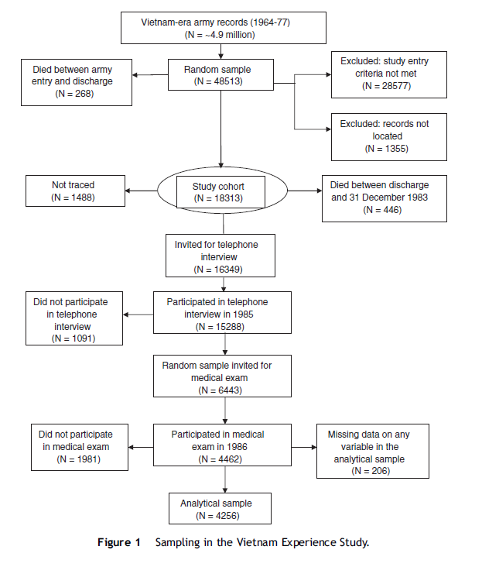
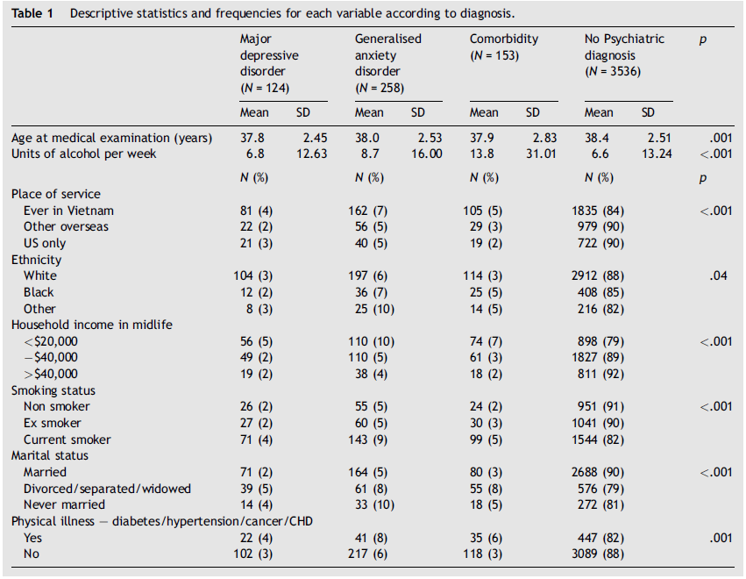
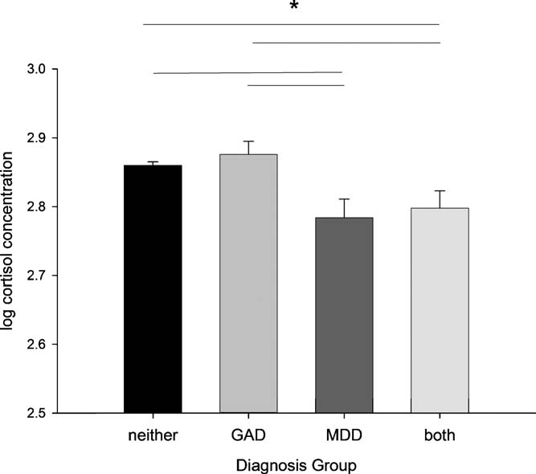
Figure 2

Mean (standard error) logged cortisol concentration by MDD and GAD diagnosis group with full adjustment for con- founding variables (*p < .05).
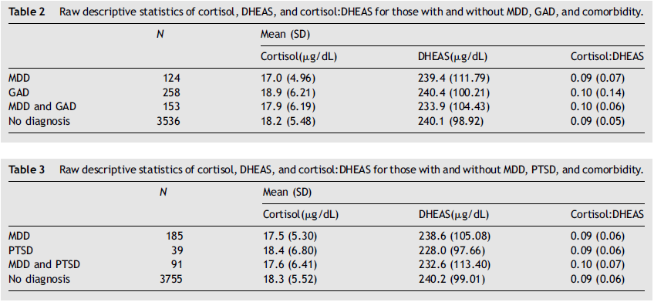
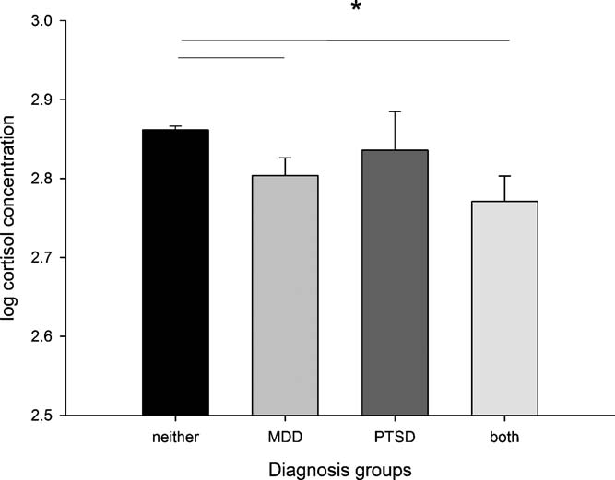

Figure 3 Mean (standard error) logged cortisol concentration by MDD and PTSD diagnosis group with full adjustment for confounding variables (*p < .05).
References
Arlt, W., Haas, J., Callies, F., Reincke, M., Hubler, D., Oettel, M., Ernst, M., Schulte, H.M., Allolio, B., 1999. Biotransformation of oral dehydroepiandrosterone in elderly men: significant increase in circulating estrogens. J. Clin. Endocrinol. Metab. 84, 2170—2176.
Arlt, W., Justl, H.G., Callies, F., Reincke, M., Hubler, D., Oettel, M., Ernst, M., Schulte, H.M., Allolio, B., 1998. Oral dehydroepian- drosterone for adrenal androgen replacement: pharmacokinetics and peripheral conversion to androgens and estrogens in young healthy females after dexamethasone suppression. J. Clin. Endo- crinol. Metab. 83, 1928—1934.
American Psychiatric Association, 1980. Diagnostic and Statistical Manual of Mental Disorders, 3rd. ed. American Psychiatric Asso- ciation, Washington, DC.
Bauer, M.E., 2005. Stress, glucocorticoids and ageing of the immune system. Stress 8, 69—83.
Berr, C., Lafont, S., Debuire, B., Dartigues, J.F., Baulieu, E.E., 1996.
Relationships of dehydroepiandrosterone sulfate in the elderly with functional, psychological, and mental status, and short-term mortality: a French community-based study. Proc. Natl. Acad. Sci. U.S.A. 93, 13410—13415.
Boscarino, J.A., 1996. Posttraumatic stress disorder, exposure to combat, and lower plasma cortisol among Vietnam veterans: findings and clinical implications. J. Consult. Clin. Psychol. 64,
191—201.
Boscarino, J.A., 2004. Posttraumatic stress disorder and physical illness: results from clinical and epidemiologic studies. Ann. N Y Acad. Sci. 1032, 141—153.
Breslau, N., Davis, G.C., Peterson, E.L., Schultz, L.R., 2000. A second look at comorbidity in victims of trauma: the posttraumatic stress disorder-major depression connection. Biol. Psychiatry 48, 902-909.
Brown, T.A., Campbell, L.A., Lehman, C.L., Grisham, J.R., Mancill, R.B., 2001. Current and lifetime comorbidity of the DSM-IV anxiety and mood disorders in a large clinical sample. J. Abnormal Psychol. 110, 585—599.
Buford, T.W., Willoughby, D.S., 2008. Impact of DHEA(S) and cortisol on immune function in aging: a brief review. Appl. Physiol. Nutr. Metab. 33, 429—433.
Burke, H.M., Davis, M.C., Otte, C., Mohr, D.C., 2005. Depression and cortisol responses to psychological stress: a meta-analysis. Psy- choneuroendocrinology 30, 846—856.
Butcher, S.K., Killampalli, V., Lascelles, D., Wang, K., Alpar, E.K.,
Lord, J.M., 2005. Raised cortisol:DHEAS ratios in the elderly after injury: potential impact upon neutrophil function and immunity. Aging Cell 4, 319—324.
Campbell, D.G., Felker, B.L., Liu, C.F., Yano, E.M., Kirchner, J.E.,
Chan, D., Rubenstein, L.V., Chaney, E.F., 2007. Prevalence of depression-PTSD comorbidity: implications for clinical practice guidelines and primary care-based interventions. J. Gen. Intern. Med. 22, 711—718.
Checkley, S., 1996. The neuroendocrinology of depression and chron- ic stress. Br. Med. Bull. 52, 597—617.
de Kloet, C., Vermetten, E., Lentjes, E., Geuze, E., van Pelt, J.,
Manuel, R., Heijnen, C., Westenberg, H., 2008. Differences in the response to the combined DEX-CRH test between PTSD patients with and without co-morbid depressive disorder. Psychoneuroen- docrinology 33, 313—320.
Decker, S.A., 2006. Low salivary cortisol and elevated depressive affect among rural men in Botswana: reliability and validity of laboratory results. J. Physiol. Anthropol. 25, 91—101.
DeRubeis, R.J., Hollon, S.D., Amsterdam, J.D., Shelton, R.C., Young, P.R., Salomon, R.M., O’Reardon, J.P., Lovett, M.L., Gladis, M.M., Brown, L.L., Gallop, R., 2005. Cognitive therapy vs medications in the treatment of moderate to severe depression. Arch. Gen. Psychiatry 62, 409—416.
Deuschle, M., Schweiger, U., Weber, B., Gotthardt, U., Korner, A., Schmider, J., Standhardt, H., Lammers, C.H., Heuser, I., 1997. Diurnal activity and pulsatility of the hypothalamus—pituitary— adrenal system in male depressed patients and healthy controls. J. Clin. Endocrinol. Metab. 82, 234—238.
Dinan, T.G., 1994. Glucocorticoids and the genesis of depressive illness. A psychobiological model. Br. J. Psychiatry 164, 365—371. Ehlert, U., Gaab, J., Heinrichs, M., 2001. Psychoneuroendocrinolo- gical contributions to the etiology of depression, posttraumatic stress disorder, and stress-related bodily disorders: the role of the hypothalamus—pituitary—adrenal axis. Biol. Psychol. 57, 141—152.
Engeland, C.G., Cacioppo, J.T., Bosch, J.A., Marucha, P.T., 2003. Oral wound healing is delayed in the aged and in women. Brain Behav. Immun. 17, 173.
Finckh, A., Berner, I.C., Aubry-Rozier, B., So, A.K., 2005. A random- ized controlled trial of dehydroepiandrosterone in postmeno- pausal women with fibromyalgia. J. Rheumatol. 32, 1336—1340. Foy, D.W., Carroll, E.M., Donahoe Jr., C.P., 1987. Etiological factors in the development of PTSD in clinical samples of Vietnam combat veterans. J. Clin. Psychol. 43, 17—27.
Gaudiano, B.A., Zimmerman, M., 2010. Does comorbid posttraumatic stress disorder affect the severity and course of psychotic major depressive disorder? J. Clin. Psychiatry 71, 442—450.
Gaylord, K.M., 2006. The psychosocial effects of combat: the frequently unseen injury. Crit. Care Nurs. Clin. North Am. 18, 349—357.
Goodyer, I.M., Herbert, J., Altham, P.M., Pearson, J., Secher, S.M., Shiers, H.M., 1996. Adrenal secretion during major depression in 8- to 16-year-olds, I. Altered diurnal rhythms in salivary cortisol and dehydroepiandrosterone (DHEA) at presentation. Psychol. Med. 26, 245—256.
Hazeldine, J., Arlt, W., Lord, J.M., 2010. Dehydroepiandrosterone as a regulator of immune cell function. J. Steroid Biochem. Mol. Biol. 120, 127—136.
Heim, C., Ehlert, U., Hellhammer, D.H., 2000. The potential role of hypocortisolism in the pathophysiology of stress-related bodily disorders. Psychoneuroendocrinology 25, 1—35.
Heim, C., Newport, D.J., Mletzko, T., Miller, A.H., Nemeroff, C.B., 2008. The link between childhood trauma and depression: insights from HPA axis studies in humans. Psychoneuroendocrinology 33, 693—710.
Heuser, I., Deuschle, M., Luppa, P., Schweiger, U., Standhardt, H., Weber, B., 1998. Increased diurnal plasma concentrations of dehydroepiandrosterone in depressed patients. J. Clin. Endocri- nol. Metab. 83, 3130—3133.
Hoge, C.W., Auchterlonie, J.L., Milliken, C.S., 2006. Mental health problems, use of mental health services, and attrition from military service after returning from deployment to Iraq or Afghanistan. JAMA 295, 1023—1032.
Hoge, C.W., Castro, C.A., Messer, S.C., McGurk, D., Cotting, D.I., Koffman, R.L., 2004. Combat duty in Iraq and Afghanistan, mental health problems, and barriers to care. New Engl. J. Med. 351, 13—22.
Holsboer, F., Lauer, C.J., Schreiber, W., Krieg, J.C., 1995. Altered hypothalamic-pituitary-adrenocortical regulation in healthy sub- jects at high familial risk for affective disorders. Neuroendocri- nology 62, 340—347.
Hood, S.D., Melichar, J.K., Taylor, L.G., Kalk, N., Edwards, T.R., Hince, D.A., Lenox-Smith, A., Lingford-Hughes, A.R., Nutt, D.J., 2010. Noradrenergic function in generalized anxiety disorder: impact of treatment with venlafaxine on the physiological and psychological responses to clonidine challenge. J. Psychophar- macol. DOI: 0269881109359099[pii]10.1177/0269881109359099 [epub ahead of print].
Jefferies, W.M., 1991. Cortisol and immunity. Med. Hypotheses 34, 198—208.
Kanter, E.D., Wilkinson, C.W., Radant, A.D., Petrie, E.C., Dobie, D.J., McFall, M.E., Peskind, E.R., Raskind, M.A., 2001. Glucocor- ticoid feedback sensitivity and adrenocortical responsiveness in posttraumatic stress disorder. Biol. Psychiatry 50, 238—245.
Kara, S., Yazici, K.M., Gulec, C., Unsal, I., 2000. Mixed anxiety— depressive disorder and major depressive disorder: comparison of the severity of illness and biological variables. Psychiatry Res. 94, 59—66.
Kathol, R.G., Anton, R., Noyes, R., Gehris, T., 1989. Direct compari- son of urinary free cortisol excretion in patients with depression and panic disorder. Biol. Psychiatry 25, 873—878.
Kellner, M., Muhtz, C., Peter, F., Dunker, S., Wiedemann, K., Yassour- idis, A., 2010. Increased DHEA and DHEA-S plasma levels in patients with post-traumatic stress disorder and a history of childhood abuse. J. Psychiatr. Res. 44, 215—219.
Kessler, R.C., Berglund, P., Demler, O., Jin, R., Merikangas, K.R., Walters, E.E., 2005a. Lifetime prevalence and age-of-onset dis- tributions of DSM-IV disorders in the National Comorbidity Survey Replication. Arch. Gen. Psychiatry 62, 593—602.
Kessler, R.C., Chiu, W.T., Demler, O., Merikangas, K.R., Walters, E.E., 2005b. Prevalence, severity, and comorbidity of 12-month DSM-IV disorders in the National Comorbidity Survey Replication. Arch. Gen. Psychiatry 62, 617—627.
Kessler, R.C., Sonnega, A., Bromet, E., Hughes, M., Nelson, C.B., 1995. Posttraumatic stress disorder in the National Comorbidity Survey. Arch. Gen. Psychiatry 52, 1048—1060.
Lesch, K.P., Laux, G., Schulte, H.M., Pfuller, H., Beckmann, H., 1988. Corticotropin and cortisol response to human CRH as a probe for HPA system integrity in major depressive disorder. Psychiatry Res. 24, 25—34.
Mantella, R.C., Butters, M.A., Amico, J.A., Mazumdar, S., Rollman, B.L., Begley, A.E., Reynolds, C.F., Lenze, E.J., 2008. Salivary cortisol is associated with diagnosis and severity of late-life generalized anxiety disorder. Psychoneuroendocrinology 33, 773—781.
Mason, J.W., Wang, S., Yehuda, R., Riney, S., Charney, D.S., South- wick, S.M., 2001. Psychogenic lowering of urinary cortisol levels linked to increased emotional numbing and a shame-depressive syndrome in combat-related posttraumatic stress disorder. Psy- chosom. Med. 63, 387—401.
McEwen, B.S., 2000. Allostasis and allostatic load: implications for neuropsychopharmacology. Neuropsychopharmacology 22, 108—124.
Michael, A., Jenaway, A., Paykel, E.S., Herbert, J., 2000. Altered salivary dehydroepiandrosterone levels in major depression in adults. Biol. Psychiatry 48, 989—995.
Muhtz, C., Wester, M., Yassouridis, A., Wiedemann, K., Kellner, M., 2008. A combined dexamethasone/corticotropin-releasing hor- mone test in patients with chronic PTSD–—first preliminary results. J. Psychiatr. Res. 42, 689—693.
O’Donnell, C., Wolffsohn, J.S., 2004. Grading of corneal transparen- cy. Cont Lens Anterior Eye 27, 161—170.
Orentreich, N., Brind, J.L., Rizer, R.L., Vogelman, J.H., 1984. Age changes and sex differences in serum dehydroepiandrosterone sulfate concentrations throughout adulthood. J. Clin. Endocrinol. Metab. 59, 551—555.
Peeters, F., Nicolson, N.A., Berkhof, J., 2004. Levels and variability of daily life cortisol secretion in major depression. Psychiatr. Res. 126, 1—13.
Phillips, A.C., Batty, G.D., Gale, C.R., Deary, I.J., Osborn, D., MacIntyre, K., Carroll, D., 2009. Generalised anxiety disorder, major depressive disorder, and their comorbidity as predictors of all-cause and cardiovascular mortality: the Vietnam Experience Study. Psychosom. Med. 71, 395—403.
Phillips, A.C., Carroll, D., Burns, V.E., Drayson, M., 2005. Neuroti- cism, cortisol reactivity, and antibody response to vaccination. Psychophysiology 42, 232—238.
Phillips, A.C., Carroll, D., Gale, C.R., Lord, J.M., Arlt, W., Batty, G.D., 2010. Cortisol, DHEAS, their ratio and the metabolic syn- drome: evidence from the Vietnam experience study. Eur. J. Endocrinol. 162, 919—923.
Pico-Alfonso, M.A., Garcia-Linares, M.I., Celda-Navarro, N., Herbert, J., Martinez, M., 2004. Changes in cortisol and dehydroepiandros- terone in women victims of physical and psychological intimate partner violence. Biol. Psychiatry 56, 233—240.
Porter, R.J., Gallagher, P., Watson, S., Smith, M.S., Young, A.H., 2003. Elevated prolactin responses to L-tryptophan infusion in medication-free depressed patients. Psychopharmacology 169, 77—83.
Posener, J.A., Charles, D., Veldhuis, J.D., Province, M.A., Williams, G.H., Schatzberg, A.F., 2004. Process irregularity of cortisol and adrenocorticotropin secretion in men with major depressive disorder. Psychoneuroendocrinology 29, 1129—1137.
Prince, M., Patel, V., Saxena, S., Maj, M., Maselko, J., Phillips, M.R., Rahman, A., 2007. No health without mental health. Lancet 370, 859—877.
Radford, D.J., Wang, K., McNelis, J.C., Taylor, A.E., Hechenberger, G., Hofmann, J., Chahal, H., Arlt, W., Lord, J.M., 2010. Dehdy- droepiandrosterone Sulfate Directly Activates Protein Kinase C- {beta} to Increase Human Neutrophil Superoxide Generation. Mol. Endocrinol. 24, 813—821.
Reeves, R.R., Parker, J.D., Konkle-Parker, D.J., 2005. War-related mental health problems of today’s veterans: new clinical aware- ness. J. Psychosoc. Nurs. Ment. Health Serv. 43, 18—28.
Resnick, H.S., Kilpatrick, D.G., Dansky, B.S., Saunders, B.E., Best, C.L., 1993. Prevalence of civilian trauma and posttraumatic stress disorder in a representative national sample of women. J. Con- sult. Clin. Psychol. 61, 984—991.
Robins, L., Helzer, J., Cottler, L., 1987. Diagnostic Interview Sched- ule (version III-A) Training Manual. Veterans Administration, St Louis.
Sacco, M., Valenti, G., Corvi Mora, P., Wu, F.C., Ray, D.W., 2002. DHEA, a selective glucocorticoid receptor antagonist: its role in immune system regulation and metabolism. J. Endocrinol. Invest. 25, 81—82.
Schatzberg, A.F., Rothschild, A.J., Langlais, P.J., Bird, E.D., Cole, J.O., 1985. A corticosteroid/dopamine hypothesis for psychotic depression and related states. J. Psychiatr. Res. 19, 57—64.
Sondergaard, H.P., Hansson, L.O., Theorell, T., 2002. Elevated blood levels of dehydroepiandrosterone sulphate vary with symptom load in posttraumatic stress disorder: findings from a longitudinal study of refugees in Sweden. Psychother. Psychosom. 71, 298—303. Spivak, B., Maayan, R., Kotler, M., Mester, R., Gil-Ad, I., Shtaif, B., Weizman, A., 2000. Elevated circulatory level of GABA(A)–—an- tagonistic neurosteroids in patients with combat-related post- traumatic stress disorder. Psychol. Med. 30, 1227—1231.
Strous, R.D., Maayan, R., Lapidus, R., Stryjer, R., Lustig, M., Kotler, M., Weizman, A., 2003. Dehydroepiandrosterone augmentation in the management of negative, depressive, and anxiety symptoms in schizophrenia. Arch. Gen. Psychiatry 60, 133—141.
Tafet, G.E., Feder, D.J., Abulafia, D.P., Roffman, S.S., 2005. Regula- tion of hypothalamic-pituitary-adrenal activity in response to cognitive therapy in patients with generalized anxiety disorder. Cogn. Affect. Behav. Neurosci. 5, 37—40.
The Centers for Disease Control Vietnam Experience Study, 1988a. Health status of Vietnam veterans. I. Psychosocial characteris- tics. JAMA 259, 2701—2707.
The Centers for Disease Control Vietnam Experience Study, 1988b. Health status of Vietnam veterans. II. Physical Health. JAMA 259, 2708—2714.
The Centers for Disease Control Vietnam Experience Study, 1989. Health Status of Vietnam veterans. III: Medical Examinations. Centers for Disease Control, Atlanta.
Thomson, F., Craighead, M., 2008. Innovative approaches for the treatment of depression: targeting the HPA axis. Neurochem. Res. 33, 691—707.
Vythilingam, M., Gill, J.M., Luckenbaugh, D.A., Gold, P.W., Collin, C., Bonne, O., Plumb, K., Polignano, E., West, K., Charney, D., 2010. Low early morning plasma cortisol in posttraumatic stress disorder is associated with co-morbid depression but not with enhanced glucocorticoid feedback inhibition. Psychoneuroendo- crinology 35, 442—450.
Vythilingam, M., Lawley, M., Collin, C., Bonne, O., Agarwal, R., Hadd, K., Charney, D.S., Grillon, C., 2006. Hydrocortisone impairs hippocampal-dependent trace eyeblink conditioning in post- traumatic stress disorder. Neuropsychopharmacology 31, 182—188.
Vythilingam, M., Vermetten, E., Anderson, G.M., Luckenbaugh, D., Anderson, E.R., Snow, J., Staib, L.H., Charney, D.S., Bremner, J.D., 2004. Hippocampal volume, memory, and cortisol status in major depressive disorder: effects of treatment. Biol. Psychiatry 56, 101—112.
Wodarz, N., Rupprecht, R., Kornhuber, J., Schmitz, B., Wild, K., Riederer, P., 1992. Cell-mediated immunity and its glucocorti- coid-sensitivity after clinical recovery from severe major depres- sive disorder. J. Affect. Disord. 25, 31—38.
World Health Organisation, 1992—1994. International Statistical Classification of Diseases and Related Health Problems (10th Revision). WHO, Geneva.
Yehuda, R., Kahana, B., Binder-Brynes, K., Southwick, S.M., Mason, J.W., Giller, E.L., 1995. Low urinary cortisol excretion in Holo- caust survivors with posttraumatic stress disorder. Am. J. Psychi- atry 152, 982—986.
Yehuda, R., Lowy, M.T., Southwick, S.M., Shaffer, D., Giller Jr., E.L., 1991. Lymphocyte glucocorticoid receptor number in posttrau- matic stress disorder. Am. J. Psychiatry 148, 499—504.
Yehuda, R., Southwick, S.M., Nussbaum, G., Wahby, V., Giller Jr., E.L., Mason, J.W., 1990. Low urinary cortisol excretion in patients with posttraumatic stress disorder. J. Nerv. Ment. Dis. 178, 366—369.
Yehuda, R., Teicher, M.H., Trestman, R.L., Levengood, R.A., Siever, L.J., 1996. Cortisol regulation in posttraumatic stress disorder and major depression: a chronobiological analysis. Biol. Psychia- try 40, 79—88.
Young, A.H., Gallagher, P., Porter, R.J., 2002. Elevation of the cortisol-dehydroepiandrosterone ratio in drug-free depressed patients. Am. J. Psychiatry 159, 1237—1239.
Young, E.A., 1998. Sex differences and the HPA axis: implications for psychiatric disease. J. Gend. Specif. Med. 1, 21—27.
Young, E.A., Kotun, J., Haskett, R.F., Grunhaus, L., Greden, J.F., Watson, S.J., Akil, H., 1993. Dissociation between pituitary and adrenal suppression to dexamethasone in depression. Arch. Gen. Psychiatry 50, 395—403.

