COVID-19 incidence and mortality and effect of primary tumour subtype and patient demographics: a prospective cancer cohort study (UKCCMP)

Lennard YW Lee⁺ (DPhil), Prof Jean-Baptiste Cazier⁺ (PhD), Thomas Starkey⁺ (MSci), Sarah EW Briggs (MRCP), Roland Arnold (PhD), Vartika Bisht (MSc), Stephen Booth (FRCPath), Naomi A Campton (PhD), Vinton WT Cheng (DPhil), Graham Collins (DPhil), Helen M Curley (PhD), Philip Earwaker (DPhil), Matthew W Fittall (PhD), Spyridon Gennatas (PhD), Anshita Goel (PhD), Simon Hartley (PhD), Daniel J Hughes (MRCP), David Kerr (FMedSci), Alvin JX Lee (PhD), Rebecca J Lee (PhD), Prof Siow Ming Lee (FRCP) Hayley Mckenzie (MBBS), Chris P Middleton (PhD), Nirupa Murugaesu (PhD), Tom Newsom-Davis (FRCP), Anna C Olsson-Brown (MBChB), Claire Palles (PhD), Prof Tom Powles (MD), Emily A Protheroe, Karin Purshouse (MBBS), Archana Sharma-Oates (PhD), Shivan Sivakumar (PhD), Ashley J Smith (MSc), Oliver Topping (MBChB), Chris D Turnbull (DPhil), Csilla Várnai (PhD), UK Coronavirus Cancer Monitoring Project Team, Adam DM Briggs (DPhil), Prof Gary Middleton (FRCP)*, Rachel Kerr (FRCP)*

Affiliations:
Institute of Cancer and Genomic Sciences, University of Birmingham, UK (L YW Lee DPhil, T Starkey MSci, J Cazier PhD, R Arnold PhD, H Curley PhD, A Goel PhD, C P Middleton PhD, C Palles PhD, C Várnai PhD), Nuffield Department of Medicine, University of Oxford, UK (S Briggs, MRCP, C D Turnbull DPhil), Department of haematology, University of Oxford, UK (S Booth FRCPath, G Collins DPhil), Institute of Translational Medicine, Birmingham Health Partners, Birmingham, UK (N A Campton PhD), Leeds Institute of Medical Research, University of Leeds​, Leeds, UK (V WT Cheng Phil), The Royal Marsden Hospital NHS Foundation Trust, London, UK (M W Fittall PhD, S Gennatas PhD, ), Centre for Computational Biology, University of Birmingham, UK (J-B Cazier PhD, V Bisht MSc, S Hartley, C P Middleton PhD, C Várnai PhD), Advanced Research Computing, University of Birmingham, UK (S. Hartley), Department of Cancer Imaging, King's College London, London (D J Hughes MRCP), Nuffield Division of Clinical and Laboratory Services, Oxford University, Oxford, UK (D Kerr FMedSci), UCL Cancer Institute, University College London, London, UK (A JX Lee PhD), The University of Manchester, Manchester, UK (R J Lee PhD), The Christie NHS Foundation Trust, Manchester, UK (R J Lee PhD), University College London, UK (S M Lee FRCP), University Hospital Southampton, UK (H Mckenzie MBBS), St George's University Hospitals NHS Foundation Trust, London, UK (N Murugaesu PhD), Chelsea and Westminster Hospital NHS Foundation Trust, London, UK (T Newsom-Davies FRCP), The Clatterbridge Cancer Centre, Wirral, UK (A C Olsson-Brown MBChB), Bart's Cancer Institute, London, UK (T Powles MD), University of Birmingham medical School, University of Birmingham, UK (E A Protheroe), Edinburgh Cancer Research Centre, University of Edinburgh, Edinburgh, UK (K Purshouse MBBS). Institute of Inflammation and Ageing, University of Birmingham, Birmingham, UK (A Sharma-Oates PhD), Department of Oncology, Oxford University, Oxford, UK (S Sivakumar PhD, R Kerr FRCP), Consultancy Support, Oxford, UK (A J Smith MSc), Warwick Medical School, University of Warwick, Coventry, UK (A DM Briggs DPhil), Institute of Immunology and Immunotherapy, University of Birmingham, UK (G Middleton FRCP), University Hospitals Birmingham, UK (LYW Lee DPhil, O Topping, P Earwaker DPhil, G Middleton FRCP)

Corresponding Author: Gary Middleton, Institute of Immunology and Immunotherapy, University of Birmingham, Edgbaston, Birmingham B15 2TT, UK. g.middleton@bham.ac.uk, 0121 414 7144
⁺Joint first Author: Lennard YW Lee & Jean-Baptiste Cazier & Thomas Starkey
*Joint Senior Author: Gary Middleton & Rachel Kerr
Running Title: A detailed analysis of risk to cancer patients with COVID-19

Keywords: cancer, coronavirus, COVID-19, SARS-CoV-2, United Kingdom, Public Health, subtype, age, demographics
Abstract

Background
Patients with a diagnosis of cancer are purported to have poor outcomes from COVID-19. However, cancer is a heterogeneous group of diseases encompassing a spectrum of tumour subtypes. The aim of this study is to evaluate COVID-19 risk according to tumour subtype and patient demographics in the cancer population.

Methods
A comparison of adult cancer patients enrolled in the UK Coronavirus Cancer Monitoring Project (UKCCMP) from 18th March to 8th May and a parallel non-COVID-19 UK cancer control population cohort was performed, analysing effect of tumour subtype and patient demographics (age and sex) on the incidence and mortality from COVID-19 using univariate and multivariable models.

Findings
In 1,044 patients with COVID-19, an overall case fatality rate of 0.31 was observed, of which 92.5% (295/319) of deaths due to COVID-19. Age is a risk factor for COVID-19 with a case fatality rate (CFR) in the 40-49, 50-59, 60-69, 70-79 and over 80 groups being 0.10, 0.17, 0.28, 0.35 and 0.48 respectively. Patients with haematological malignancies (leukaemia/lymphoma/myeloma) run a more severe COVID-19 trajectory (OR 1.57, 95% CI 1.15-2.15; p<0.01) compared to patients with solid organ tumours. CFR following COVID-19 in patients with leukaemia is increased compared to other cancer types, even considering other risk factors (OR 2.25, 95% CI [1.13 to 4.57]; p=0.02). Recent chemotherapy use in haematological patients is associated with additional risk of death on multivariate analyses (OR 2.09 95% CI [1.09 to 4.08]; p=0.03).

Interpretation
Cancer patients with different tumours have differing SARS-CoV-2 susceptibility and COVID-19 phenotypes. We have generated individualised risk tables for cancer patients taking into account age/sex and tumour subtype. This will be useful for physicians to have an informed risk-benefit discussion to explain COVID-19 risk and to enable an evidenced approach to national social isolation policies.

Funding
University of Birmingham, University of Oxford
Introduction

The disease course of individuals contracting SARS-CoV-2 infection is phenotypically diverse. Many patients suffer only mild symptoms and it is becoming increasingly apparent from antibody data that others suffer no symptoms at all but can actively carry and transmit the infection. However, at the other end of the spectrum, some individuals develop very severe symptoms and can follow an extreme phenotype with the development of respiratory failure, cytokine release syndrome and multi-organ failure. Subgroups of COVID-19 patients have been identified who appear to be at increased risk of morbidity and mortality, including patients of advancing age, male gender (versus female) and those with co-morbidities such as hypertension, chronic lung disease, diabetes and cancer. ¹

Since COVID-19 started to spread across the globe in early 2020, patients with a diagnosis of cancer were designated as a particularly vulnerable subgroup of the population. Cancer patients have been reported to be not only at increased risk of contracting SARS-CoV-2 infections, but also of running a more severe disease course, with a large proportion requiring higher levels of intensive care, having a more rapidly evolving disease, and with increased risk of death. ² ³ ⁴ However, cancer encompasses a myriad of disease, with a diverse array of primary tumour subtype and stages, affecting a heterogeneous group of patients of all ages, and which result in very different cancer prognoses and outcomes. Therefore, labelling all cancer patients as ‘COVID-19 vulnerable’ is probably neither reasonable nor informative.

As a consequence of generic advice given to ‘COVID-19 clinically vulnerable’ members of the population, cancer patients (of any age, gender, tumour subtype and stage) have been labelled as high risk from COVID-19 and this has led to sweeping changes in cancer management for all cancer types over the last few months, including abbreviation of radiotherapy, switching from IV to oral chemotherapy regimens, and modification in immunotherapy usage. ⁵ ⁶ ⁷ ⁸ These changes, perhaps reasonably in an acute pandemic situation, were instigated with very little evidence to support them. Due to a paucity of evidence, there has been little attempt to define the individualised risk for a given patient, taking into account their primary tumour subtype, age and gender.

We report here, from the UK Coronavirus Cancer Monitoring Project ⁹, the first analysis of the complex interaction between patient demographics and tumour subtype, to more accurately estimate the risk of SARS-CoV-2 infection / COVID-19 in patients with cancer. We describe the clinical outcomes of COVID-19+ cancer patients entered on the UKCCMP registry, and compare primary cancer subtype prevalence/case fatality rate to the United Kingdom’s (UK) Office for National Statistics (ONS) cancer incidence data.
Methods

Study Design and Participants
The UK Coronavirus Cancer Monitoring Project (UKCCMP) database of United Kingdom (UK) cancer patients has been designed as a Public Health Surveillance registry for the COVID-19 pandemic and a prospective observational cohort study ¹⁰. The database was designed as a public health surveillance registry to support rapid clinical decision making, in accordance with the UK Policy Framework for Health and Social Care Research, the UK National Research Ethics Service, and the UK Governance Arrangement for Research Ethic Committees. Ethical approval was not specifically required, as confirmed following consultation with the Health Research Authority (HRA). The study involved the collection of clinical and outcome data as routinely recommended for good practice. Each participating centre was required to obtain local approvals and follow local information governance processes. Written consent was not required for inclusion in this study. Eligibility criteria were (1) adult patients (18 and older), (2) with active cancer, (3) who presented to the UKCCMP network from March 18th 2020 to 8th May 2020, (4) with a positive SARS-CoV-2 PCR test were eligible for enrolment on the registry. Patients with active cancer were defined as those with metastatic cancer or those undergoing anti-cancer treatment in any setting (curative/radical/adjuvant/neoadjuvant) or those treated within the past 12 months with surgery/systemic anti-cancer therapy/radiotherapy. All patients attended secondary care to be reviewed for potential hospitalization and were not part of a proactive surveillance program. Management of cancer patients with COVID-19 was directed by the patient’s clinician team without input from the UKCCMP and were based on local policies and standard UK clinical practice at the time of this study. Decisions on ITU admission and ventilation were guided by the UK National Health Service, National Institute of Health and Care Excellence COVID-19 rapid guidelines. ¹¹ This study was conducted in accordance with the Strengthening the Reporting of Observational studies in Epidemiology (STROBE) statement.

Data Collection and analysis
Data collection was performed as previously outlined ¹⁰. Tumour subtype and demographics analysis utilised the latest release of the “Cancer Registration Statistics, England, 2017” ¹². This is the latest cancer registration database in England and involves registrations of patients up to 2017. Cancer registrations in England take years after a given calendar year to reach nationally validated quality control measures for robustness of analyses due to continuing accrual of registrations.

Outcomes
The main outcome of interest was the effect of primary tumour subtype, age and gender, and likelihood of contracting SARS-CoV-2 infection and subsequent COVID-19 clinical course. A comparison of adult cancer patients enrolled in the UK Coronavirus Cancer Monitoring Project (UKCCMP) and a parallel non-COVID-19 UK cancer control population cohort was performed (the UK Office for National Statistics (ONS) cancer control dataset), analysing effect of tumour subtype and patient demographics (age and sex) on the incidence and mortality from COVID-19 using univariate fisher exact tests and multivariable logistic regression. The primary outcome of interest was all-cause inpatient case fatality rate (during the COVID-19 episode). This included death designated as a direct result of COVID-19 as well as death from any other cause such as cancer progression and treatment toxicity. Skin cancers were not included in these analyses as the majority are not managed in oncological setting so they are not representative as a comparison group.

Statistical analysis & Data visualisation

This analysis was a pre-planned analysis milestone. Analyses were performed without an a priori power calculation, as this were not possible due to the lack of information about the effect size/interactions and the nature and rapid evolution of the pandemic. Patients that had missing data points required for a particular analysis were excluded. A two-sided Fisher’s exact test was used to compare categorical data from different categories. Multivariable logistic regression ¹³ was used to estimate odds ratios and 95% confidence intervals of each defined factor after adjustment for potential confounders of patient age and gender. Analyses were performed in R version 3.6.3.

Role of the funding source

The funder of the study had no role in study design, data collection, data analysis, data interpretation, or writing of the report. LL, JBC, TS, RA, VB, NAC, HMC, AS, SH, CPM, CP, ASO, CDT, CV had access to the raw data. LL, JBC, TS, GM, RK had the final responsibility for the decision to submit for publication
Results

We are reporting on 1,044 patients with active cancer and a documented SARS-CoV-2 infection/COVID-19 registered in the UKCCMP database from the 18th of March with outcomes censored at 8th May 2020. 87 patients were excluded from the analysis as they had an unspecified tumour site or malignant neoplasia of the skin. Of this cohort, 595/1044 were men (57.0%) and the median age was 70 years, IQR 60-77. Patients were followed up from the point of COVID-19 diagnosis to either discharge from hospital or death. Median follow up was 6 days (IQR 2-11).

The demographics and cancer subtype of the COVID-19+ cancer population from the UKCCMP registry were compared with those from the population of cancer patients represented in the ONS cancer census which was used as a historical control group. Compared to the ONS control population of cancer patients, we found that COVID-19+ cancer patients were significantly more likely to be male (57.1% (592/1037) in UKCCMP vs 51.3% (145034/282878) in ONS, OR 1.26 95% CI [1.12 to 1.43]; p<0.01), but the age distribution of cancer patients who contracted COVID-19 was not significantly different to the ONS cancer control population (median age group 70-79 for both series) (appendix page 2).

We found that certain tumour subtypes were overrepresented in the UKCCMP COVID-19+ patient cohort compared with the ONS control population. Patients with haematological malignancies appeared to be at significantly increased risk, and these included those with leukaemia (OR 2.82 95% CI [2.21 to 3.55]; p<0.01), myeloma (OR 2.03 95% CI [1.42 to 2.83]; p<0.01) and lymphomas (OR 1.63 95% CI [1.28 to 2.06]; p<0.01) (Table 1). In contrast, patients with lung cancer and prostate cancer were relatively underrepresented in the COVID19+ UKCCMP series compared to the control ONS series of cancers. Lung cancer made up 10.7% (111/1041) of the UKCCMP series compared to 13.7% (38878/282878) of ONS cases (OR 0.75 95%CI [0.61-0.91]; p<0.01). Similarly, prostate cancer comprised 11.0% (114/1041) of the UKCCMP series compared to 14.6% (41200/282878) of the ONS cohort (OR 0.72 95%CI [0.59-0.88]; p<0.01).

319 of the 1044 COVID-19+ UKCCMP cancer patients died, a case fatality rate (CFR) 0.31, of which the cause of death was recorded as due to COVID-19 in 92.5% (n=295). The all-cause CFR in cancer patients following COVID-19 was significantly linked to increasing age, with the CFR in the 40-49, 50-59, 60-69, 70-79 and over 80 groups being 0.10, 0.17, 0.28, 0.35 and 0.48 respectively, and no deaths recorded in the under 40 group (Figure 1, Appendix page 2-3). In addition, the all-cause CFR in cancer patients once they had contracted COVID-19 was significantly associated with gender, in males being 0.36 (212/595) and that in females being 0.24 (105/445), (OR 1.92 95% CI [1.51 to 2.45], p<0.01)

We compared the case fatality rate for each primary tumour subtype in the UKCCMP to a reference, the C15-C26 subtype (digestive organs) as it was the tumour subtype with the central case fatality rate. On univariate analysis we observed a significantly higher risk in patients with prostate cancer (OR 2.14, 95% CI [1.17 to 3.96]; p=0.01), and leukaemia (OR 2.03, 95% CI [1.04 to 3.97]; p=0.04) and a significantly lower risk for patients with breast cancer (OR 0.53, 95% CI [0.28 to 1.00]; p<0.05) and female genital cancers (OR 0.36, 95% CI [0.13-0.87]; p=0.03) (Figure 2, appendix page 3). We then performed a multivariate correction for clinically relevant confounders, age and gender. Compared to the rest of the UKCCMP cohort, patients with leukaemia remained at significantly increased case fatality rate (OR 2.25, 95% CI [1.13 to 4.57]; p=0.02), (Table 2, appendix page 4). After multivariate correction, prostate cancer was no longer significantly associated with increased case fatality rate, and breast and female genital cancers were no longer associated with reduced case fatality rate, highlighting the striking effect of patient age and gender on case fatality rate. Also, on multivariate analysis, we did not find a significantly increased case fatality rate from COVID-19 in the lung cancer population (OR 1.41 95%CI [0.75-2.67]; p=0.29) compared to the rest of the UKCCMP population.

We then undertook a specific detailed analysis of the 227 patients with haematological malignancies who were diagnosed with COVID-19. Compared to the remainder of the UKCCMP cohort (with non-haematological cancers), we found that these patients presented with similar symptoms (appendix page 5). Adjusting for potential confounding variables of age and gender, patients with haematological malignancies were significantly more likely to require high flow oxygen (OR 1.82 95% CI [1.11 to 2.94]; p =0.015)], non-invasive ventilation (OR 2.10 95% CI [1.14-3.76; p=0.01]), ITU admission for ventilation (OR 2.73 % CI [1.43 to 5.11]; p<0.01) and have a severe/critical disease course (OR 1.57 95% CI [1.15 to 2.15]; p<0.01) (appendix page 5). 47.6% (108/227) of patients with haematological malignancies had received recent chemotherapy within 4 weeks of COVID-19 presentation (appendix page 5). On univariate analysis, recent use of chemotherapy in haematology patients was not associated with significantly increased risk of death compared to those who had no recent chemotherapy use. However, following correction for age and gender, patients with haematological malignancies who had recent chemotherapy were at increased risk of death during the COVID-19 associated admission (OR 2.09 95% CI [1.09 to 4.08]; p=0.03).
Discussion
Our results show that cancer patients with different tumours have differing SARS-CoV-2 susceptibility and COVID-19 disease phenotypes, notably an association of increased SARS-CoV-2 hospital presentations in patients with haematological cancers. We have generated individualised risk tables for cancer patients displaying effect of age/sex and tumour subtype.

There are variations and challenges in determining if COVID-19 was the direct cause of death for a patient, or if it was a terminal event in a patient who was approaching the end of their cancer care. All-causes case fatality rate was analysed in study and we feel this was a strength, in addition to the comparisons to a general cancer population control group.

Patients with haematological malignancies (leukaemias, lymphomas and myelomas) are overrepresented, perhaps suggestive of an a priori increased viral susceptibility. Patients with extranodal NK/T-cell lymphoma-C86, Waldenström macroglobulinemia-C88, unspecified neoplasm of lymphoid, hematopoietic and related tissue-C96 were greatly overrepresented. The reasons for this are unclear and likely reflects the small number of patients involved and stochastic effects (n=29), but it is possible that these haematological subtypes may have a specific immunological susceptibility to COVID-19 infection.

Case fatality rate was compared relative to the median reference group, in order not to exaggerate the odds ratio and to take the most conservative approach. Patients with haematological malignancies were at greater risk of having a more severe COVID-19 clinical phenotype, to require more intensive supportive interventions, and to suffer an elevated risk of death. On multivariate analysis, patients with leukaemia still had a significantly higher risk of death related to COVID-19, considering age and gender. Admittedly, there are challenges in interpretation as this study relied on ICD-10 cancer subtype codes and leukaemia encompass a heterogeneous group of conditions. However, the increased case fatality rate in haematological malignancies is similar to that observed in a pre-print article from the United Kingdom ¹⁴ and Chinese cohorts ¹⁵ ¹⁶, but in contrast to a recent American cohort study ¹⁷ which does not suggest increased mortality in this group.

Recent large COVID-19 cancer cohorts of predominantly solid organ tumours have identified no significant excess mortality risk from recent chemotherapy. ¹⁰ ¹⁷ In this study, we have identified that in haematological malignancies, following multivariable analysis, risk does appear to be heightened by recent (within 4 weeks) or current chemotherapy, similar to that observed in other cohorts. ¹⁸

There are likely to be a number of possible reasons for these observations. The immunological disruption per se observed in patients with leukaemia and the use of intensely myelosuppressive regimes may result in a devastating combination of risk, both in terms of the likelihood of initial SARS-CoV-2 infection, its ability to gain a foothold in the host and also in terms of the downstream disease course and likelihood of severe consequences such as cytokine storm and significant multiorgan failure. Further validation work is therefore important.

Contrary to the findings from the Chinese series and data from a European registry ¹⁹, we found that patients with lung cancer were relatively underrepresented in the UKCCMP cohort compared to the ONS data. In addition, once COVID-19 was established in lung cancer patients, we found no significantly increased case fatality rate compared to the general COVID19+ cancer population within UKCCMP, suggesting that lung cancer patients are not a specifically vulnerable group. There are likely to be a number of reasons for this difference in findings. Firstly, there are methodological differences, with this study comparing lung cancer cases to a cancer population rather than a non-cancer population. Secondly, there may now be more effective shielding of lung cancer patients at an early stage in the pandemic when they were designated as clinically vulnerable. Thirdly, lung cancer is the commonest cancer in China, and hence would be overrepresented in their COVID-19+ cancer patient population and finally the European registry does not use a controlled group and this highlights the importance of our intra population-controlled studies.

Prostate cancer patients were relatively underrepresented in the UKCCMP cohort again compared to ONS data. In terms of risk of death once COVID-19 was established, initially the prostate cancer group of patients did appear to be an increased case fatality rate, but multivariate analysis showed that actually their risk was no greater than the rest of the COVID-19+ cancer population in UKCCMP, reflecting again the importance of age and gender more specifically as factor.

Patients with breast cancers or malignancies of the female genital tract appeared to be at much lower risk, either of contracting or of dying from COVID-19. However multivariate analysis again demonstrated that this protection was by virtue of the patients being female, rather than an inherently lower risk tumour per se.

We accept some the limitations in our report. Our analyses are based on symptomatic cancer patients who seek help from cancer centres. Therefore, the cohort may not be entirely representative of all patients with cancer, and we observe a high proportion of patients with advanced/metastatic disease, patients who are under ongoing active oncological follow-up. It is also unlikely that patients on an end of life pathway or residing in nursing homes/hospices would be reported or included in this registry. There are potential limitations with the use of ONS control population of cancer patients as our comparator. In the presented study, we report on patients with current “active Cancer” whereas the ONS control population is a historical control, consisting of all patients with a diagnosis of cancer in 2017 and it is possible that prognoses and therapeutic choices may have changed during this period. Therefore, it would be useful to perform analyses using more contemporaneous controls when these data become available. Other possible limitations include that performance status, patient co-morbidity scale/index and ethnicity were not initially collected as part of the study data entry form and therefore could not be used in multivariable models. However, rates of COVID-19 in cancer patients remain thankfully low overall and the age distribution of patients in the UKCCMP reflects the age distribution in the ONS dataset suggesting that our comparator population is as appropriate as possible at this stage.

In addition, as discussed, we observed a low admission rate of cancer patients to ITU, which is likely to impact on COVID-19 outcomes in cancer patients in the United Kingdom ¹⁰. Reasons for this low ITU admission rate, perhaps due to perceived futility of intensive support in cancer patients, warrants further exploration.

Despite these limitations, our study is unique in comparing a large cancer COVID-19 population collected in real time to an accurate geographically appropriate cancer population control dataset. Morbidity and case fatality rate from COVID-19, once established, in UK cancer patients attending hospital is relatively high, particularly in those with haematological malignancies and advancing age, but we have established that not all cancer patients are affected equally, which is a very important finding, and will allow clinicians some ability to risk stratify their cancer populations and make informed decisions on appropriate levels of social isolation/shielding. Future work by the UKCCMP, in collaboration with international consortia will define risk in much greater granularity, including different subtypes of a given tumour.
 | UKCCMP cases (%) | ONS cases (%) | Odds Ratio (95% CI) | p value
Patient Features
-Male | 595 (57.0%) | 145034 (51.3%) | 1.26 (1.12-1.43) | 0.0002
-Female | 445 (42.6%) | 137844 (48.7%)
-Other | 4 (0.4%) | 0 (0.0%)
-Median age/years | 70 | NA*
Cancer Subtype
-Breast (C50-C50) | 143 (13.7%) | 46109 (16.3%) | 0.82 (0.68-0.98) | 0.026
-Colorectal (C18-C21) | 124 (11.9%) | 36039 (12.7%) | 0.93 (0.76-1.12) | 0.46
-Prostate (C61) | 114 (11.0%) | 41200 (14.6%) | 0.72 (0.59-0.88) | 0.0008
-Lung (C34) | 111 (10.7%) | 38878 (13.7%) | 0.75 (0.61-0.91) | 0.0033
-Digestive organs (non-colorectal) (C15-C26) | 95 (9.1%) | 30096 (10.6%) | 0.84 (0.68-1.04) | 0.12
-Urinary tract (C64-C68) | 77 (7.4%) | 19333 (6.8%) | 1.09 (0.85-1.38) | 0.46
-Female genital organs (C51-C58) | 56 (5.4%) | 17969 (6.4%) | 0.84 (0.63-1.10) | 0.23
-Lip, oral cavity and pharynx (C00-C14) | 33 (3.2%) | 7558 (2.7%) | 1.19 (0.82-1.69) | 0.33
-Central nervous system (C69-C72) | 25 (2.4%) | 5038 (1.8%) | 1.36 (0.87-2.02) | 0.13
-Mesothelial and soft tissue (C45-C49) | 16 (1.5%) | 4682 (1.7%) | 0.93 (0.53-1.52) | 0.90
-Respiratory and intrathoracic organs (not lung) (C30-C39) | 11 (1.1%) | 2780 (1.0%) | 1.08 (0.53-1.94) | 0.75
-Bone and articular cartilage (C40-C41) | 4 (0.4%) | 376 (0.1%) | 2.90 (0.78-7.50) | 0.053
-Male genital organs (C60-C63) | 4 (0.4%) | 2435 (0.9%) | 0.44 (0.12-1.14) | 0.13
-Endocrine glands (C73-C75) | 4 (0.4%) | 3374 (1.2%) | 0.32 (0.09-0.82) | 0.0096
-Lymphoma (C81-C85) | 79 (7.6%) | 13537 (4.8%) | 1.63 (1.28-2.06) | <0.0001
-Leukaemia (C91-C95) | 79 (7.6%) | 8018 (2.8%) | 2.82 (2.21-3.55) | <0.0001
-Myeloma (C90) | 37 (3.6%) | 5033 (1.8%) | 2.03 (1.42-2.83) | 0.0001
-Other Haematological (C86, C88, C96) | 29 (2.8%) | 423 (0.1%) | 19.14 (12.59-28.05) | <0.0001
Table 1: Demographics and tumour subtype representation in the UKCCMP Covid-19 cohort compared to the ONS cancer control population. * Individual ages not available in dataset. Univariate analysis was performed, p values were determined by Fisher exact test and unadjusted for age and gender.

Tumour subtype | No. of Deaths | Case-fatality rate | Univariate odds ratio (95% CI) | p value | Multivariable adjusted odds ratio (95% CI) | p value
Prostate (C61) | 49 | 0.43 | 2.14 (1.17-3.96) | 0.014 | 1.09 (0.51-2.33) | 0.82
Lung (C34) | 43 | 0.387 | 1.62 (0.89-3.00) | 0.118 | 1.41 (0.75-2.67) | 0.29
Mesothelial and soft tissue (C45-C49) | 6 | 0.375 | 1.18 (0.37-3.51) | 0.772 | 1.52 (0.43-5.30) | 0.51
Urinary tract (C64-C68) | 23 | 0.299 | 1.08 (0.54-2.13) | 0.834 | 0.87 (0.41-1.81) | 0.72
Colorectal (C18-C21) | 35 | 0.282 | 1.03 (0.56-1.90) | 0.934 | 0.85 (0.44-1.64) | 0.63
Central nervous system (C69-C72) | 7 | 0.28 | 1.15 (0.39-3.18) | 0.797 | 1.87 (0.57-6.05) | 0.29
Respiratory organs (C30-C39) | 3 | 0.273 | 0.84 (0.17-3.29) | 0.813 | 0.96 (0.18-4.10) | 0.95
Lip, oral cavity and pharynx (C00-C14) | 8 | 0.242 | 0.75 (0.28-1.85) | 0.542 | 0.77 (0.25-2.27) | 0.64
Breast (C50) | 26 | 0.182 | 0.53 (0.28-1.00) | 0.049 | 0.97 (0.40-2.52) | 0.94
Female genital organs (C51-C58) | 7 | 0.125 | 0.36 (0.13-0.87) | 0.031 | 0.79 (0.24-2.63) | 0.70
Myeloma (C90) | 16 | 0.432 | 1.85 (0.81-4.22) | 0.142 | 1.65 (0.71-3.85) | 0.24
Leukaemia (C91-C95) | 33 | 0.418 | 2.03 (1.04-3.97) | 0.038 | 2.25 (1.13-4.57) | 0.02
Lymphoma (C81-C85) | 25 | 0.316 | 1.60 (0.80-3.19) | 0.184 | 1.72 (0.81-3.68) | 0.16
Other Haematological (C86, C88, C96) | 7 | 0.241 | 0.81 (0.28-2.12) | 0.675 | 0.81 (0.26-2.33) | 0.70
Digestive organs (C15-C17, C22-C26) | 28 | 0.295 | Reference | Reference | Reference | Reference

Table 2: All-cause case fatality rate following COVID-19 by tumour subtype, before and after age and sex correction. Odds ratio was performed relative to Digestive organs (non-colorectal) (C15-C26). Multivariable corrections were performed correcting for patient age and gender.

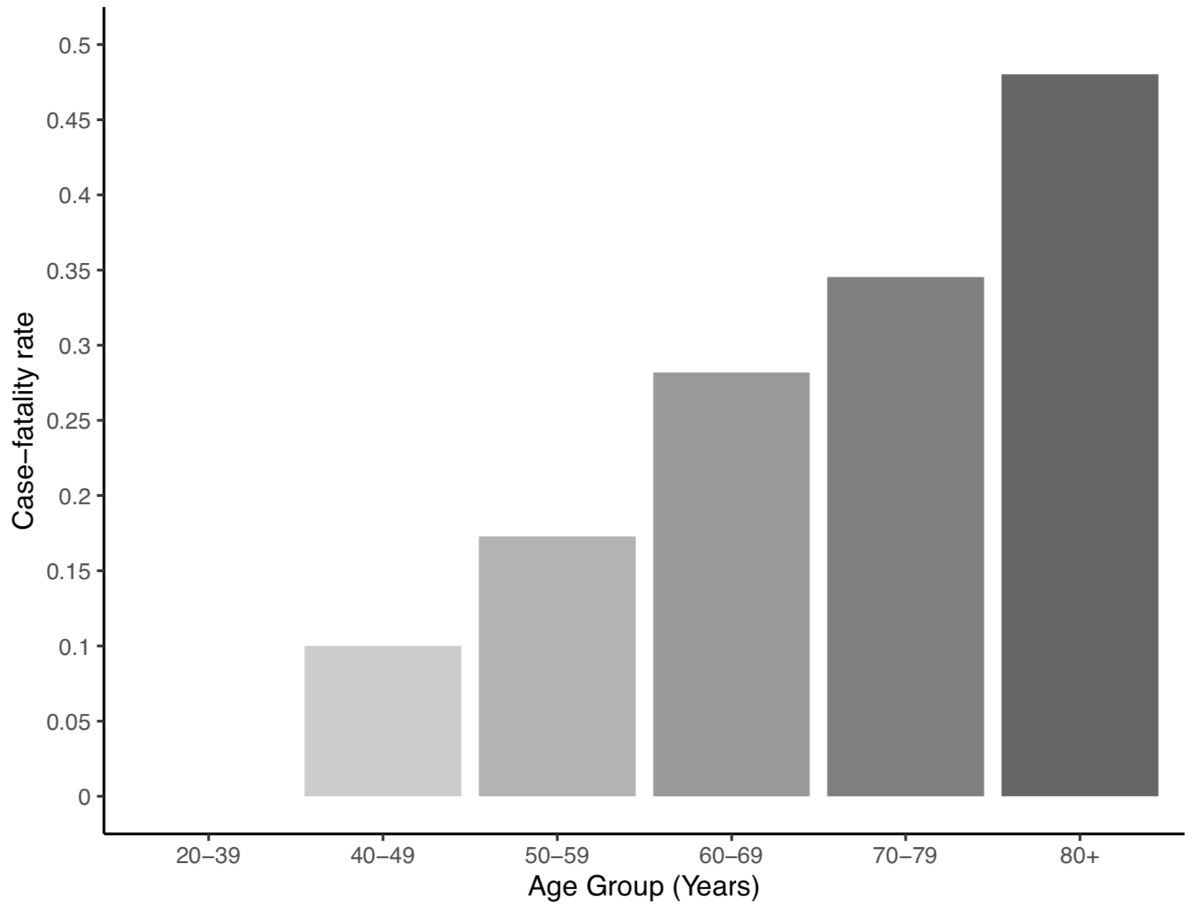
Figure 1: Age and risk of all-cause case fatality rate of patients following a presenting with COVID-19 in the UKCCMP cohort.

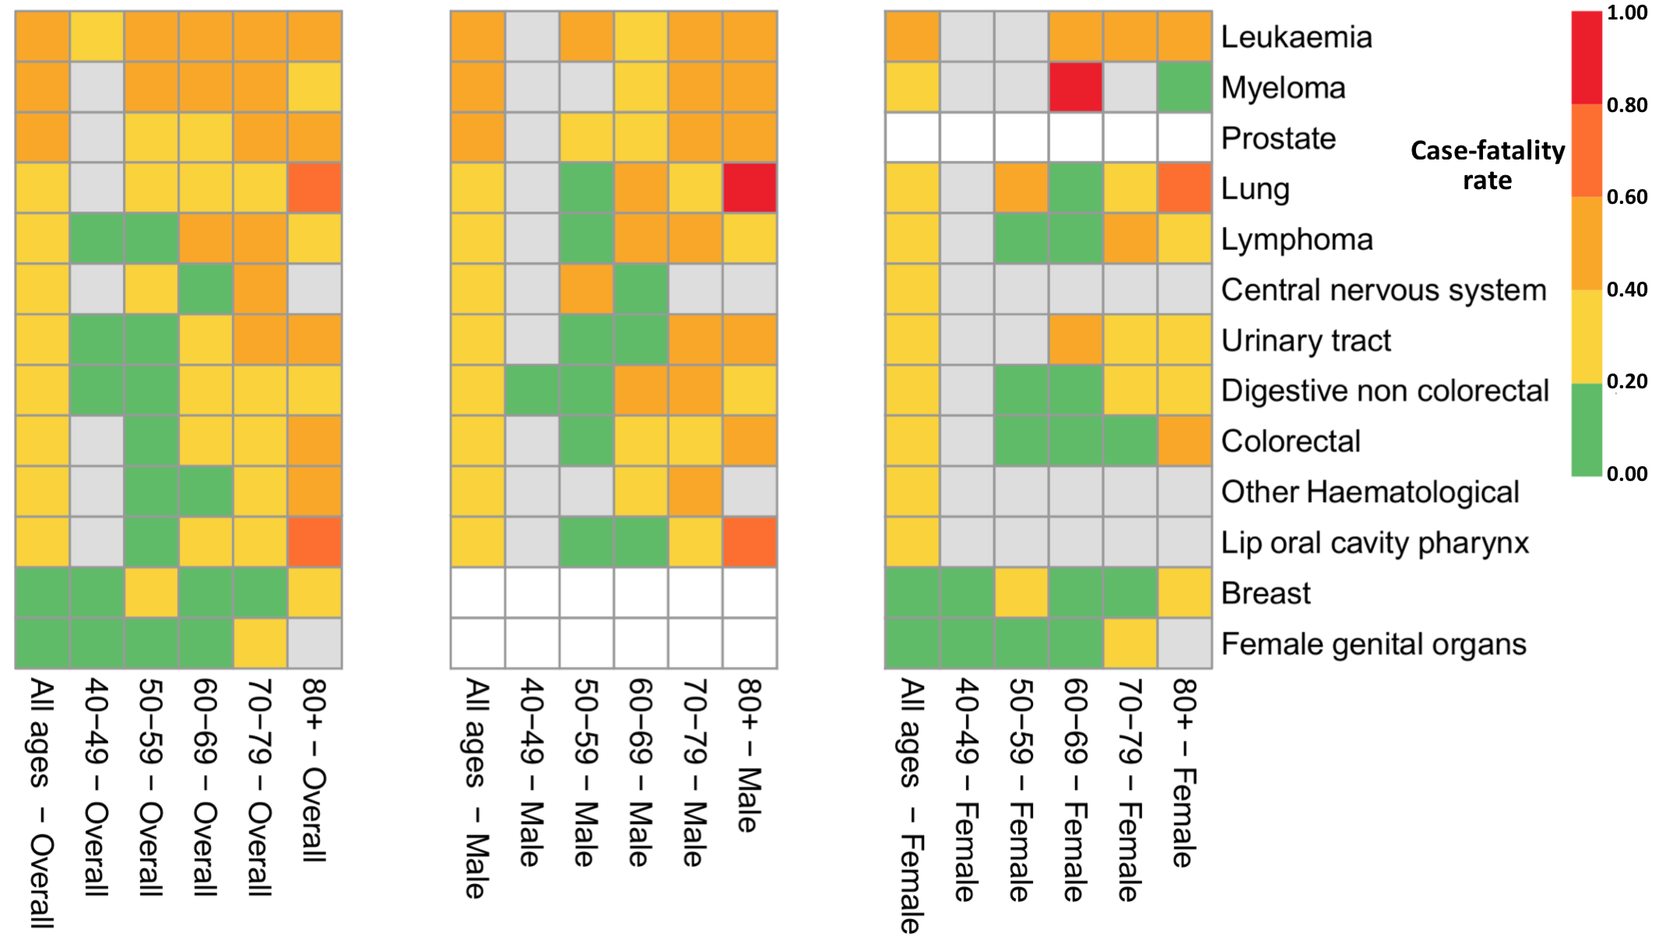

Figure 2: Heatmap demonstrating case fatality rate following a COVID-19 presentation, broken down by tumour subtype, age and gender. Grey bars represent where number of cases were less than 4.
Acknowledgements
The authors thank the patients and their families affected by COVID-19, oncologists, acute physicians and healthcare staff working tirelessly on the frontlines of the COVID-19 pandemic.

We would like to thank all members of the UKCCMP reporting network and ERRIs for their hard work in contributing data at a challenging time as listed in the web appendix (appendix page 1)

We would like to acknowledge the University of Birmingham and the University of Oxford in funding this study.

Author Contributions
LYWL, JBC, SB, StB, RA, GC, VC, HMC, DJH, DK, AJXL, ACOB, CP, KP, AB, GM, and RK were involved in the study design; LYWL, JBC, MWF, SG, AJXL, RL, SML, NM, TND, ACOB, TP, KP, OT, SS, GM, RK and UKCCMP were involved in the data collection; LYWL, JBC, TS, RA, VB, NAC, VC, HMC, PE, AG, SH, DJH, AJXL, HM, CPM, ACOB, CP, EP, KP, ASP, AS, CV, VW, GM and RK were involved in data acquisition and management; LYWL, JBC, SB, TS, CDT, AB, GM, and RK were involved in data analysis and interpretation; LYWL, JBC, KP, TS, SB, AB, GM, and RK were involved in manuscript writing; and RK made the decision to submit.

Funding statement
SB is funded by a Medical Research Council Clinical Research Training Fellowship (MR/P001106/1). ADMB ADMB is funded by the National Institute for Health Research (NIHR) Applied Research Collaboration (ARC) West Midlands. LL is supported by the NIHR Oxford BRC.

Declaration of interest

ACOB has received grant support from Roche, Bristol-Myers-Squibb, Eli Lily, Novartis and UCB Pharma, and personal fees from Roche, Bristol-Myers-Squibb, all outside the submitted work. NM has advisory board roles for Pfizer, Rocher, Boehringer Ingelheim; received speakers’ bureau from Merck, Pfizer and Roche, all outside the submitted work. TND has received personal fees from Astra Zeneca, Amgen, Bayer, BMS, Boehringer Ingelheim, MSD, Lily, Novartis, Pfizer, Roche, Takeda and non-financial support from BMS, MSD, Roche and Takeda, all outside the submitted work. The other authors have nothing to disclose.
REFERENCES

1. Report of the WHO-China Joint Mission on Coronavirus Disease 2019 (COVID-19). https://www.who.int/publications-detail/report-of-the-who-china-joint-mission-on-coronavirus-disease-2019-(covid-19).
2. Liang, W. et al. Cancer patients in SARS-CoV-2 infection: a nationwide analysis in China. Lancet Oncol. 21, 335–337 (2020).
3. Yu, J., Ouyang, W., Chua, M. L. K. & Xie, C. SARS-CoV-2 Transmission in Patients With Cancer at a Tertiary Care Hospital in Wuhan, China. JAMA Oncol. (2020) doi:10.1001/jamaoncol.2020.0980.
4. Miyashita, H. et al. Do Patients with Cancer Have a Poorer Prognosis of COVID-19? An Experience in New York City. Ann. Oncol. 0, (2020).
5. ESMO. Cancer Patient Management During the COVID-19 Pandemic. https://www.esmo.org/guidelines/cancer-patient-management-during-the-covid-19-pandemic.
6. Clinical guide for the management of non-coronavirus patients requiring acute treatment: Cancer. https://www.england.nhs.uk/coronavirus/publication/specialty-guides/.
7. Banna, G., Curioni-Fontecedro, A., Friedlaender, A. & Addeo, A. How we treat patients with lung cancer during the SARS-CoV-2 pandemic: primum non nocere. ESMO Open 5, (2020).
8. European Association of Urology Guidelines Office Rapid Reaction Group: An Organisation-wide Collaborative Effort to Adapt the European Association of Urology Guidelines Recommendations to the Coronavirus Disease 2019 Era - European Urology. https://www.europeanurology.com/article/S0302-2838(20)30324-9/fulltext.
9. Anil, I. et al. The UK Coronavirus Cancer Monitoring Project: protecting patients with cancer in the era of COVID-19. Lancet Oncol. 0, (2020).
10. Lee, L. Y. W. et al. COVID-19 mortality in patients with cancer on chemotherapy or other anticancer treatments: a prospective cohort study. The Lancet 0, (2020).
11. COVID-19 rapid guideline: critical care in adults. 13 (2020).
12. Cancer registration statistics, England - Office for National Statistics. https://www.ons.gov.uk/peoplepopulationandcommunity/healthandsocialcare/conditionsanddiseases/bulletins/cancerregistrationstatisticsengland/2017.
13. Peduzzi, P., Concato, J., Kemper, E., Holford, T. R. & Feinstein, A. R. A simulation study of the number of events per variable in logistic regression analysis. J. Clin. Epidemiol. 49, 1373–1379 (1996).
14. Collaborative, T. O. et al. OpenSAFELY: factors associated with COVID-19-related hospital death in the linked electronic health records of 17 million adult NHS patients. medRxiv 2020.05.06.20092999 (2020) doi:10.1101/2020.05.06.20092999.
15. Yang, K. et al. Clinical characteristics, outcomes, and risk factors for mortality in patients with cancer and COVID-19 in Hubei, China: a multicentre, retrospective, cohort study. Lancet Oncol. 0, (2020).
16. He, W. et al. COVID-19 in persons with haematological cancers. Leukemia 34, 1637–1645 (2020).
17. Kuderer, N. M. et al. Clinical impact of COVID-19 on patients with cancer (CCC19): a cohort study. The Lancet 0, (2020).
18. Tian, J. et al. Clinical characteristics and risk factors associated with COVID-19 disease severity in patients with cancer in Wuhan, China: a multicentre, retrospective, cohort study. Lancet Oncol. 0, (2020).
19. Garassino, M. C. et al. COVID-19 in patients with thoracic malignancies (TERAVOLT): first results of an international, registry-based, cohort study. Lancet Oncol. 0, (2020).

Research in Context

Evidence before the study:
A literature review was performed using PubMed for all studies from 1st December 2019 to 1st July 2020 related to SARS-CoV-2 infection susceptibility and clinical course of coronavirus disease (COVID-19) in cancer patients. This used the search terms, COVID-19, SARS-CoV-2, cancer and was not limited to English language publications. Several studies describe the correlations of patient demographics, namely age and gender and increased COVID-19 morbidity and mortality including Docherty et al (2020), Robilotti et al (2020), Miyashita et al (2020). Two pivotal cancer cohorts have identified no significant effect of chemotherapy on mortality, Lee et al (2020), Kuderer et al (2020) and this was also noted by Vaugnat et al (2020). However, a small study had identified a small risk, Yang et al (2020). The effect of cancer subtype is unclear. Dai et al (2020) identified that patients with haematological or lung malignancies have a poorer disease course. The elevated risk in haematological malignancies was also noted by Yang et al (2020) and in lung cancer by Garassino et al (2020), but Kuderer et al (2020) did not identify increased mortality by cancer subtype.

Added value of the study
This UK Coronavirus Cancer Monitoring Project (UKCCMP) study is a national monitoring project of cancer patients who contract COVID-19 disease, consisting of 1044 patients to date. We have compared cancer patients enrolled in the UKCCMP and a parallel non-COVID-19 UK cancer control population cohort, analysing the effect of tumour features (primary subtype and stage) and patient demographics (age and sex) on the risk and the trajectory of COVID-19 disease. Tumour features (primary subtype and stage) as well as patient demographics impact on viral susceptibility and COVID-19 disease phenotype. There is increased SARS-CoV-2 susceptibility in patients with haematological cancers (leukaemia/lymphoma/myeloma). Haematology patients run a more severe COVID-19 disease trajectory and require more intensive clinical support with additional risk conferred by recent chemotherapy use. As observed in the general population, age and gender are predominant risk factors for SARS-CoV-2 infection and severity of COVID-19 disease for most cancer patients.

Implications of all the available evidence
Our data indicates that cancer patients with different tumours have differing SARS-CoV-2 susceptibility and COVID-19 disease phenotypes, notably association of increased SARS-CoV-2 susceptibility in patients with haematological cancers. We have generated individualised risk tables for cancer patients taking into account age/sex and tumour subtype. This will be useful for physicians to have a more informed risk-benefit discussion to explain COVID-19 risk to their cancer patients.

